CSA1411-COMPILER DESIGN

LAB EXPERIMENTS

NAME:- DENVAR JOE H

REG NO:- 192511438

EXPERIMENT – 4:
AIM:-
Design a lexical Analyzer to validate operators to recognize the operators +,-,*,/ using regular Arithmetic operators.
CODE:-
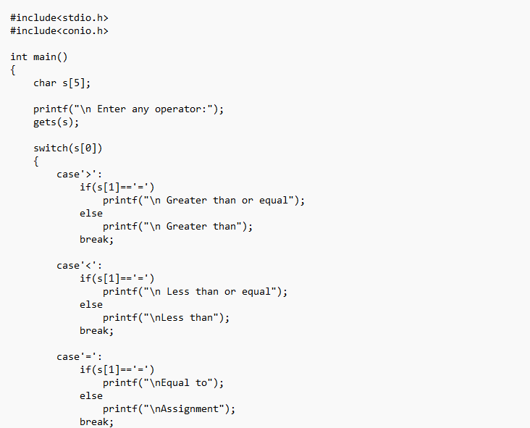
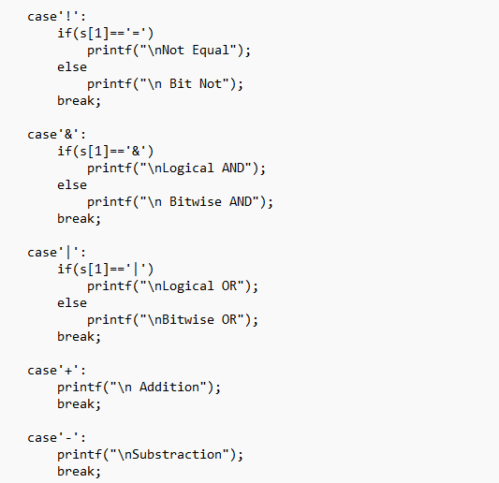
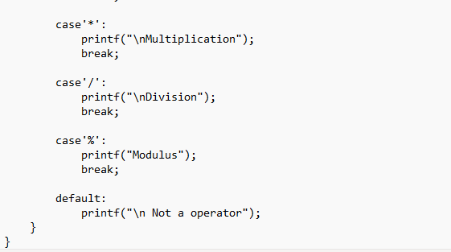

OUTPUT:
