CSA1411-COMPILER DESIGN

LAB EXPERIMENTS

NAME:- DENVAR JOE H

REG NO:- 192511438

EXPERIMENT – 30:
AIM:-
Implement a LEX program to check whether the mobile number is valid or not.
CODE:-
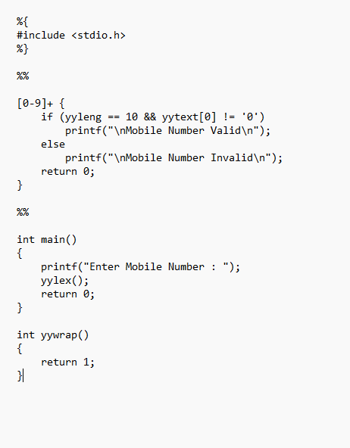
OUTPUT:-
