CSA1411-COMPILER DESIGN

LAB EXPERIMENTS

NAME:- DENVAR JOE H

REG NO:- 192511438

EXPERIMENT – 27:
AIM:-
Write a LEX program to count the number of comment lines in a given C program and eliminate them and write into another file.
CODE:-
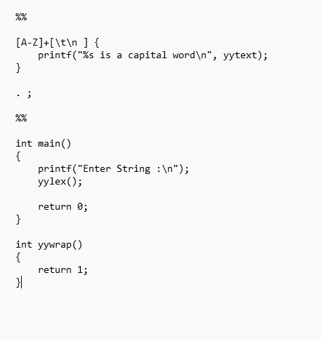
OUTPUT:-
