CSA1411-COMPILER DESIGN

LAB EXPERIMENTS

NAME:- DENVAR JOE H

REG NO:- 192511438

EXPERIMENT – 19:
AIM:-
ignore comments. Although the syntax specification states that identifiers can be arbitrarily long, you may restrict the length to some reasonable value. Write a LEX specification file to take input C program from a .c file and count t he number of characters, number of lines & number of words
CODE:-
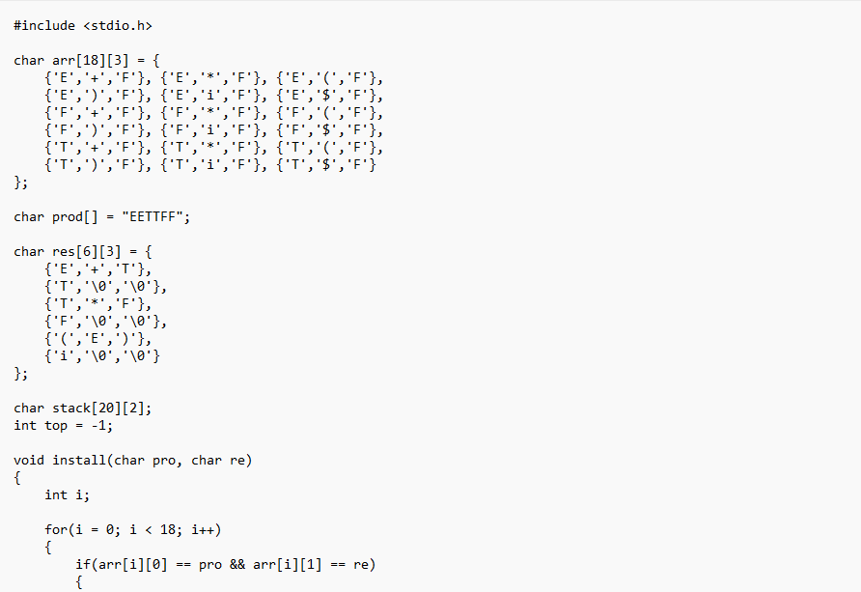
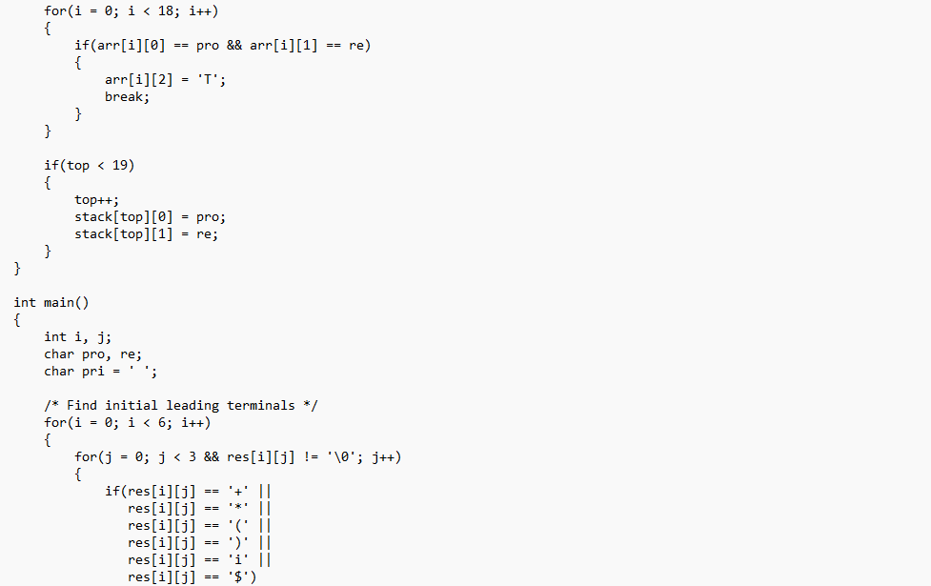
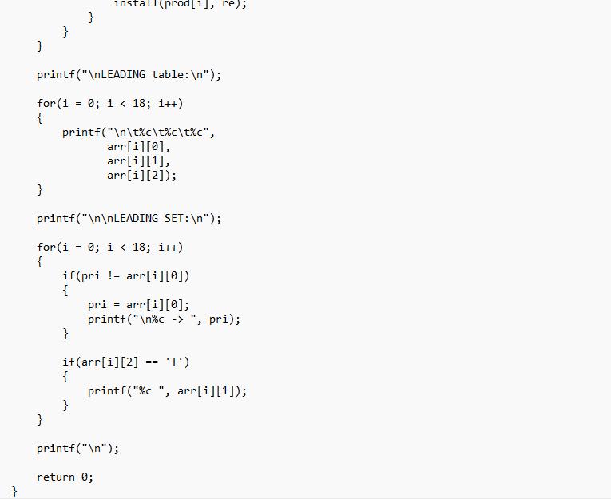

OUTPUT:
