CSA1411-COMPILER DESIGN

LAB EXPERIMENTS

NAME:- Denvar Joe H

REG NO:- 192511438

EXPERIMENT – 24:
AIM:-
Write a LEX program to print all HTML tags in the input file.
CODE:-
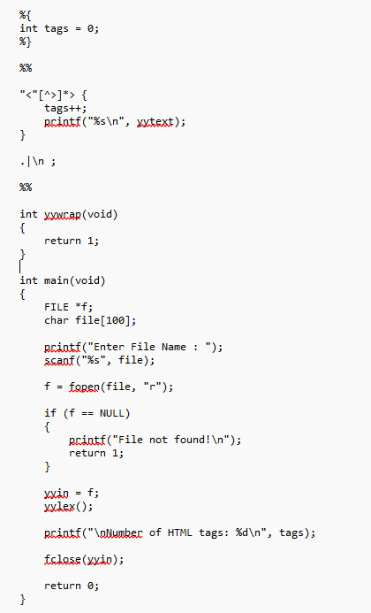

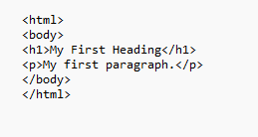
OUTPUT:-
