CSA1411-COMPILER DESIGN

LAB EXPERIMENTS

NAME:- DENVAR JOE H

REG NO:- 192511438

EXPERIMENT – 14:
AIM:-
The main function of the Intermediate code generation is producing three address code statements for a given input expression. The three address codes help in determining the sequence in which operations are actioned by the compiler. The key work of Intermediate code generators is to simplify the process of Code generators. Write a C Program to Generate the Three address code representation for the given input statement.
CODE:-
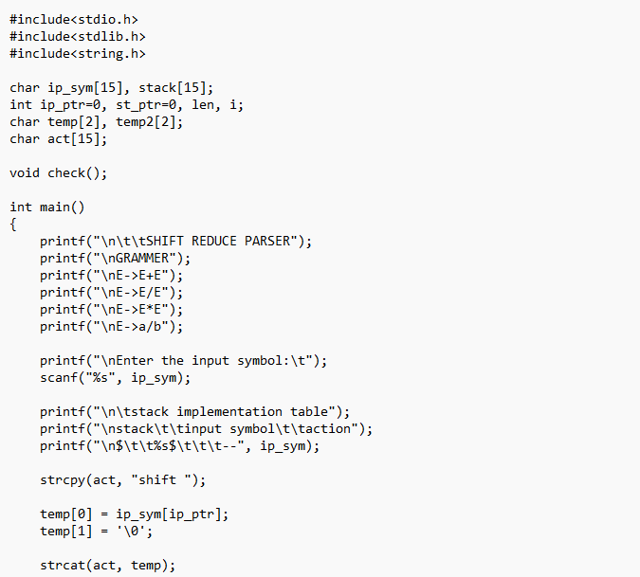
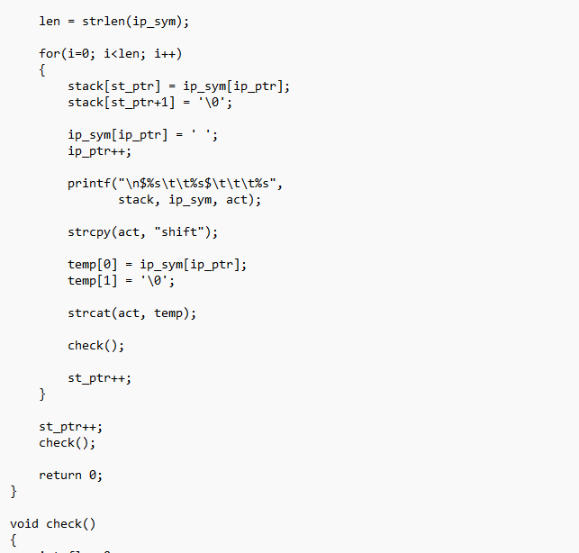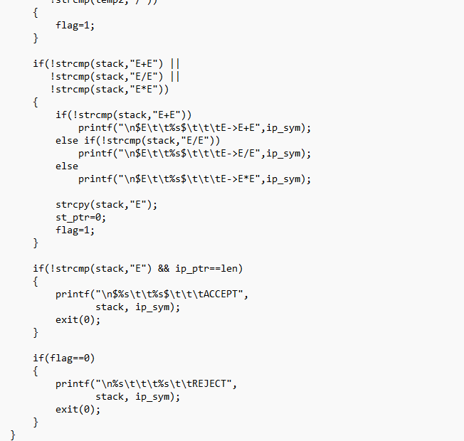

OUTPUT:
