CSA1411-COMPILER DESIGN

LAB EXPERIMENTS

NAME:- DENVAR JOE H

REG NO:- 192511438

EXPERIMENT – 20:
AIM:-
LEX program to print all the constants in the given C source program file.
CODE: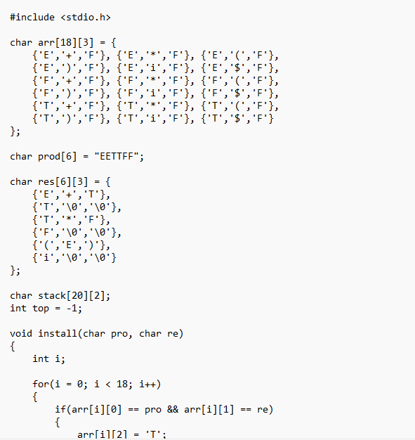
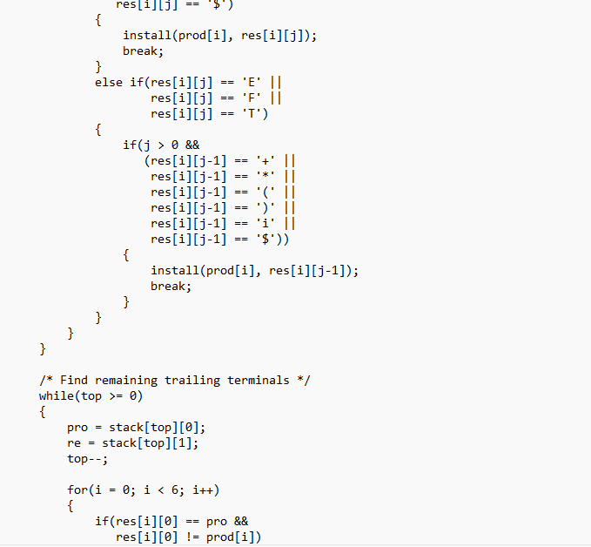
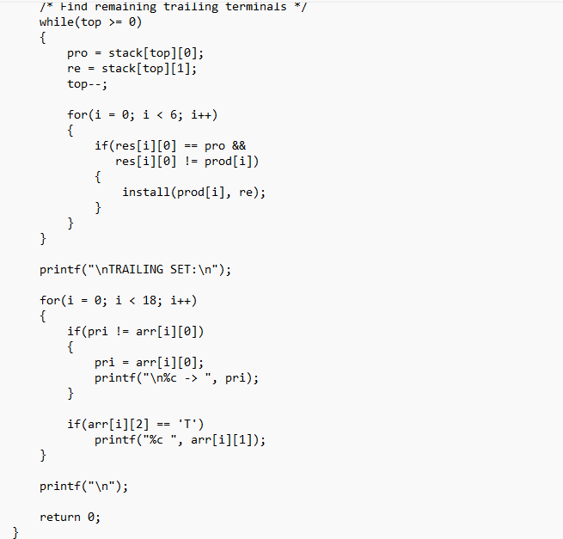
OUTPUT:
