CSA1411-COMPILER DESIGN

LAB EXPERIMENTS

NAME:- DENVAR JOE H

REG NO:- 192511438

EXPERIMENT – 11:
AIM:-
Implement a C program to perform symbol table operations.
CODE:-
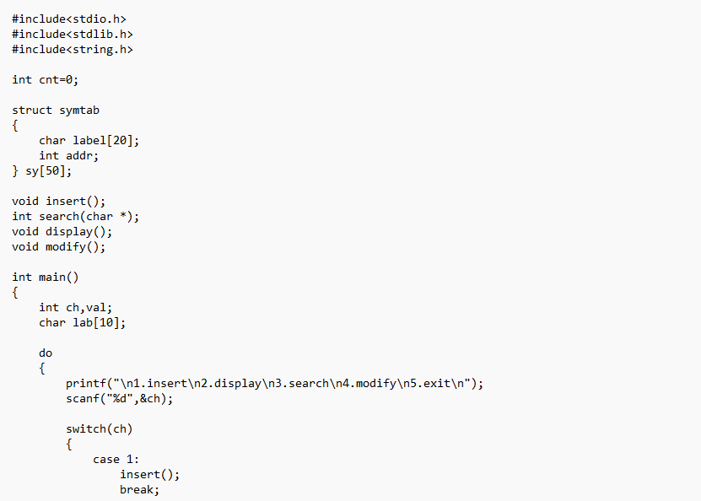
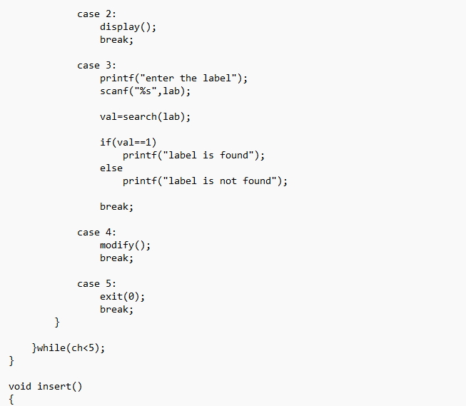
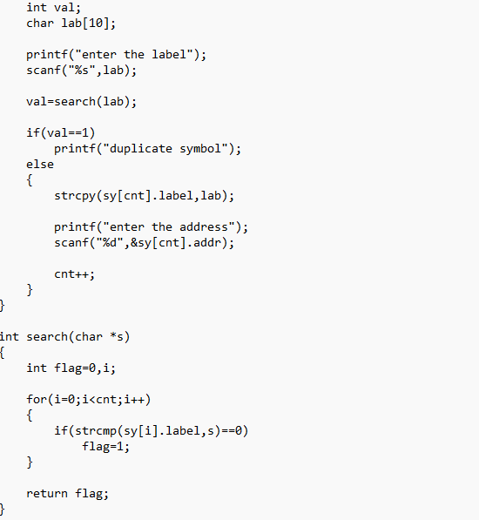
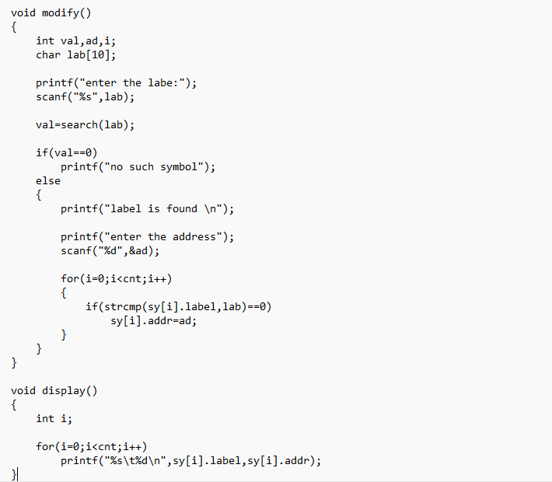
OUTPUT:
