CSA1411-COMPILER DESIGN

LAB EXPERIMENTS

NAME:- DENVAR JOE H

REG NO:- 192511438

EXPERIMENT – 3:
AIM:-
Design a lexical Analyzer for a given language should ignore the redundant spaces, tabs, and new lines and ignore comments.
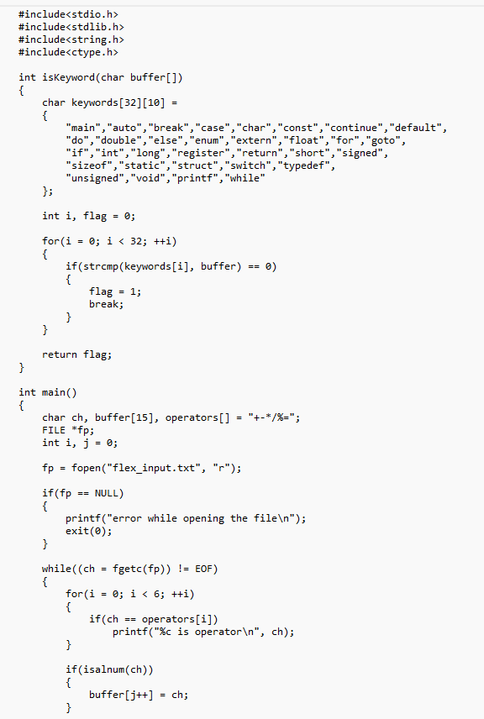
CODE:-
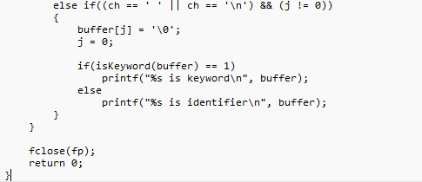
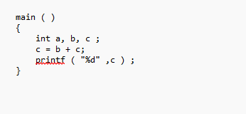
INPUT:-

OUTPUT:-
