CSA1411-COMPILER DESIGN

LAB EXPERIMENTS

NAME:- DENVAR JOE H

REG NO:- 192511438

EXPERIMENT – 10:
AIM:-
Implement a C program to eliminate left factoring from a given CFG.
S → iEtS / iEtSeS / a
E → b
CODE:-
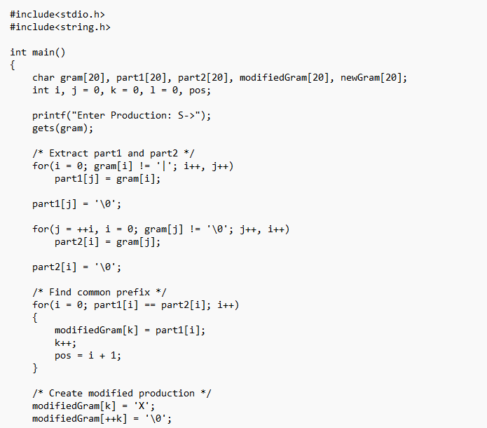
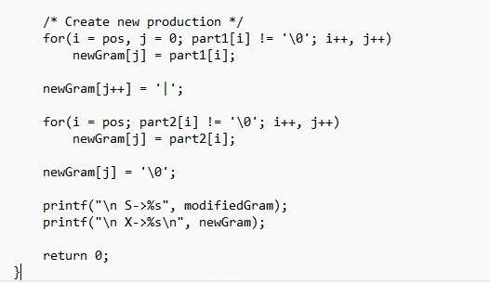

OUTPUT:
