CSA1411-COMPILER DESIGN

LAB EXPERIMENTS

NAME:- DENVAR JOE H

REG NO:- 192511438

EXPERIMENT – 29:
AIM:-
Write a LEX Program to convert the substring abc to ABC from the given input string
CODE:-
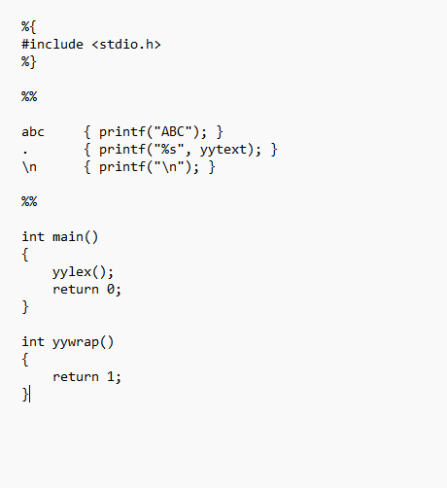
OUTPUT:-
