CSA1411-COMPILER DESIGN

LAB EXPERIMENTS

NAME:- DENVAR JOE H

REG NO:- 192511438

EXPERIMENT – 25:
AIM:-
Write a LEX program which adds line numbers to the given C program file and display the same in the standard output.
CODE:-
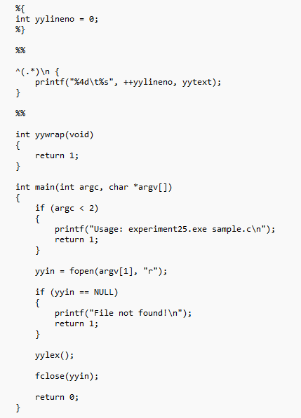
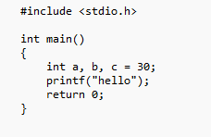
OUTPUT:-

