CSA1411-COMPILER DESIGN

LAB EXPERIMENTS

NAME:-DENVAR JOE H

REG NO:- 192511438

EXPERIMENT – 32:
AIM:-
Write a LEX program to count the number of vowels in the given sentence.
CODE:-
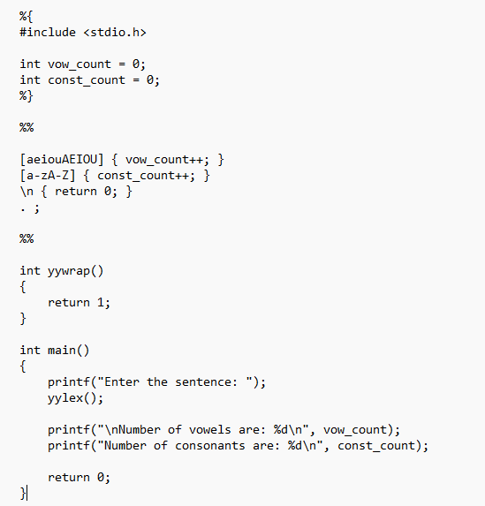
OUTPUT:-
