CSA1411-COMPILER DESIGN

LAB EXPERIMENTS

NAME:-DENVAR JOE H

REG NO:- 192511438

EXPERIMENT – 31:
AIM:-
Implement Lexical Analyzer using FLEX (Fast Lexical Analyzer). The program should separate the tokens in the given C program and display with appropriate caption.
CODE:-
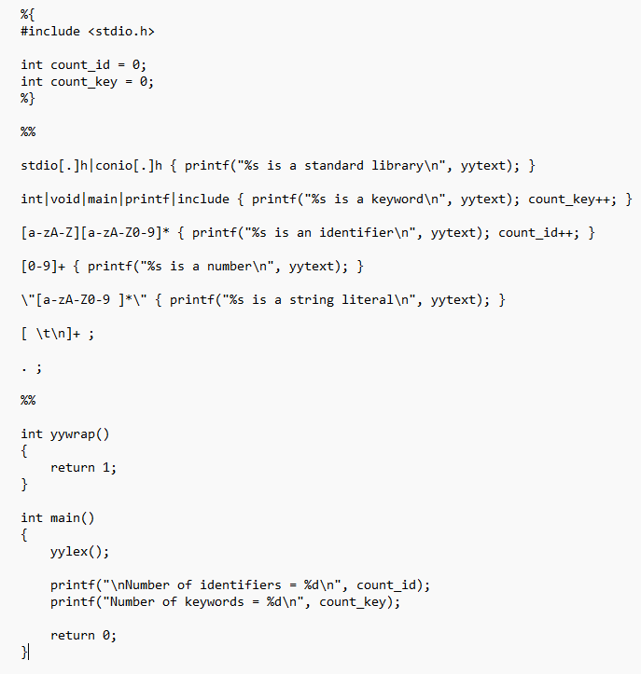
OUTPUT:-
