CSA1411-COMPILER DESIGN

LAB EXPERIMENTS

NAME:- DENVAR JOE H

REG NO:- 192511438

EXPERIMENT – 9:
AIM:-
Implement a C program to eliminate left recursion from a given CFG.
S → (L) / a
L → L , S / S

CODE:-
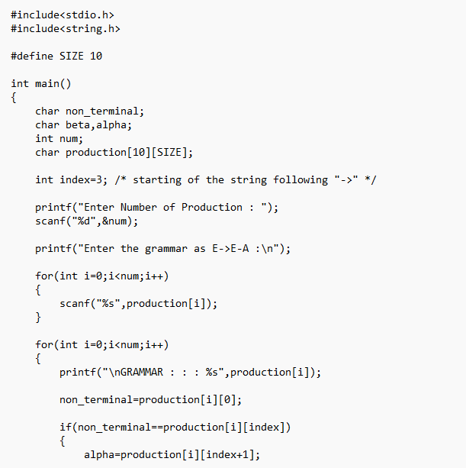
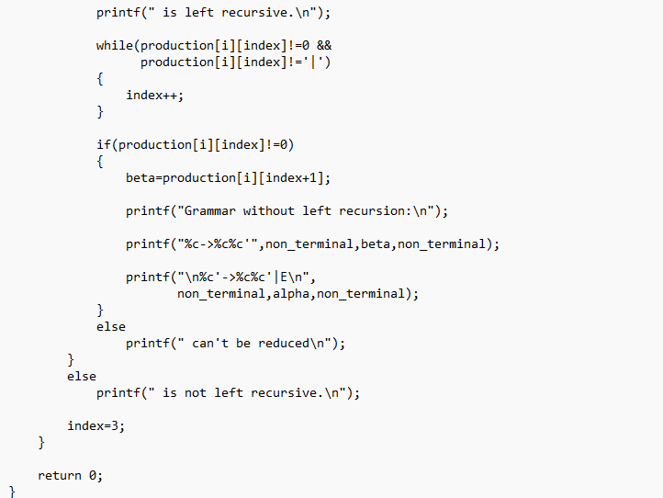
OUTPUT:
