CSA1411-COMPILER DESIGN

LAB EXPERIMENTS

NAME:- DENVAR JOE H

REG NO:- 192511438

EXPERIMENT – 23:
AIM:-
Write a LEX program to count the number of Macros defined and header files included in the C program.
CODE:-
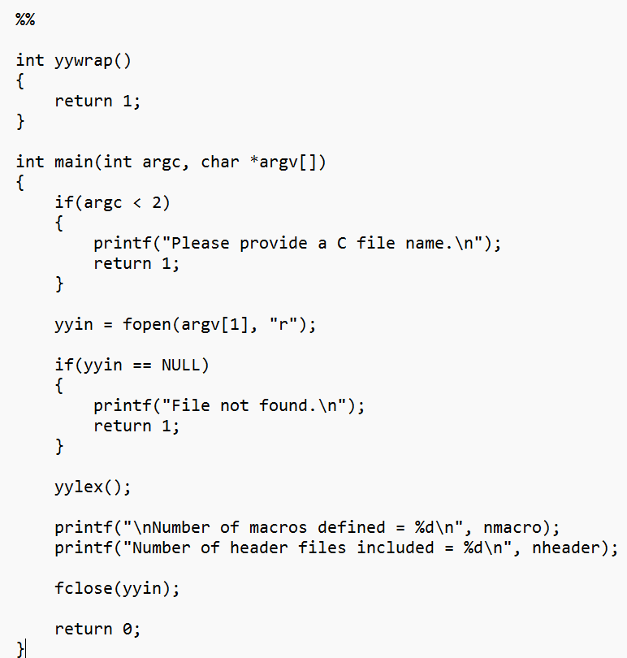
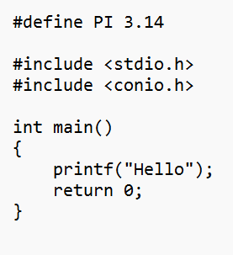
OUTPUT:-
