CSA1411-COMPILER DESIGN

LAB EXPERIMENTS

NAME:- DENVAR JOE H

REG NO:- 192511438

EXPERIMENT – 28:
AIM:-
Write a LEX Program to check the email address is valid or not.
CODE:-
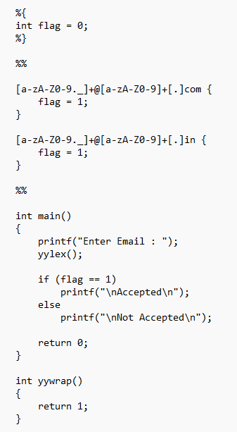

OUTPUT:-
