CSA1411-COMPILER DESIGN

LAB EXPERIMENTS

NAME:- DENVAR JOE H

REG NO:- 192511438

EXPERIMENT – 16:
AIM:-
Write a C program to implement the back end of the compiler.
CODE:-
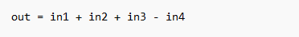
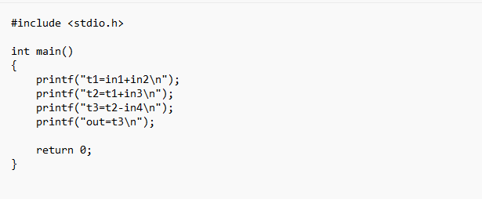
OUTPUT: 