CSA1411-COMPILER DESIGN

LAB EXPERIMENTS

NAME:- DENVAR JOE H

REG NO:- 192511438

EXPERIMENT – 15:
AIM:-
Write a C program for implementing a Lexical Analyzer to Scan and Count the number of characters, words, and lines in a file
CODE:-
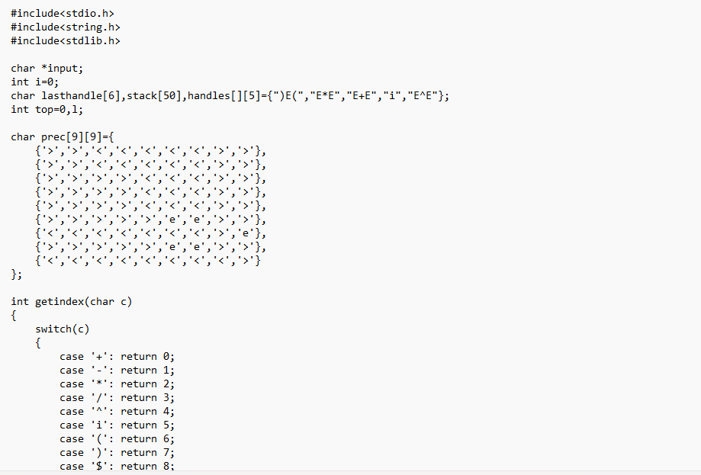
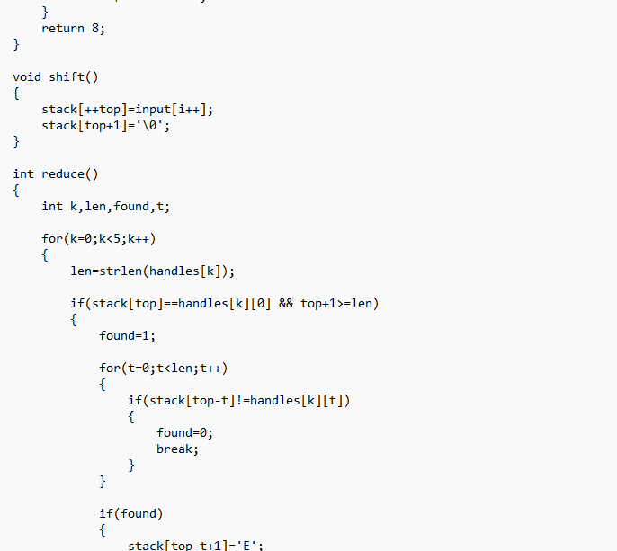
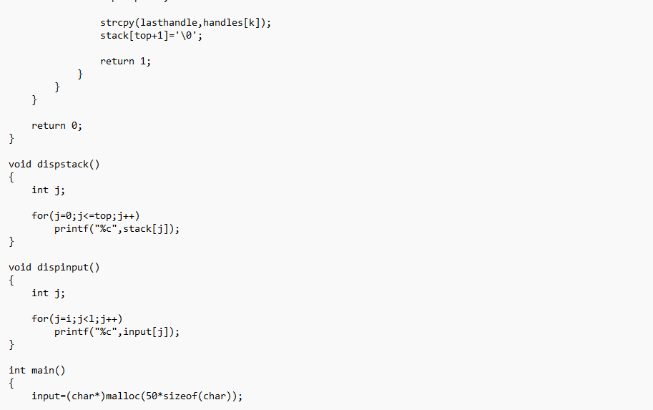
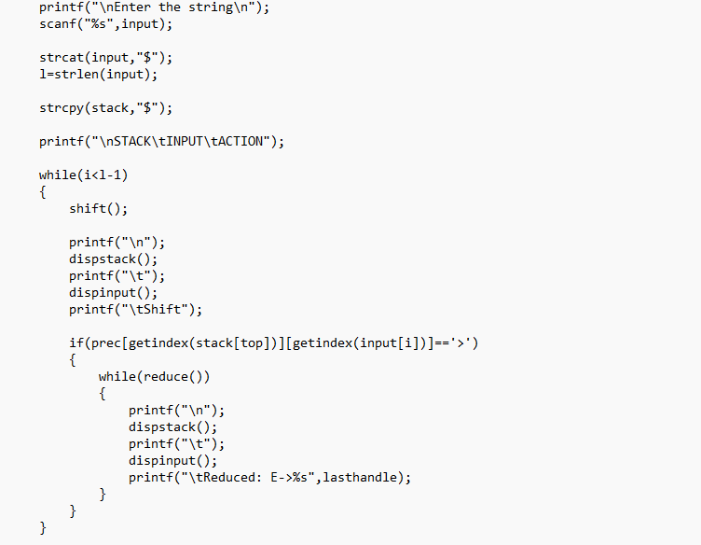
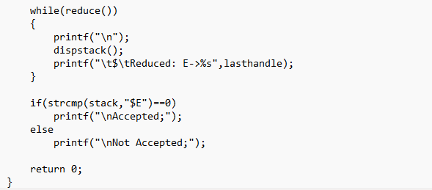
OUTPUT:
