A PROJECT REPORT ON“SMART TROLLEY USING RFID TECHNOLOGY”



**TEAM ID :- 62889**

**PREPARED BY :-**

**BARIA DHARMIK M. (160600109006)**

**KHARVA JAINIL (160600109018)**

**PATEL HARSHIL R. (160600109033)**

**RAI DURGESH A. (160600109039)**

**GUIDED BY :- ASST Prof. Nisha Babulal Lodha**

**GUJARAT TECHNOLOGICAL UNIVERSITY**





**DEPARTMENT OF ELECTRICAL ENGINEERING**

**GOVERNMENT ENGINEERING COLLEGE**

**GODHRA**

**ACKNOWLEDGEMENT**

This satisfaction and euphoria that accompany the successful completion of any task would be incomplete without the mentioning of the people whose constant guidance and encouragement made it possible.

We take pleasure in presenting before you, our project, which is result of studied blend of both research and knowledge.

We express our earnest gratitude to our internal guide, Prof. Nisha Babulal Lodha, Department of Electrical Engineering, our project guide, for her constant support, encouragement and guidance. We are grateful for his Co-operation and his valuable suggestions.

Finally, we express our gratitude to all other members who are involved either directly or indirectly for the completion of this project.

**CHAPTER : 1**

**INRODUCTION**

**1.1 Problem summary**

According to present scenario, now a days shopping at big malls & hyper city is becoming a daily activity in metro cities. Due to this a huge rush at malls on holidays and weekend occurred. After purchasing the product at the billing counter the cashier prepare the bill by scanning the bar code of the product which is a time consuming process and due to this long queues are seen in the mall and nowadays the shoplifting is also increased in the mall due to which there is huge loss to the mall profit as the shoplifter steals the items and also the inventory management is also very tedious job.

**1.2 Aim and objectives of the project**

Our main objective of our product is to provide a technology oriented, low –cost, easily usable, and rugged system for assisting shopping for the peoples. Here we have built a RFID powered electronic shopping cart to enhance the overall shopping experience for the consumer. As the consumer put any product in the cart it will automatically detect the product detail and its price and it will be shown on the lcd screen of the trolley after completing the shopping the trolley will generate an automatic live bill by itself and also RFID is also work as Anti-Shoplifting device as having a transmitter and receiver at the doorway as every item is concealed with RFID tag and the receiver picks ups the radio signal form the tag and transmit and sound the alarm. Using RFID we can also mange a stock and update the stock also by getting the online data at the server of mall.

* 1. **Problem specification**

1. The billing process is very time consuming as cashier scan the barcode of product one by one because if this lots of time is wasted of the consumer.
2. Nowadays the shoplifting is also increased in the mall due to which the stores and malls faces losses.
3. The stock management is also a time consuming for the shopkeeper.
   1. **Brief literature review**

Title of Project: - Smart Trolley Using RFID

Research Publication: - International Research Journal of Engineering and Technology (IRJET)

Authors :- Vaishali Rane, Krutik Shah, Kaushal Vyas, Sahil Shah, Nishant Upadhyay

Web Search :- <https://www.irjet.net/archives/V6/i1/IRJET-V6I1203.pdf>

Summary Of the Project :

By means of this paper we tend to intent to modify the billing process, build it swift & increase the protection using RFID technique. The cart has the feature calculate mechanically and show the entire costs of all the product within it. This makes it simple for the client to understand what amount he or she has got to pay during shopping and not at the checkout. One can delete the product from the cart by just scanning it again if he or she does not want it. The system proposed is highly dependable, authentic, trustworthy and time-effective. There will be reduction in wage amount given to workers, reduction in theft. Also, the system is very time-efficient. This will take the looking expertise to a special level. Different parameters such as the system parameters of smart trolley like products name and products cost are continuously display.

* 1. **Plan of their work**

First we had think about our domain that it is possible or not? Then after we had watched and read a lots of blog and videos on YouTube about the Smart Trolley using RFID Technology. After then we had decided the components of our project and make a proper planning of the project and then we go chronologically of our planning and make the halfway of our project in this semester.

* 1. **Material/Tools required**
     1. **NODE MCU ESP8266**

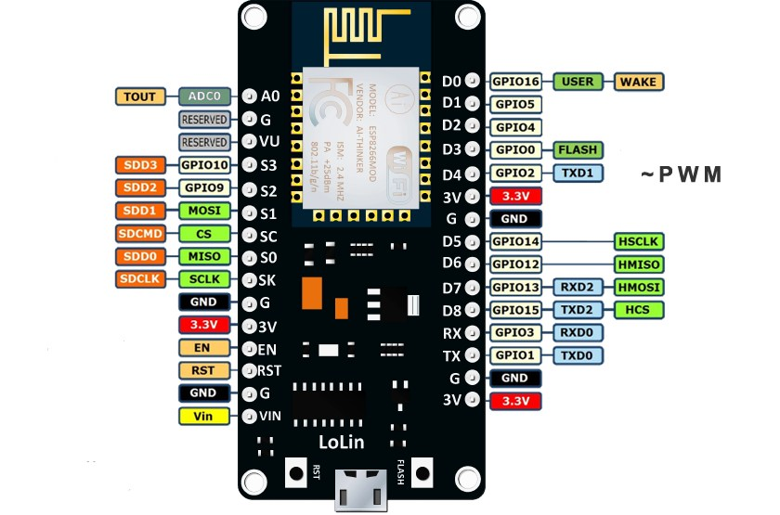

1.6.1(A) NODE MCU ESP8266

The NodeMcu Esp8266 is perfect for this project as a low-cost an open source IoT platform. It includes firmware which runs on the ESP8266 Wi-Fi SoC from Espressif Systems, and hardware which is based on the ESP-12 module. ... It is based on the eLua project, and built on the Espressif Non-OS SDK for ESP8266. It uses many open source projects, such as lua-cjson and SPIFFS.

Arduino Uno was the first choice for the project as it as more analog pin and digital pins for the connection and also it will have 5v output pins but NodeMcu Esp8266 will be a better choice in place of Uno because it is Iot device and it has an in built Wi-Fi and also so we don’t have to buy ZigBee for the Wi-Fi communication between the trolley and central billing system.

* + 1. **EM-18 RFID READER MODULE**

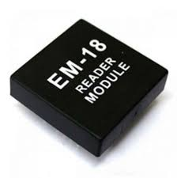

1.6.2(A) EM-18 RFID READER MODULE

For reading the rfid tag or rfid sticker we have used Em-18 Reader module and soldered a buzzer and led connected with module as the customer scan any product it will produce buzzing sound and a green led will be blink.

The EM-18 RFID Reader module operating at 125 kHz is an inexpensive solution for your RFID based application. The Reader module comes with an on-chip antenna and can be powered up with a 5V power supply. Power-up the module and connect the transmit pin of the module to receive pin of your microcontroller. Show your card within the reading distance and the card number is thrown at the output.

* + 1. **20*4 I2C LCD DISPLAY**

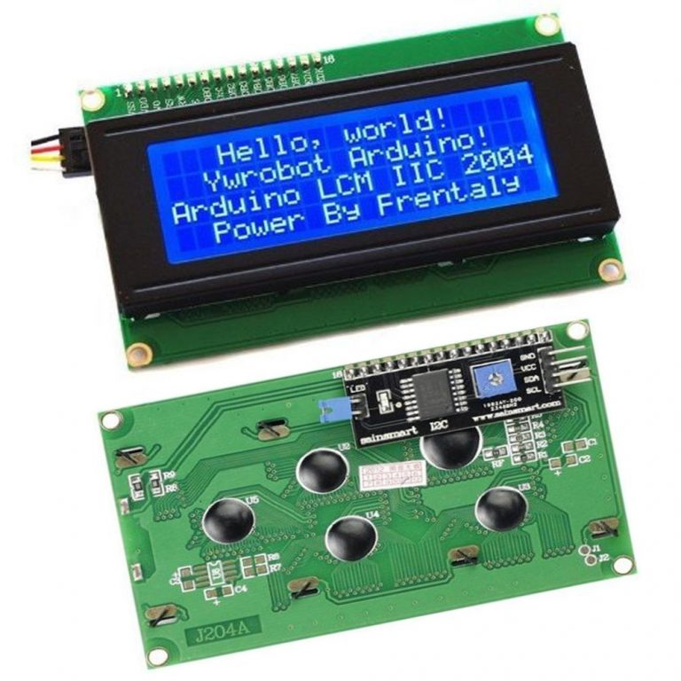

1.6.3(A) 20*4 I2C LCD DISPLAY

20*4 LCD Display with I2C Interface. LCDs are useful for creating standalone projects. This LCD Display utilizes an I2C interface, which means that fewer pins are necessary to use this product than would be needed with a regular 20*4 LCD Display (just four connections, VCC, GND, SDA & SCL are required).

* + 1. **BATTERY**

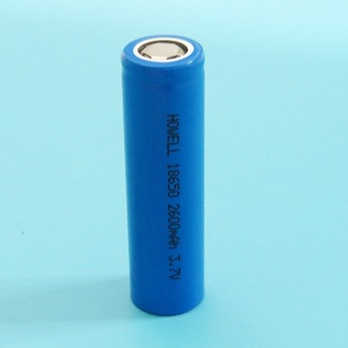

1.6.4(A) BATTERY

When considering electric energy storage systems that are capable of giving supply to the components of the smart trolley like the microcontroller board ,Lcd display and the rfid reader module. So we have consider the choice of a portable energy storage system. So we have used this 3.7 V 186050 2600mah battery with a 5V step up booster module.

We can also use Power bank or 5v DC power supply adapter for the supply of energy to the components.

* + 1. **USB Power Step-up Boost Module**

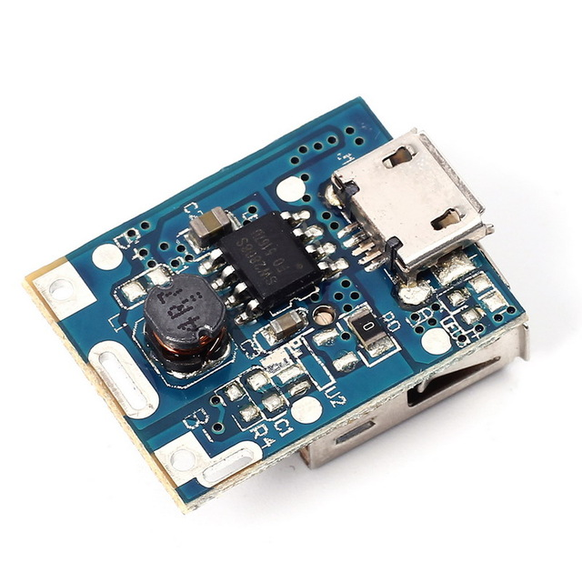

1.6.5(A) STEP UP POWER MODULE

To charge our battery and step up the voltage of the battery from 3.7 V to 5v. We use the step up power module which step up up the voltage around 5V with this also it also charge the battery.

Minimum Input voltage: 3. 7V~5. 5V for charging the battery and max output voltage is 5V which is the need of our project the max output current is around 1 A.

**CHAPTER : 2**

**DESIGN**

**2.1 ANALYSIS**

**DATA SERVER**

**POWER SUPPLY**

**NODEMCU ESP8266**

**RFID READER**

**LCD DISPLAY**

**BUZZER & LED**

**(BLOCK DIAGRAM)**

**2.2 ALGORITHM PART FOR SMART TROLLEY**

**START**

**INITLALISE THE SYSTEM**

**SCAN RFID TAGS**

**IS RFID TAG?**

**TTGAS**

**TAGS**?

RF

RFID

**READ DATA FROM MEMORY**

**DISPLAY ON THE LCD**

**TOTAL AMOUNT**

**ADD ITEM COST AS ITEM ARE ADDED**

**IF ITEM IS**

**REMOVEDD**

**TOTAL WILL BE SAME**

**SEND THE TOTAL AMOUNT**

**PRINT BILL**

**END**

**2.3 DESIGN CANVASES**

**2.3.1 AEIOU CANVAS**

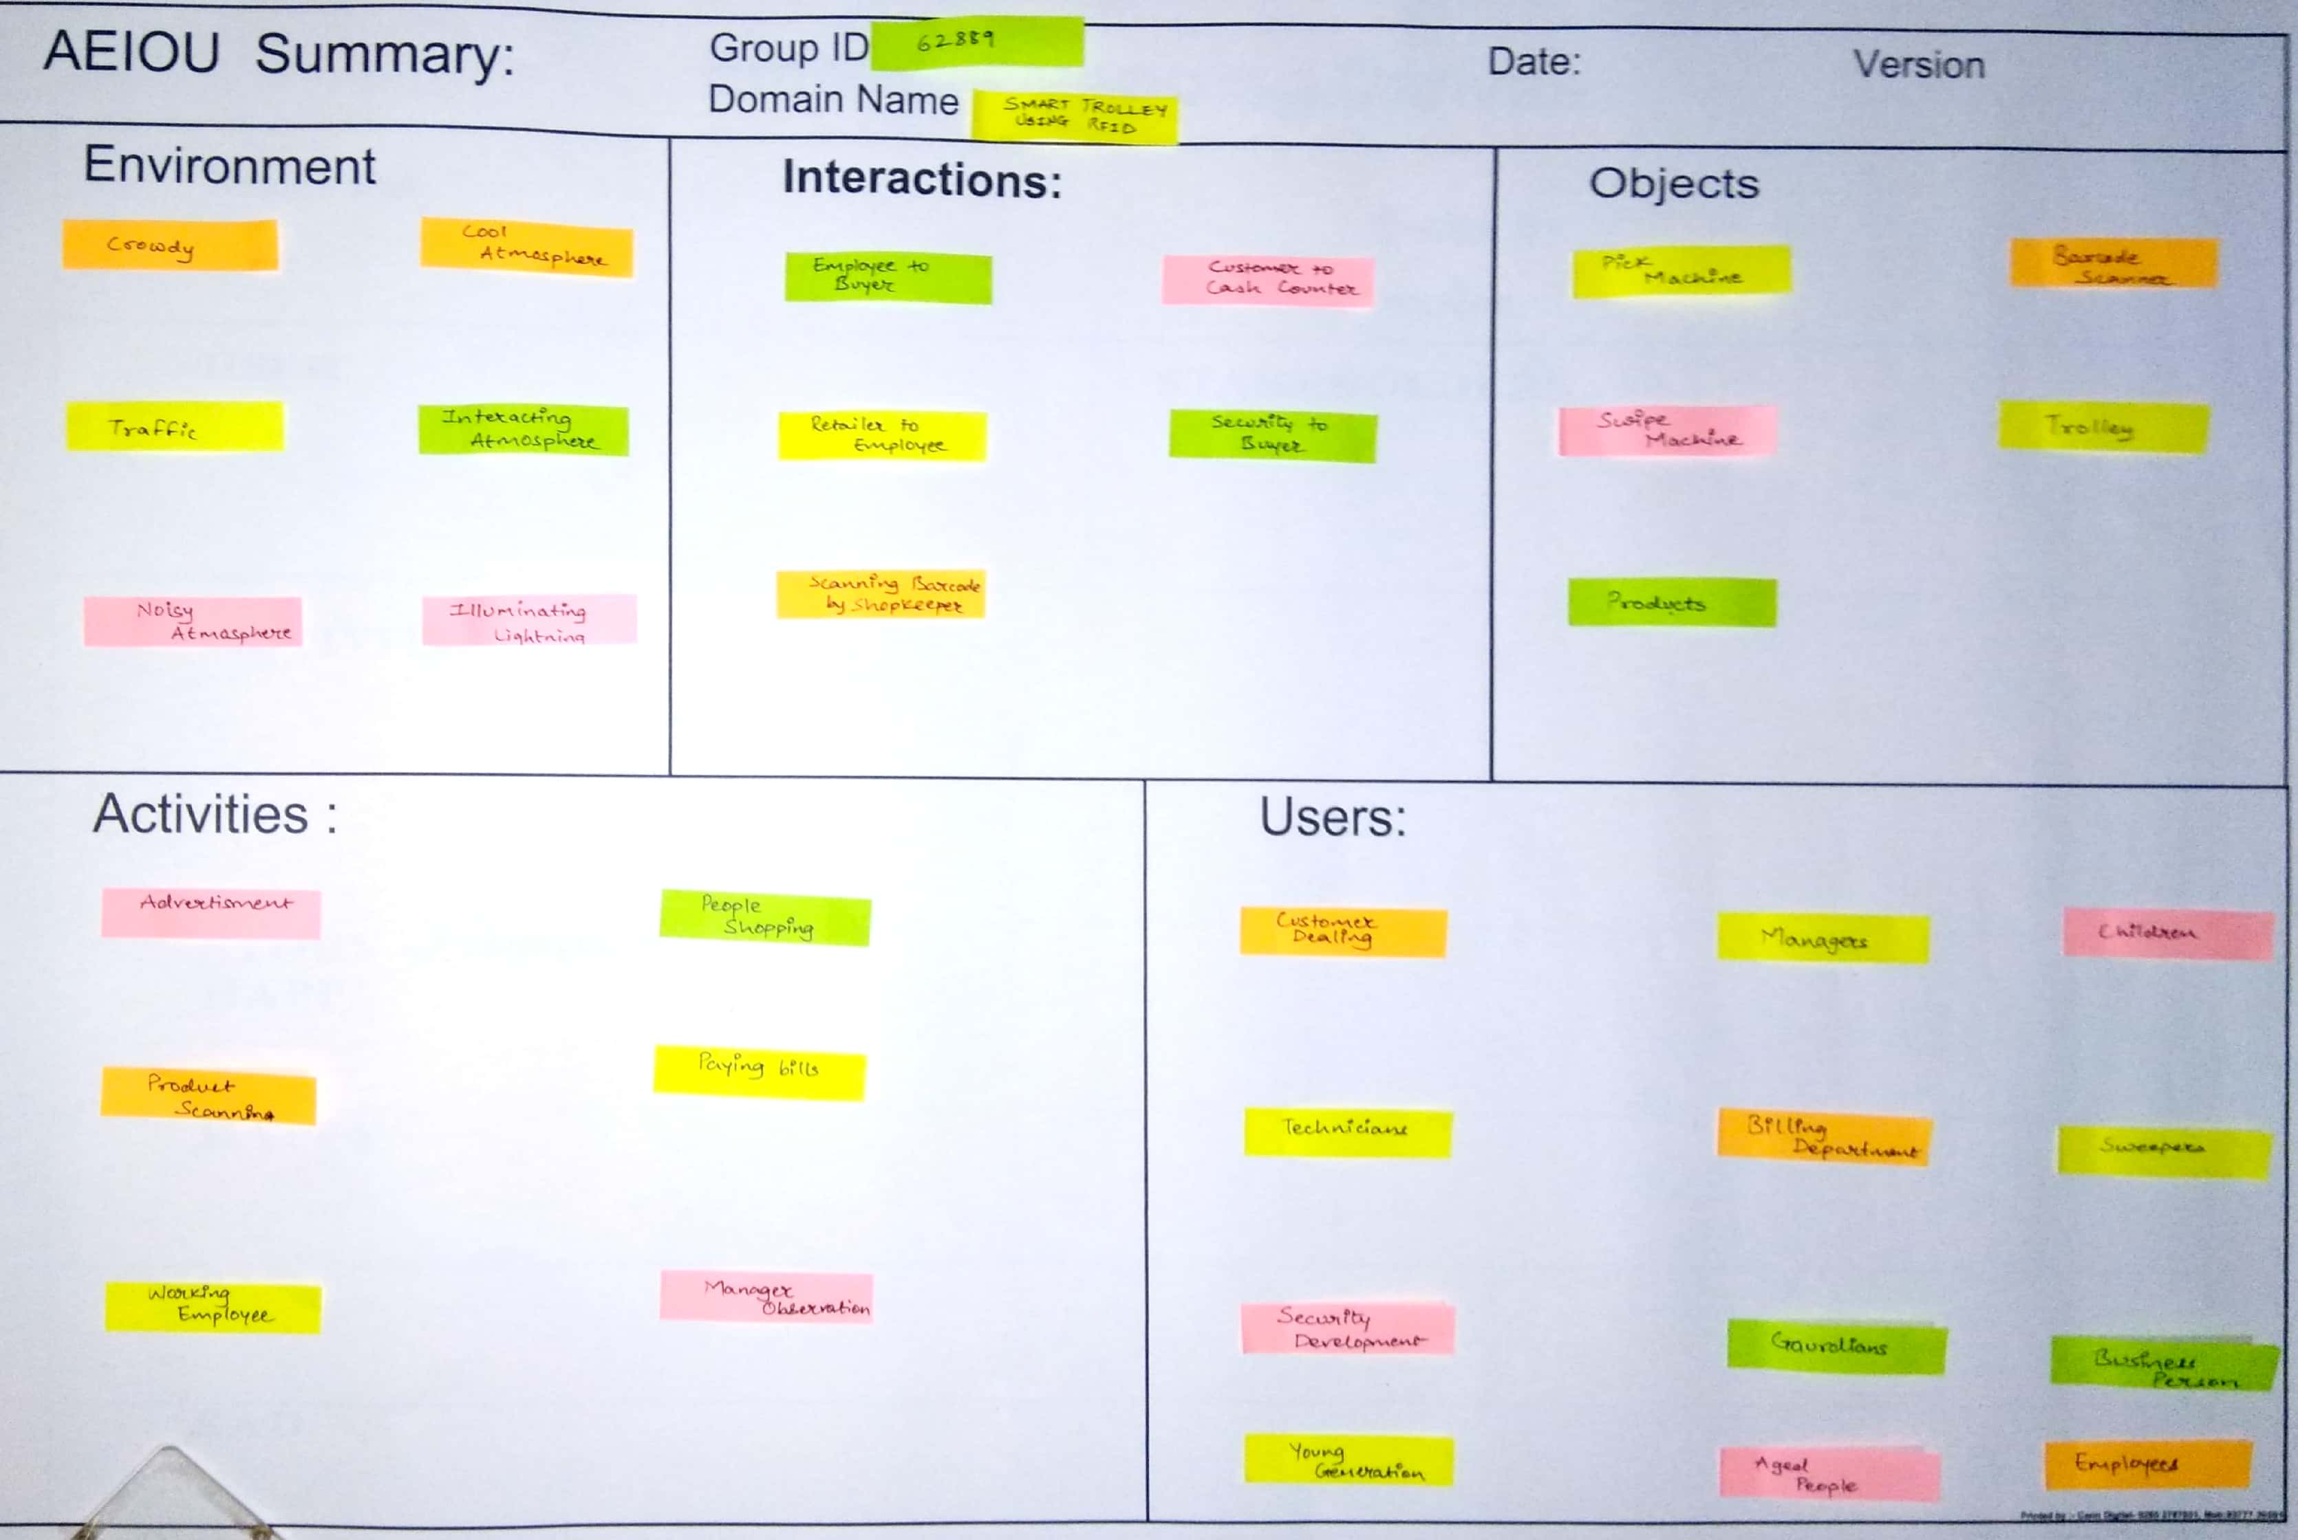

2.3 (A) AEIOU Canvas

The first step we have done taking out details about our project and collect some important information. The information which we had collect is very helpful for our Smart Trolley project. For designing we interacted with internal guide, and with shop Manager. They helped us to select the objects which we have used in our project. Like, Microcontroller board, Lcd Display, Rfid reader module and Rfid tags.

**2.3.2 EMPATHY MAPPING CANVAS**

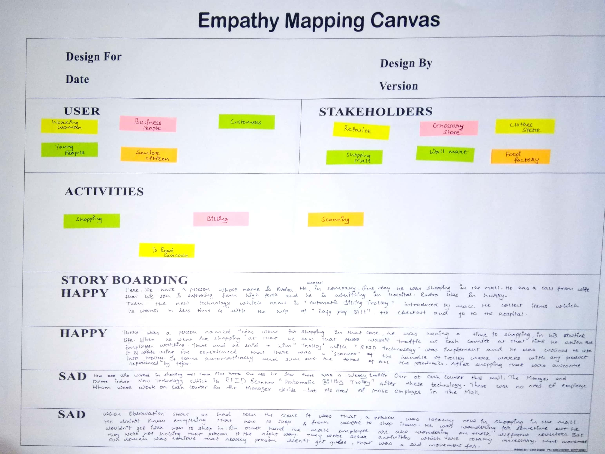

2.3 (B) Empathy Mapping

The stakeholders like, Retailer, Grocery store, clothes store, shopping mall, wall mart and food factory etc. Are helpful in our project but they are not directly involve in it. When we were collecting information regarding project we have some happy and sad story related to the mall experiencing of people mentioned in the Empathy canvas.

**2.3.3 IDEATION CANVAS**

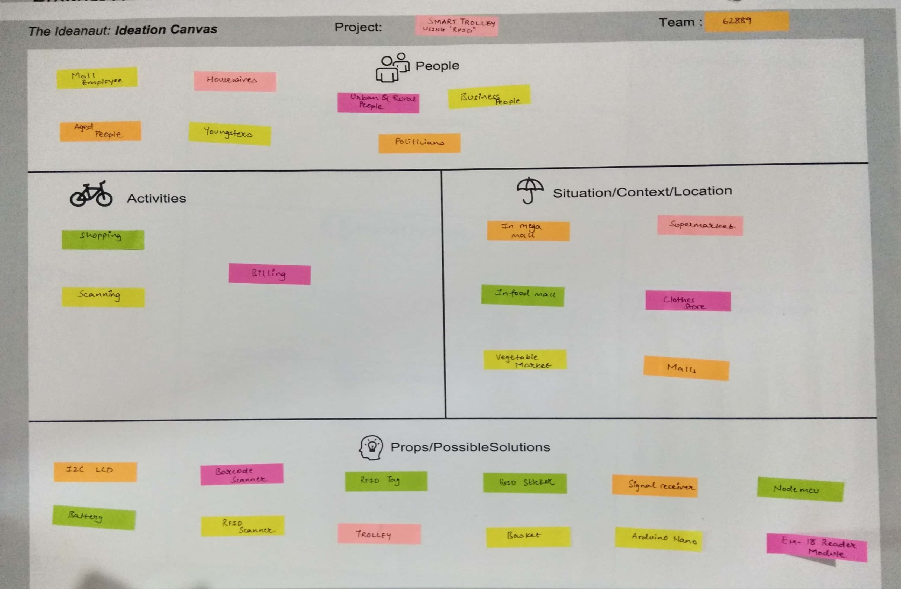

2.3 (C) Ideation canvas

After analysis and collecting information we tried to solve possible solutions. We solved the problem of central billing system as we were using ZigBee on instead of this we are using NodeMcu as it is Iot device and it is also less expensive then ZigBee and also it work as microcontroller so it work in two ways first as a programming board and second as Wi-Fi module that we can transfer the data to the central billing system.

**2.3.4 PRODUCT DEVELOPMENT CANVAS**

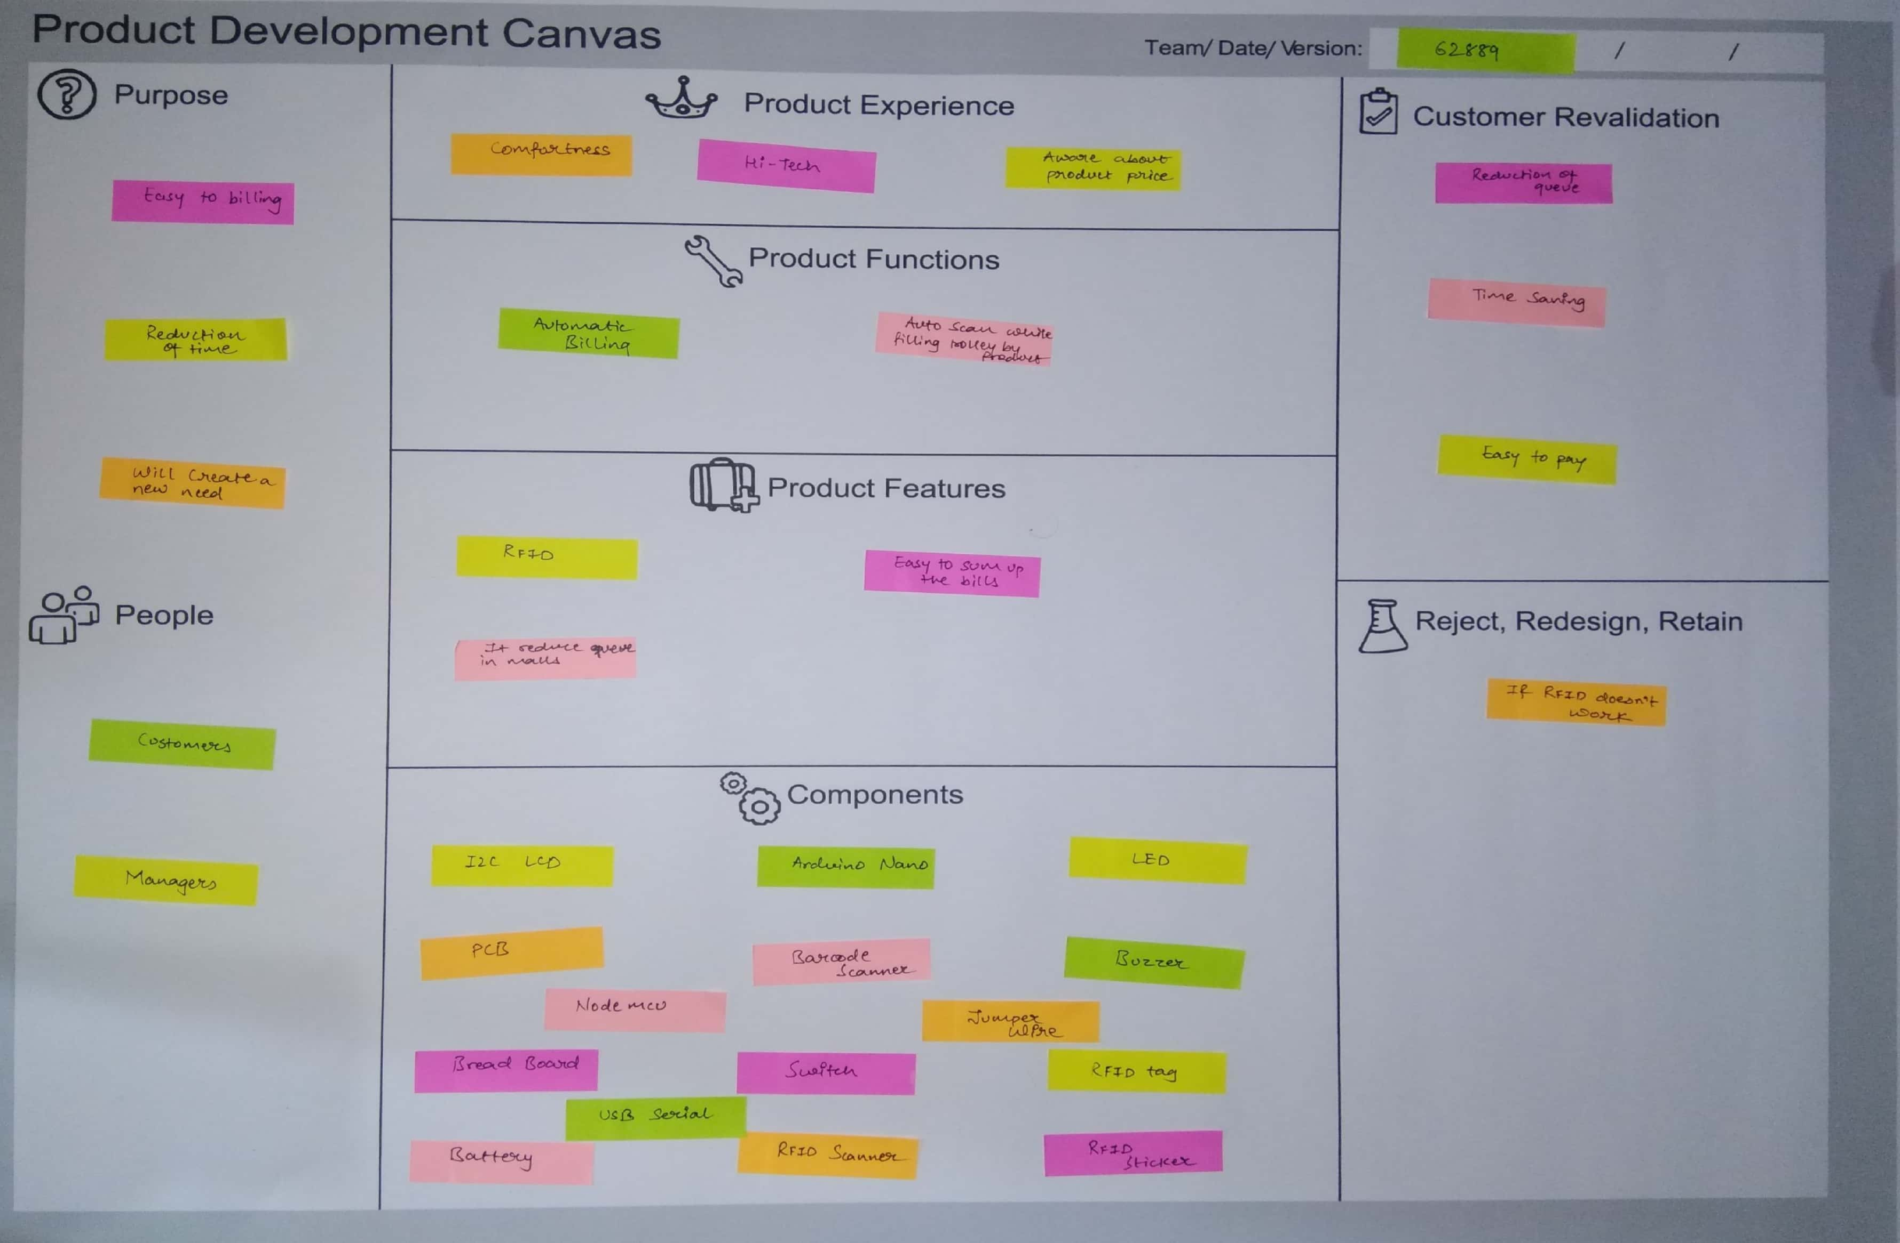

2.3 (D) Product Development canvas

The purpose of our project is to make the billing process system easier and reduce the queue in the mall and also the shoplifting will also be stopped so for the making of the smart trolley we have used NodeMcu board,I2c Lcd Display, Rfid reader module, Rfid tags and sticker and aslo a power adapter.

**2.3.5 THE BUSINESSS MODEL CANVAS**

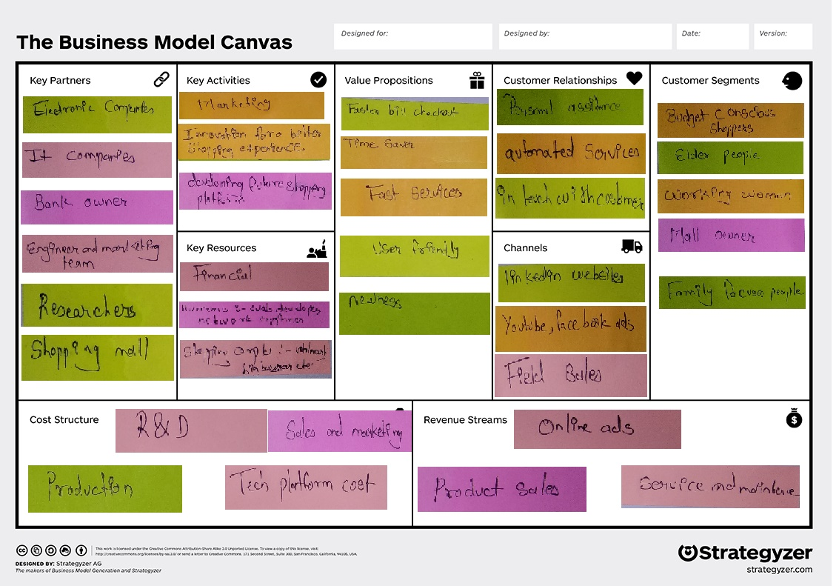

2.4 (E) Business model canvas

In this Business Model Canvas the strategic management and lean start up template for developing new or documenting existing business models. It is a visual chart with elements describing fans or product's value proposition. Infrastructure, customers, and finances.

**CHAPTER : 3**

**3.1 CODING**

* **FINAL CODING OF SMART TROLLEY**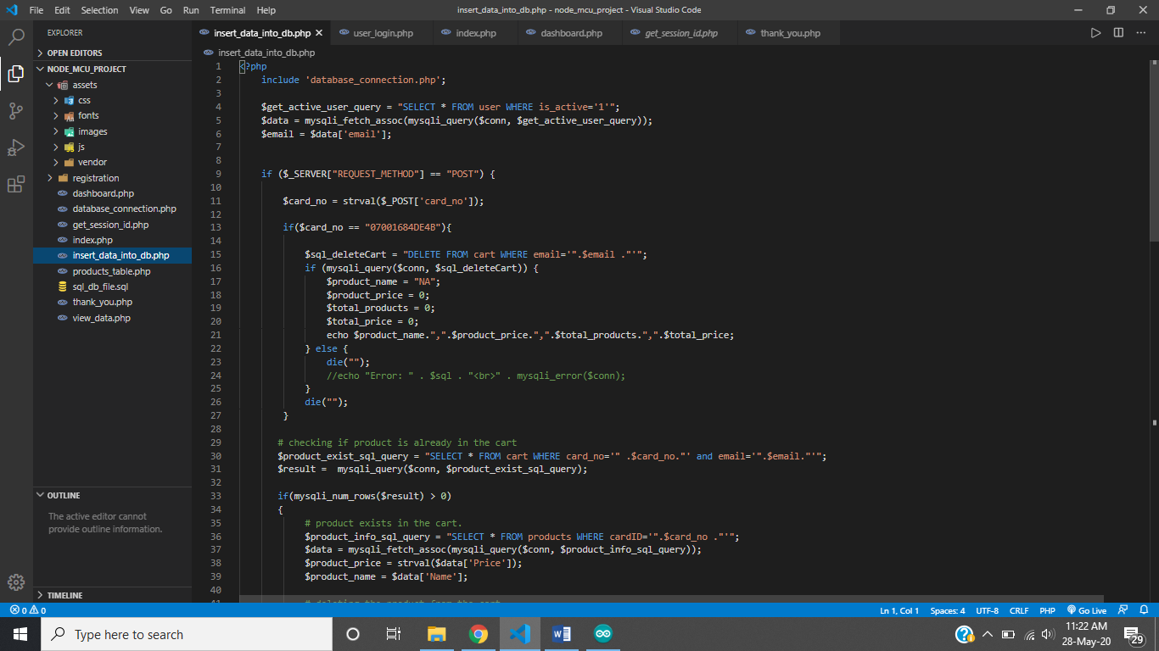

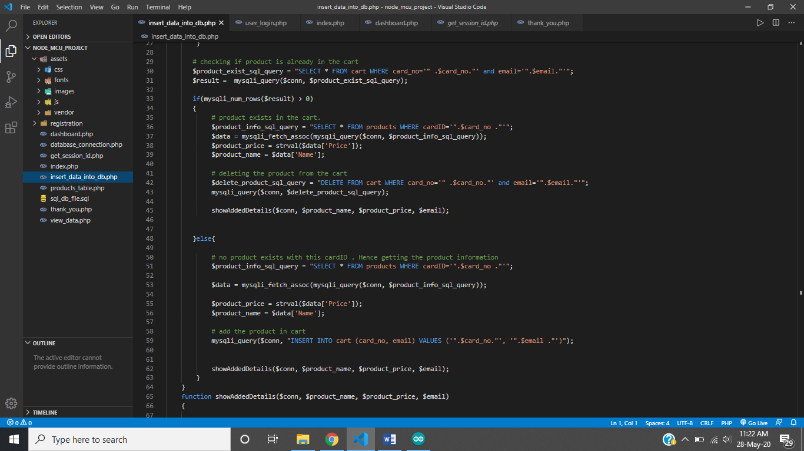

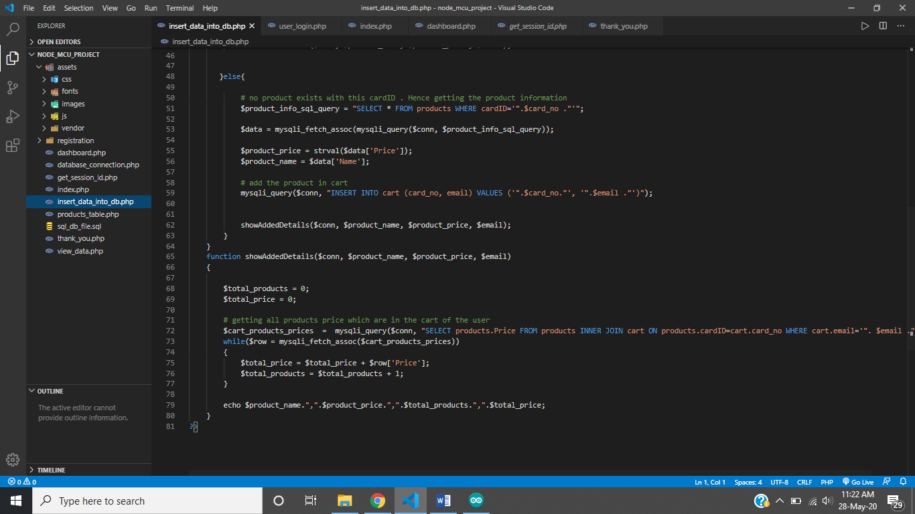

1. **DATABASE OF PRODUCT**

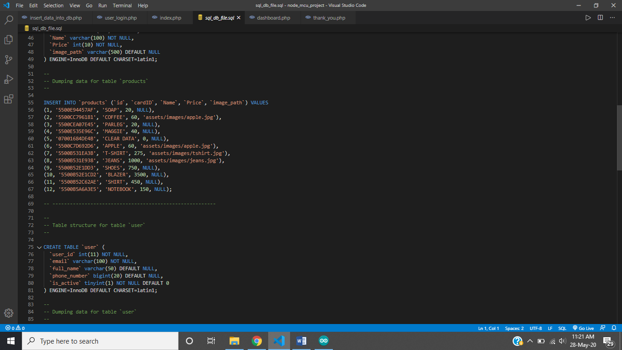

**3.2 OUTCOME**

* **LCD DISPLAY INTERFACE WITH EM-18 And NODEMCU**

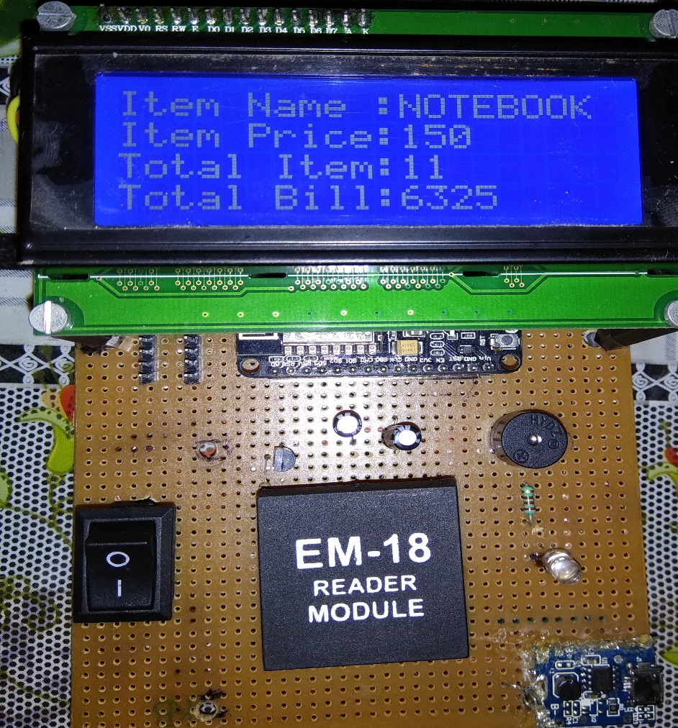

* LOGIN PAGE:-

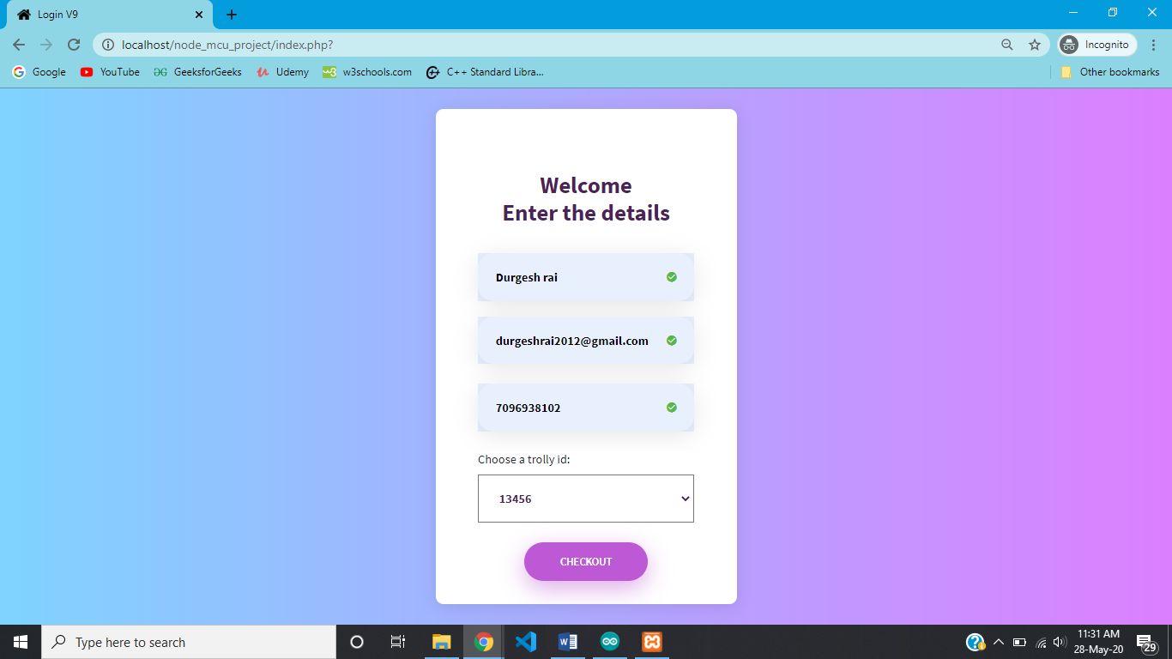

* BILLING DESK: -

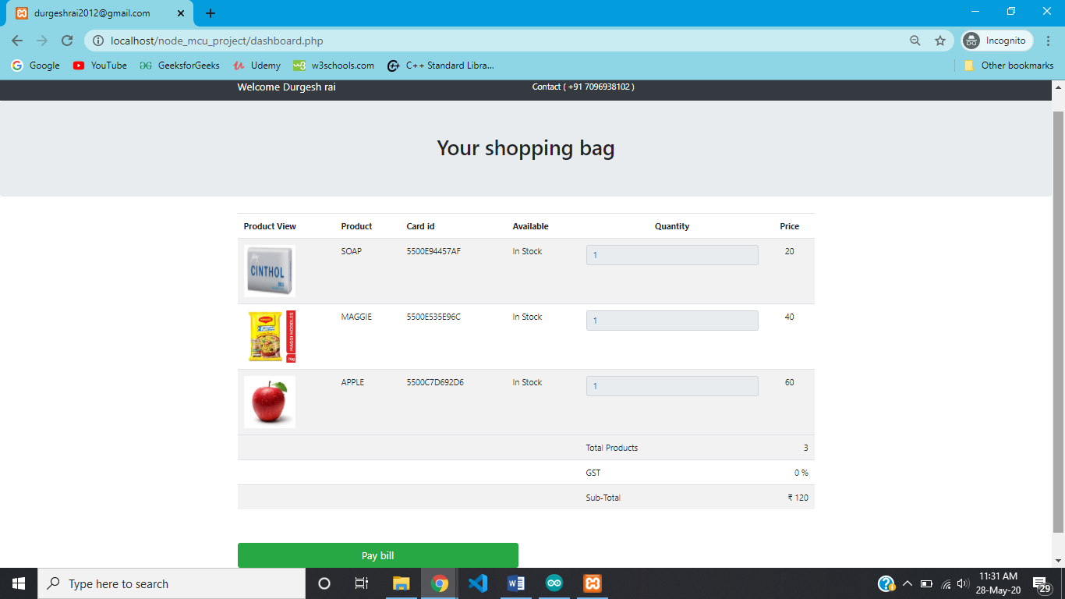

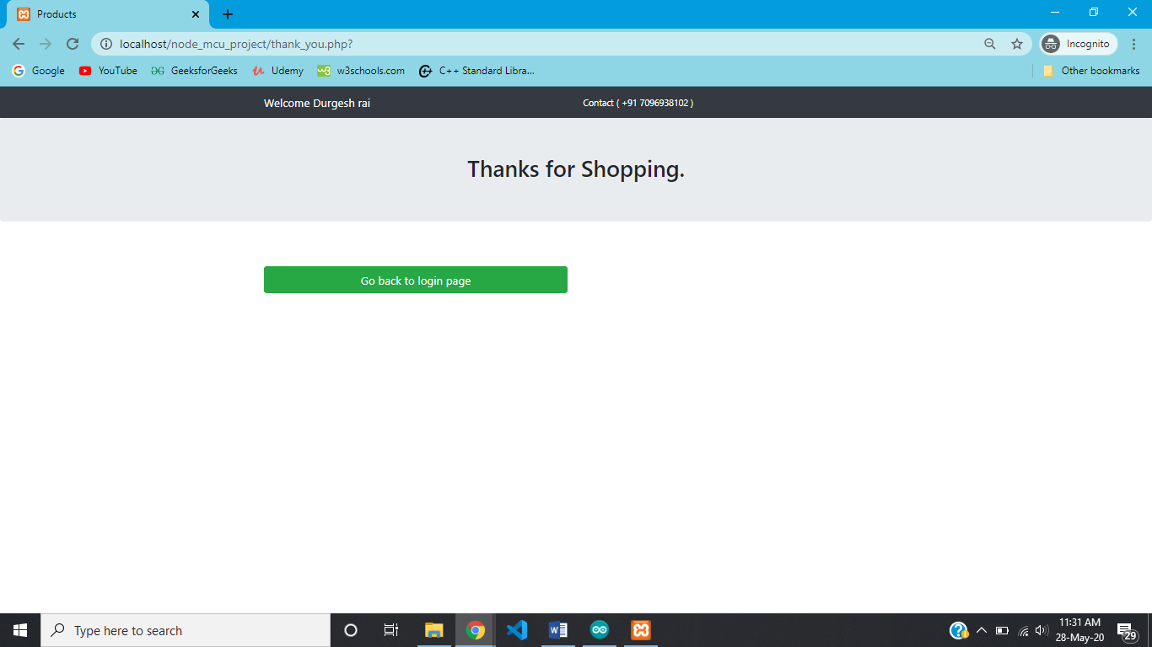

C

**3.3 COST ANALYSIS**

|  |
| --- |
| Cwefeqg  **Components Approximate cost (INR)**   1. Node MCU 420 2. RFID Reader module 450 3. RFID Tags * 12 180 4. LCD DISPLAY 600 5. 3.7v DC BATTERY 120 6. 5v Step up boost module 100 7. Buzzer and Led 25   **TOTAL 1895** |

**CHAPTER : 4**

**SUMMARY**

**4.1 ADVANTAGES**

1) It saves customers time.

2) It also reduces the payoff given for workers.

3) It is possible to rewrite the RFID tags.

4) It doesn’t need line of sight.

5) Shoplifting will be stop.

**4.2 FUTURE SCOPE**

Smart shopping trolley application creates an automated central billing system in malls. By using the node mcu, the product information are directly sent to billing system. So that customers no need to wait in a long queue. It is trustworthy, highly dependable and time efficiency. The proposed smart shopping trolley system will reduce the customer’s time in searching the location of the product. The customer just types the name of the product he/she want to purchase on his/her android or iOS device. The trolley will automatically guide them to the location of the product.

**4.3 REFERNCES**

* [https://www.arduino.cc](https://www.arduino.cc/)
* <https://www.instructables.com/circuits/>
* <https://www.github.com>
* <https://www.roboindia.com>
* <https://www.cpprefernces.com>
* <https://www.ifuturetech.org>