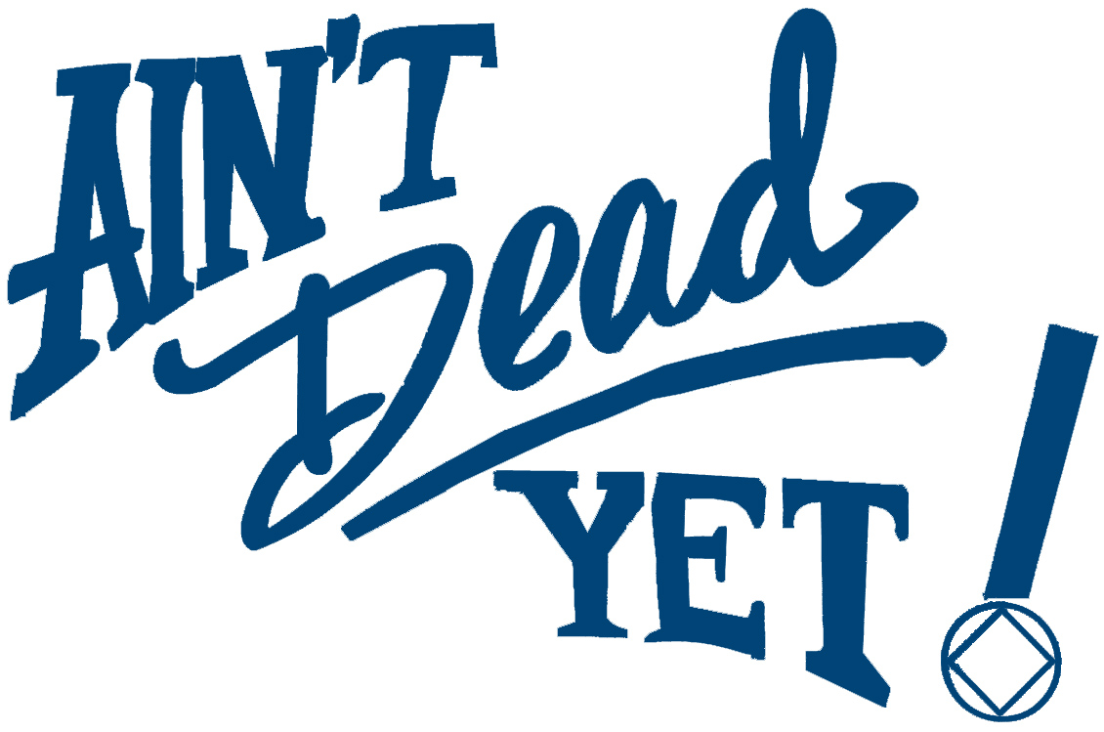
ADY Activities Committee
presents:
A day of learning -
Fun for addicts!

Basic Text Day!
We will study the basic text and have an open forum discussion for enjoyment and education!

8085 E. Hampden Sat January 26, 5:30 p.m.

Refreshments will be provided, bring some too!
Potluck, fellowship, and learn our literature!

