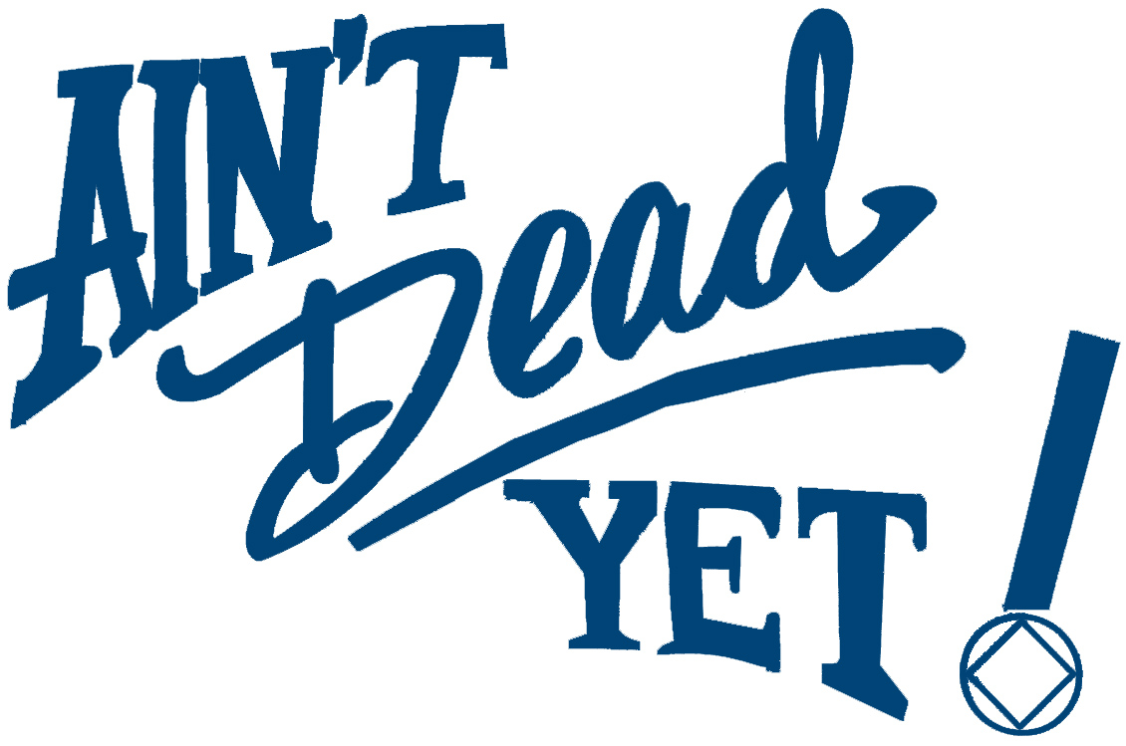
Activities Committee Presents:
A Family Holiday Outing -
Fun for Addicts, Parents, Kids,
Elephants, Zebras, Penguins, Bugs,
Giraffes, Seals, Lizards, Snakes,
Lions, Tigers, and Bears, Oh My!
Zoo Lights
Saturday Dec 22nd at 5pm
Meet at 8085 E. Hampden

Rides offered from ADY to the Zoo and back. We will leave ADY at 5:30pm and be back by 9:30pm.

Adults (Ages 12-64) $8
Children (Ages 3-11) $4
Seniors (Ages 65+) $6
$2 less for Zoo members
Financial assistance for admission for those that need it.
Dress warm

