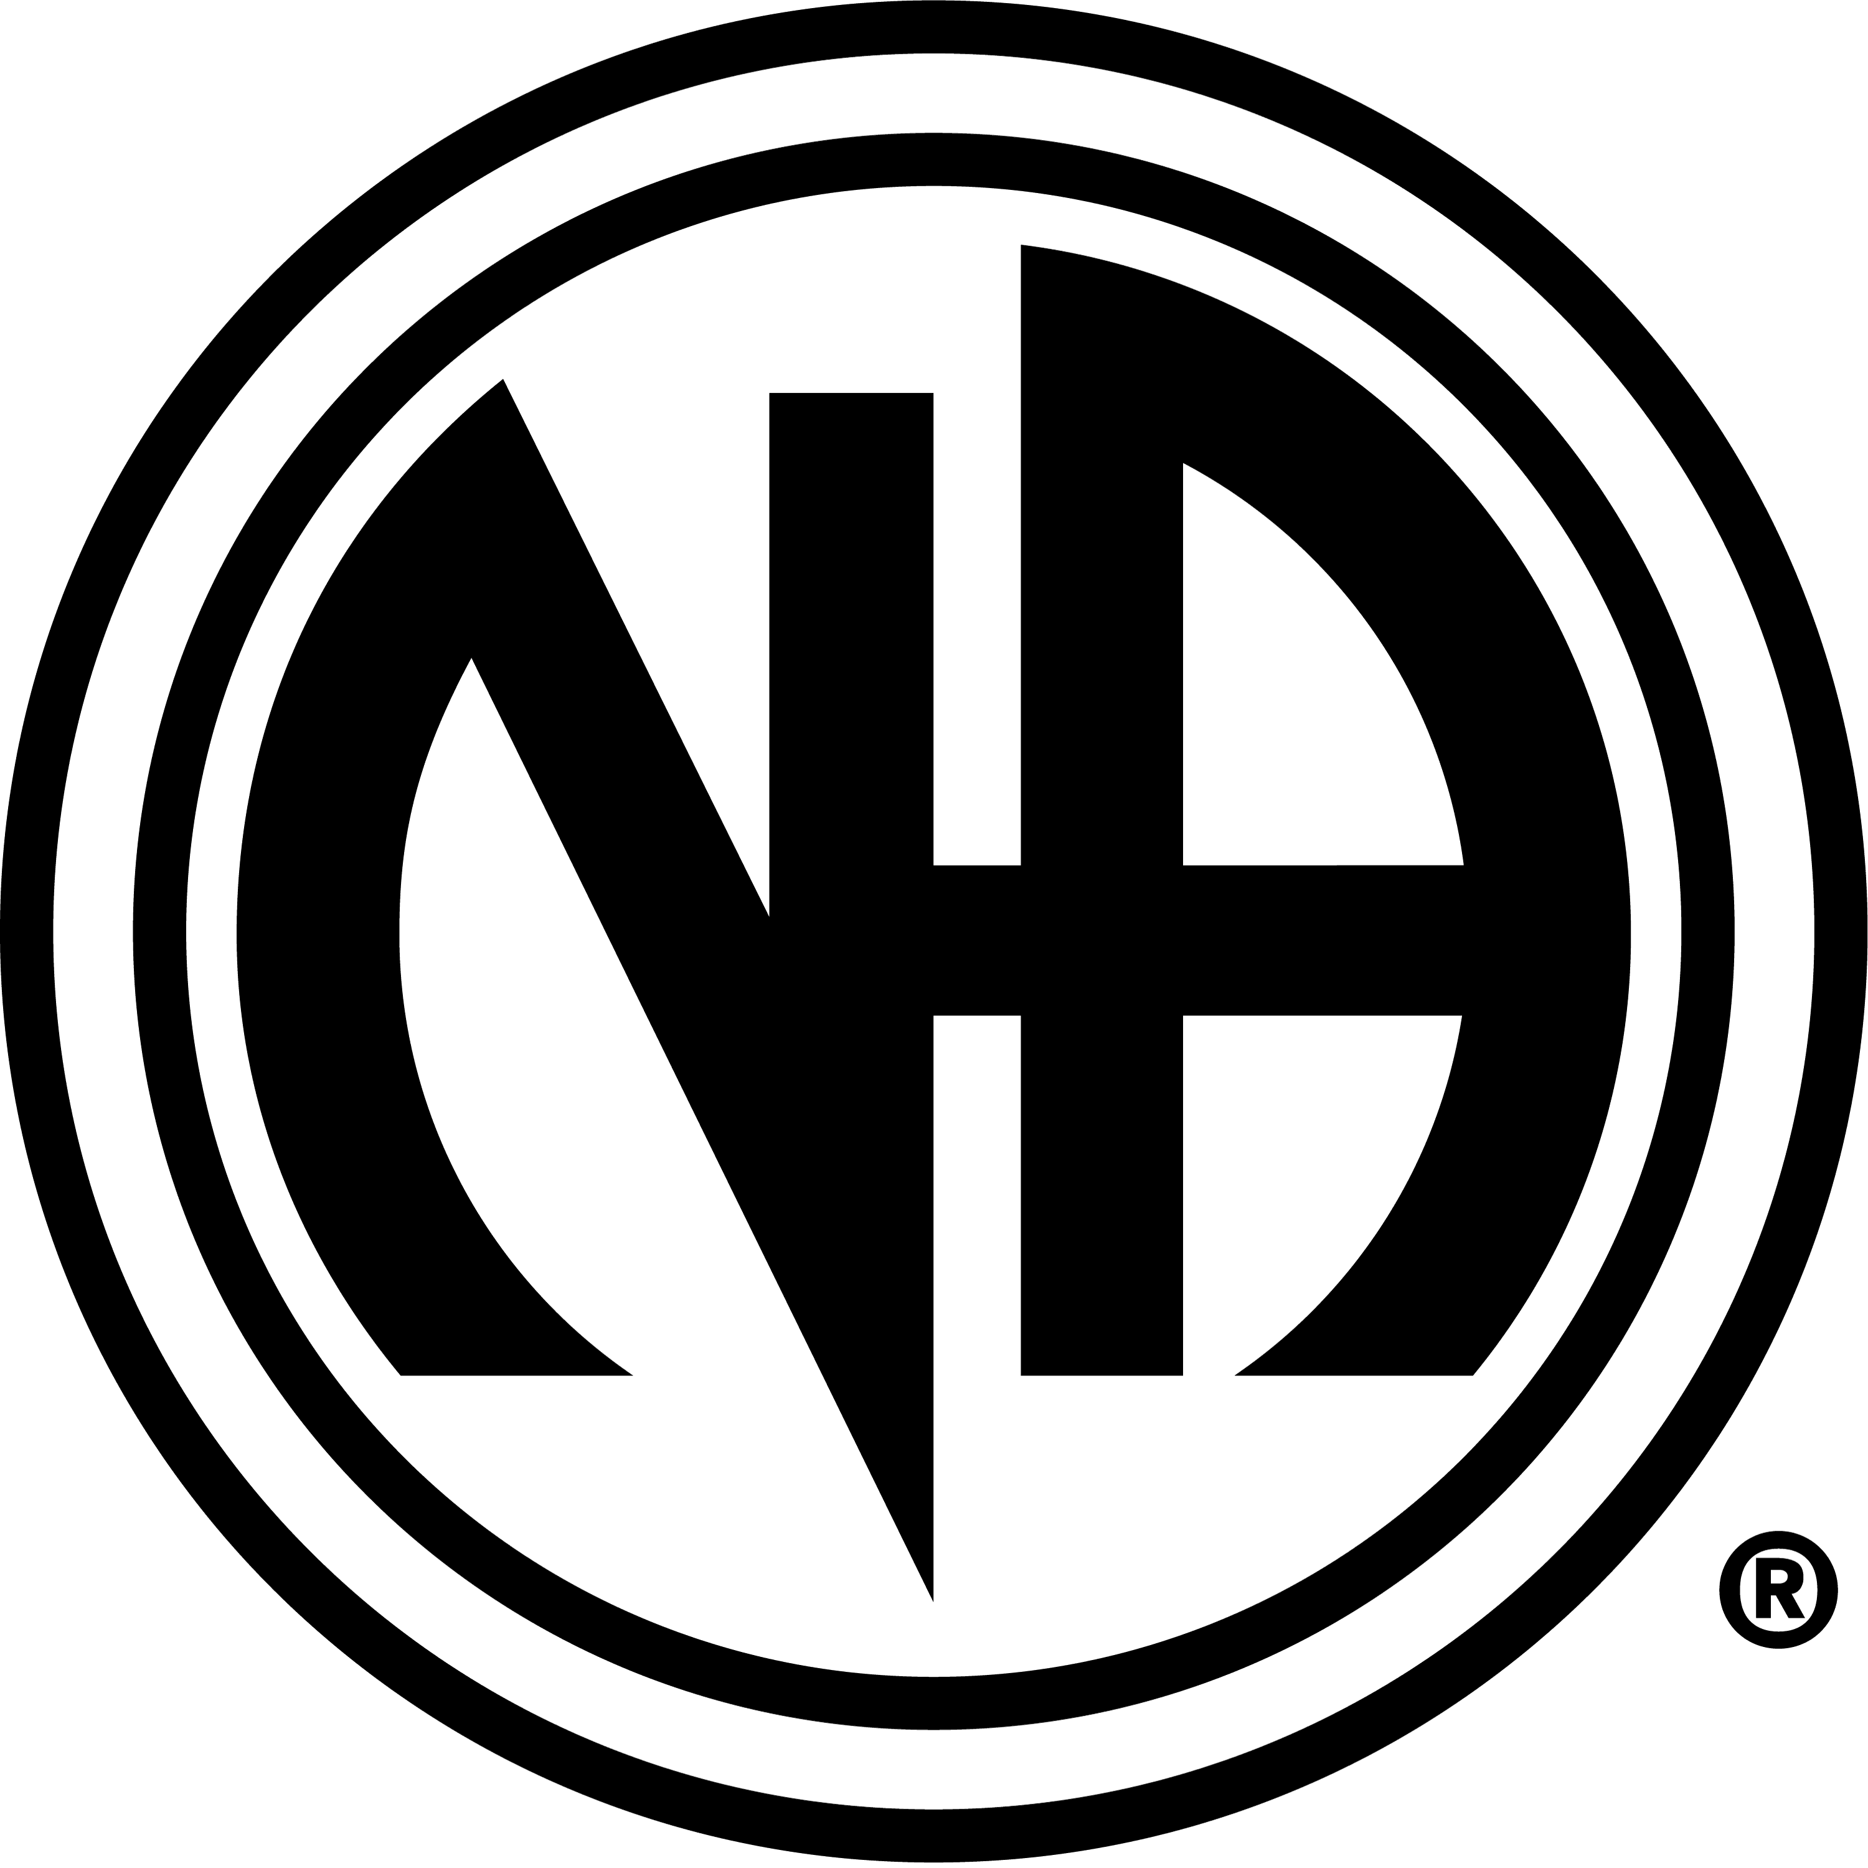
July 11-13, 2008
Windy Point Group Campground
At Lake Dillon

Clean & Serene

CAMPvention

WHAT: The Clean and Serene Group of NA would like to invite everyone to our second annual campout. A back to nature experience in a recovery atmosphere filled with fellowship, recovery discussion, a campfire speaker meeting on Saturday and general fufu, feel good crap.

WHEN: Campground Check in starts at 12pm, Friday, July 18 2008
Check out is 12pm, Sunday, July 19 2008

WHERE: ! DO NOT GO TO THE LAKE DILLON LOCATION IT IS CLOSED FOR THE SEASON – DUE TO BEATLE KILL !
-- THE NEW LOCATION AND DATE IS:
YMCA Snow Mountain Ranch
Reservation is under the name Krizman, campers should know that when they get there.
Tent only camping in the Iroquois campground.
Unfortunately there are no pop-up spaces on Friday but there are some on Saturday.
Individuals will have to make their own reservation if they want it.
There are rooms available in the lodge; individuals will be responsible for their own
There is tons of entertainment, swimming, fishing hiking, biking, rec. center

Directions: I-70 to exit 232 (US 40 to Granby), go over Berthoud Pass and through Winter Park. Entrance is 12 miles past winter Park on the left (west) side of US 40 follow the road approximately 1 mile to the Administration Building. www.ymcarockies.org or 800-777-9622



