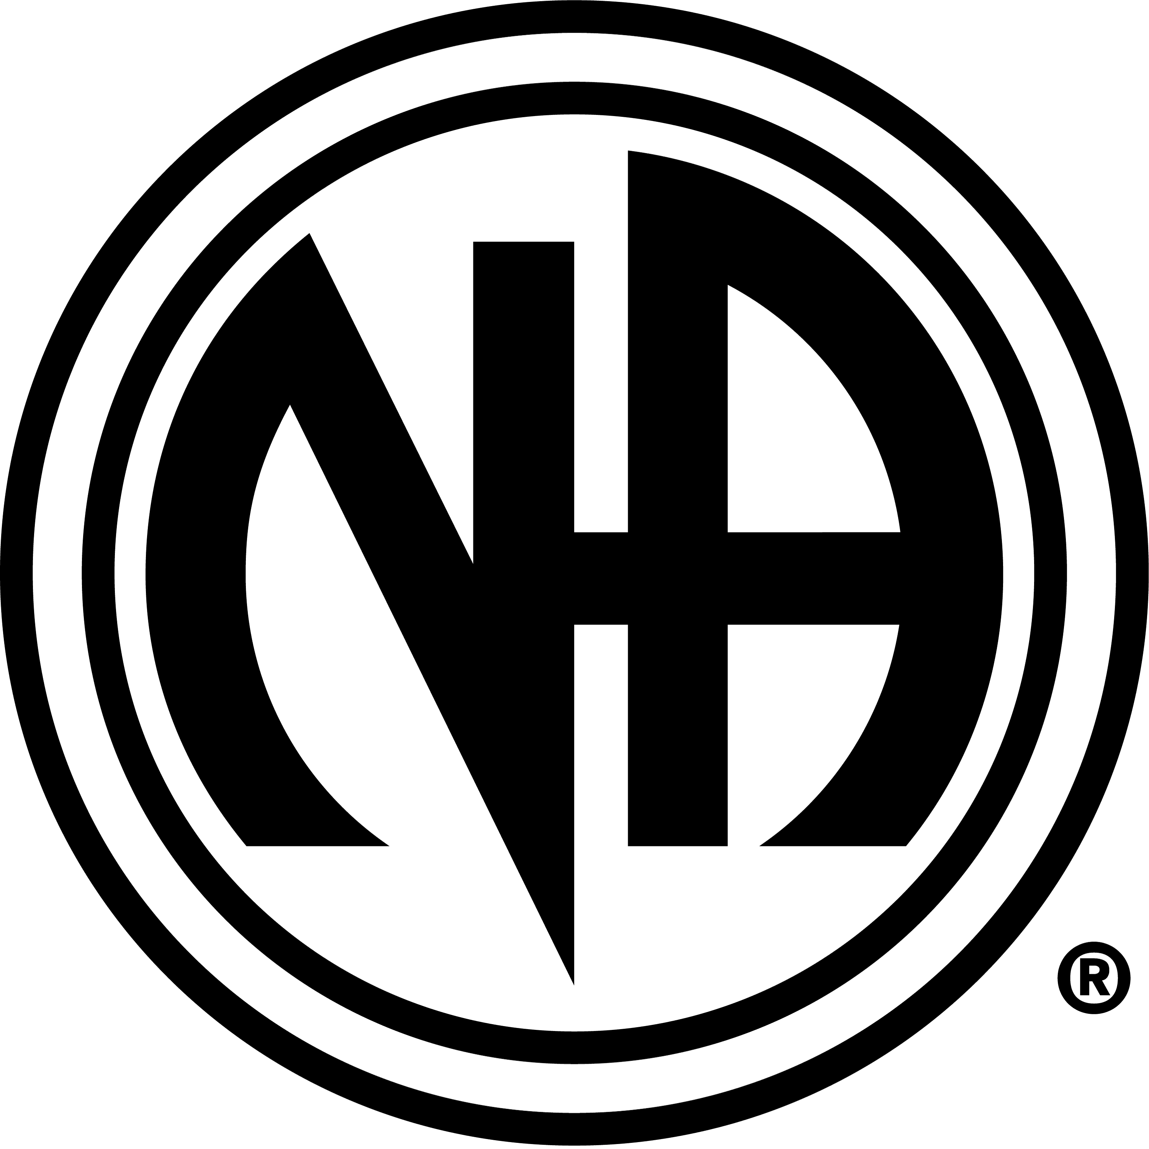

New Narcotics Anonymous Meeting

Clean With an Altitude

Meets every Tuesday Evening at 7pm till 8pm
Open discussion format.

at the
Coal Creek Canyon Coffee and Book Store
(Formally Cosmic Coffee House)
30230 HWY 72 Coal Creek Canyon (Golden)
6.5 miles west of the Cross Roads
(intersection of HWY 93 and HWY 72)

