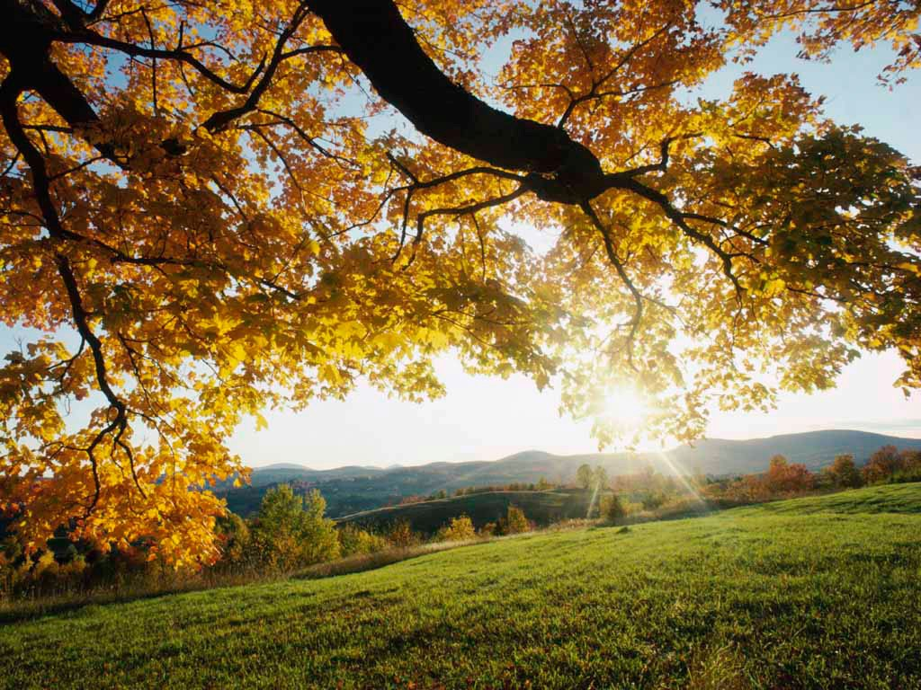
Please join us at

Thanksgiving Day
for our
1st annual
after dinner
dessert potluck

Thursday, November 22nd
7:30pm to 9:00pm
St. Luke’s United Methodist Church
8817 S. Broadway Rm. # 106
(Northwest corner of the church, lower level)

