CPSM Pan-Cancer and Proteomics Survival Report
Oct 12, 2026 · @Denver Ncube
The corrected CPSM/MTLR runs across all 33 TCGA cohorts find robust, held-out-replicated prognostic gene signal in 13 RNA cohorts but only 4 RPPA cohorts. Of 2,611 recurrent genes, 92% of cohort-level hits replicate on held-out data, yet 48% change risk direction between tumour types. Adding molecular features to clinical models raised the test C-index by at least 0.02 in 19 of 39 assessable runs. The legacy gene lists for the seven original cohorts rested on a broken median split and mostly do not survive FDR correction.

Pipeline and corrections
Every number in this report comes from a deterministic R engine running CPSM 1.4.0 and MTLR; the FrontierAgent orchestrated, verified and diagnosed runs but computed nothing. Each of the 33 TCGA cohorts was run twice: on bulk RNA-seq (top 5,000 variable genes, FPKM) and on the RPPA protein panel (about 220-460 antibodies).
Per cohort and platform the engine:
- Builds the clinical block from TCGA-CDR (Liu et al. 2018) with whitelisted columns only, and removes OS.time after data_process_f so survival time cannot enter the clinical screen.
- Chooses the endpoint: locked by config, or OS when there are at least 40 events and a 10% event rate, otherwise PFI.
- Splits 80/20 into training and held-out test sets (seed 123456), normalizes, and runs LASSO stability selection (50 repeats, alpha 1, selection frequency 0.6).
- Fits four MTLR models: Model 1 clinical only, Model 2 LASSO prognostic index (PI) only, Model 3 clinical + PI, Model 4 clinical + top 10 univariate genes.
- Fits a continuous Cox model per gene on the training set (HR per SD, BH FDR, cox.zph) and replicates its direction on the test set with training-derived scaling.
Correction | Defect in earlier runs | Effect on earlier results | Status in this run
Univariate median cutoff | median(tr_data1[1, i]) took the median of the first sample only | Median-split HRs used arbitrary cutoffs; Model 4 gene choice affected | Fixed upstream in CPSM 1.4.0 (already_fixed)
Empty-result guard | do.call(rbind, list()) returns NULL, then crashes | Univariate step crashed when no feature reached p <= 0.05 | Patched in memory at load (applied)
Model 3 median assignment | Missing $ in survival_summary_tr3Median | Model 3 training median MAE miscomputed or errored | Fixed upstream (already_fixed)
OS.time in clinical screen | Survival time could enter as a clinical covariate | Leaked the outcome into Model 1 and Model 3 | Removed before screening
LASSO method | Single cv.glmnet fit in older CPSM | Unstable gene sets | Stability selection, uniform threshold across cohorts
Two consequences of the fixes matter for reading the results. Under the uniform 0.6 selection threshold LASSO kept fewer than two features in 11 cohort-platform runs, so Models 2 and 3 are legitimately absent there. CPSM 1.4.0 also drops genes whose most frequent value covers 80% of training samples; the engine logs every dropped gene.

Cohort coverage and QC
All 66 cohort-platform runs produced output except two RPPA runs: 29 RNA and 26 RPPA runs succeeded fully, and 4 RNA and 5 RPPA runs were partial (LASSO not estimable, so Models 2 and 3 absent). Tiers were fixed in config/pipeline.yaml before recurrence was examined:
- Replicated: at least 10 FDR < 0.05 genes, at least 70% of them with the same HR direction on the held-out test set, and at least 10 test events.
- Supported, underpowered: meets the signal rules but has fewer than 10 test events.
- Exploratory: at least 10 FDR genes but held-out agreement below 70%.
- Minimal signal: fewer than 10 FDR genes.
Tier | RNA cohorts | RPPA cohorts
Replicated | 13 | 4
Supported, underpowered | 2 | 1
Exploratory | 5 | 1
Minimal signal | 13 | 25
Not usable (failed) | 0 | 2

Cohort | Endpoint | n (RNA) | Events (test) | RNA tier | RNA FDR genes | RNA held-out agreement | RPPA tier | RPPA FDR features
KIRC | OS | 525 | 174 (33) | Replicated | 2385 | 0.93 | Replicated | 70
LGG | OS | 484 | 124 (22) | Replicated | 2969 | 0.96 | Replicated | 130
SARC | OS | 258 | 98 (21) | Replicated | 108 | 0.88 | Replicated | 13
SKCM | OS | 448 | 213 (44) | Replicated | 1426 | 0.96 | Replicated | 44
BLCA | OS | 402 | 177 (30) | Replicated (partial) | 299 | 0.88 | Minimal signal (partial) | 1
HNSC | OS | 513 | 216 (39) | Replicated | 456 | 0.84 | Minimal signal | 0
LIHC | OS | 351 | 126 (28) | Replicated (partial) | 383 | 0.98 | Minimal signal | 0
LUAD | OS | 499 | 181 (38) | Replicated | 534 | 0.80 | Minimal signal (partial) | 0
MESO | OS | 85 | 73 (17) | Replicated | 771 | 0.90 | Minimal signal | 0
PAAD | OS | 172 | 92 (20) | Replicated | 492 | 0.86 | Minimal signal | 0
PRAD | PFI | 497 | 93 (13) | Replicated | 591 | 0.86 | Minimal signal | 6
UCEC | OS | 532 | 91 (14) | Replicated | 575 | 0.82 | Minimal signal | 3
LAML | OS | 130 | 78 (16) | Replicated | 87 | 0.95 | Failed | -
ACC | PFI | 78 | 40 (8) | Supported, underpowered | 1632 | 0.85 | Supported, underpowered | 45
UVM | PFI | 75 | 29 (6) | Supported, underpowered | 1255 | 0.90 | Failed | -
STAD | OS | 383 | 154 (29) | Exploratory | 145 | 0.43 | Exploratory | 15
BRCA | OS | 1056 | 151 (32) | Exploratory | 20 | 0.50 | Minimal signal | 9
CESC | OS | 279 | 70 (15) | Exploratory | 181 | 0.66 | Minimal signal | 0
KIRP | OS | 281 | 44 (8) | Exploratory | 1196 | 0.65 | Minimal signal | 8
THYM | PFI | 118 | 21 (3) | Exploratory | 23 | 0.39 | Minimal signal | 6
CHOL | PFI | 34 | 20 (2) | Minimal signal | 0 | - | Minimal signal (partial) | 0
COAD | OS | 437 | 98 (16) | Minimal signal | 6 | 0.50 | Minimal signal | 0
DLBC | PFI | 46 | 12 (5) | Minimal signal | 0 | - | Minimal signal | 0
ESCA | OS | 181 | 76 (13) | Minimal signal | 0 | - | Minimal signal | 0
GBM | OS | 277 | 223 (44) | Minimal signal | 1 | 1.00 | Minimal signal | 3
KICH | PFI | 65 | 11 (3) | Minimal signal | 0 | - | Minimal signal | 0
LUSC | OS | 478 | 203 (46) | Minimal signal | 0 | - | Minimal signal (partial) | 0
OV | OS | 420 | 260 (48) | Minimal signal (partial) | 1 | 1.00 | Minimal signal | 0
PCPG | PFI | 175 | 20 (5) | Minimal signal | 5 | 0.60 | Minimal signal (partial) | 0
READ | PFI | 158 | 36 (7) | Minimal signal | 0 | - | Minimal signal | 0
TGCT | PFI | 129 | 33 (5) | Minimal signal (partial) | 0 | - | Minimal signal | 0
THCA | PFI | 502 | 51 (11) | Minimal signal | 2 | 1.00 | Minimal signal | 4
UCS | PFI | 55 | 36 (9) | Minimal signal | 0 | - | Minimal signal | 0
RNA endpoints: OS in 21 cohorts, PFI in 12. CESC and KIRP used OS for RNA but PFI for RPPA, because fewer RPPA samples fell below the OS event thresholds. The two failed RPPA runs: TCGA-LAML has no RPPA data category at GDC, and UVM had only 12 samples with a valid PFI endpoint. Large cohorts such as LUSC (203 events), OV (260) and GBM (223) still show minimal gene-level signal, so a minimal-signal tier is not just a power problem.

Model performance
Adding gene or protein features to the clinical MTLR model raised the held-out C-index by at least 0.02 in 19 of 39 assessable runs, lowered it in 14 and changed it by less than 0.02 in 6. The other 25 runs had fewer than 10 test events and are not assessable.
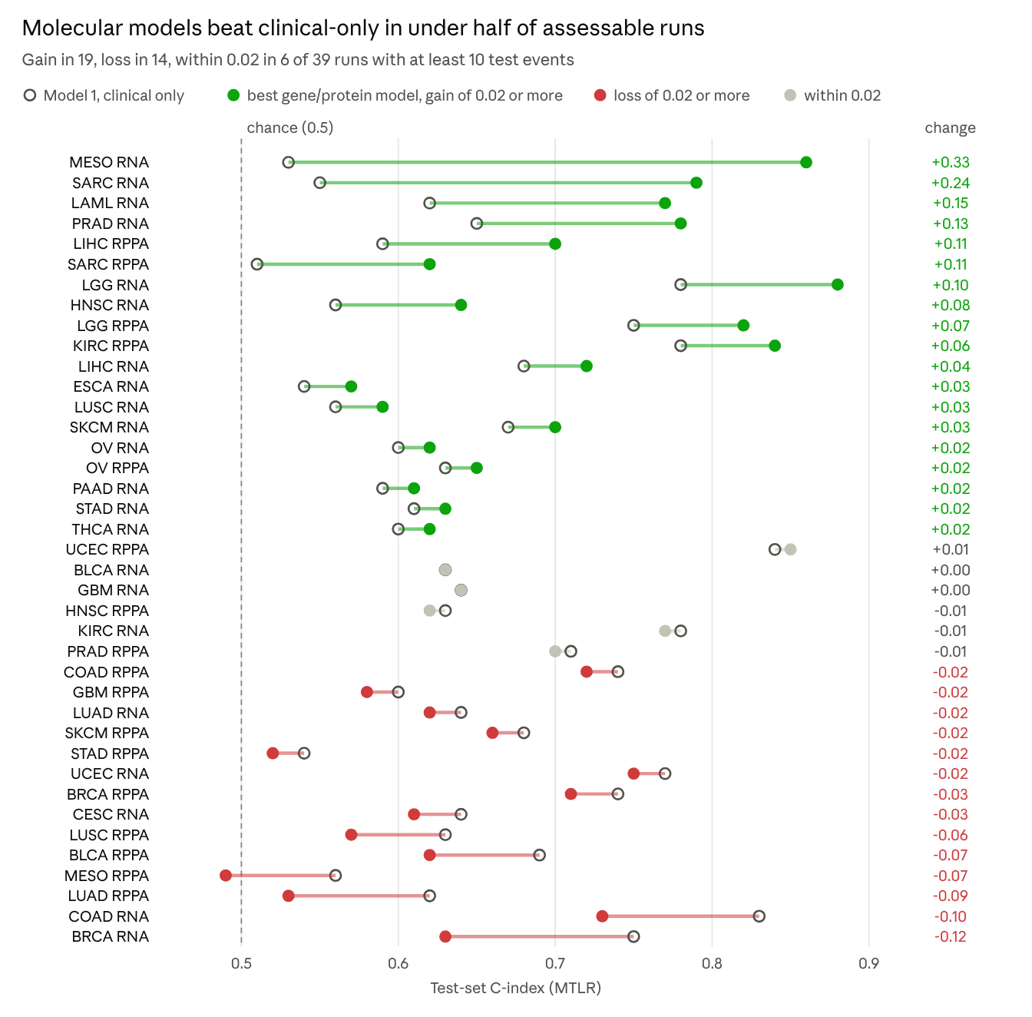
results/_pan_cancer/pan_cancer_model_comparison.csv · 39 of 64 cohort-platform runs (those with at least 10 test events)
The largest gains are in RNA runs for MESO (+0.33), SARC (+0.24), LAML (+0.15) and PRAD (+0.13), where clinical covariates alone sit near chance. Clinical-only models win where staging is already strong: COAD RNA (0.83) and BRCA RNA (0.75). RPPA adds value in KIRC, LGG, LIHC, SARC and OV, and loses in 9 of 17 assessable RPPA runs. The best molecular model is picked by its test C-index, so the gains are an optimistic upper bound.

Prognostic genes
Across the 13 replicated RNA cohorts, 2,611 genes reached FDR < 0.05 in two or more cohorts, out of 11,333 significant gene-cohort pairs in the primary set. Of these, 928 were consistently risk-associated, 426 consistently protective, and 1,257 (48.1%) changed direction between cohorts. Held-out replication was strong: 6,223 of 6,793 recurrent gene-cohort hits (91.6%) kept their HR direction on the test set. Adding the underpowered ACC and UVM cohorts gives 3,363 recurrent genes, of which 1,723 (51.2%) are discordant.
The concordant risk genes form one proliferation and mitotic program (TPX2, UBE2C, KIF20A, AURKB, CDC20, BIRC5, MKI67, FOXM1), shared mainly by KIRC, LGG, LIHC, LUAD, MESO, PRAD and SKCM. HR is per standard deviation of training-set expression.
Gene | Cohorts at FDR < 0.05 | Held-out direction agrees | Median HR per SD | PH violations | Cohorts
TPX2 | 9 | 9/9 | 1.64 | 2 | KIRC, LGG, LIHC, LUAD, MESO, PAAD, PRAD, SKCM, UCEC
UBE2C | 8 | 8/8 | 1.56 | 2 | KIRC, LGG, LIHC, LUAD, MESO, PRAD, SKCM, UCEC
KIF20A | 8 | 8/8 | 1.56 | 2 | KIRC, LGG, LIHC, LUAD, MESO, PAAD, PRAD, SKCM
AURKB | 8 | 8/8 | 1.47 | 2 | KIRC, LGG, LIHC, LUAD, MESO, PRAD, SARC, SKCM
CDC20 | 7 | 7/7 | 1.61 | 2 | KIRC, LGG, LIHC, LUAD, MESO, PRAD, SKCM
H2AX | 7 | 7/7 | 1.53 | 1 | KIRC, LGG, LIHC, LUAD, MESO, PRAD, SKCM
CEP55 | 7 | 7/7 | 1.53 | 1 | KIRC, LGG, LIHC, LUAD, MESO, PAAD, SKCM
BIRC5 | 7 | 7/7 | 1.50 | 2 | KIRC, LGG, LIHC, LUAD, MESO, PRAD, SKCM
MKI67 | 7 | 7/7 | 1.47 | 2 | KIRC, LGG, LIHC, LUAD, MESO, PRAD, SKCM
FOXM1 | 7 | 7/7 | 1.45 | 3 | KIRC, LGG, LIHC, LUAD, MESO, PRAD, SKCM
The most recurrent protective genes are CBX7, CLEC3B and HLF (5 cohorts each, median HR per SD 0.59 to 0.69), followed by ALDH2, ATP8A1, NDRG2 and ABAT (4 cohorts each).
Discordant genes are reported, not averaged. The most recurrent ones flip between tumour types while replicating within each:
Gene | Risk / protective cohorts | Held-out direction agrees | Per-cohort HR per SD
ANXA2 | 5 / 1 | 6/6 | BLCA 1.34, KIRC 1.33, LGG 1.84, LUAD 1.35, PAAD 1.81, UCEC 0.70
CYP27A1 | 1 / 5 | 6/6 | HNSC 0.75, LGG 1.70, LIHC 0.77, LUAD 0.76, PAAD 0.69, PRAD 0.67
FLNC | 5 / 1 | 6/6 | BLCA 1.28, KIRC 1.31, LGG 1.61, LUAD 1.36, PRAD 0.69, SKCM 1.19
GBP2 | 4 / 2 | 5/6 | BLCA 0.74, KIRC 1.36, LGG 1.31, LUAD 1.27, PAAD 1.87, SKCM 0.63
OAS1 | 4 / 2 | 5/6 | BLCA 0.74, LGG 1.72, LUAD 1.27, PAAD 1.43, PRAD 1.32, SKCM 0.77
APOL1 | 3 / 3 | 6/6 | BLCA 0.73, KIRC 1.30, LGG 1.49, LUAD 1.42, SARC 0.65, SKCM 0.74
Interferon-response genes (GBP2, OAS1, APOL1) are protective in BLCA and SKCM but risk-associated in LGG, LUAD and PAAD. That is consistent with immune infiltration being favourable in immunogenic tumours, but this run does not test that explanation. LGG often carries the opposite sign to other cohorts (CYP27A1, SNCG).

Proteomics
Protein-level models add little survival information beyond clinical covariates in the seven original cohorts, and the CPTAC results are too small to trust. RPPA replicates only in KIRC, LGG, SARC and SKCM, where it mirrors the RNA signal.
The proteomics arm has two parts:
- Agent RPPA runs (corrected). All 33 cohorts, same engine and patches as RNA, features with more than 30% missing values dropped, the rest median-imputed.
- Manual RPPA and CPTAC runs (August 2026). The seven original cohorts, run with CPSM_Proteomics_Master_Pipeline.R. CPTAC uses mass-spec proteomics on separate patient sets for GBM, LUAD, LUSC and PAAD (CPTAC3), so it is not a matched comparison with TCGA.
Cohort | Manual RPPA best test C | Agent RPPA Model 1 (clinical) | Agent RPPA best molecular model | CPTAC patients (OS events) | CPTAC best test C (train C)
BRCA | 0.67 (PI) | 0.74 | 0.71 (Model 3) | 101 (2) | no model
COAD | 0.70 (clinical) | 0.74 | 0.72 (Model 4) | not exported | -
GBM | 0.63 (clinical) | 0.60 | 0.58 (Model 3) | 97 (70) | 0.31 (0.82)
LUAD | 0.52 (PI) | 0.62 | 0.53 (Model 4) | 107 (24) | 0.71 (0.99)
LUSC | 0.59 (PI) | 0.63 | 0.57 (Model 4) | 104 (25) | 0.62 clinical; PI 0.26 (0.83)
PAAD | 0.57 (PI) | 0.57 | 0.72 (Model 3), 8 test events | 137 (100) | 0.63 (0.76)
PRAD | failed | 0.71 | 0.70 (Model 3) | not in cptac | -
What the table shows:
- The corrected run recovers PRAD RPPA, which failed in the manual run, and gives all four models for BRCA, LUAD, LUSC and PAAD, where the manual run produced only the PI model.
- Clinical-only beats every RPPA model in BRCA, COAD, GBM, LUAD and LUSC. Only PAAD shows an RPPA gain, on 8 test events, which is too few to assess.
- CPTAC models overfit. LUAD reaches train C 0.99 against test 0.71 with 15 LASSO proteins from about 13,000; GBM and LUSC protein models score below 0.5 on the test set. With roughly 20 test patients each, these numbers carry little information. BRCA CPTAC has 2 deaths in 101 patients and cannot be modelled.
Across all agent RPPA runs, 267 antibodies reached FDR < 0.05 in at least one cohort and 78 in two or more. The most recurrent are IGFBP2 and PAI1 (risk in GBM, KIRC and LGG), and EIF4G and DNMT1 (risk in LGG, SARC and BRCA or ACC). RPPA FDR counts are not comparable with RNA counts: a panel of about 450 antibodies carries a far smaller multiple-testing burden than 5,000 genes.

Legacy vs corrected
The legacy gene lists for the seven original cohorts came from a broken median split, and most of those genes do not survive FDR correction in the corrected run. Gene directions mostly hold, though: 91-98% of legacy genes still present keep the same HR sign under the continuous Cox model.
The agent did not run compare_legacy.R (inputs/legacy_results/ is empty), so the gene columns below were computed for this report from the legacy workbooks' Survival_Genes sheets with the same logic.
Cohort | Legacy genes (p <= 0.05, median split) | Legacy median split: smaller group share | Legacy genes in corrected gene set | Same HR direction | Of those, FDR < 0.05 now | Corrected FDR genes, all | Legacy Model 1 test C | Corrected Model 1 test C
PRAD | 3,310 | 0.19 | 844 | 96% | 286 | 591 | 0.68 | 0.65 (PFI)
LUAD | 2,129 | 0.30 | 773 | 98% | 281 | 534 | 0.73 | 0.64
PAAD | 715 | 0.28 | 415 | 96% | 123 | 492 | 0.51 | 0.59
BRCA | 1,864 | 0.27 | 493 | 91% | 10 | 20 | 0.73 | 0.75
COAD | 1,157 | 0.28 | 311 | 91% | 6 | 6 | 0.64 | 0.83
GBM | 1,017 | 0.21 | 241 | 92% | 1 | 1 | 0.71 | 0.64
LUSC | 1,261 | 0.27 | 318 | 91% | 0 | 0 | 0.53 | 0.56
What changed and why:
- Median split. A true median split puts about half the patients in each group; the corrected run measures 0.50 in every cohort. The legacy splits put only 19-30% of patients in the smaller group, because the cutoff was the first sample's value. Legacy "median-split HRs" therefore compared arbitrary groups.
- Significance. Legacy lists used raw p <= 0.05 across thousands of genes. Under BH FDR, BRCA, COAD, GBM and LUSC keep almost nothing. Only LUAD, PAAD and PRAD retain hundreds of genes.
- Model C-index. Legacy and corrected C-indices are not directly comparable: the gene universe, endpoint (PRAD is now PFI), clinical block (OS.time removed) and split all changed. Legacy gene models were also badly overfit (BRCA Model 2 train C 0.98 vs test 0.62).
- Universe. Only 241-844 legacy genes fall inside the corrected top-5,000-variance set, so absence from the corrected list does not mean a gene was refuted.

Limitations and open questions
The gene-level findings are well supported; the model-level gains are not yet. Every C-index comes from one 80/20 split, and 25 of 64 runs have fewer than 10 test events.
- Single split. One seed (123456) per run. Test C-indices on 10-50 events vary by several hundredths between splits, which is the size of most gains in the chart.
- Optimistic model choice. The "best molecular model" is picked by its test C-index, so model gains are an upper bound.
- Proportional hazards. A median 7.3% of genes per RNA cohort violate PH (cox.zph), rising to 32% in LGG (1,580 genes), 20% in THCA and 18% in TGCT. HR per SD is an average effect over follow-up for those genes.
- Gene universe. RNA models use the top 5,000 genes by variance of bulk FPKM, so recurrence counts say nothing about lower-variance genes.
- Mixed endpoints. 21 RNA cohorts use OS and 12 use PFI, and CESC and KIRP switch endpoint between RNA and RPPA. Cross-cohort recurrence mixes these endpoints.
- RPPA imputation. Missing antibody values are median-imputed using whole-cohort medians, before the split. The test set therefore influences imputation slightly.
- CPTAC. About 20 test patients per cohort, separate patients from TCGA for four cohorts; treat as exploratory only.
- Stale agent reports. results/LUAD/LUAD_agent_report.md and results/CHOL/CHOL_agent_report.md (15 Sep) describe a failed first launch. The corrected runs (27 Sep qc.json) supersede them, and no other cohort has an agent report.
Open questions:
- ☐ Rerun the seven locked cohorts with compare_legacy.R so the legacy comparison above is produced by the engine itself.
- ☐ Repeat the split (e.g. 20 seeds) for replicated cohorts to put intervals on the C-index gains.
- ☐ Decide whether the 11 runs without a stable LASSO set should keep the uniform 0.6 selection threshold or be reported without Models 2 and 3, as now.
- ☐ Regenerate per-cohort agent reports from the corrected qc.json files.

Sources
All figures were read from local result files on 12 Oct 2026. Nothing was re-run except the legacy gene comparison, which was computed read-only.
What | File
Tiers, events, FDR counts, held-out agreement | ~/work/CPSM_agent/results/_pan_cancer/pan_cancer_cohort_tiers.csv
Headline metrics and tier rules | results/_pan_cancer/pan_cancer_headline_metrics.csv, config/pipeline.yaml
Test C-index by model | results/_pan_cancer/pan_cancer_model_comparison.csv
Recurrent genes (primary and extended) | results/_pan_cancer/pan_cancer_recurrent_genes_primary.csv, ..._extended.csv
Per-gene and per-antibody HRs | results/_pan_cancer/pan_cancer_gene_hr_long.csv
Per-cohort QC, patches, failures | results/<COHORT>/qc.json, results/<COHORT>/rppa/qc.json and logs
Pipeline design and patches | ~/work/CPSM_agent/README.md, AGENTS.md, R/cohort_pipeline.R
Manual RPPA and CPTAC results | ~/Desktop/CPSM_Multiomics/CPSM_Proteomics/CPSM_Proteomics_Outputs/
CPTAC sample and event counts | CPSM_Proteomics/CPTAC_exports/<COHORT>_CPTAC_combined.tsv
Legacy workbooks and model performance | ~/Desktop/CPSM_Multiomics/CPSM_<COHORT>/
~/Documents/CPSM_Proteomics could not be read (macOS privacy block on Documents). This report uses the CPSM_Proteomics copy in ~/Desktop/CPSM_Multiomics; if the Documents copy differs, the proteomics section needs a recheck.

