Additional Documentation for “VNC Password Changing” (using Terminal)
- Login to remote using putty (or ssh).
- Login as root user by cm “sudo su -”.
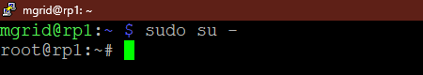
- Change the password of the VNC server using the command “vncpasswd”
- We can go through the doc as follows.
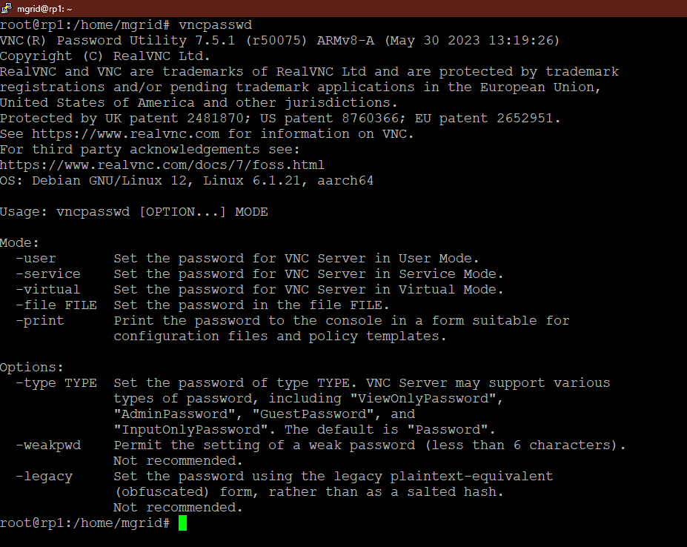
- But we are interested for command “vncpasswd -service”.
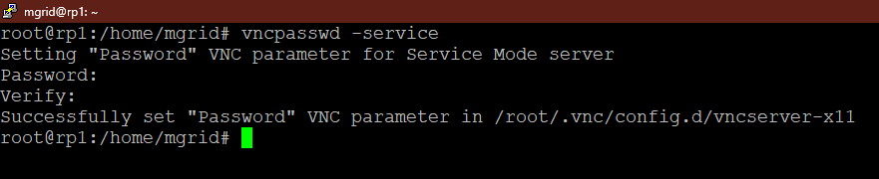
- The password will be created and will be stored in the mentioned location and we need to update the created file.
- Edit the file vncserver-x11 by command “nano /root/.vnc/config.d /vncserver-x11”
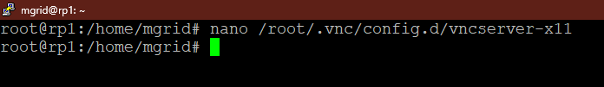
- We need to add Authentication line to the file.
  - For authenticating using system password add line
“Authentication=SystemAuth”
- For authenticating using a separate password for VNC add line
“Authentication=VncAuth”
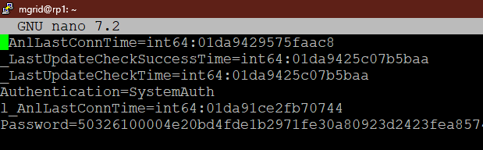
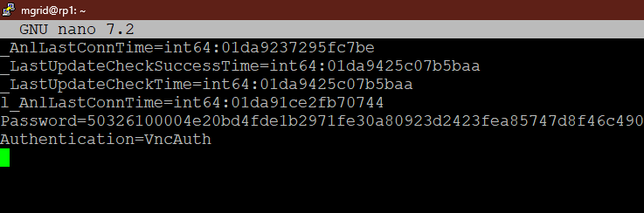
- Now restart the VNC Server using the command
“systemctl restart vncserver-x11-serviced”
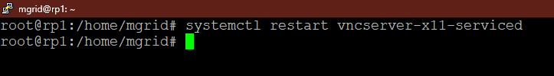
- Now we can login remotely using the VNC Password rather than System password.
