Documentation for “Remote Access of Devices”
- Requirements
  - Laptop/Desktop with RealVNC software
  - Remote_access.exe file provided by Denvik.
  - Internet Connection
  - IP address of the device to be controlled.

- Steps to install RealVNC Viewer Software
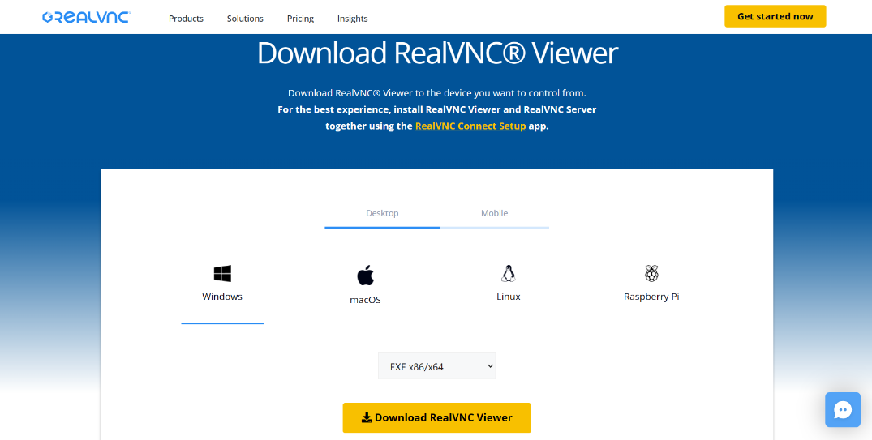
  - Visit the Website Download VNC Viewer | VNC® Connect (realvnc.com) Select your operating System (Windows/Linux/Mac) and download the RealVNC Viewer software.

  - After Downloading, run the “VNC-Server-x.xx.x-Windows.exe” file to install RealVNC and go through the default installation settings and finish the setup.
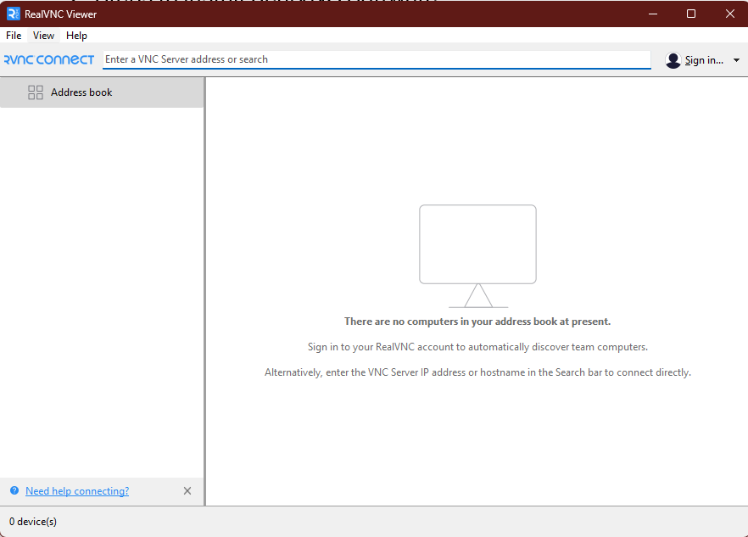
  - Open your RealVNC viewer software.
- Usage of the “Remote_access.exe”
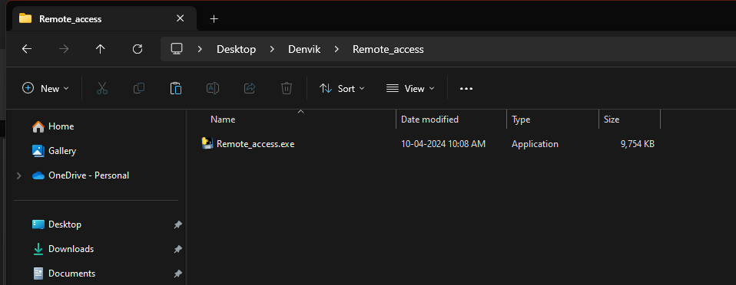
  - Run the “Remote_access.exe” executable file by double clicking it.

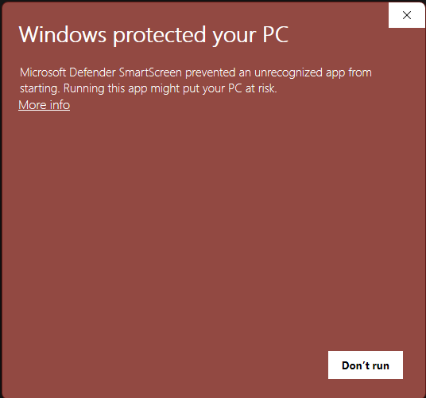
  - If You Get an error message as shown below click on “More info” label.

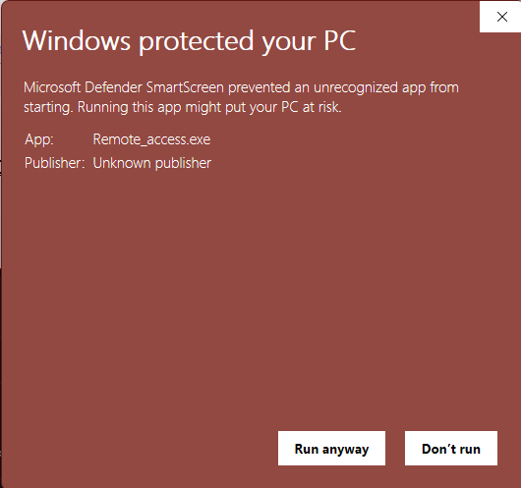
  - Next click on “Run anyway”
  - Excel Sheet containing the list of devices will be provided. From the list of Devices copy the IP address of the device you want to control the parameters.
Device | IP Address
Device 1 | 192.168.xxx.xxx
Device 2 | 192.168.xxx.xxx
------- | --------
Device n | 192.168.xxx.xxx

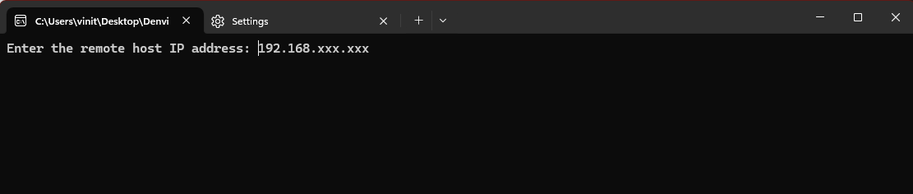
  - Paste your device IP address on the CMD prompt and press Enter on Keyboard.

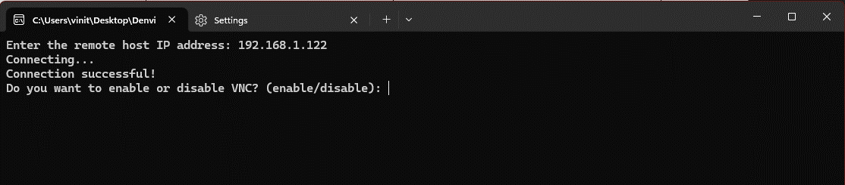
  - It will ask “Do you want to enable or disable VNC? (enable/disable):”

    - Enable – It will activate VNC Immediately and it will remain turned ON until you disable it.
    - Disable – It will immediately deactivate VNC and it will remain turned OFF until you enable it.

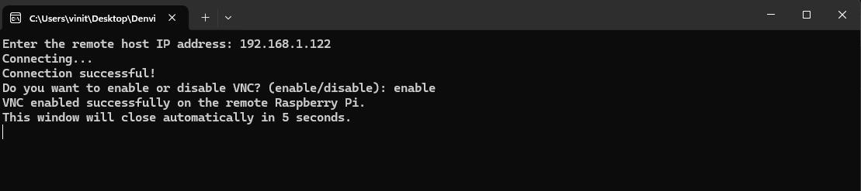
  - Type “enable” and press Enter on Keyboard to enable VNC.

  - VNC will be enabled and the CMD window will automatically close after 5 seconds.
- Steps to get the remote access using RealVNC Viewer.
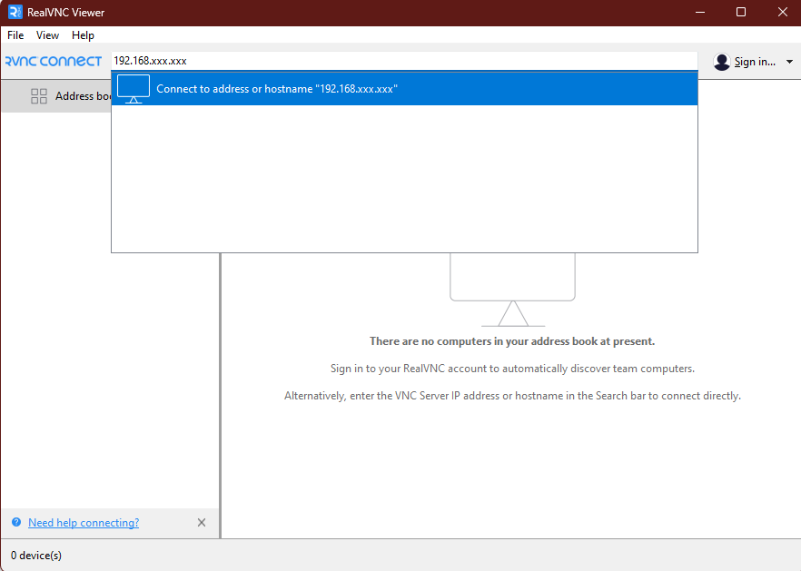
  - After successfully activating the VNC on your device, use the same device IP address and paste in the search box and press enter on keyboard.

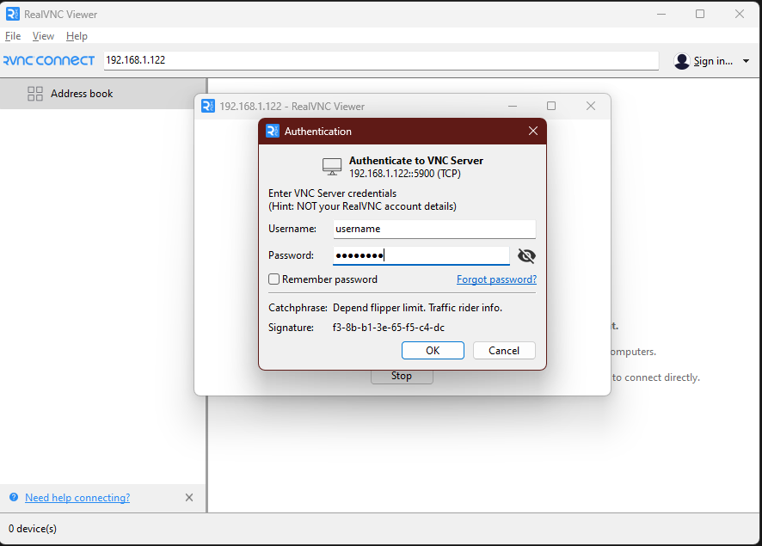
  - Enter your device “username” and “password” in the respective sections and press “OK” button.

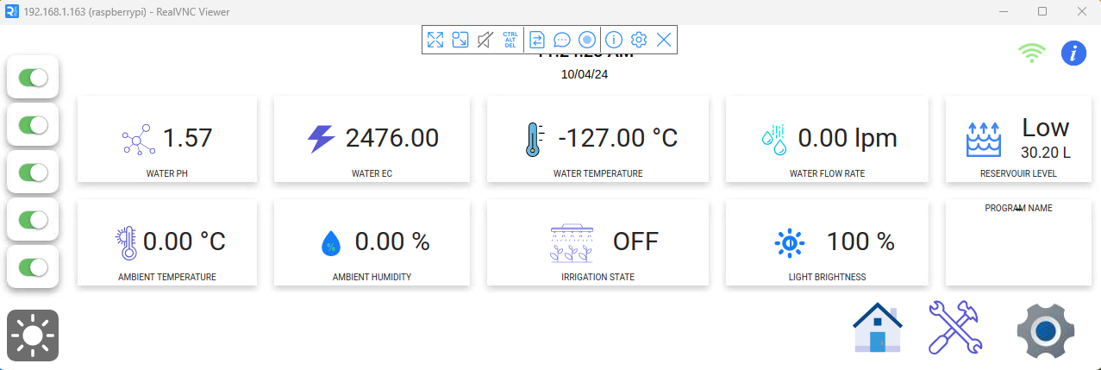
  - After accessing the device, hover at the top section of the window to view options and click on the “x” icon to “End Session”.

- Note:
  - Don’t forget to disable the VNC* after you have completed the remote access.
  - Run the “Remote_access.exe” executable file again.
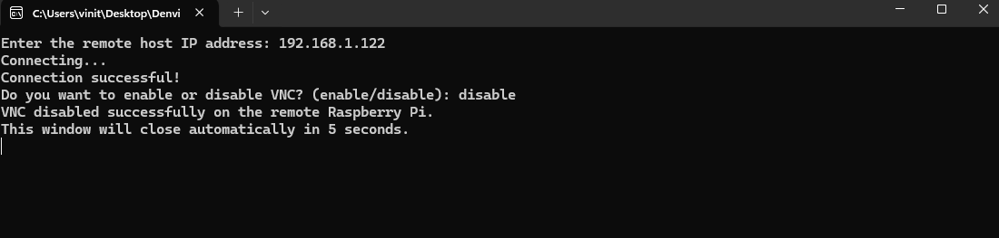
  - Follow steps from 3.1 to 3.6. After that type “disable” and press Enter on Keyboard.

  - RealVNC will be deactivated and the CMD window will automatically close after 5 seconds.

* If you don’t disable the VNC after accessing the device it may introduce some bug in the UI.

