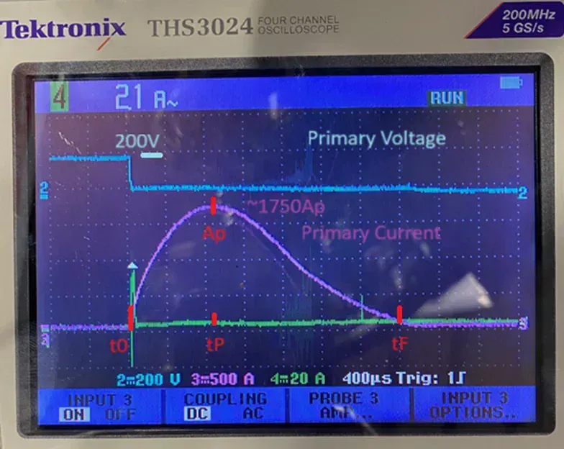
— Concise Technical Requirements (ready for design / ordering)
- Function / purpose
- Pulse transformer (energy-transfer mode): transfers a high-current pulse from a low-turn primary into a high-voltage charge on the secondary capacitors for electrostatic repulsion of unwanted particles.
- Operating conditions (measured / target)
- Discharge source (primary capacitor): 2.0 mF, initial voltage ≈ 200 V.
- Primary short-circuit voltage during discharge: ~30 V (observed), theoretical short = 0 V.
- Primary pulse waveform (CH3, violet):
  - Peak current (Ip,peak) ≈ 1 750 A (±5%).
  - Pulse full-width t0→tF ≈ 2.4 – 2.8 ms.
  - Time to peak tP ≈ 800 µs.
  - Repetition rate (pulse frequency) = 125 Hz.
- Secondary required (load):
  - Target capacitor bank voltage (after charge): 3.0 – 3.5 kV (positive polarity).
  - Load capacitance (three series caps): total C ≈ 0.11 – 0.16 µF.
  - Energy per pulse (at 3.5 kV, C=0.11 µF): ≈ 0.67 J (example).
  - Average output power at 125 Hz ≈ Energy × 125 ≈ 80–85 W (order of magnitude).
- Electrical topology & protection
- Primary turns Np: 1–2 turns (as given / preferred).
- Secondary turns Ns: MINIMUM 50 turns.
- Secondary output protected by MOV/varistor rated 4–6 kV across outputs.
- Output polarity: positive.
- Output load: bridge rectifier to capacitor bank (direct connection) with 200 kΩ discharge resistor across the caps.
- Cooling: natural convection (no forced cooling required for baseline rating; design for safe ΔT at ~80–120 W average).
- Insulation & mechanical
- Insulation class: rated for ≥4 kV continuous/co-duty on secondary; design creepage/clearance per 6 kV surge rating.
- Winding separation: full high-voltage spacing or impregnation/oil as required by chosen enclosure and safety class.
- Physical constraints: none specified (assume no tight space limits).
- Preferred core construction: laminated silicon-steel E/I or large cross-section toroidal E-I lamination. Gapped cores are not appropriate for transformers (they are for inductors).
- Required deliverables from designer / vendor
- Core geometry and manufacturer part number (laminated core) with Ae (effective cross-section) and mean magnetic path length lm.
- Confirm Ns and Np, wire gauge & insulation spec, HV clearance, window area for insulation and varnish/impregnation.
- Losses estimate at pulse duty and temperature rise for natural convection.
- Mechanical drawing for winding turn placement and HV standoffs.
- Prototype test plan: verify open-circuit secondary voltage, short-circuit primary current waveform, temperature rise, varistor clamping behavior.
*Important notice:* transformer doesn't use whole energy to charge capacitors. Generated energy is used to create plasma for DLC process.
circuit description:
discahrge capacitors -> mains filter with 6mH common mode chocke (with L1 (Phase in/out) and L2 (Neutral in/out) wired symmetrically on a core) rated 10A, wired caps --> Filter Phase in[l1in -> l1out -> l2in -> l2out] Filter Neutral out --> Dropless transformer primary --> rest of circuit: 20uH (Air coil formed by large-diameter cable 2-3 windings) + 1-10Ohm (Plasma)"

