1. I`ve created a free trial cloud instance at your web <https://rocket.chat/>
2. Set test account to <https://denys.rocket.chat/admin/info> with the pw Monblan11*
3. Created two test users: Test user1 (with the rules User, Guest) and Test user2 (Leader, Admin)

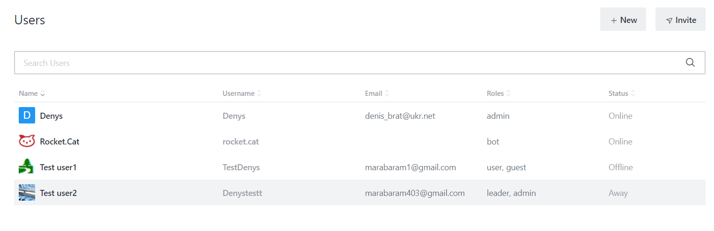

1. Installed separate inet browser and logged into [https://denys.rocket.chat](https://denys.rocket.chat/admin/info) with the user`s account
2. Installed Rocket.Chat desktop app for Wind10 at <https://rocket.chat/install/>
3. Set my account at the desktop app

* There is a default Room called General including 3 users in it

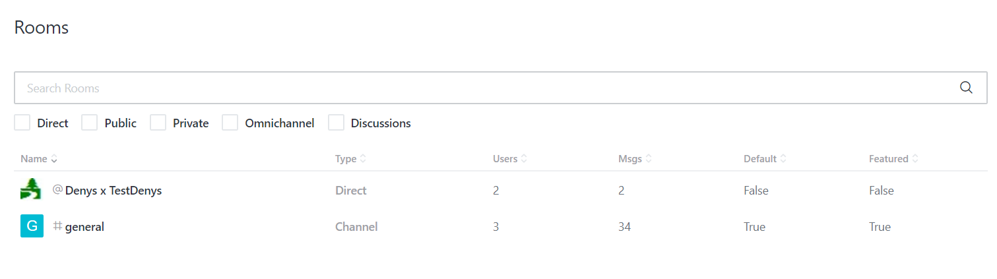

* There is a list of rules to set for a user

1. Admin
2. Moderator
3. Leader
4. Owner
5. User
6. bot
7. app
8. guest
9. anonymous
10. livechat agent
11. livechat manager