Case Study:   
**Taxi Company**

Summary:

Taxi Management System Overview

Details:

The Taxi Management System is a computer program designed to streamline the operations of a taxi service. It provides a digital platform for managing drivers, cars, orders, payments, and customer complaints efficiently.

Driver and Car Management:

* Information such as driver names, license details, car types, brands, and registration numbers is stored.
* The system keeps track of drivers and cars associated with the taxi service.

Operator Console:

* Operators, who manage and coordinate taxi services, are registered in the system.
* They are responsible for assigning drivers to shifts and handling customer orders.

Driver Shifts:

* The program manages the working shifts of taxi drivers.
* It opens and closes shifts, associating each shift with a specific driver, car, and operator.

Accounting and Reporting:

* Cash reports are generated to record the financial transactions for each driver shift.
* The program provides an overview of the current system status, including active drivers, opened orders, and free drivers.

Order Lifecycle:

* The program simulates the lifecycle of an order, from creation to completion.
* It tracks stages like driver appearance, customer pickup, and order completion.

Order Handling:

* The system facilitates the creation, tracking, and completion of taxi orders.
* Orders include details such as customer name, phone number, destination, and requested taxi type (e.g., standard, express, economy).

Complaints Handling:

* Customer complaints are recorded and associated with specific orders and operators.
* This feature allows the taxi service to address customer feedback and improve service quality.

Exception Handling:

* The system is designed to handle exceptional cases, such as closed driver shifts or busy drivers, ensuring smooth operations.

**Use Case Diagram:**

Accountant:

The accountant logs in to the system to view the daily cash reports. They can see a summary of earnings, transactions, and other financial details for each driver shift.

Driver:

The driver logs in to the system to start their shift, associating themselves with a specific car. At the end of the shift, they close it in the system.

Operator:

The operator logs in to the system to manage incoming orders. They assign an available driver to an order based on factors like location and availability. Also operator register the complains from customers.

Customer:

The customer uses the system to place a taxi order. They provide details like the destination, taxi type, and contact information.The customer uses the system to provide feedback on the service or lodge a complaint about a specific order.

**Class-Package Diagram:**

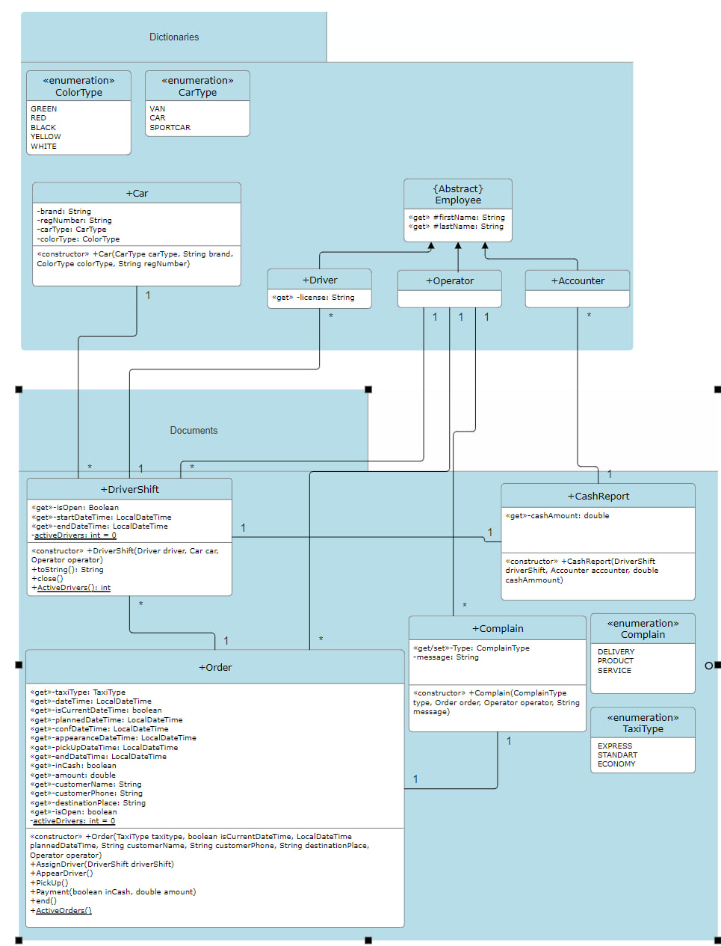

**Class-Package Diagram with Exceptions:**

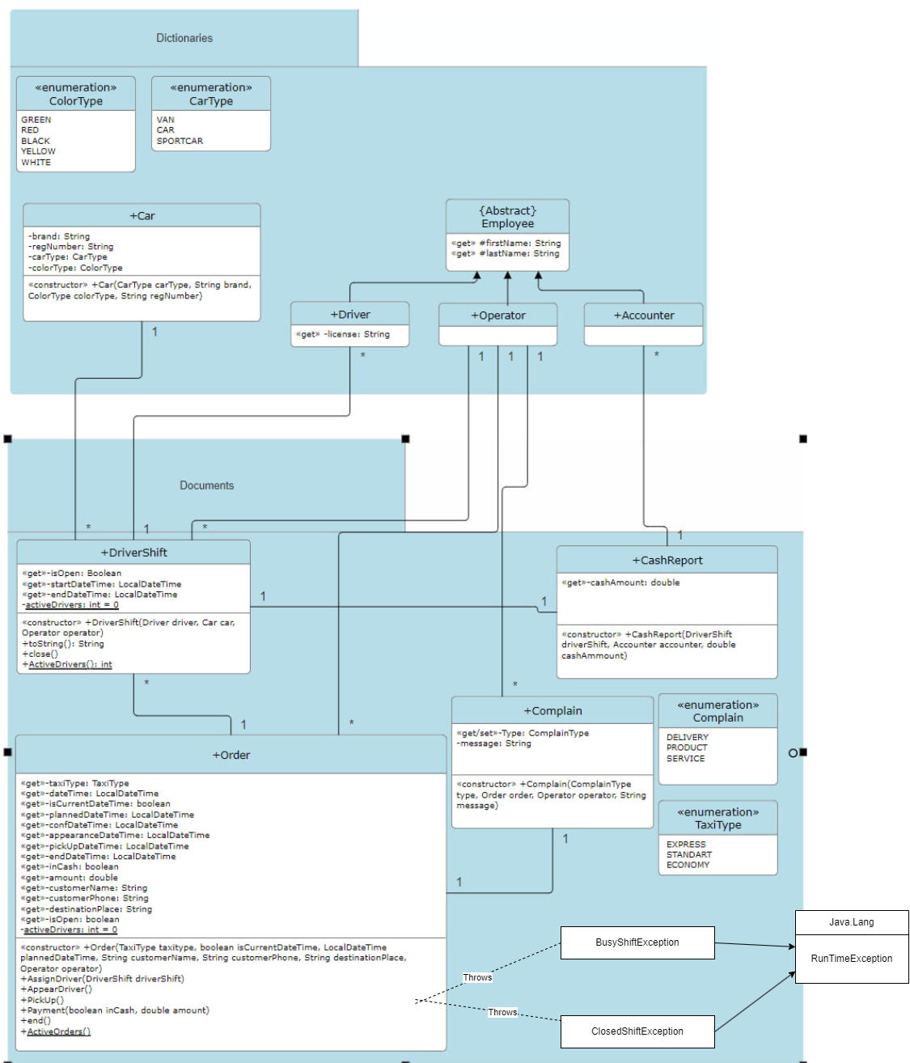

**Database:**

The taxi management system is designed to create and manage a database that facilitates the efficient operation of a taxi service. The program uses a relational database to store and organize information about various entities such as drivers, cars, operators, orders, cash reports, and complaints.

Accounter:

Accountant table have an id, firstName, lastName columns.

Car:

This table have such columns like id, carType, brand, colorType, regNumber.

Cashreport:

This table have a records of id, cashAmount, driverShiftId, accounterId.

Complain:

Here we have records such as id, complainType, message, orderId, operatoId.

Driver:

That table have id, firstName, lastName, license columns.

DriverShift:

In this table we have id, startDateTime, endDatetime, shiftOpened, driverId, carId, operatorId.

Operator:

Here we have only id, firstName, lastName.

OrderDoc:

Here we have all records. Such as id, taxiType, createDateTime, isCurrentDateTime, isPlannedDateTime,

confirmDateTime, apprearanceDateTime, pickUpDateTime, endDateTime, inCash, amount, customerName,

customerPhone, destinationPlace, driverShiftId, operatorId, orderOpened culumns.

