University of Technology, Jamaica
Faculty of Engineering and Computing - School of Computing and Information Technology

Web Programming
CIT2011

Individual Assignment #1 - Website Storyboard & Specification Guide

Denyse Shakespeare
1305116
Sirisha Badhika
October 18, 2026

Part A: Storyboard Layout Designs
- Mobile Layout (600px) - Single-column, vertically stacked, compact navigation layout.

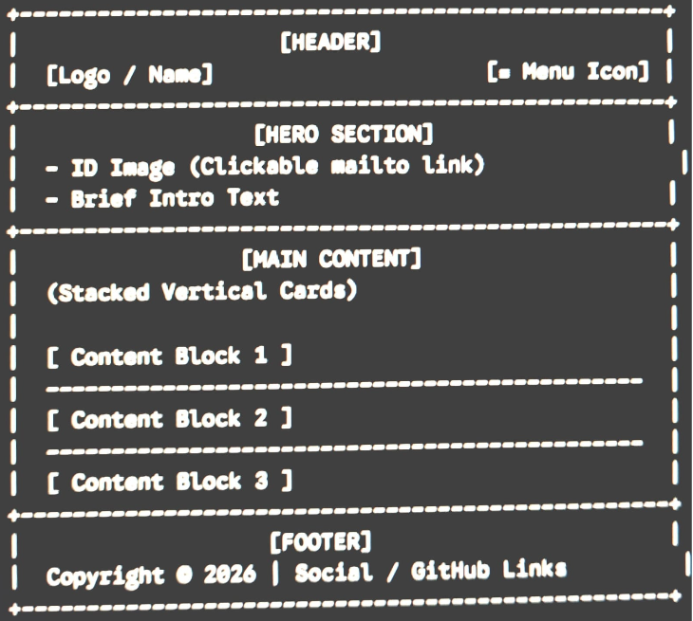

- Desktop Layout (>= 950px) - Multi-column layout utilizing screen width with sticky header navigation.

- 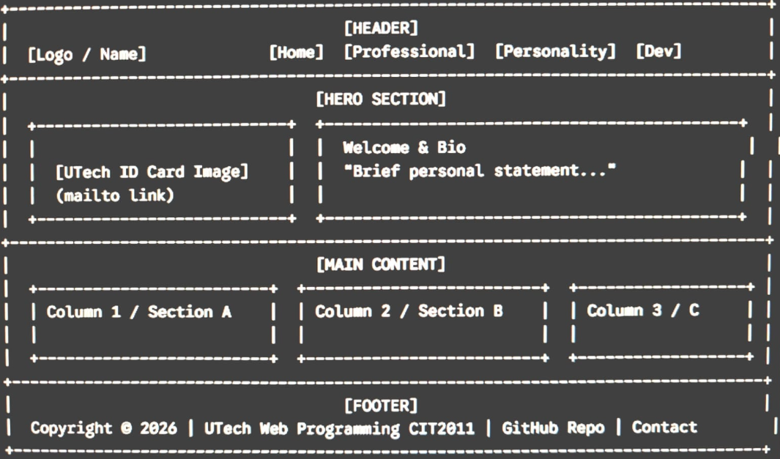

Part B: Asset & Style Guide
- Color Palette:
  - Primary Color: #1A365D - RGB(26, 54, 93) (Deep Navy Blue)
  - Secondary Color: #2B6CB0 - RGB(43, 108, 176) (Accent Blue)
  - Background Color: #F7FAFC - RGB(247, 250, 252) (Soft Off-White)
  - Text Color: #2D3748 - RGB(45, 55, 72) (Dark Slate Charcoal)
  - Accent / Highlight: #D69E2E - RGB(214, 158, 46) (Warm Gold)

- Typography:
  - Font Family: 'Roboto', Google Fonts, sans-serif
  - Root Font Size: 16px
  - Root Font Weight: 400 (Normal text), 700 (Headings)

- Icons & Media Dimensions:
  - Google Material Icons Size: 24px x 24px (standard header/footer icons)
  - UTech ID Image Dimensions: 300px x 200px (aspect ratio preserved)

Part C: GitHub Repository Link
Repository URL: https://github.com/Denyse-Shakespeare/1305116_IA1_S1AY27/

Part D: Free Hosting Link
Live Hosted Website URL: https://[your-username].github.io/[your-repo-name]/ (or Netlify / Vercel link)

APA References Page
Clason, G. S. (1926). The Richest Man in Babylon. Signet. https://icrrd.com/public/media/16-05-2021-070111The-Richest-Man-in-Babylon.pdf
Harvard Office of Career Services. (n.d.). Create a strong resume. Harvard Faculty of Arts and Sciences. https://careerservices.fas.harvard.edu/resources/create-a-strong-resume/
Indeed Editorial Team. (2023). What makes a good resume? Indeed Career Guide. https://www.indeed.com/career-advice/resumes-cover-letters/what-makes-a-good-resume

