Function Explaination

**Flowchart:**

/*Set the target position of a leg, calculate the speed to move the leg to that position.*/

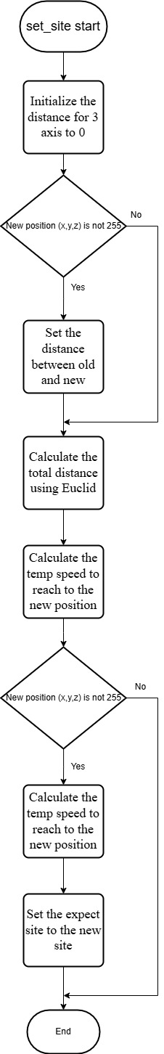

**Code:**

void set_site(int leg, float x, float y, float z)

{

float length_x = 0, length_y = 0, length_z = 0; //Initialize the distance

if (x != KEEP) //if x = KEEP = 255

length_x = x - site_now[leg][0];

if (y != KEEP)

length_y = y - site_now[leg][1];

if (z != KEEP)

length_z = z - site_now[leg][2];

float length = sqrt(pow(length_x, 2) + pow(length_y, 2) + pow(length_z, 2));

temp_speed[leg][0] = length_x / length * move_speed * speed_multiple;

temp_speed[leg][1] = length_y / length * move_speed * speed_multiple;

temp_speed[leg][2] = length_z / length * move_speed * speed_multiple;

if (x != KEEP)

site_expect[leg][0] = x;

if (y != KEEP)

site_expect[leg][1] = y;

if (z != KEEP)

site_expect[leg][2] = z;

}

**Euclidean Distance Formual:**

In mathematics, the Euclidean distance between two points in Euclidean space is the length of the line segment between them. It can be calculated from the Cartesian coordinates of the points using the Pythagorean theorem, and therefore is occasionally called the Pythagorean distance.

Formula: $d= \sqrt[2]{{(x2-x1)}^{2}+{(y2-y1)}^{2}}$

