**Russian Peasant’s Algorithm – Analysis**

* I first tried passing 24 and 26 into the algorithm to make sure it works as intended. The value that I was expecting was 384. After running the algorithm, it outputs 384, which tells me that the algorithm is working fine.
* I then tried different values with increasing lengths:

123 * 123

123456 * 123456

123456789 * 123456789

123456789123L * 12345678

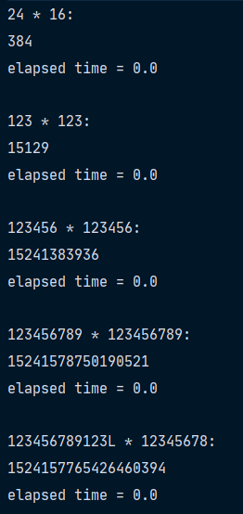Here are the results:

As the elapsed time of each test is very small, its hard to graph the results.

Time complexity is O(logn)