Binary Compression

1. 40 bits
2. 32 bits

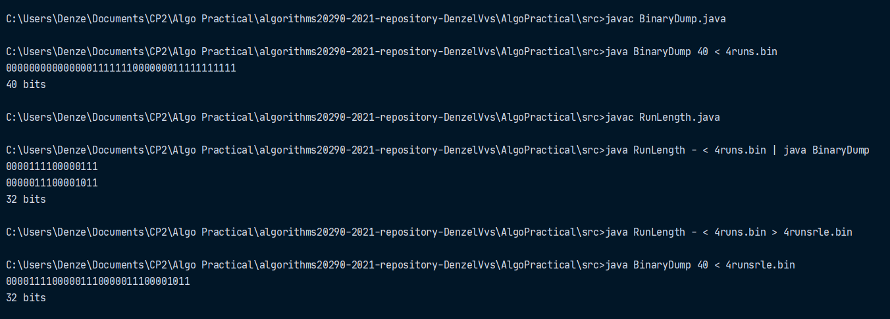Compression Ratio : 40 / 32 = 0.8 = 80%

ASCII Compression

1. 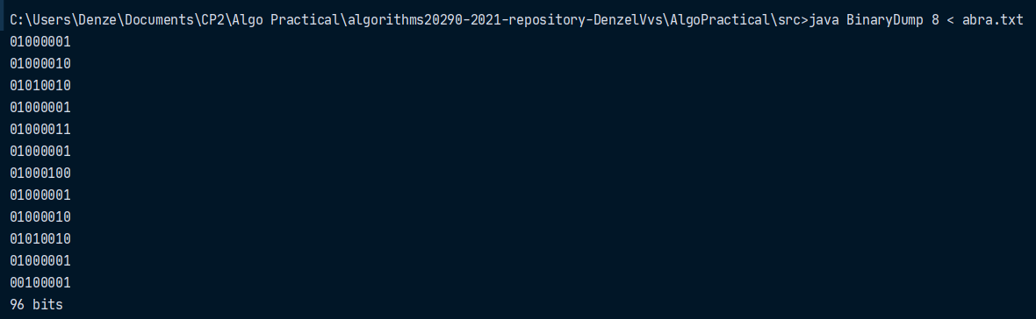96 bits
2. 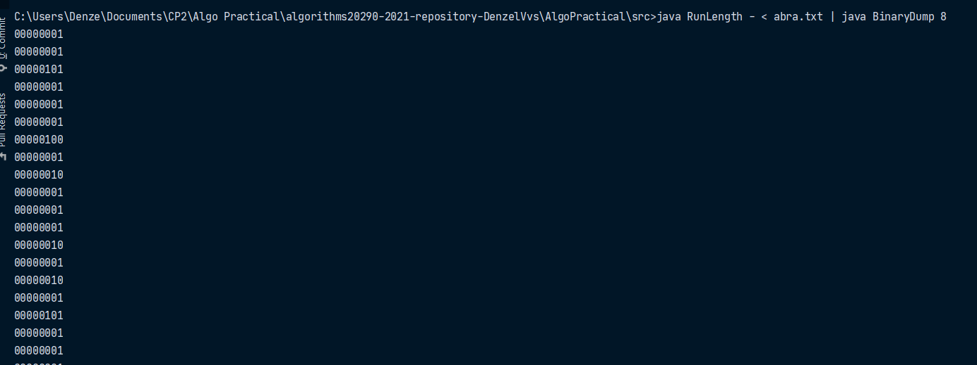416 bits

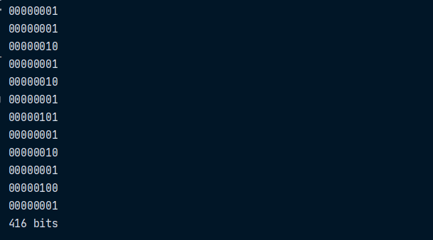

Compression Ratio: 416 / 96 = 4.33 = 433%

Why do you think you got this? –

What is happening? –

Bitmap Compression

1. q32x48.bin = **1536 bits**
2. q32x48rle.bin = **1144 bits**
3. Compression Ratio : 1144 / 1536 = **0.74479 = 74.479%**
4. q64x96.bin = **6144 bits**
5. q64x96rle.bin =**2296 bits**
6. Compression Ratio : 2296 / 1536 = **0.373698 = 37.3698%**
7. I think this is because q64x96.bin has more bits to be compressed which causes its compression ratio to be lower.