**FIDO: Food and Item Donation Tracking System**

**Lanzaderas Denzel T**

**Agustin, Danielle Olive Anne**

**Tagsip Gladys**

**Aldeza Pedro Miles**

**Department of Information Technology**

**College of Information Technology and Computing**

**UNIVERSITY OF SCIENCE AND TECHNOLOGY OF SOUTHERN PHILIPPINES**

**Cagayan De Oro City**

**December 2020**

**CHAPTER 1**

**Introduction**

* 1. **Background and Rationale**

Advances in technology have enabled a wide range of applications to be developed that can be used by people who are on the move or by people who like the “one-click away” process.

Donation on the other hand is something that has been given to a charity and barangays, it could either be food or money. The act of donating can be done randomly or after every disaster that causes chaos to a certain place and its people.

With today’s improvement of technology, different kinds of smart phones are being produced every day that range from low, middle, to high range with its own bracket of pricing per range. With that information, owning a mobile phone has become the trend since lots of affordable smartphones have been released lately. As of 2020, there are approximately 79.05 million smartphone users in the Philippines, and it has continued to rise since 2015 (Martha Jean Sanchez, 2020). One of the major advantages of owning a smartphone is the mobile application. Mobile applications or apps are a major part of a mobile phone. Applications give life to a smartphone. They have made our lives very easy. With that being said, there are mobile applications that are made to help in donations such as money and food to the less fortunate and for areas knocked down by natural disasters, turning donation into a “one-tap away” process. Remembering Sendong being the strongest typhoon that happened here in our local city. A total of 158,268,291.71 worth of food and item donations from the different disaster preparedness departments in Cagayan de oro city were accumulated. The 7,739,376.00 worth of food and non-food items as additional standby relief resources for the victims of Sendong thru DSWD - NROC (Benito Ramos, 2012).

**1.2 Statement of the Problem**

With the present system, the ways of donating and receiving donations lack modernization, since donation operations are being done manually here in our locality. The problem investigated on this research concerns how individuals or groups can donate to a charity and how charity or barangay can find and track donations through technology solutions.

**1.3 Objectives of the study**

**1.3.1 General Objective**

This study aims to design and develop a donation tracking system using web and mobile applications.

**1.3.2 Specific Objectives**

- To design a system that utilizes an android device to help charity and barangay find and track donations of the donors.

- To design a web application to be used by non-government organizations where we can register users and verify their legibility.

- To develop and implement web applications and android applications to be used in a donation tracking system.

**1.4 Significance of the Study**

The proposed system will contribute to those organizations who have the primary goal of helping less fortunate people and individuals that want to donate food and items.

The project’s goal is to help charities or barangay and donors to find and track donations by providing them with an advanced solution which acts the same way as the manual process but through technologies.

**1.5 Scope and limitation**

The proposed system can help charities, organizations and local government units that support people in need, and the donor can be any user of the app that wishes to donate food or items only with no money involved. The organization can be a barangay or charity that has the primary goals to help those who are less fortunate such as victims of natural disasters and people living in poverty. This research will be conducted in the municipality of Cagayan de Oro City. The study focuses on giving the goods to the registered organization only. The study foresight to connect the system to the database of fully verified departments that has the data of the organization that the system needs.

**Chapter 2**

**Review of Related Literature**

**2.1 Introduction**

As the genre of technology pushes the world forward to a better future, manual doings such as donating have been innovated to become a one-tap away on your smartphones. Smartphones on the other hand continue to progress everyday with the latest technology available, so why not make use of it to do something good right?

The purpose of this chapter is to focus on the summaries, insights of existing donation mobile applications from varying sources.

**2.2 FOOD WASTAGE REDUCTION THROUGH DONATION**

It was published in 2018, the proposed system presents a new internet-based application that provides a platform for donating leftover food to all needy people/organizations. The system is shown to be an effective means of donating things to organizations, etc. over the internet. It shows the potential for avoiding the wastage of food. It provides information about the motivation to come up with such an application, thereby describing the existing donation system and how the product works for betterment of the society. This system will create a common collaboration portal for hotels/restaurants and charities, charity can directly contact restaurants who have food remaining and report generation which will show how much food is donated by which restaurant and providing reward points for them .In this system Food Donor, Food receiver, Third party vendor, admin and premium user are the main modules where FoodDonor can be any organization, institute or college who wants to donate food and create a new food donation request and Food receiver can be any charity firm seeking for food. A new food donation request will be created on the portal and once the request is accepted, a notification is sent to a Third party vendor which is responsible for moving food from food donor to food receiver. The premium users are the ones who donate food on a daily basis (J Manikandan.,et.al,2018).

**2.3 FOOD FOR YOU (F4U) MOBILE CHARITY APPLICATION**

It was published in 2018, F4U mobile application has three types of users, which are needy, donator and food supplier. The donor could be anyone that generous to do the charity whether to donate their money or food. The suppliers are all the peoples or organizations that want to sell food for the donators. This system connects all the users on the same platform that allow them to easily interact or communicate with each other. Needy users can choose and can make requests for food given by donors nearby their location. The donor users are facilitated with functions to donate food, money and services to those needy. Furthermore, users from the supplier category are provided with functions of selling food and managing foods’ transfer. All users can track donation and business transaction status as well as the delivery status. There are listed Charity Nongovernment Organizations so that the people can donate money to the organization using this system. Through this mobile application, they also can view the news related to the charity, donation and application itself. (Suraya Masro.,et al 2018).

**2.4 BLOOD DONOR TRACKER BY USING GPS**

It was published in 2018, the proposed system acts as an important role in saving life of human beings and which is also its main aim. The project Android Blood Bank system is developed so that users can view the information about registered blood donors and receivers such as name, address, and other such personal information along with their details of blood group and other medical information of donor and receiver. The proposed system also has a login page where the user is required to register and only then can view the availability. Thus this application helps to select the right donor online instantly using medical details along with the blood group. The main aim of developing this application is to reduce the time to a great extent that is spent in searching for the right donor and the availability of blood required. Thus this application provides the required information in no time and also helps in quicker decision making. This project Android Blood Bank system is developed so that the users can view the information about the registered blood donors such as name, address, and other such personal information along with their details of blood group and other medical information of donor. The project also has a login page where the user is required to register and only then can view the availability of blood and may also register to donate blood if he/she wishes to.

**2.5 SYSTEM AND METHOD FOR TRACKING CHARITABLE DEDUCTIONS**

A system and method for recording and tracking charitable donations over a period of one or more years, and for determining the tax consequence associated with such donations based upon taxing authority guidelines (including laws, regulations, rules, guidelines, or other mandates) applicable to the time period in which such donations were made. One aspect of the invention is directed to a method implemented by software for tracking charitable donations over a period of years whereby a user is prompted to select a donation and a year in which the donation was made from memory; the software retrieves a tax-deductible valuation associated with that donation and stores the donation and value in the memory in association with each other. Another aspect of the invention is directed to a system for determining the tax-deductible value of charitable donations whereby a partner server electronically captures sales data of items and sends the sales data to a system server that stores such data in memory.

**2.6 SYSTEM AND METHOD FOR TRACKING CHARITABLE DONATIONS**

A system and method for allowing individuals to track their personal quantitative measure of success at causing donations to be made to charitable organizations. Under this system, the total dollar amount of all donations made by an individual, summed with all donations made by those donors who this individual personally encouraged to make a donation, summed with the donations made by donors who were indirectly encouraged by the individual (encouraged by someone else who was directly or indirectly encouraged by the individual) to make a donation, represents a score, or quantitative measure of the level of success, that the individual has attained in their effort to cause donations to be made to charitable organizations. The invention can be implemented as a system for facilitating and tracking donations, and reporting via the Internet and other media, this quantitative measure of success at causing donations to be made to charitable organizations that an individual has attained over their lifetime.

**Chapter 3**

**METHODOLOGY**

The purpose of this chapter is to present the steps and the different diagrams that will conclude with the proposed system that we are aiming for.

**3.1 Information Gathering**

In collecting the data and information for the study, the researchers used qualitative methods such as surveys and audio recordings.

The proponents organized researches in acquiring the data and conducted surveys and audio recordings in order to generate reliable information from the different barangay and Charity organizations. The proponents also did an audio interview with the donation in charge from CSWD to gather information regarding donation storage, their ways of receiving and disposing of the goods. According to Mr. Joel A. Tuquib Head Officer Supply from CSWD - CDO that the manual process of receiving and disposing starts from having two types of donors, donors who donate randomly and donors who donate after a disaster. They specified that donations are not stored for long, they prioritized disaster-struck areas but also intended to dispose of donations to registered organizations for the reason of not storing the goods especially those easily rotten goods.

**3.2 Designing the System Flow**

In order to understand and analyze the concept of our study and visualize the flow, process, and functionality of the system, modeling diagrams were applied.

3.2.1 System Architecture

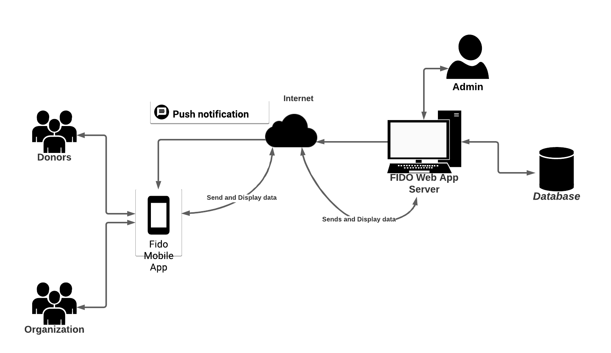

Figure 3.2.1 System Architecture

Figure 3.2.1 represents how the system is implemented. Where push notification serves as a tracking module. The users will access the mobile app via the internet, features intended for each user will be passed on to the web app server. Once the matching has been done, notification through push notification will be sent back to the users. Transaction will be stored on the database server. Admin is the one to manage the data stored on the database through the web app server.

3.2.2 Use Case Diagram

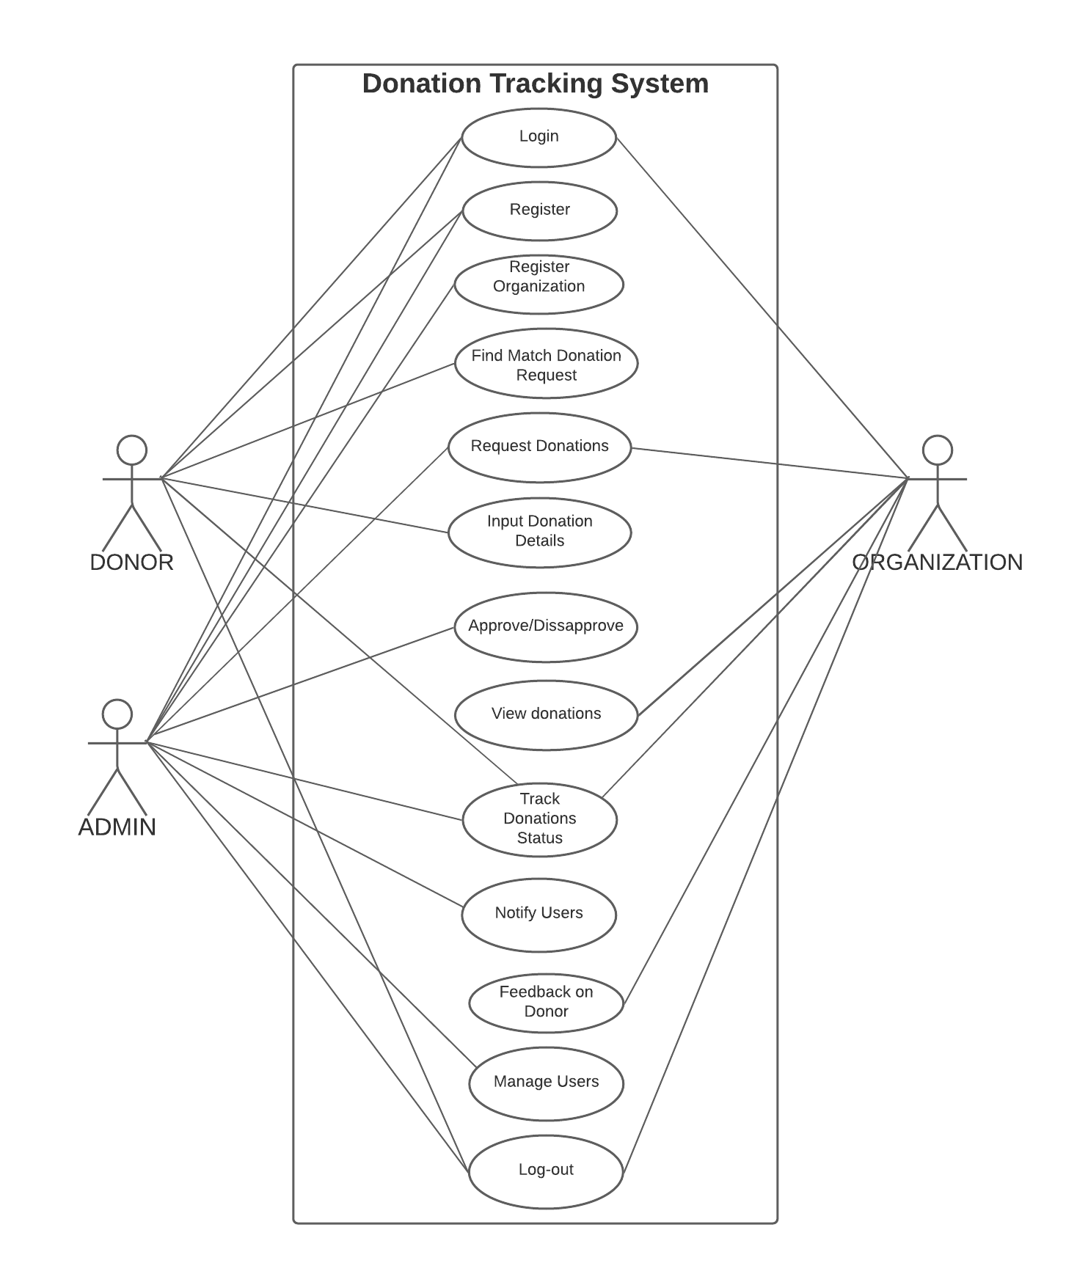

Figure 3.2.3– User Overview

**User Overview**

Figure 3.2.3 shows the interaction between the actors in the system. The system consists of three (3) people who have different roles and privileges. Namely: Admin, Donor, and Organization can be charity or barangay.

**1. Admin** - the one who manages the system. The admin can register certified Charity and Barangays. The admin can also view the tracking status of the donation. The admin can also post-donation even with the absence of stock donations

**2. Donor**- the one who can access the donating feature. The Donor can donate either food or items or both. Once the matching is done, the profile of the receiving party will be displayed on the Donor’s profile. The Donor can track their donation from time to time to verify if the donation has arrived at its destination.

**3. Organization** – has access to the system. Can post and request their much-needed donations. Can view the donation that has been matched to their request. Can track the status of the donation as to its whereabouts.

3.2.3 Context Diagram

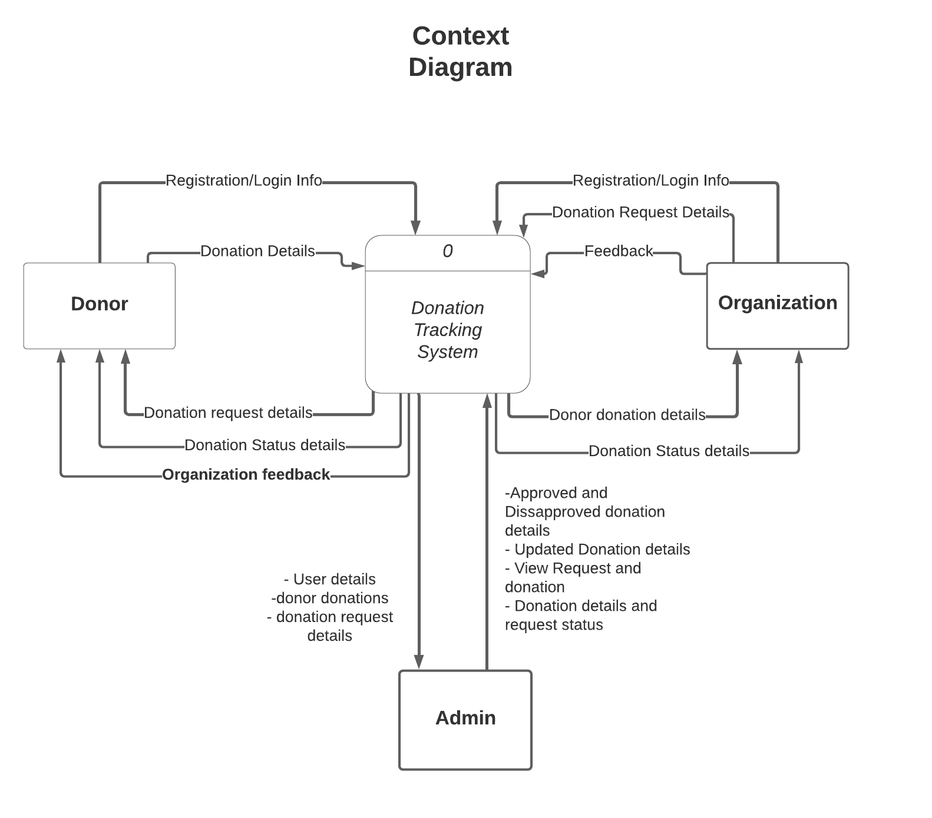

Figure 3.2.3 Context Diagram

**System Overview**

In figure 3.2.3, the diagram shows the whole process of the system. This section explains the details of the system for users to understand the details and boundaries of the system to be designed in our project. This points out the flow and between the actors on our system and their external counterparts.

3.2.4 Data Flow Diagram

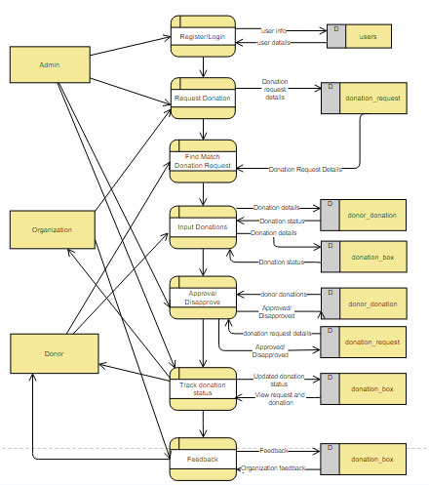

Figure 3.2.4 Data Flow Diagram

Figure 3.2.4 The figure above shows the operation, functionality, and implementation of the system. The figure explains the chronological flow of data involving different transactions in the system. It also indicates the path of data being distributed. The figure also shows the breakdown of every transaction in the system.

3.2.5 Designing the Database

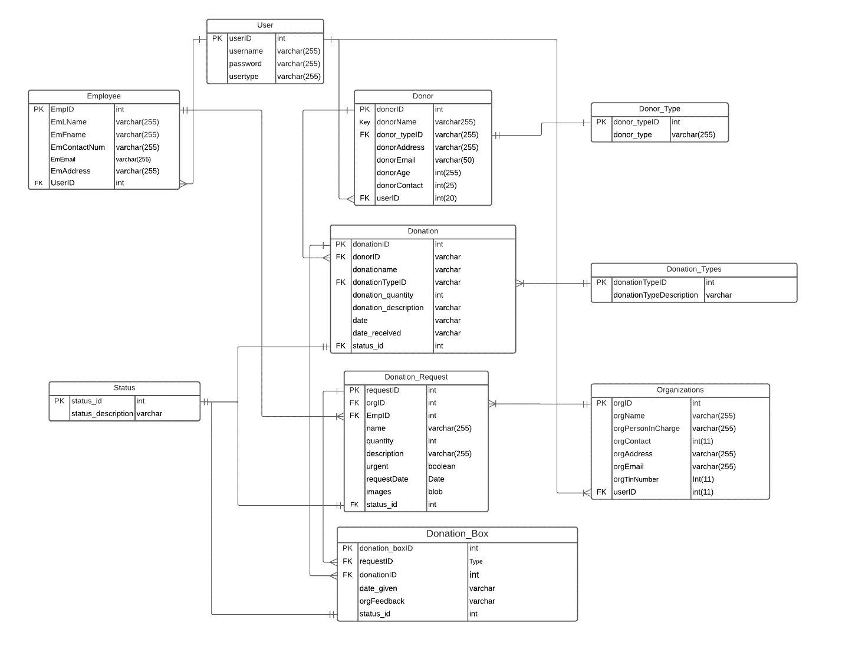

Figure 3.2.5 Entity Relationship Diagram

The figure shows the different entities in the database. It also shows the different tables are being related. With this, the proponents can determine the kind of relationship the tables have.

**3.3 Web Application tools**

Web technologies such as HTML, CSS, Javascript, PHP will be used for the development of the admin web application.

**HTML** in developing web applications the researchers used HTML, it stands for Hypertext Markup Language. It is a set of markup symbols or codes inserted into a file intended for display on the Internet. The markup tells web browsers how to display a web page's words and images. This can be used to ensure the proper formatting of text and images for the internet browser.

**CSS** stands for Cascading Style Sheets, the researchers used this for designing the layout and variations in displaying the web app.

**Javascript** is a programming language used on our client-side to make the web pages more interactive

**PHP** for the server-side programming language the researchers used PHP or Hypertext Preprocessor, with this the content can be dynamic, and it can collect user form data for it to be stored in the database.

**3.4 Mobile Application Tools**

**Flutter**

The researchers used Flutter technology in developing the mobile application. Flutter is free and open-source Google’s UI toolkit used in building native applications. In addition, the proponents decided to use flutter instead of other software development kits since it enables developers for fast development which allows fast rendering of designs with the use of Stateful Hot Reload, it has great documentation and a large number of communities.

**Flutter Local Push Notification**

Flutter local notification will be used in the system, in order for the users to be notified or updated on the donation and donation request status.

**3.5 Database**

**Mysql**

MYSQL will be used for the storing of users and donation data. It is an open-source relational database management system (RDBMS).In addition, the proponents decided to use MySQL because of the large community and provide large support for every application that is needed.

The researchers will also use phpMyadmin as a localhost web server, for the reason that the system generates queries to be displayed for the user. Localhost will serve as the testing environment of the prototype for evaluation and functionality of the flow of the system.

**3.6 System Requirements**

**Windows 10 and above Operating System**

Windows 10 and above version is a computer operating system that offers a much lighter and faster operating system to be used by the admin. And offers excellent antivirus protection.

**Android Phone Version 5.0 (Lollipop) or above**

Android is open-source software and operating system for mobile operating systems developed by Google. Android 5.0 above version runs on multiple devices and can run smoothly. . The operating system also features push notifications which can be controlled by the user.

**3.7 Fido System Prototype**

With the use of Adobe XD the android pages will be designed according to the created system flow. A mobile application that will provide the donor and recipients a user interface to donate, input needed items, and track donations.

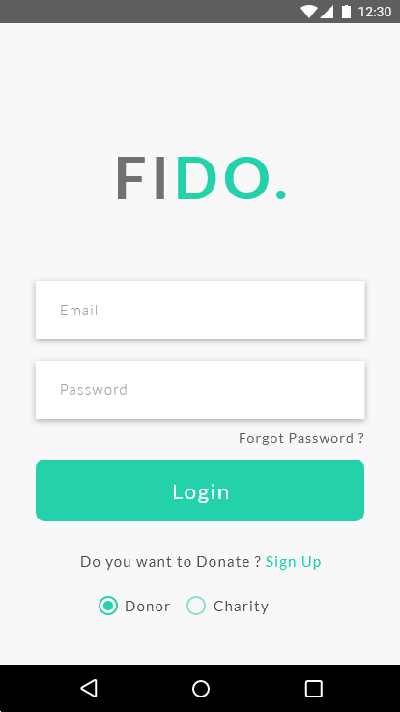 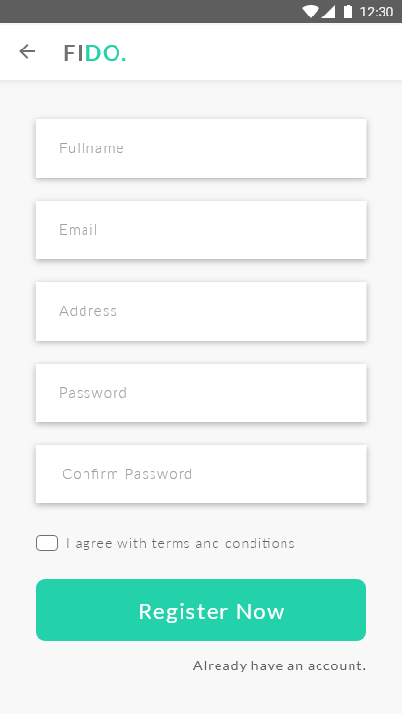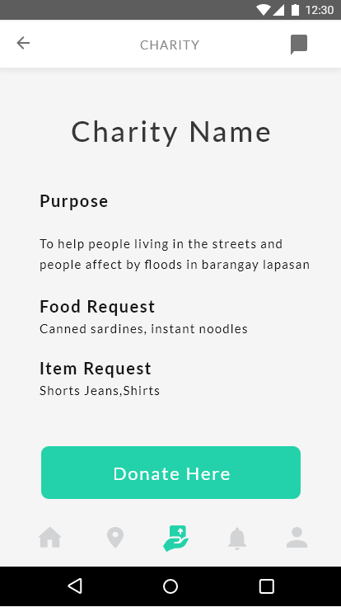

Figure 3.7.1(from left to right)(a) donor login (b)donor registration(c)home

Figure 3.7.1 shows a registered donor can (a) log in or if not yet registered; the donor will have to (b) register. After the donor logged in or registered, the donor will be shown on the (c) home page which shows the list of organization requests.

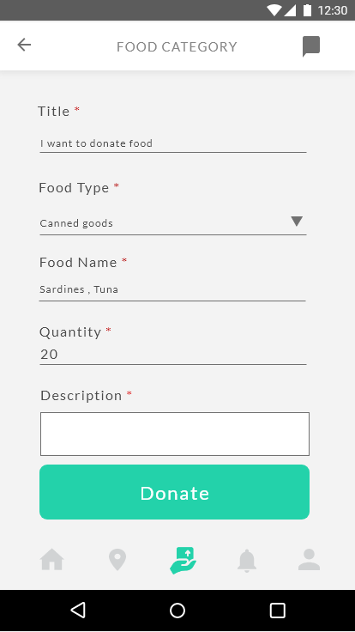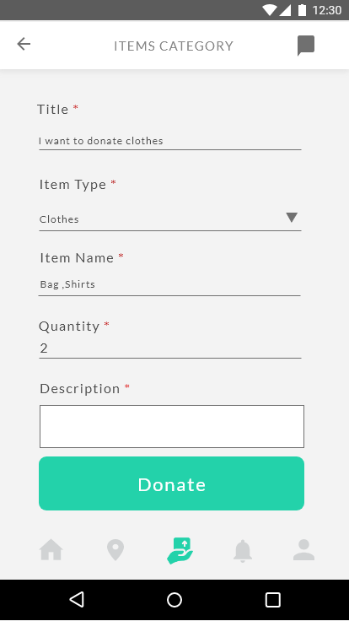

Figure 3.7.1.2 donation details of donor

Figure 3.7.1.2 show a donation category of a donor(a) the donor can choose whether its donation is food or item then the donor will input its donation to the selected or match the organization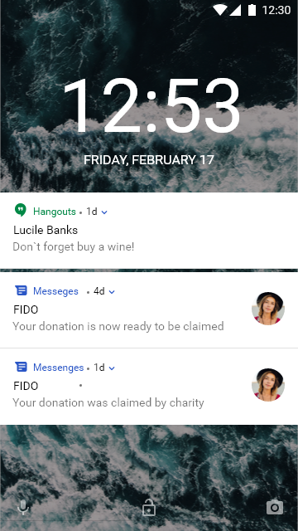

Figure 3.7.1.3 push notification

Figure 3.7.1.3 show the tracking details of donation using push notification

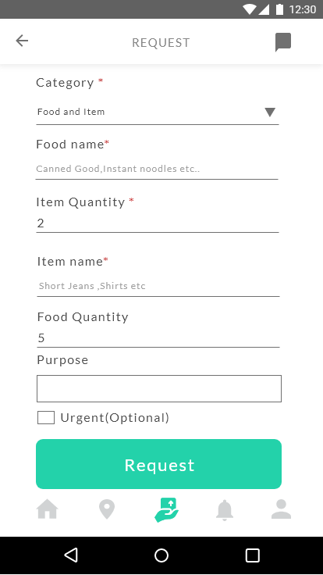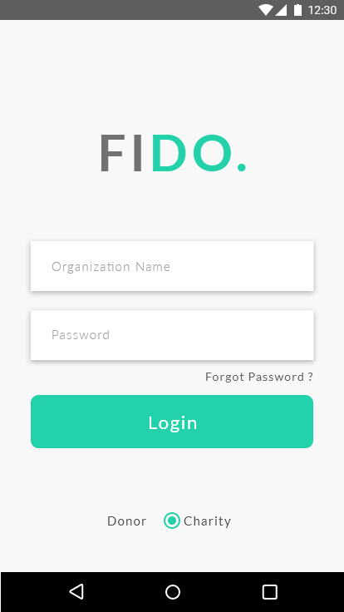

Figure 3.7.1.4 (from left to right) (a)organization login (b)request donation

Figure 3.7.1.4 shows the organization login, the organization will be registered by the admin and will be given login credentials. After the organization logged in, it will be directed to the request page form.

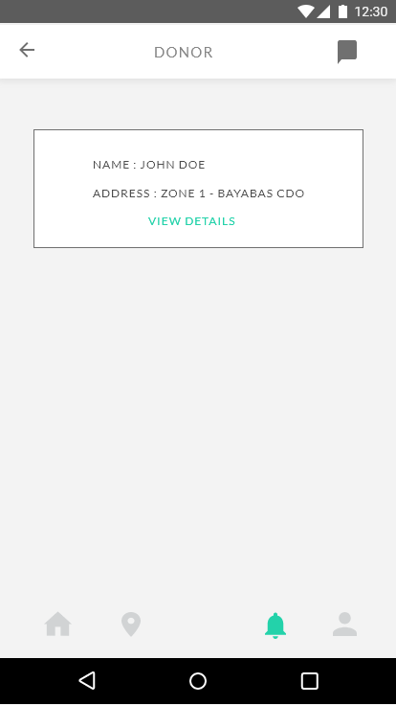

Figure 3.7.1.5 (a)organization donor donation details

Figure 3.7.1.5 shows the organization donor and display the current status of a donation

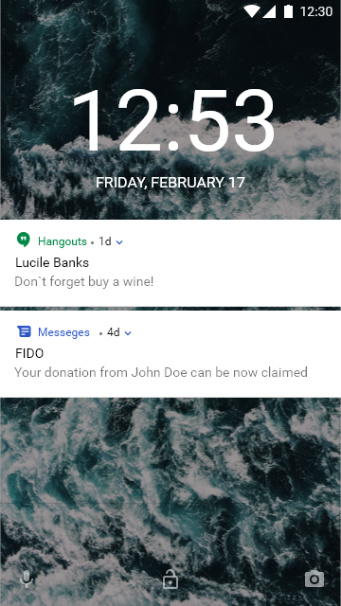

Figure 3.7.1.6 (a)organization push notification

Figure 3.7.1.6 shows the push notification that will be received by the organization to update the current status of donation from the donor

**3.7.2 Designing the Admin Web application**

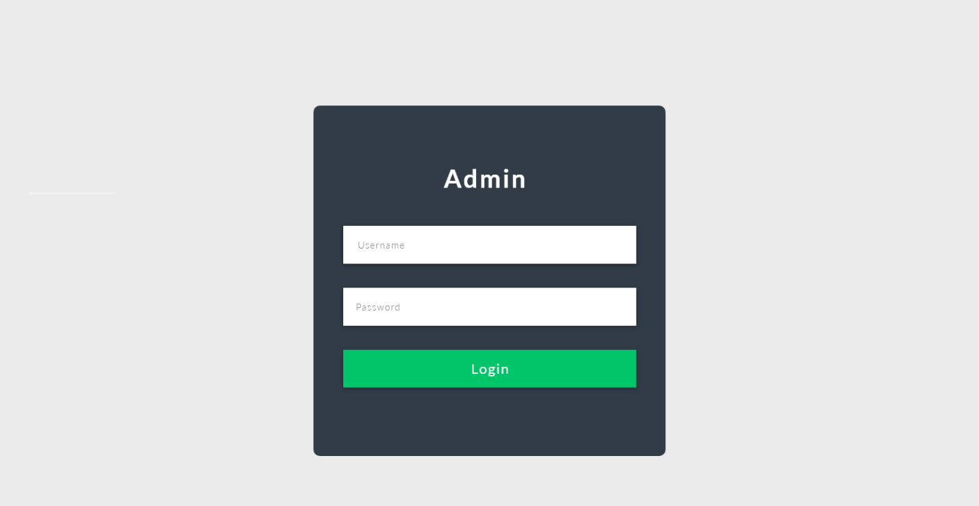

Figure 3.7.2.1. Desktop Log-In

Figure 3.7.2.1 shows the login page of the admin. The admin will input its username and password

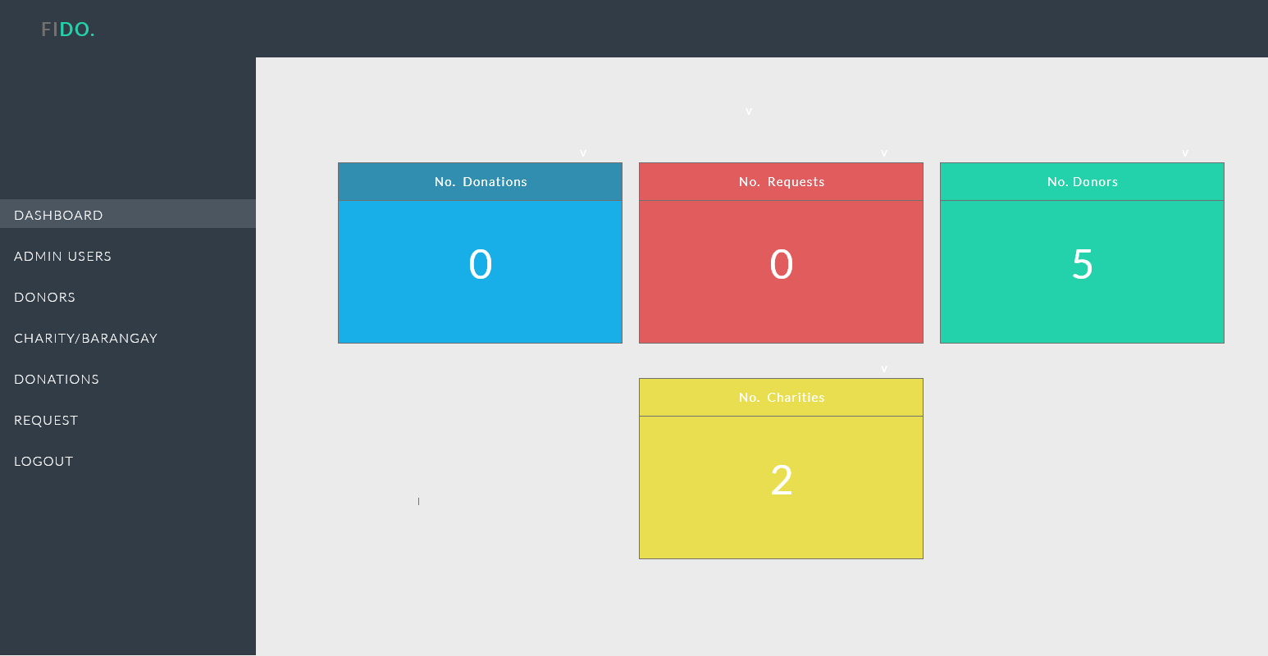

Figure 3.7.2.2 Donor Dashboard

Figure 3.7.2.2 shows the total donation,request,donors and organization

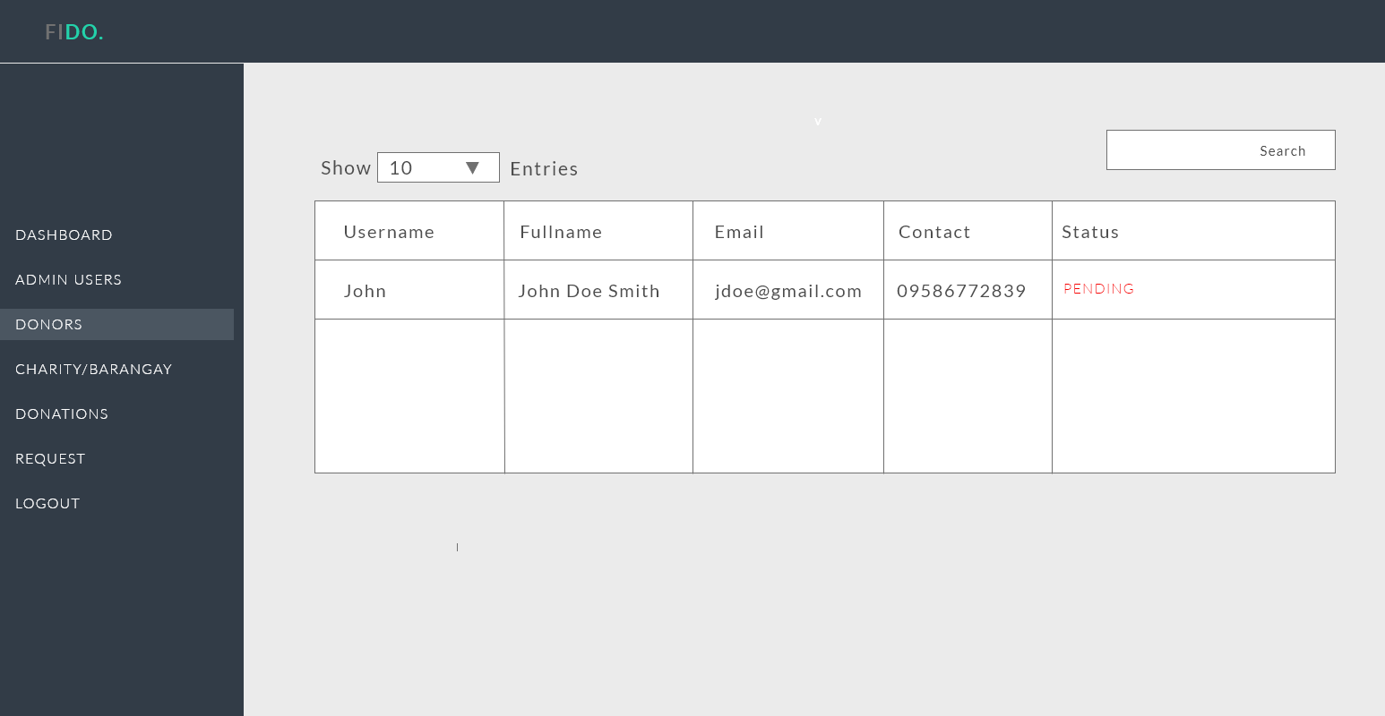

Figure 3.7.2.3 Donors Details

Figure 3.7.2.2 shows the total donation,request,donors and organization

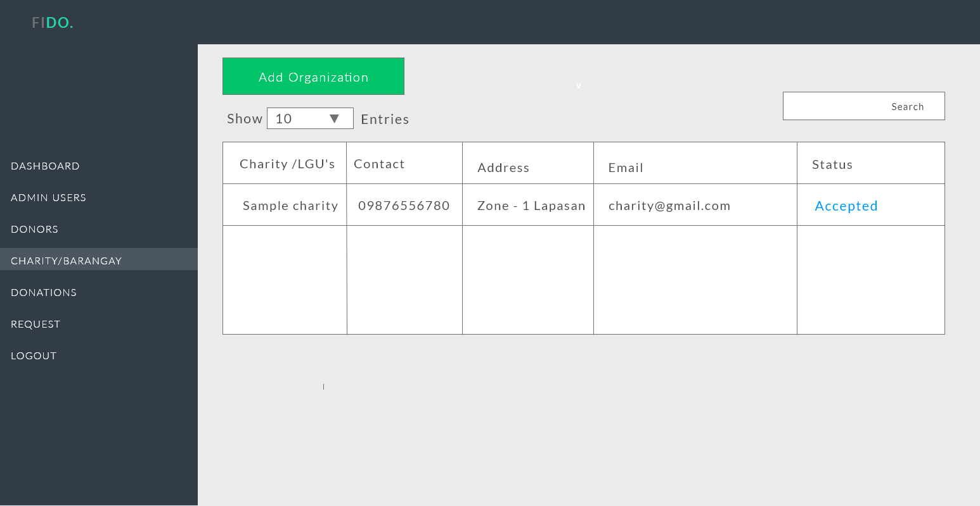

Figure 3.7.2.3 Organization(Charity or Barangay)

Figure 3.7.2.3 shows the list of organization details

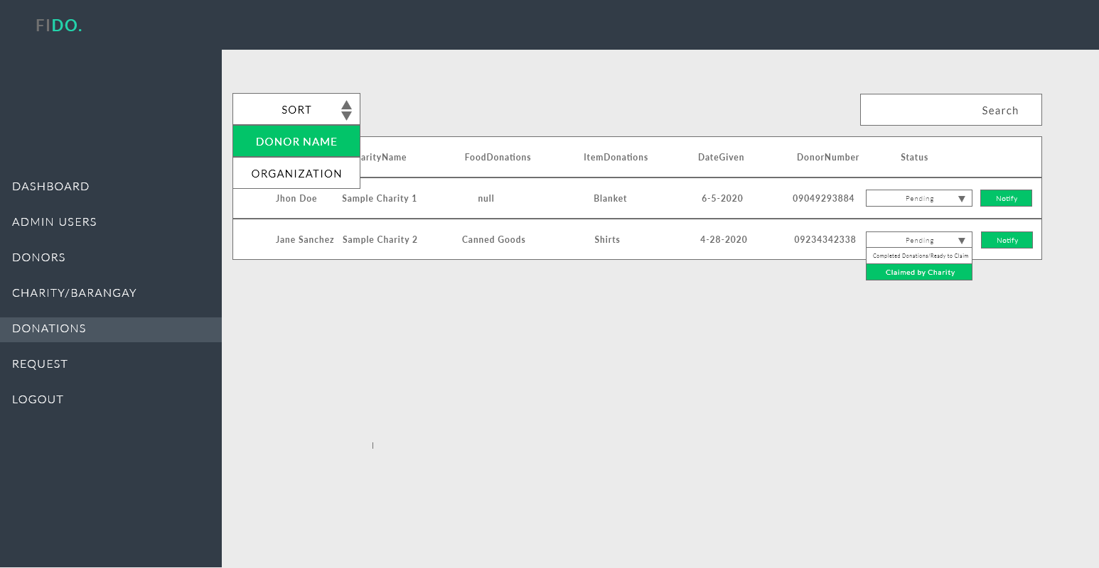

Figure 3.7.2.4 Request and Donation Inventory

Figure 3.7.2.4 show the donor donation and organization request. It also updates the donations status for the organization and donor

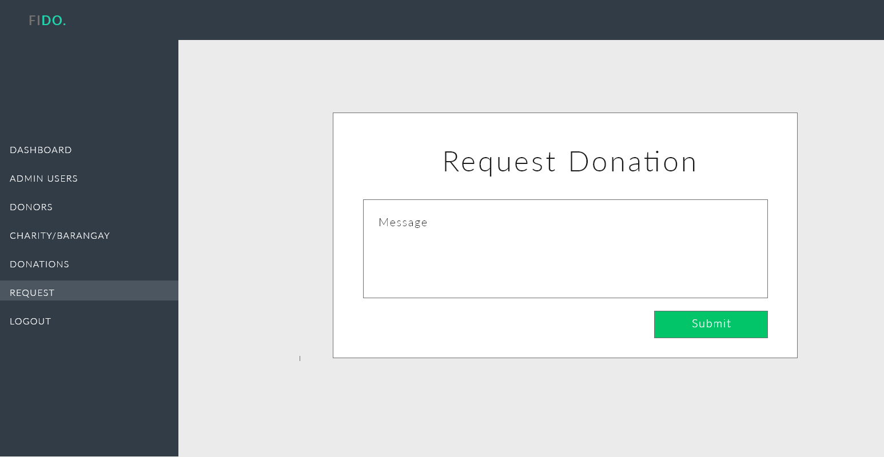

Figure 3.7.2.5 Admin donation request

Figure 3.7.2.5 shows where the admin can broadcast donation request to the donors

**3.9 Algorithms to be used**

**Naive String Algorithm** is an algorithm that checks matches for all string characters. The donor inputs its donation then matches the string to the requests inputted by the charity or barangay.

**First in First out Algorithm** will be used in the system, the first charity or barangay in the queue will be the first charity or barangay that firstly requests donations and will be pop out by the system when the donation is already completed. Priority queuing will also be used in the system when the request of the charity or barangay is marked as urgent.

**Usability Test**

Participant ID: Site: Date: / /

System Usability Test

Instructions: For each of the following statements, mark each box that best describes your reactions to our system.

**Strongly Disagree Strongly Agree**

|  |  |  |
| --- | --- | --- |
| 1 | I think that I would like to use this app. | ☐ ☐ ☐ ☐ ☐ |
| 2 | I found this app unnecessarily complex | ☐ ☐ ☐ ☐ ☐ |
| 3 | I would imagine that the prospective users of this app would learn to use this system very quickly. | ☐ ☐ ☐ ☐ ☐ |
| 4 | I found the various features of this app were well integrated. | ☐ ☐ ☐ ☐ ☐ |
| 5 | I felt very confident using the app | ☐ ☐ ☐ ☐ ☐ |
| 6 | I thought there was too much inconsistency in this app | ☐ ☐ ☐ ☐ ☐ |
| 7 | There was too much to learn before I could learn to use this app | ☐ ☐ ☐ ☐ ☐ |
| 8 | Security of my identity is well protected in this app | ☐ ☐ ☐ ☐ ☐ |
| 9 | I thought the app rightfully served its purpose | ☐ ☐ ☐ ☐ ☐ |

Please provide any comments about this system.

**Reference**

**https://library.ndsu.edu/ir/bitstream/handle/10365/28696/Charitable%20Donations.pdf?sequence=1&isAllowed=y**

**https://core.ac.uk/download/pdf/82657924.pdf**