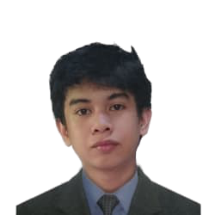

**Denzel Lanzaderas**

Web Developer

I am Denzel Lanzaderas a student of University of Science and

Technoglogy of Southern Philippines and a passionate

Web developer

# C:\Users\Kirby Cordero\Downloads\phone-call.png

**CAREER OBJECTIVE**

**CONTACT**

Secure a position in a creative and dynamic work environment where I can apply my skills in web development.

**BS in Information and Technology**

University of Science and Technology of Southern Philippines

2015 - 2021

**SKILLS**

**Language:**

HTML, CSS, SASS,

JavaScript, PHP,

Dart, Flutter, Java ,React Js

**Database:**

MYSQL

**Software Skills:**

Adobe Photoshop, Adobe XD, Filmora

Version Control

**Email:** denzellanzaderas@gmail.com

**Phone:** 09262133932

**Address:** Zone – 1 Bayabas

Bayabas Cagayan de Oro City

C:\Users\Kirby Cordero\Downloads\computer.png

**CERTIFICATE**

**Univesity of Minnesota**

*Introduction to UI Design*

*•* And online course designed to teach students to design

user Interface

**University of Michigan**

*Building Web Application in PHP*

**•**And online course in coursera designed to build web

applications and a tutorial on about PHP.

**University of Michigan**

*Building Databases Application in PHP*

* And online course in coursera designed to build web applications with the implementation of crud and mysql database.

Game

Movies

Music

Programming

**Passions**

**Project**

*Fido - Food and Item Donation Tracking System*

• Utilizes flutter to design and implement the project.

• Uses Html, Bootstap, Php,

MYSQL and Javascript

**EDUCATION**

**Freelancer**

*www.designcrowd.com*

* Design mock-up design for websites using Adobe Photoshop.
* Design images using photo manipulation.
* Edit videos and images.

**EXPERIENCE**