CIAF-LCM with Governance Gates:
Lifecycle Evidence and Runtime Enforcement for AI Systems
  - Revised draft positioned as the follow-on operating paper to the standalone CIAF-LCM process paper
Denzil Greenwood
Founder and Head Researcher, CognitiveInsight.ai
April 2026

Abstract
This paper presents CIAF-LCM with Governance Gates as the operating model that follows the standalone CIAF-LCM process paper. The earlier paper defines how governance policy is versioned, translated into machine-evaluable logic, and derived into runtime-capable gates. This paper focuses on what happens next: how lifecycle events are structured into receipts, how lightweight evidence capture is separated from fuller materialization, how gates evaluate consequential events, and how those outcomes become portable evidence. CIAF-LCM, or Lazy Capsule Materialization, addresses a practical tension in AI governance: strong accountability typically requires rich evidence, while production systems require low runtime burden. The proposed model resolves this tension by capturing lightweight evidence footprints continuously and materializing heavier evidence capsules only when triggered by a policy gate, an audit demand, a runtime escalation, an incident, or another inspection event. The paper defines the receipt model, explains the gate taxonomy, describes deny-by-default enforcement and denial receipts, and walks through an end-to-end lifecycle example from dataset registration through training, validation, deployment, runtime inference, and investigation. It positions CIAF-LCM with Governance Gates as the operational mechanics of AI Governance Evidence Infrastructure and argues that receipts plus gates provide a practical path from policy intent to proof-bearing control.

1. Introduction
This paper assumes that the CIAF-LCM process model has already been established. In that process model, governance policy is versioned, translated into machine-evaluable logic, derived into gates, and linked to receipts and vaulted evidence. The purpose of the present paper is narrower: it explains the operating mechanics of that model. Its subject is how lifecycle events become receipts, how those receipts remain lightweight by default, how fuller evidence is materialized only when needed, and how governance gates turn policy logic into explicit runtime control.
That distinction matters because the standalone CIAF-LCM paper and this paper should do different jobs. The standalone paper defines the policy-to-process sequence. This paper defines the event-to-receipt and gate-to-outcome mechanics. In other words, the earlier paper explains why governance policy becomes executable. This paper explains how executable governance generates portable, inspectable evidence in practice.
The design problem is straightforward but stubborn. Rich evidence capture can create cost, performance, privacy, and storage pressures, especially in systems with high interaction volumes or large numbers of intermediate artifacts. Yet weak capture leaves organizations with gaps that often become visible only during audit, incident review, or dispute handling. Existing standards and governance frameworks reinforce the need for lifecycle traceability and durable control evidence, but they do not prescribe a concrete operating model for how to achieve it. NIST’s AI RMF frames governance as a cross-cutting function across the AI lifecycle, while the EU AI Act places explicit emphasis on logging and record-keeping for high-risk systems. This paper proposes CIAF-LCM with Governance Gates as one implementable operating pattern for that expectation.
The central claim of this paper is that governance becomes operational when lifecycle events are treated as evidence-bearing events evaluated through explicit control points. In this view, datasets, training runs, evaluations, promotions, deployments, runtime decisions, tool invocations, escalations, denials, and incidents are not merely operational facts; they are structured candidates for receipt generation and gate evaluation. Gates convert policy requirements into state transitions, while lazy capsule materialization manages the cost of evidence collection by separating continuous lightweight capture from triggered heavier materialization.

Figure 1. Receipt anatomy and lifecycle placement.
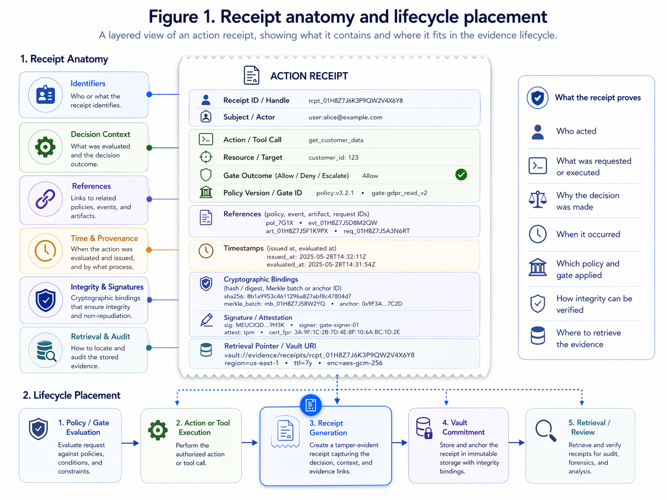
Figure 1. Receipt anatomy and lifecycle placement. A layered anatomy of a receipt showing identifiers, cryptographic bindings, references, timestamps, signatures, gate outcome, and retrieval pointers.

2. Design Goals
CIAF-LCM with Governance Gates is governed by five primary design constraints. First, the runtime burden must remain low enough that evidence capture does not become operationally prohibitive. Second, the resulting evidence must be independently verifiable rather than dependent on trust in the platform that generated it. Third, receipts must be portable so they can be exchanged across organizational, vendor, and audit boundaries. Fourth, the lifecycle model must remain model-agnostic so it can describe classical machine learning, deterministic decision systems, large language models, retrieval-augmented systems, and agentic workflows without collapsing into one vendor-specific event grammar. Fifth, the system must remain inspection-ready, meaning that evidence can be retrieved, reconstructed, and explained after the fact without relying on fragile narrative reconstruction.
These goals intentionally distinguish CIAF-LCM from ordinary telemetry collection. Observability stacks such as OpenTelemetry are optimized to generate, export, and collect traces, metrics, and logs so operators can understand system state and behavior. CIAF-LCM does not replace observability; it overlays governance semantics and evidence structure on top of lifecycle events that matter for accountability. Where observability seeks system understanding, CIAF-LCM seeks verifiable accountability.
The design also assumes that evidence is not binary. Some events justify only a lightweight footprint, while others justify richer materialization. The architecture does not optimize for maximal capture everywhere; it optimizes for accountable selectivity, where lightweight capture is continuous and heavier evidence is materialized only when justified by gates, inspection needs, incidents, disputes, or review triggers.

3. Lifecycle Events and Receipt Structure
A lifecycle receipt is the atomic accountability object in CIAF-LCM. It is not a screenshot, a dashboard row, or an unstructured log line. It is a structured record designed to stand on its own as an evidence-bearing object while also linking to prior and downstream events. At minimum, a receipt should include a globally unique receipt identifier, a receipt type, a canonicalization version, a timestamp and time source, references to the subject event, artifact, or decision, cryptographic hashes over the canonicalized evidence payload, signature metadata, a key identifier, and the policy or control context under which the receipt was created.
Required receipt elements should be small enough to capture continuously. These typically include the event class, subject references, principal or actor reference, model or system identifier, policy context identifier, minimal outcome fields, and cryptographic bindings. Optional receipt elements may include human-readable explanations, supporting artifacts, evaluation pointers, feature lineage pointers, prompt or retrieval hashes, environment details, approval chains, justification text, and retrieval links into the evidence vault. The distinction between required and optional fields is essential to the LCM pattern: all receipts must be verifiable, but not all receipts must be equally heavy.
The structure should also support linkage. A training receipt should reference the dataset receipt or dataset root used for training. A validation receipt should reference the specific training receipt and evaluation bundle. A deployment receipt should reference the validated model state and the promotion gate outcome. A runtime action receipt should reference the deployed state, the acting principal or agent, and the policy decision that allowed, denied, or escalated the action. In this way, receipts form a chain of evidence rather than a flat event ledger.
Table 1. Minimal receipt field model
Field | Status | Purpose | Example content
receipt_id | Required | Unique evidence object identifier | rcpt:deploy:2026-04-18:0012
receipt_type | Required | Event class for interpretation | deployment_receipt
canonicalization_version | Required | Normalizes payload before hashing | ciaf-c14n-1
subject_ref | Required | Artifact, decision, or action being evidenced | model:v4.3.2
actor_ref | Required | Human, service, or agent principal | agent-claims-001
policy_context | Required | Policy or control regime in force | approval-gate-v2
hash / signature | Required | Integrity and non-repudiation binding | sha256 + Ed25519
supporting_refs | Optional | Links to artifacts, approvals, evals, prompts | eval_bundle:2026q2-a

4. Lazy Capsule Materialization
Lazy Capsule Materialization is the rule that separates continuous capture from full evidence expansion. Under this approach, the system records small, durable footprints at event time and postpones expensive enrichment until a trigger justifies it. A footprint might include the event identifier, event type, actor reference, subject reference, timestamp, policy context, and cryptographic bindings. A fully materialized capsule may additionally include evaluation artifacts, approval records, environment attestations, feature lineage, prompts or context digests, attached explanations, related tickets, denial rationale, and retrieval pointers for supporting objects.
This separation matters for performance and storage. Runtime-heavy systems can generate millions of events whose accountability value is highly uneven. Capturing every associated artifact at full fidelity would quickly create cost and privacy burdens, and in some environments it could also increase operational risk by over-retaining sensitive inputs or outputs. By contrast, a lightweight footprint preserves the existence, integrity, ordering, and minimum interpretability of the event while leaving deeper materialization to moments when inspection value exceeds collection cost.
Materialization triggers should be explicit. Common triggers include entry to a governance gate, model promotion, approval or denial of a privileged action, policy conflict, threshold breach, human override, incident declaration, dispute initiation, regulator or auditor request, random control sampling, or export of an artifact into an external environment. The key architectural principle is that materialization is not arbitrary; it is control-linked. This gives the system a principled answer to why a heavy evidence object exists for one event but not another.
Figure 2. Lifecycle timeline with light capture and trigger points

Figure 2. Lifecycle timeline with light capture and trigger points. The figure should show progression from dataset registration through runtime action, highlighting which events create lightweight footprints and which ones trigger full materialization.

5. Governance Gates
Governance gates are the enforcement points that translate policy into lifecycle state transitions. They are not merely review checkpoints. In the broader CIAF-LCM process model, these gates are derived from machine-evaluation policy logic; they are not freestanding checkpoints. Operationally, a gate evaluates whether prerequisites have been satisfied and produces an explicit outcome: approve, deny, escalate, or inspect. In a deny-by-default architecture, the burden is on the system to prove that required conditions were met before a consequential event or action was allowed to proceed. The gate therefore functions as both a control mechanism and an evidence generator.
Several gate types are especially useful. A provenance gate checks whether a dataset, artifact, or external dependency satisfies source, lineage, or handling requirements. A validation gate checks whether evaluation prerequisites, thresholds, and review criteria have been met before a model can advance. An approval gate checks whether the required human or system authorization has been granted. A deployment gate checks whether the release artifact corresponds to the approved and validated state. A runtime gate mediates sensitive inferences, tool use, or agent actions. An incident gate governs transitions into containment, investigation, or remediation flows. Additional sector-specific gates can be layered on top of these core types.
Denial receipts are a core feature, not a side effect. When a gate blocks an action, the system should emit a signed denial receipt that records the attempted action, acting principal, evaluated rule or policy bundle, decision outcome, time, and denial reason. This matters because successful governance is often expressed in actions that did not occur. Without denial receipts, organizations can claim that a policy exists but have limited evidence that the policy actively constrained the system in practice.
Table 2. Gate taxonomy
Gate type | Purpose | Typical trigger | Control effect
Provenance | Verify source, lineage, and handling constraints | Dataset onboarding; import | allow / deny / inspect
Validation | Verify testing, thresholds, and review completeness | Model promotion request | approve / deny / escalate
Approval | Verify required authority and segregation of duties | Deployment or high-risk release | approve / deny
Runtime | Mediate sensitive decisions, tool use, and agent actions | Privileged action or policy-sensitive inference | allow / deny / escalate
Incident | Control containment and investigation state changes | Detected anomaly, complaint, or breach | inspect / contain / escalate
Figure 3. Gate-decision state machine

Figure 3. Gate-decision state machine. The figure should show approve, deny, escalate, and inspect paths, with each path emitting a corresponding receipt.

6. End-to-End Flow
Consider a high-stakes AI workflow in which a model is trained for claims triage and later used by a controlled agent to recommend or auto-execute downstream actions. The lifecycle begins with dataset registration. A dataset receipt is created containing the dataset identifier, source class, handling status, cryptographic root, and provenance gate outcome. The actual dataset contents need not be stored inside the receipt; the receipt binds the dataset state and relevant policy context.
A training run then produces a training receipt. The receipt references the dataset root, code version, environment digest, training parameters, and output model identifier. If the training run is ordinary and internal, the receipt may remain relatively light. If the run is selected for review or promotion, the system materializes a fuller capsule that includes environment attestation, reproducibility metadata, and supporting artifacts. A validation receipt follows, linking the candidate model to the evaluation bundle, thresholds, review outcomes, and validation gate result. Only after the validation and approval gates succeed can a deployment receipt be issued, binding the deployed artifact to the validated state and the approving authority.
At runtime, an inference receipt references the deployed model state and records the governance-relevant context of the interaction. If the system is agentic, a pre-action runtime gate evaluates whether the requested tool use or transaction is within authority. If the action is permitted, an action receipt records the decision path; if it is denied, a denial receipt is emitted instead. Later, if a complaint or anomaly triggers an investigation, the incident process materializes a linked bundle from prior receipts and supporting artifacts. The investigator is not forced to reconstruct the lifecycle from scratch because the evidence chain already exists.

7. Operational Tradeoffs
The LCM model improves accountability efficiency, but it does not eliminate tradeoffs. Performance costs remain, especially when gate evaluation requires complex policy checks or when materialization pulls large supporting artifacts into scope. Storage costs are lower than in always-capture systems, yet they are still meaningful because evidence must remain durable and queryable. Privacy constraints may also limit which prompts, inputs, outputs, or feature details can be retained directly. In many cases, hashes, references, and selective redaction will be preferable to wholesale payload retention.
Human workflow implications are equally important. Gates are powerful, but if they are designed poorly they can create friction, override fatigue, or a false sense of completeness. Governance design therefore needs calibration: not every event should face the same gate burden, and not every gate should require direct human intervention. Escalation logic, sampling strategies, and clearly defined control ownership help preserve operational usability.
Interoperability is another tradeoff. The value of a receipt architecture increases when receipts can move across tools, teams, and trust boundaries. However, portability is difficult when schemas are tightly coupled to a single platform or sector. CIAF-LCM therefore benefits from a thin required core, layered extensions, and stable canonicalization rules. This is also where the evidence vault becomes crucial: the vault paper addresses custody, verification, and export mechanics in more depth.

8. Limitations and Future Work
This paper does not propose a universal industry standard for lifecycle receipts, nor does it claim that one receipt schema will fit every regulated context. Sector-specific extensions will almost certainly be required for domains such as credit, healthcare, defense, or public-sector decision systems. The paper also does not resolve all questions around confidential computing, privacy-preserving evidence, selective disclosure, or zero-knowledge proof patterns for AI governance.
Another open issue is proof gradation. Receipts can differ in evidentiary strength depending on the quality of key management, the trust assumptions of the signing system, the durability of storage, and the completeness of linked artifacts. Future work should define assurance profiles so that consumers of the evidence can understand not just that a receipt exists, but what level of trust it meaningfully supports.
Finally, CIAF-LCM should be tested against real operational baselines. Comparative work is needed across full-capture logging, lightweight receipt capture, and LCM-triggered materialization, including throughput, storage growth, retrieval time, privacy exposure, and audit usefulness. Those comparisons will make the runtime and storage benefit of the approach empirically clearer.

9. Conclusion
CIAF-LCM with Governance Gates is the operational mechanism that follows the standalone CIAF-LCM process model inside the broader category of AI Governance Evidence Infrastructure. Its premise is that governance becomes credible when lifecycle events and runtime actions are expressed as evidence-bearing state transitions rather than treated as documentation afterthoughts. Receipts provide the atomic units of accountability; lazy capsule materialization makes their collection operationally feasible; and governance gates make policy enforceable through explicit allow, deny, escalate, and inspect outcomes.
Taken together, these elements provide a model-agnostic approach to lifecycle accountability for high-stakes AI. The standalone CIAF-LCM paper defines why policy becomes executable governance. This paper explains how lifecycle evidence can be captured and enforced in practice. The next paper, focused on the evidence vault, completes the picture by specifying how these receipts and capsules are sealed, stored, linked, exported, and independently verified over time.

References
[1] NIST, “Artificial Intelligence Risk Management Framework (AI RMF 1.0),” 2023.
[2] EU AI Act Service Desk, “Article 12: Record-keeping,” describing logging and traceability obligations for high-risk AI systems.
[3] OpenTelemetry Documentation, “What is OpenTelemetry?” and related logs and traces documentation.

AI uses disclosure
This document, “CIAF-LCM with Governance Gates: Lifecycle Evidence and Runtime Enforcement for AI Systems,” was prepared for concept development and publication planning in April 2026. It was authored by Denzil Greenwood, Founder and Head Researcher at CognitiveInsight.ai.
AI tools were used to assist with drafting and with the creation of supporting figure concepts, with human review and editorial control applied to both.

Research papers and continued work
1. Cognitive Insight Audit Framework Lazy Capsule Materialization (CIAF-LCM)
2. CIAF-LCM with Governance Gates: Lifecycle Evidence and Runtime Enforcement for AI Systems
3. A Tamper-Evident Evidence Vault for AI Lifecycle Events, Decisions, and Audit Packs
4. Dual-Layer Provenance for AI-Generated Artifacts: Explicit Watermarks and Forensic Fingerprints
5. Governance Planes for Agentic AI: Identity, Policy, Privilege, Execution, and Evidence
6. Shadow AI Governance: Bringing Unmanaged AI Use into the Evidence Perimeter
7. CIAF-LCM Proposed Schema Documentation

