**THEORY:**

**Microcontroller AT89S52:**

8051 is the name of a big family of microcontrollers. 'AT89S52' is a typical 8051 microcontroller

The major heart of this project is AT89S52 microcontroller. The AT89S52 provides the following standard features: 8 kilo bytes of Flash, 256 bytes of RAM, 32 I/O lines, Watchdog timer, two data pointers, three 16-bit timer/counters, a six-vector two-level interrupt architecture, a full duplex serial port, on-chip oscillator, and clock circuitry. In addition, the AT89S52 is designed with static logic for operation down to zero frequency and supports two software selectable power saving modes. The Idle Mode stops the CPU while allowing the RAM, timer/counters, serial port, and interrupt system to continue functioning. The Power-down mode saves the RAM contents but freezes the oscillator, disabling all other chip functions until the next interrupt or hardware reset.

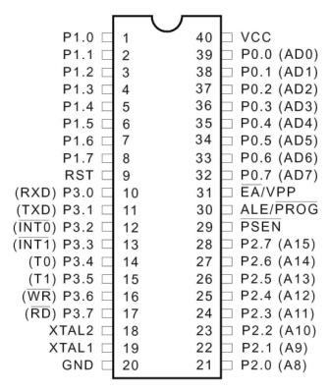

**CRYSTAL OSCILLATOR:**

Crystal oscillator is used to generate clock pulses, and clock pulse is used to provide the mean for timing calculation, which is mandatory to synchronise all the events. These type of crystals used in almost every modern digital equipment like in computers, watches etc. Most commonly used Crystal is **quartz.**It's a resonant oscillator circuit and capacitors are used to oscillate the crystal, so we have connected here 22pf capacitors.

**16X2 char LCD:**

16x2 LCD is one of the most used display unit. 16x2 LCD means that there are two rows in which 16 characters can be displayed per line, and each character takes 5X7 matrix space on LCD.  LCD pins are of five categories, power pins, contrast pin, control pins, data pins and backlight pins

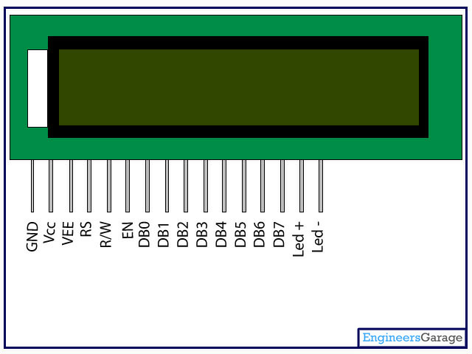

|  |  |  |  |
| --- | --- | --- | --- |
| **Category** | **Pin NO.** | **Pin Name** | **Function** |
| Power Pins | 1 | VSS | Ground Pin, connected to Ground |
| 2 | VDD or Vcc | Voltage Pin +5V |
| Contrast Pin | 3 | V0 or VEE | Contrast Setting, connected to Vcc thorough a variable resistor. |
| Control Pins | 4 | RS | Register Select Pin, RS=0 Command mode,  RS=1 Data mode |
| 5 | RW | Read/ Write pin, RW=0 Write mode,  RW=1 Read mode |
| 6 | E | Enable, a high to low pulse need to enable the LCD |
| Data Pins | 7-14 | D0-D7 | Data Pins, Stores the Data to be displayed on LCD or the command instructions |
| Backlight Pins | 15 | LED+ or A | To power the Backlight +5V |
| 16 | LED- or K | Backlight Ground |

**RS:** RS is the register select pin. We need to set it to 1, if we are sending some data to be displayed on LCD. And we will set it to 0 if we are sending some command instruction like clear the screen (hex code 01).

**RW:** This is Read/write pin, we will set it to 0, if we are going to write some data on LCD. And set it to 1, if we are reading from LCD module. Generally this is set to 0, because we do not have need to read data from LCD. Only one instruction “Get LCD status”, need to be read some times.

**E:** This pin is used to enable the module when a high to low pulse is given to it. A pulse of 450 ns should be given. That transition from HIGH to LOW makes the module ENABLE.

**Preset commands of LCD:**

|  |  |
| --- | --- |
| **Hex Code** | **Command to LCD Instruction Register** |
| 0F | LCD ON, cursor ON |
| 01 | Clear display screen |
| 02 | Return home |
| 04 | Decrement cursor (shift cursor to left) |
| 06 | Increment cursor (shift cursor to right) |
| 05 | Shift display right |
| 07 | Shift display left |
| 0E | Display ON, cursor blinking |
| 80 | Force cursor to beginning of first line |
| C0 | Force cursor to beginning of second line |
| 38 | 2 lines and 5×7 matrix |
| 83 | Cursor line 1 position 3 |
| 3C | Activate second line |
| 08 | Display OFF, cursor OFF |
| C1 | Jump to second line, position 1 |
| OC | Display ON, cursor OFF |
| C1 | Jump to second line, position 1 |
| C2 | Jump to second line, position 2 |

**RFID READER & TAGS:**

RFID stands for Radio Frequency Identification. RFID is a technology that serves to detect and identify an object through the data transmitted via radio frequency. The system requires a minimum of a tag (which serves as a transponder), a reader (who serves as interrogator)

An RFID module basically comprise of two parts, namely, a tag (RFID card) and a reader. However a typical RFID system consists of an antenna, a transceiver and a transponder(RF tag). The radio frequency is read by the transceiver and the information is transferred to a device for further processing. The information (the unique serial number) to be transmitted is stored in the RF tag or transponder.

The transponder contains a chip and an antenna mounted on a substrate. The chip transmits the relevant information through antenna. The antenna also receives the electromagnetic waves sent by the RFID reader.

Different RFID tags work on different frequencies. Here low frequency, 125 kHz, RFID tags have been used. These tags work within a range of 5-8cm which is sufficient for this  project. When an RFID tag comes in this range, the reader detects it and sends a unique code of the tag serially over the Tx line. This serial code, consisting of 12 bytes, is received by the UART module of the microcontroller.

A serial level converter is required for AT89S52 to receive these serial signals. IC MAX232 can be used for this purpose to interface the RFID reader with microcontroller. The LCD is initialized to display the code. When a card/tag comes in the proximity of RFID reader, the microcontroller reads the code and sends it to the LCD module. The RFID tag used over here is passive.

**Passive RFID** tags do not possess their own power supply, the small electrical current induced in the antenna by incoming radio frequency scan provides enough power for the tag to send the response. Because of the power and cost concerns, the response of passive RFID tag is necessarily brief, its just an ID number.

**Active RFID** tags must have a power source and may have longer ranges and larger memories than passive tags as well as the ability to store the additional information sent by the transceiver. The technological difference between the tag types does not affect their abilities to collect travel data.

**MAX-232:**

The MAX-232 IC is an [integrated circuit](http://www.edgefxkits.com/blog/relay-driver-circuit-using-uln2003-ic/) which consists of 16 pins and it is a resourceful IC mostly used in the voltage level signal problems. Generally, the MAX-232 IC is used in the RS232 communication system for the conversion of voltage levels on TTL devices that are interfaced with the PC serial port and the Microcontroller. This IC is used as a hardware layer converter like to communicate two systems simultaneously. MAX232 can convert the signals like RX, TX, CTS, and RTS and it is a dual driver/receiver.

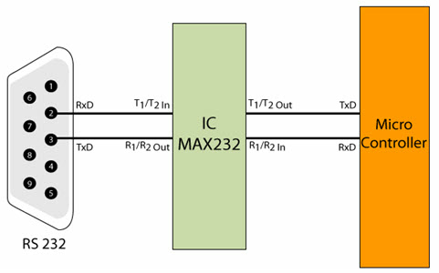

**GEAR MOTOR:**

A gear motor is a device which allows low-[horsepower](http://www.wisegeek.com/what-is-horsepower.htm) motors to drive a great deal of force on an object with low speed. It consists of a [reduction gear](http://www.wisegeek.com/what-is-a-reduction-gear.htm) train and an electric motor, which both come fully integrated into an easily mountable and configurable system. The benefit of using gear motors is that they simplify the design and manufacturing of power tools and machines which require high torque, or moment of force, at low shaft speeds or at low revolutions per minute speeds.

A small minority of gear motors are direct current (DC) powered. DC-powered motors are primarily employed in the automotive industry as important components of car construction, including windshield wiper motors, power winches on trucks, and power seat or [power window](http://www.wisegeek.com/what-is-a-power-window.htm) motors.

**L293D:**

[L293D](http://www.engineersgarage.com/electronic-components/l293d-motor-driver-ic) is a motor driver. As its name suggests it can drive a motor (normally DC motors & gear motors up-to certain range). Since the output voltage of 8051 is limited to 5V only thus motors with higher required voltage need some drivers to provide them their desired input voltage.

What L293D does is, it takes the TTL (0/5v) input from the output pins of [8051 microcontroller](http://www.engineersgarage.com/8051-microcontroller) and forwards the output through itself of higher voltage(required by gear motors).

Connecting a gear motor directly to the pins of 8051 would not work. It may even damage the microcontroller.

L293D is a 16-pin IC which can control a set of two DC motors simultaneously in any direction. It means that you can control two DC motor with a single L293D IC.

The L293D can drive small and quiet big motors as well.

It works on the concept of H-bridge. H-bridge is a circuit which allows the voltage to be flown in either direction. As you know voltage need to change its direction for being able to rotate the motor in clockwise or anticlockwise direction, Hence H-bridge IC are ideal for driving a DC motor.

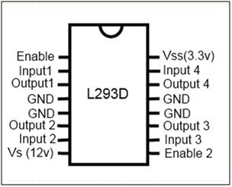

There are two Enable pins on L293D. Pin 1 and pin 9, for being able to drive the motor, the pin 1 and 9 need to be high. For driving the motor with left H-bridge you need to enable pin 1 to high. And for right H-Bridge you need to make the pin 9 to high. If anyone of the either pin1 or pin9 goes low then the motor in the corresponding section will suspend working. It’s like a switch.

There are 4 input pins for this L293D, pin 2, 7 on the left and pin 15 ,10 on the right. Left input pins will regulate the rotation of motor connected across left side and right input for motor on the right hand side. The motors are rotated on the basis of the inputs provided across the input pins as LOGIC 0 or LOGIC 1.

In simple you need to provide Logic 0 or 1 across the input pins for rotating the motor.

Let’s consider a Motor connected on left side output pins (pin 3,6). For rotating the motor in clockwise direction the input pins has to be provided with Logic 1 and Logic 0.

• Pin 2 = Logic 1 and Pin 7 = Logic 0 | Clockwise Direction  
• Pin 2 = Logic 0 and Pin 7 = Logic 1 | Anticlockwise Direction  
• Pin 2 = Logic 0 and Pin 7 = Logic 0 | Idle [No rotation] [Hi-Impedance state]  
• Pin 2 = Logic 1 and Pin 7 = Logic 1 | Idle [No rotation]

In a very similar way the motor can also operated across input pin 15,10 for motor on the right hand side.

VCC is the voltage that it needs for its own internal operation 5V; L293D will not use this voltage for driving the motor. For driving the motor it has a separate provision to provide motor supply VSS.  L293d will use this to drive the motor. It means if you want to operate a motor at 9V then you need to provide a Supply of 9V across VSS Motor supply.

The maximum voltage for VSS motor supply is 36V. It can supply a max current of 600mA per channel. Since it can drive motors Up to 36V hence you can drive pretty big motors with this L293D.

 VCC pin 16 is the voltage (in this case 5V) for its own internal Operation. The maximum voltage ranges from 5V and upto 36V.

**WORKING:**

The main objective of this project is collecting toll and reduce traffic and improve service. The RFID card will be given to the user which contains the digital code, which have the corresponding details stored in the centralized database system which can be accessed in the relevant office as and when required. The microcontroller reads the RFID card number from the RFID reader. It sends this data to the LCD so that the person operating this product reads the balance of the card. Microcontroller sends the data to the motor depending upon the RFID card number. When vehicle owner keeps his tag before reader it immediately works on the tag information and content of data and everything is displayed. Tags having correct information can pay money and gate works, opens or closes with in time. Tags with any defaults or insufficient balance are invalid and gate doesn’t open.

Whenever any person buys a vehicle, first he/she need to get his/her vehicle registered at the RTO office. RTO people will assign a number plate to it along with it they will give a RFID enabled tag. This card will have a unique ID feasible to use with that vehicle only. They will also create an account for that particular smart card and maintain transaction history in database. Owner of the vehicle needs to deposit some minimum amount to this account.

Every time a registered vehicle approaches the toll booth, the RFID circuit will read the RFID enable smart card fixed on the windscreen of the vehicle. Transaction will begin, depending upon the balance available toll will be deducted directly or the vehicle will be directed towards another lane to pay tax manually. The software further updates the details in the Centralized database server.

On the other hand, whenever any vehicle owner registers a complaint at the RTO office regarding theft of the vehicle respective entry is made in the database. Now any vehicle arriving at toll booth with same ID as already present in stolen vehicle category will be easily identified as the ID assigned with it is unique.

All the toll plazas will be connected to each other along with the centralized server in the form of LAN. Updates of any sort of transaction will be immediately updated to local database and centralized server.

• **RFID card:** This is one of the most important part of the project. RFID cards are used for applications as access control in security system, cashless payment etc.

• **RFID reader:** A RFID reader is a device which is used to interrogate an RFID tag. It reads the unique number from the RFID cards and sends it to the microcontroller.

• **Microcontroller:** The AT89S52 is a low-power, high-performance CMOS 8-bit microcontroller with 4K bytes of In System Programmable Flash memory. The device is manufactured using Atmel’s high-density non-volatile memory technology and is compatible with the industry- standard 80C51 instruction set and pin out. Microcontroller is the heart of the complete system. It is actually responsible for all the process being executed. It will monitor & control all the peripheral devices or components connected in the system. In short we can say that the complete intelligence of the project resides in the software code embedded in the Microcontroller. The controller here user will be of 8051 family. This unit requires +5VDC for it proper operation. Microcontroller is the CPU of our project.

The various functions of microcontroller are:

* Reading the RFID card number from the RFID reader.

* Sending this data to the LCD so that the person operating this project should read various informative messages.

* Sending the data to the motor or buzzer depending upon the RFID card number and balance inside the car.

• **LCD:** It is called Liquid Crystal Display. We are going to use 16x2 character LCD. This will be connected to microcontroller. The job of LCD will be to display all the system generated messages coming from the controller. LCD will provide interactive user interface. This unit requires +5VDC for it proper operation. This module is used for display the present status of the system.

• **Power Supply:** This unit will supply the various voltage requirements of each unit.

• **Motor driver:** Motor driver is an IC which is used to drive the motor.

• **DC Motor:** Motor is used to open the gate.

**ADVANTAGES:**

**\***Automatic collection of toll tax.

* Free flow of traffic.

* Time saving.

* Record maintenance.

* Problems with pursuing toll evaders**.**