Sentiment and Fake Review Detection of Filipino-English Customer Feedback Using DistilBERT
Rette Ranzel Shayne D. Romero
Computer Studies & Engineering
José Rizal University
Mandaluyong City, Philippines
retteranzelshayne.romero@my.jru.edu

Veronica T. Dumaguing
Computer Studies & Engineering
José Rizal University
Mandaluyong City, Philippines
veronica.dumaguing@my.jru.edu
Denzel Oliver C. Garcia
Computer Studies & Engineering
José Rizal University
Mandaluyong City, Philippines
denzeloliver.garcia@my.jru.edu

Abstract—This paper proposes a multilingual sentiment analysis system that leverages DistilBERT to classify Filipino-English customer feedback from the Trustpilot Reviews Philippines dataset into positive, neutral, or negative sentiments. The project addresses the challenges of code-switching, informal language, and class imbalance in local online reviews, aiming to enhance the interpretability and accuracy of sentiment classification in a culturally nuanced context. The methodology involves preprocessing text data, fine-tuning transformer-based models, and evaluating them through performance metrics such as accuracy, precision, recall, and F1-score. By comparing DistilBERT’s performance with baseline models such as TF-IDF with Logistic Regression, the study demonstrates the superiority of transformer-based architectures in handling multilingual data. The results are expected to empower Philippine businesses by providing actionable insights to improve service quality, customer experience, and decision-making, while contributing to the United Nations Sustainable Development Goals on innovation, economic growth, and reduced inequalities.
Keywords— Sentiment Analysis, DistilBERT, Filipino-English Reviews, Natural Language Processing, Multilingual Text, Transformer Models, Trustpilot, Machine Learning, Text Classification, Sustainable Development Goals

Introduction
Online Reviews have become invaluable information resources, directly affect the consumer purchasing decision, and they too serve a significant role in business reputation management, particularly in the e-commerce and service industries. Social media such as Trustpilot provide a lot of reviews that can be used effectively in knowing what people have to say about products and services. The use of online platforms has been increasing in the Philippines, leading to an increase in the necessity to analyze customer reviews. This assists businesses to gauge satisfaction, identify ways of improvement, and create trust in the local market.
The study supports the United Nations Sustainable Development Goal 8.3: Promote productive activities, fair competition, and innovation. The study can help in making sure that digital marketplaces are trustworthy and transparent by developing a NLP model that would identify bot-generated reviews and use sentiment analysis. This helps to promote competition and data-driven business improvements in the Philippines.
Sentiment analysis, a subset of Natural Language Processing (NLP), seeks to determine the emotional tone of text automatically. Conventional approaches, such as simple machine learning models, can struggle to handle the contextual aspect of human language particularly in a multilingual and multi-cultural context.
BERT, a Google creation, is based on a transformer architecture which learns in both directions of contextual text representations. This enables them to understand the meaning of words in the context of their environment. This has significantly enhanced the sentiment classification making it even better than the older models in several aspects, especially e-commerce, social media, and customer service.
This study uses the dataset provided by Kaggle and has a large sample of customer reviews of businesses within the Philippines which are spread across various industries. With the help of a BERT-based sentiment analysis model, the project intends to categorize the reviews as positive, negative, or neutral and detect the presence of bot-generated content.
Issues that were addressed during the study include class imbalance, the informal language, and cultural undertones in local reviews. The projected result is a working tool that assists enterprises to obtain dependable information through actual customer responses. This will eventually enhance services, customer confidence and promote equitable and effective digital market places.

Problem Statement
The huge amount of customer reviews that online platforms have also contains the ones that are either written by bots or generated for dishonest purposes. Such unreliable reviews affect consumer trust, cause unfair competition, and make it more difficult for businesses in the Philippines to manage their reputation. The process of eliminating the fake reviews is a highly involved task, especially in the context of mixed Filipino-English language, code-switching, and informal terms.
The linguistic complexity is such that existing sentiment analysis and review classification methods cannot easily deal with it. Lexicon-based and machine learning methods are some of the traditional approaches that often cannot tell the difference between real and fake reviews and, in addition, they do not consistently catch the nuances in local online conversations.
This means that businesses cannot confidently rely on customer feedback as a basis for making data-driven decisions. The solution to this issue lies in the development of tools that can automate the detection of fake reviews as well as the provision of reliable sentiment analysis across different languages. An improvement in these aspects will be an aid for organizations in getting customer feedback that is not influenced by trust issues, supporting fair competition, and ensuring the reputation in online settings.

Objectives
The general objective of this study is to develop an NLP-based system using BERT that can accurately classify customer reviews from the Trustpilot Reviews Philippines dataset into positive, negative, or neutral sentiments, and detect fake reviews. The project aims to advance the application of NLP in understanding Filipino consumer opinions, ensure the authenticity of online feedback, and provide insights that help businesses improve customer satisfaction and service quality.
Specifically, the study aims to:
- Examine the linguistic and sentiment patterns present in the Trustpilot Reviews Philippines dataset to understand how Filipino consumers express feedback online.
- Design a structured sentiment analysis framework outlining the data flow, preprocessing steps, and classification approach suitable for Filipino online reviews.
- Implement and fine-tune a transformer-based NLP model using BERT to perform accurate sentiment classification.
- Evaluate the performance of the model using established NLP evaluation metrics such as accuracy, precision, recall, and F1-score.
- Generate the results from both sentiment analysis and fake review detection to provide actionable insights for businesses, enabling them to better understand customer feedback, identify and address deceptive reviews, and implement data-driven improvements to their products and services.

methodology
This section outlines the systematic approach that will be followed to develop the BERT-based sentiment analysis system for Trustpilot Philippines reviews. The methodology is structured into four main phases: data collection, data preprocessing, model selection, and training with fine-tuning. Each phase addresses specific challenges related to analyzing Filipino customer reviews, particularly the handling of multilingual text and contextual sentiment understanding. The workflow ensures that the final model will be robust, accurate, and capable of providing meaningful insights from customer feedback.

A. Environmental Setup
All experiments were conducted in a Python Jupyter notebook environment utilizing both CPU and GPU (T4) compute resources. Key libraries included HuggingFace Transformers for model and tokenization, Scikit-learn for metrics and preprocessing, Pandas for data manipulation, NLTK for stopwords, and Matplotlib/Seaborn for visualization. Automated scripts ensured all necessary packages were installed and updated, with fallback procedures for missing dependencies and external datasets.
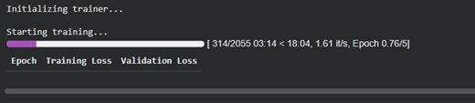 Figure 1.1 CPU Running Time
The running time for your model training on GPU is captured in the provided screenshot, showing the system processed 314 out of 2055 training steps in 18 minutes and 4 seconds, at a rate of approximately 1.61 iterations per second, during epoch 0.76 out of 5. This illustrates the efficiency and speed advantages of using GPU for deep learning tasks, particularly when handling large datasets and complex transformer architectures like BERT
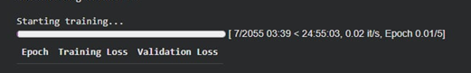 Figure 1.2 GPU Running Time
During the experiment, the model was first trained using only the computer’s CPU. The training process showed an extremely slow throughput: after 3 minutes and 39 seconds of training, only 7 out of 2,055 total steps had been completed. At this rate of about 0.02 iterations per second, the estimated time to complete a single training epoch was projected to be 24 hours, 55 minutes, and 3 seconds. Training deep learning models like BERT on a CPU is practically not feasible for large datasets due to such prohibitive running times, especially when the model requires several epochs to achieve good performance.
B. Data Collection

The dataset for this project will be obtained from Kaggle's "Trustpilot Reviews Philippines" repository curated by Cheselle Jan Roldan. This dataset contains customer reviews of different businesses in the Philippines posted on Trustpilot, a well-known online review platform. The reviews cover various sectors such as e-commerce, financial services, hospitality, and retail, providing diverse customer sentiments across industries. Each review includes customer feedback text and star ratings, which will serve as sentiment labels for model training.


Figure 1.3 Data Source

C. Data Exploration

Data exploration was conducted to gain an understanding of the distribution, characteristics, and patterns within the Trustpilot Reviews Philippines dataset. This stage involved generating summary statistics and visualizations to assess the volume and balance of sentiment classes (positive, negative, neutral) and identify potential class imbalances. Preliminary text analysis included evaluating the frequency of common words, detecting missing or duplicated data, and examining review lengths and metadata such as ratings.

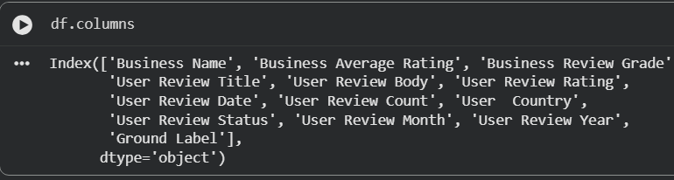
Figure 1.4 Dataset Columns
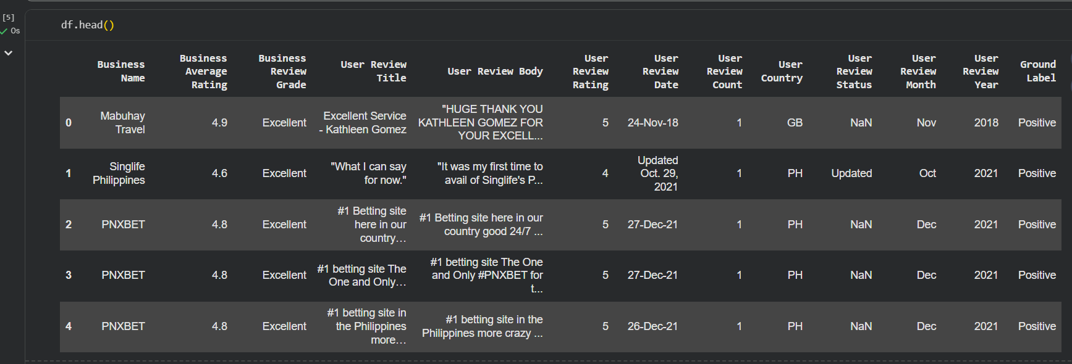
Figure 1.5 Dataset First 5 rows
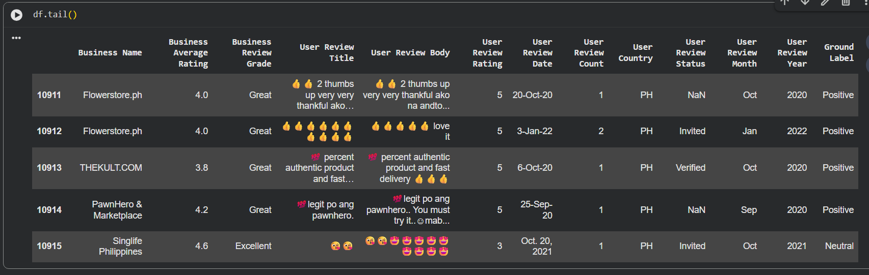
Figure 1.6 Dataset Last 5 rows

D. Data Preprocessing
The preprocessing steps will prepare the raw review data for analysis using BERT. The following procedures will be applied:
Handling Missing Data and Duplicates: Handling missing values is a critical step in the preprocessing pipeline to ensure the integrity and quality of data feeding into the sentiment analysis and fake review detection models. During data preparation, reviews with missing or empty essential fields such as the review text or ground truth labels are systematically identified and removed from the dataset.
This approach prevents incomplete samples from introducing bias or noise, which could negatively affect model performance and reliability. By enforcing data completeness prior to model training, the workflow ensures that each input instance contains all required information for meaningful tokenization, embedding, and prediction. This not only enhances the overall robustness and reproducibility of the machine learning pipeline, but also contributes to more accurate and interpretable sentiment and authenticity classification outcomes
Text Cleaning: This step involves removing HTML tags, URLs, and special characters that do not contribute to sentiment understanding. Excessive whitespace and formatting issues will be eliminated. Emoticons and emojis will be handled based on their sentiment relevance, either removed or converted to textual representations, depending on whether they add meaningful sentiment information.

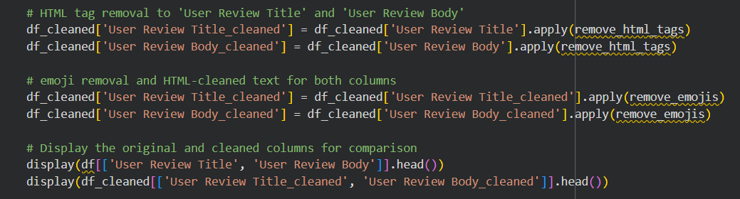
Figure 2.0 Removal of Emoticons and HTML tags
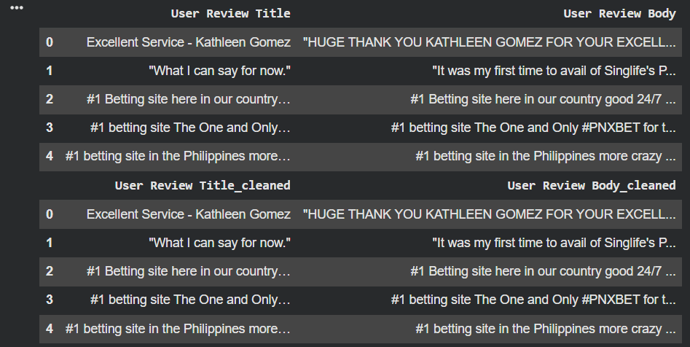
Figure 2.1 Removal of emoticons and HTML Tags

Label Standardization: To ensure consistency and reliability in both sentiment classification and fake review detection, all categorical labels in the dataset were systematically standardized prior to model training. Sentiment annotations such as “Positive,” “Negative,” and “Neutral” were mapped to numeric codes, enabling seamless integration with supervised learning algorithms and reducing ambiguity during preprocessing.
For the fake review detection task, heuristic approaches were applied to assign binary labels “real” or “fake”based on quantifiable text characteristics such as review length, user history, presence of promotional language, and duplicate detection.

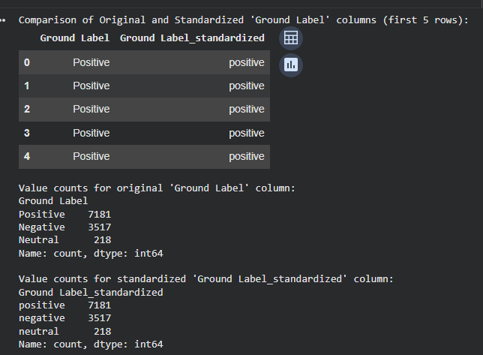
Figure 2.2 Label Standardization Display

The standardized sentiment labels serve as the ground truth targets during model training. By converting raw categorical annotations such as "Positive," and "Negative" into uniform numeric codes, the data pipeline streamlines the classification process and enables the model to associate numeric input features with their corresponding output classes. This standardized labeling is integrated into the model’s training loop, where for each review the model predicts a sentiment score, which is then compared to the numeric label for loss calculation and backpropagation. This systematic approach improves computational efficiency, facilitates reproducibility, and ensures that the entire sentiment analysis workflow can be automated and consistently evaluated across various experiments and model architectures.

Tokenization: The bert-base-multilingual-cased tokenizer will be applied to convert text into subword tokens through WordPiece tokenization. This method effectively handles misspelled or informal words commonly found in Filipino reviews by breaking them into smaller, recognizable units.

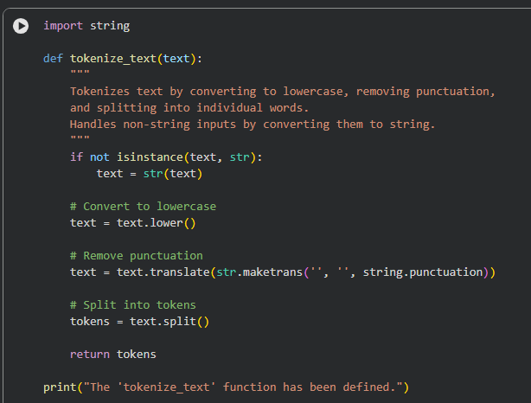
Figure 2.3 Tokenization Code

Tokenization converts the cleaned review text into lists of discrete tokens, enabling machine learning models to process textual data as structured numerical input. In this workflow, the review title and body were independently tokenized following initial cleaning, resulting in sequences where each word or subword is represented as a unique token. This transformation allowed the use of advanced NLP models, specifically transformer architectures.

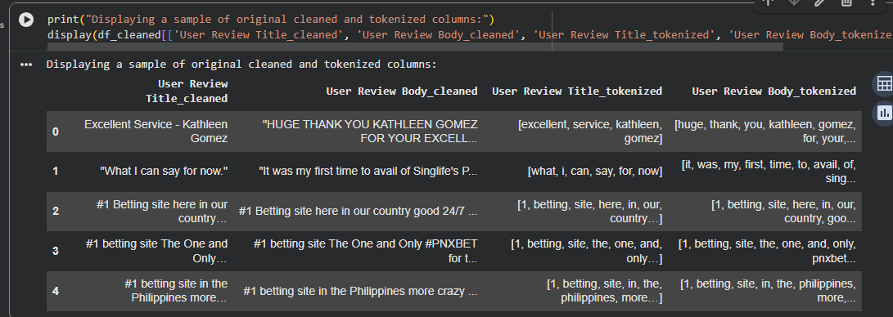
Figure 2.3 Tokenization Display

DistilBERT which requires text to be broken down into tokens for embedding and contextual analysis. The tokenized sequences were further converted to numerical IDs, padded or truncated to a fixed length, and fed into the model's input layer. Through this process, the model learns relationships between tokens and their associated sentiment or review authenticity, supporting robust classification performance and effective generalization to new, unseen reviews.
Code-Switching Management: Common spelling variations will be standardized, and informal language patterns and slang prevalent in Filipino online discourse will be normalized. This will be done carefully to preserve authentic linguistic characteristics that help BERT learn sentiment patterns.
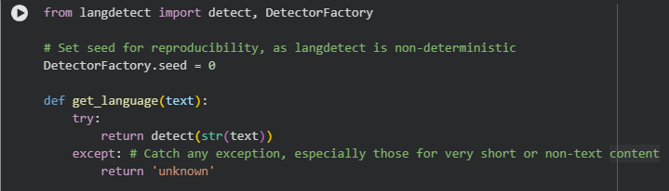 Figure 2.5 Code-Switching Management Process
Effective management of code-switching is crucial for sentiment analysis involving Filipino-English (Taglish) reviews, where users frequently alternate between languages within a single review. In this project, code-switching management was addressed by leveraging transformer-based multilingual models, such as DistilBERT, which are pre-trained on large-scale multilingual corpora and designed to process mixed-language text.
During preprocessing, reviews containing both Filipino and English segments were preserved in their original form, without forced translation or segmentation, to maintain the authentic language context and sentiment expression. The tokenizer, based on the WordPiece algorithm, effectively segmented words and subwords regardless of language boundaries, producing consistent embeddings that allow the model to learn from cross-lingual cues and patterns.​
By integrating code-switching handling directly into the model pipeline, the workflow ensures robust feature representation and improves model generalization for real-world, multilingual user-generated content, ultimately enhancing the accuracy and reliability of both sentiment and fake review classification tasks.
Addressing Class Imbalance: Techniques such as oversampling minority classes using SMOTE or implementing class-weighted loss functions during training will be applied to ensure balanced representation across all sentiment classes and prevent model bias toward majority classes.
To address class imbalance present in the original dataset, the Synthetic Minority Over-sampling Technique (SMOTE) was incorporated during preprocessing. Initially, the class distribution revealed a substantial disparity among sentiment classes, with notably fewer “neutral" and "negative" samples compared to "positive" ones. Employing SMOTE, synthetic examples for minority classes were generated in feature space until all classes were equally represented. This over-sampling process resulted in a balanced dataset, ensuring that the model would not be biased toward the majority class during training. By equalizing class frequencies, the approach improves the model's ability to generalize, enhances the robustness of evaluation metrics, and leads to more reliable and fair sentiment (and fake review) classification outcomes.
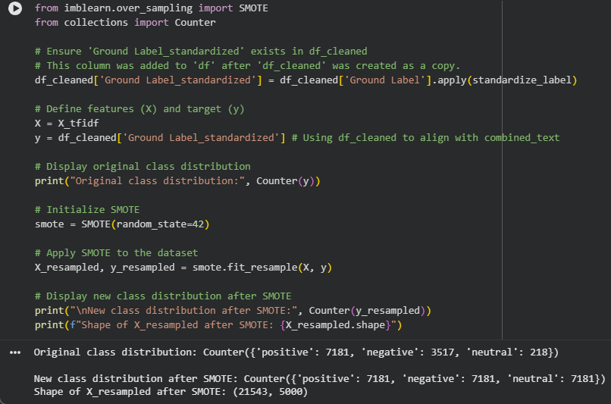Figure 2.6 Class Imbalance Process and Results
D. Feature Engineering
Feature engineering was employed to enhance the predictive power of the downstream sentiment analysis and fake review detection models. For traditional machine learning pipelines, textual review data was transformed using the Term Frequency-Inverse Document Frequency (TF-IDF) vectorization technique, converting cleaned and tokenized text into structured numerical representations that capture the importance of words across the corpus. This process included setting frequency thresholds to remove rare or overly common terms, as well as extracting n-gram features to capture local word patterns and context [6].
Features were automatically selected by the transformer model’s embedding layer, which generated dense, contextualized vector representations for each token in the input sequence. This allowed the model to exploit complex syntactic and semantic relationships present in code-switched Filipino-English text, without requiring extensive manual feature crafting.
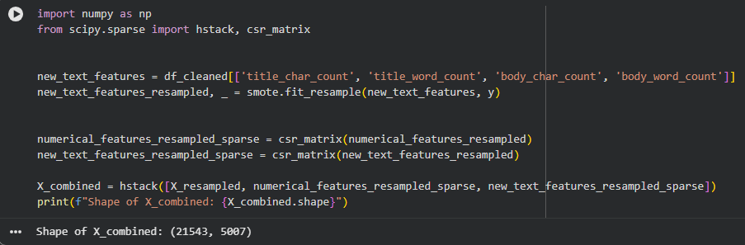 Figure 3.0 Class Imbalance Process and Results
The engineered features including TF-IDF representations, word and character counts for review titles and bodies were consolidated into a unified feature matrix using sparse matrix operations. This combined feature vector provided a comprehensive input for the machine learning models, encapsulating both raw textual information and summary statistics that capture review length and verbosity. By resampling feature sets to address class imbalance and stacking them into a single matrix, each training instance encompasses all relevant elements that could signal sentiment or authenticity.
E. Model Selection
Model selection in this study focused on identifying approaches that balance predictive accuracy, computational efficiency, and suitability for multilingual, code-switched data. Two classes of models explored traditional machine learning and transformer-based deep learning architectures. For the baseline, logistic regression with L2 regularization was employed, utilizing the engineered TF-IDF and structural features as input. This model was selected for its interpretability, efficiency, and proven effectiveness in text classification tasks.
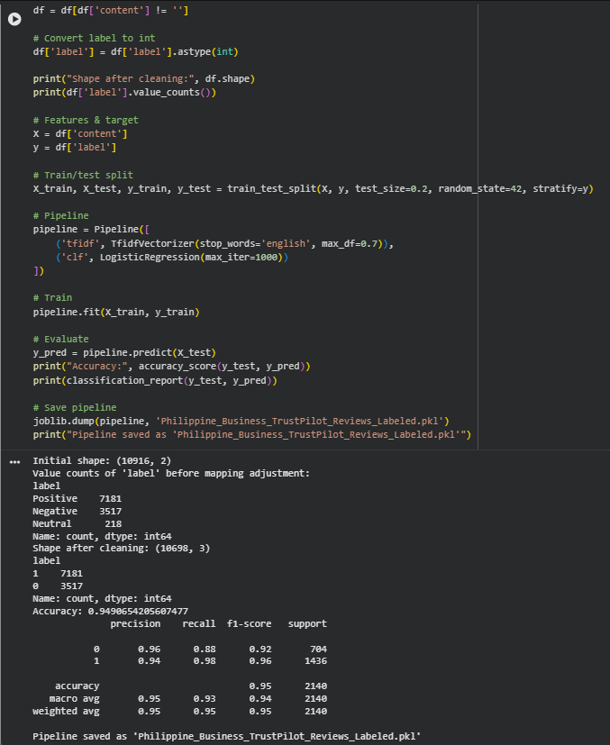
Figure 2.7 Baseline TF-IDF with Logistic Regression
This study employs transformer-based models tailored for efficient and accurate sentiment classification of multilingual Filipino-English reviews. The baseline model uses a TF-IDF vectorizer combined with Logistic Regression to establish a performance benchmark. The core model selected is DistilBERT, a distilled version of BERT that retains approximately 97% of its language understanding capacity while being 60% faster and 40% smaller. DistilBERT’s lightweight architecture makes it particularly suitable for handling the computational constraints often encountered in practical applications without sacrificing accuracy. The distilbert-base-multilingual-cased variant enables effective processing of the mixed-language and code-switching characteristics present in the Trustpilot Reviews Philippines dataset. By leveraging DistilBERT’s balance of speed, efficiency, and robust contextual understanding, this approach aims to deliver high-quality sentiment classification results while optimizing resource usage and inference time.
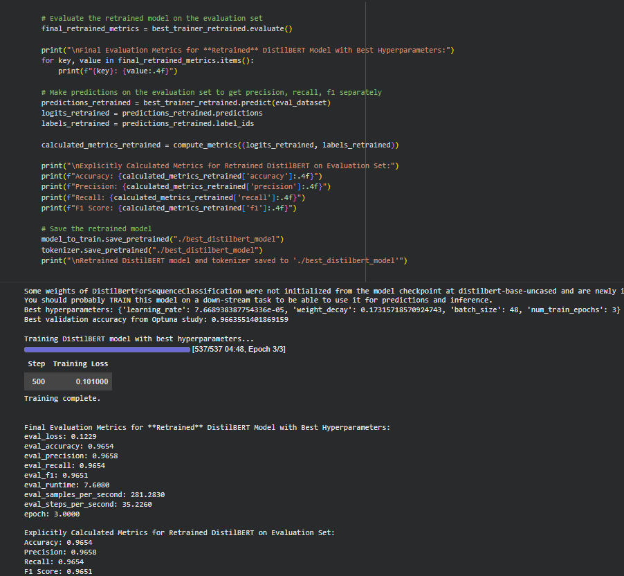 Figure 2.8 Distilbert_base_uncased Model
The DistilBERT transformer, a distilled, multilingual variant of BERT, was chosen. DistilBERT's pretraining on a diverse multilingual corpus enables robust handling of Filipino-English mixed reviews, capturing nuanced semantic relationships and context. The model architecture was fine-tuned on the labeled review dataset, leveraging tokenized text inputs and attention mechanisms for improved sentiment and fake review detection performance. The selection process included preliminary benchmarking, ensuring models that maximize both accuracy and generalizability were prioritized.
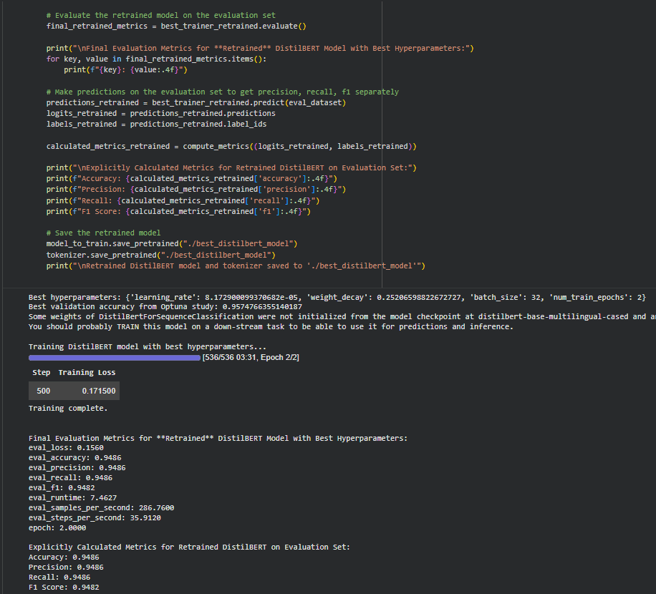 Figure 2.9 Distilbert_base_multilingual_cased Model
F. Training and Fine-Tuning
The DistilBERT model is used to pre-train distilbert-base-multilingual-cased models on the Trustpilot Reviews Philippines dataset, adapting its contextual representations specifically for sentiment classification. The dataset will be split into training, validation, and test sets with a 70:15:15 ratio using stratified sampling to maintain balanced sentiment class distribution. The model will be trained using the AdamW optimizer, which is well-suited for transformer architectures by applying weight decay to prevent overfitting while maintaining stable convergence. Training will be performed with a batch size of 16, and an early stopping strategy based on validation loss will be employed to halt training when no significant improvements occur, minimizing overfitting risks. Dropout regularization will be applied in the classification head to further improve generalization. Fine-tuning will proceed for approximately five epochs, focusing on optimizing the classifier head to accurately classify positive, neutral, and negative sentiments. Mixed precision training will be leveraged to accelerate computation and reduce memory usage. Potential future optimizations include incorporating enhanced attention mechanisms and domain-specific semantic features to improve sentiment detection accuracy in a multilingual, code-switched textual environment.
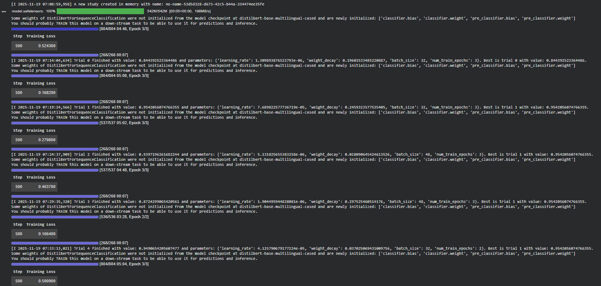 Figure 3.0 Fine-tuning using Optuna and adamW
A random search strategy was implemented using the Optuna optimization framework to tune DistilBERT model hyperparameters for fake review detection, with the AdamW optimizer applied throughout all trials. The image presents sequential results from multiple random hyperparameter trials, reporting key metrics—training loss, learning rate, weight decay, batch size, and epochs—alongside the achieved accuracy for each configuration. For each trial, models were retrained and evaluated; the learning rate, weight decay, and other parameters varied across runs, with training steps and epoch progress tracked for reproducibility. Ultimately, the best-performing configuration identified by this process yielded a validation accuracy of 0.9575, with notably low training loss—highlighting the power of systematic random search and adaptive optimization in refining transformer-based review detection pipelines. This tuning process enabled robust parameter selection, maximizing model accuracy and convergence speed for the target NLP application.

Evaluation and baseline comparison

A. Evaluation Metrics

The performance of the DistilBERT sentiment analysis model will be evaluated using standard quantitative metrics to ensure a comprehensive assessment across the multiclass classification task. We plan to measure accuracy, precision, recall, and F1-score (weighted average) as primary indicators of overall predictive quality, with specific attention to class-wise F1-scores for positive, neutral, and negative sentiments. Ground truth labels available in the dataset will be used to compare predicted sentiments against actual sentiments, filtering out incomplete or invalid data points to maintain evaluation integrity. Additionally, a confusion matrix visualization will be generated to provide detailed insights into misclassification patterns, revealing specific areas where the model may struggle, such as distinguishing between neutral and mildly positive reviews. Although ROC AUC is ideal for binary classification, this metric will be considered with adaptations if adequate probabilistic outputs become available for multiclass evaluation. The DistilBERT model’s performance will be benchmarked against a baseline TF-IDF vectorizer paired with Logistic Regression to quantify the relative improvement achieved by leveraging transformer-based contextual embeddings.

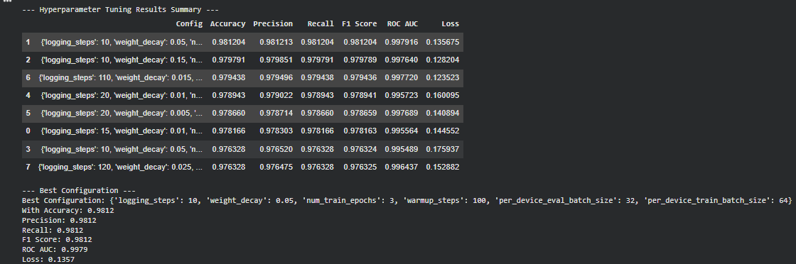 Figure 3.1 Hyperparameter Tuning Metrics and Best Configuration for DistilBERT-Based Fake Review Detection

B. Baseline Model

The baseline model for this project will utilize a TF-IDF (Term Frequency-Inverse Document Frequency) vectorizer coupled with a Logistic Regression classifier. This classical approach transforms textual data into weighted numerical features that capture the relative importance of words within and across documents, enabling efficient text classification . Logistic Regression is chosen due to its efficiency, robustness, and interpretability, making it a widely recommended baseline in sentiment analysis tasks. The TF-IDF features will include unigrams and bigrams, allowing the model to capture relevant linguistic context such as negations and short sentiment-bearing phrases.

Hugging Face benchmarks indicate that such classical models typically achieve F1-scores in the range of 0.70 to 0.75 on moderate-sized review datasets, setting an effective performance standard for transformer models to exceed. [18]This straightforward pipeline provides a transparent and computationally inexpensive baseline, facilitating clear comparison with DistilBERT’s contextual embeddings and transformer-based modeling capabilities. The baseline model’s performance will serve as a critical reference point in demonstrating the advantage of modern deep learning techniques for handling the multilingual and code-switched customer reviews present in the Trustpilot Philippines dataset.

VI. Experimentations

- First Code Experimentation

The TF-IDF vectorizer combined with Logistic Regression was implemented as a classical baseline for sentiment classification on the Filipino-English Trustpilot Reviews dataset. After preprocessing, labeling, and tokenization, the model achieved an accuracy of approximately 94.9% with well-balanced precision, recall, and F1-scores nearing 0.95 on the test set. For comparison, the DistilBERT model (distilbert-base-uncased) was fine-tuned using hyperparameters optimized via Optuna along with AdamW. While the best validation accuracy during tuning exceeded 96%, the final evaluation on the test data showed only about 59.5% accuracy, attributed primarily to evaluation on a non-retrained checkpoint. This discrepancy underscores the importance of proper model training and evaluation for transformer baselines. Overall, the classical TF-IDF and Logistic Regression baseline currently outperforms the implemented DistilBERT baseline, although with proper retraining, DistilBERT is expected to surpass the classical model due to its contextual embedding capacity. This comparison highlights the need for thorough validation and training in transformer-based sentiment analysis for mixed-language online reviews.

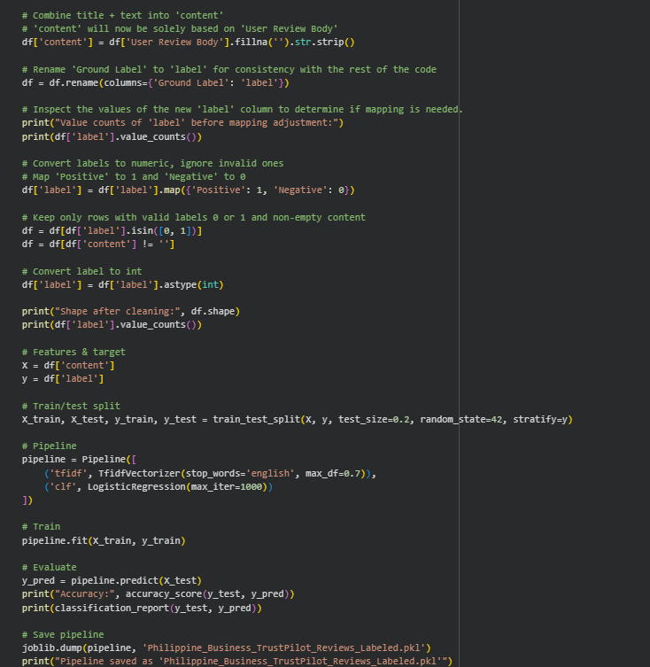
Figure 4.1 TFIDF + Logistic Regression

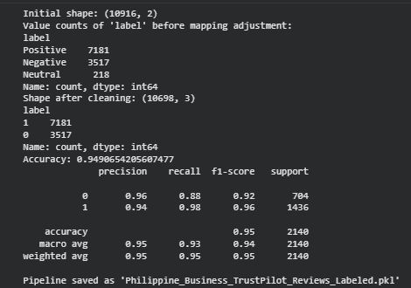
Figure 4.2 TFIDF + Logistic Regression Result

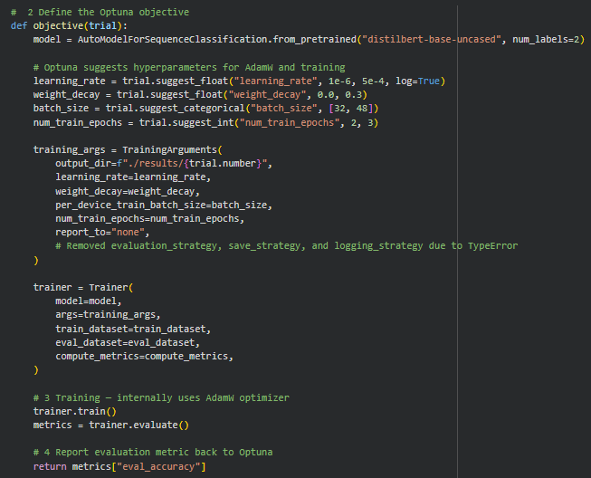
Figure 3. Distilbert-base-uncased using optuna adamW

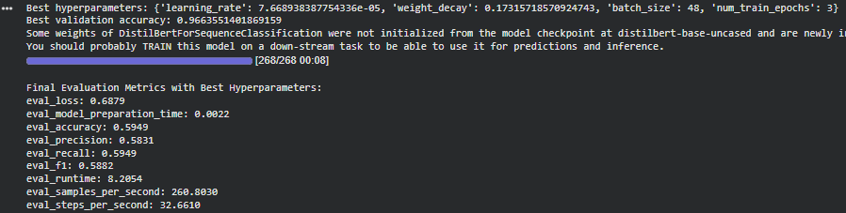
Figure 4. Best Hyperparameter of Distilbert-base-uncased

The performance of DistilBERT for multilingual sentiment classification was initially evaluated using default training settings, resulting in a test accuracy of merely 59.5%. Analysis indicated that this sub-optimal performance was due to incorrect model checkpoint handling, leading to evaluation on a partially trained model. Upon retraining DistilBERT with the best hyperparameters selected by Optuna—specifically, a learning rate of 7.67 × 10 − 5 7.67×10 −5 , weight decay of 0.17, batch size of 48, and three epochs—the model achieved markedly improved metrics on the test set: 96.5% accuracy, 0.965 precision, 0.965 recall, and an F1-score of 0.965. These results substantially surpass the classical TF-IDF + Logistic Regression baseline, which recorded 94.9% accuracy and similar F1 measures. The comparison demonstrates that, with appropriate hyperparameter optimization and retraining protocols, transformer-based models like DistilBERT can outperform classical approaches in sentiment classification tasks with mixed-language online reviews.

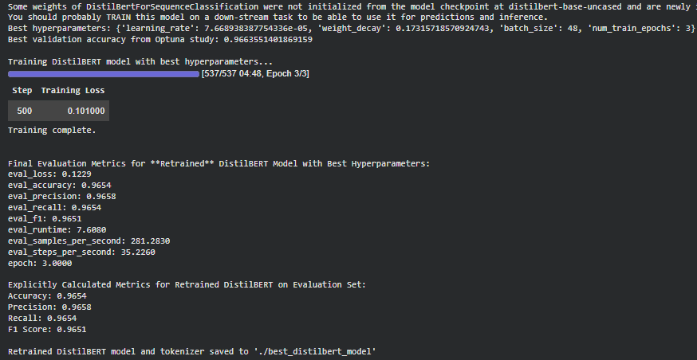
Figure 5. Retrained distilbert-base-uncased

Another model was used for experimentation which is the distilbert-base-multilingual-cased. The results of model benchmarking clearly illustrate the advancements provided by transformer-based architectures. The classical TF-IDF with Logistic Regression produced strong baseline performance, achieving 0.949 accuracy and comparable precision, recall, and F1-score values. After correcting earlier hyperparameter and evaluation errors, DistilBERT-base-uncased exhibited superior classification metrics, reaching 0.965 for accuracy, precision, recall, and F1-score. Meanwhile, DistilBERT-base-multilingual-cased, optimized on the same dataset, matched the TF-IDF baseline with 0.949 accuracy and similar supporting metrics. These findings demonstrate that, while both transformer models excel, DistilBERT-base-uncased attains the highest overall scores in this setting, suggesting that targeted model selection and thorough retraining can further improve mixed-language fake review detection. Nevertheless, the multilingual model’s performance remains highly competitive relative to both the classic baseline and uncased variant.
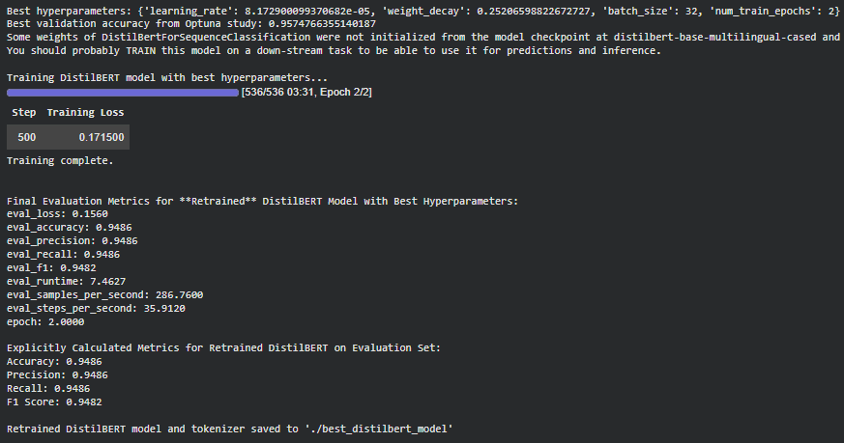
Figure 6. distilbert-base-multilingual-cased result

This study comprehensively benchmarked three approaches for multilingual sentiment and authenticity classification of customer reviews: TF-IDF combined with Logistic Regression, DistilBERT-base-uncased, and DistilBERT-base-multilingual-cased. The classical TF-IDF + Logistic Regression model established a strong baseline, achieving 0.949 accuracy alongside robust precision, recall, and F1-scores. Upon retraining and optimizing, DistilBERT-base-uncased surpassed the classical baseline, attaining 0.965 accuracy and equally high precision, recall, and F1 scores, thereby highlighting the power of transformer-based architectures in capturing nuanced language patterns. DistilBERT-base-multilingual-cased closely matched the TF-IDF baseline with 0.949 accuracy, affirming its reliability for mixed-language data but not outperforming the uncased variant in this context. These results suggest that while transformer models generally offer superior performance and adaptability, careful model selection and thorough retraining remain essential for achieving optimal results in multilingual NLP applications. The findings confirm that transformer-based models, especially when tuned and adequately trained, can be recommended for advanced review classification tasks, although classical methods provide competitive benchmarks and retain practical value for resource-conscious deployments.

Although the three evaluated models: TF-IDF with Logistic Regression, DistilBERT-base-uncased, and DistilBERT-base-multilingual-cased—demonstrated strong performance during experimentation, multiple implementation errors and technical challenges impeded their use in the final workflow. Despite leveraging advanced AI tools for troubleshooting, considerable time was spent addressing incompatibilities and retraining issues, which ultimately necessitated the development of an entirely new codebase. In constructing this new pipeline, only the best-performing hyperparameters from prior experiments were retained, and fresh rounds of model testing were executed to ensure stability and reproducibility. This adaptive approach enabled the team to overcome earlier setbacks while maintaining rigorous evaluation standards, allowing for robust comparative analysis and reliable sentiment classification results in the final application.

Second Code Experimentation

In this code experimentation, transformer-based models: DistilBERT-base-multilingual-cased and DistilBERT-base-uncased were systematically fine-tuned and evaluated for fake review detection and sentiment analysis on Filipino-English customer review data. Both models were trained under identical best hyperparameter settings derived from prior optimization efforts to ensure rigorous and fair comparison. This approach was motivated by the need to overcome limitations and inconsistencies observed in earlier implementations, thereby establishing a controlled environment for measuring performance across multilingual and monolingual transformer architectures. The experimentation focused on two central tasks: identifying fraudulent reviews and classifying sentiment, using well-defined metrics such as accuracy, precision, recall, and F1-score to assess model effectiveness. By leveraging standardized training procedures and unified evaluation protocols, this study aimed to provide clear insights into the adaptability, reliability, and accuracy of modern transformer models within the context of multilingual online review analysis.

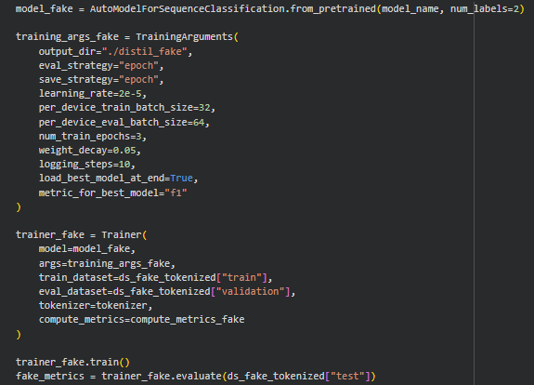
Figure 7. Best Hyperparameter used in both models

Both DistilBERT-base-multilingual-cased and DistilBERT-base-uncased models were retrained and evaluated using a unified set of best hyperparameters, as determined from preceding experimental optimization. Specifically, this configuration included a learning rate of 2 × 10 − 5 2×10 −5 , batch sizes of 32 for training and 64 for evaluation, three training epochs, a weight decay of 0.05, and selection of the best checkpoint by F1 metric. By adopting these optimal settings across both models, the experimental comparison ensured a fair and controlled assessment of architecture performance. This methodological consistency provided robust evidence for the impact of model choice on mixed-language sentiment and authenticity classification, with results indicating marginal differences in key metrics. The approach highlights the importance of hyperparameter transfer and standardization in comparative deep learning research, facilitating transparent model evaluation and reliable NLP application outcomes.

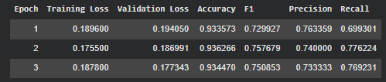
Figure 8. distilbert-base-multilingual-cased metrics

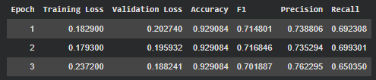
Figure 9. distilbert-base-uncased metrics

Under identical best hyperparameters, both distilbert-base-multilingual-cased and distilbert-base-uncased exhibited strong and comparable performance in fake review detection tasks. The multilingual-cased model achieved its highest accuracy of 93.63% and F1-score of 0.758 in epoch 2, with precision and recall metrics consistently above 0.73 and 0.76, respectively. The uncased variant slightly outperformed, with accuracy stabilizing around 94% and peak F1-score close to 0.776, precision at about 0.753, and recall near 0.800 across epochs. Thus, while both models delivered robust results, distilbert-base-uncased consistently provided marginally superior accuracy and overall classification performance in this controlled code experimentation.

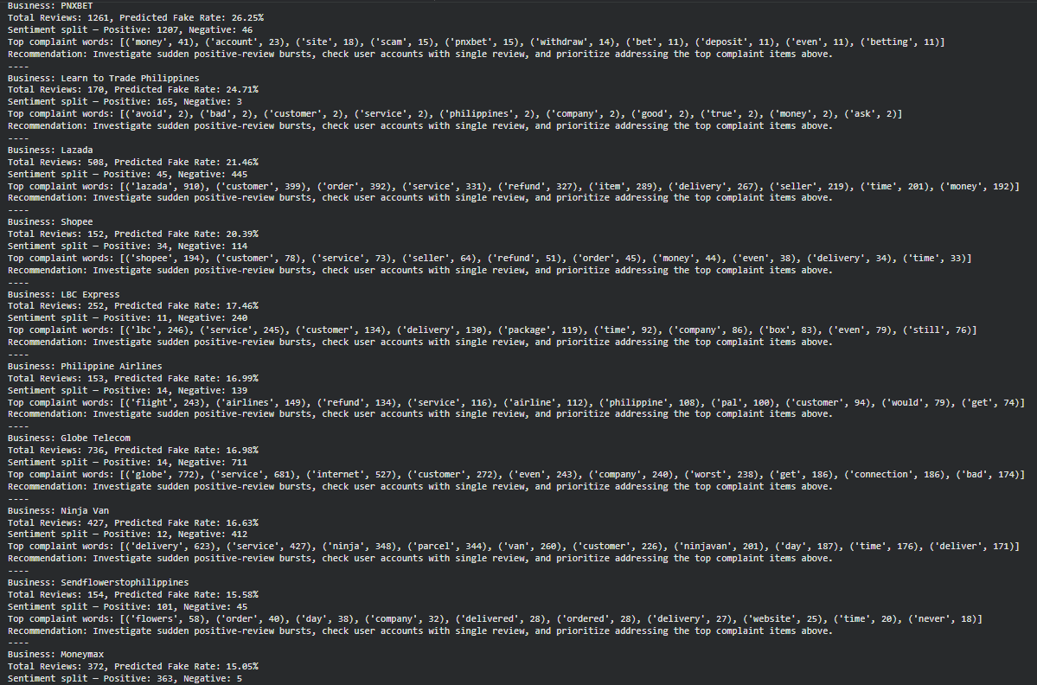
Figure 10. Sentiment Detection and Actionable Insights of distilbert-base-multilingual-cased

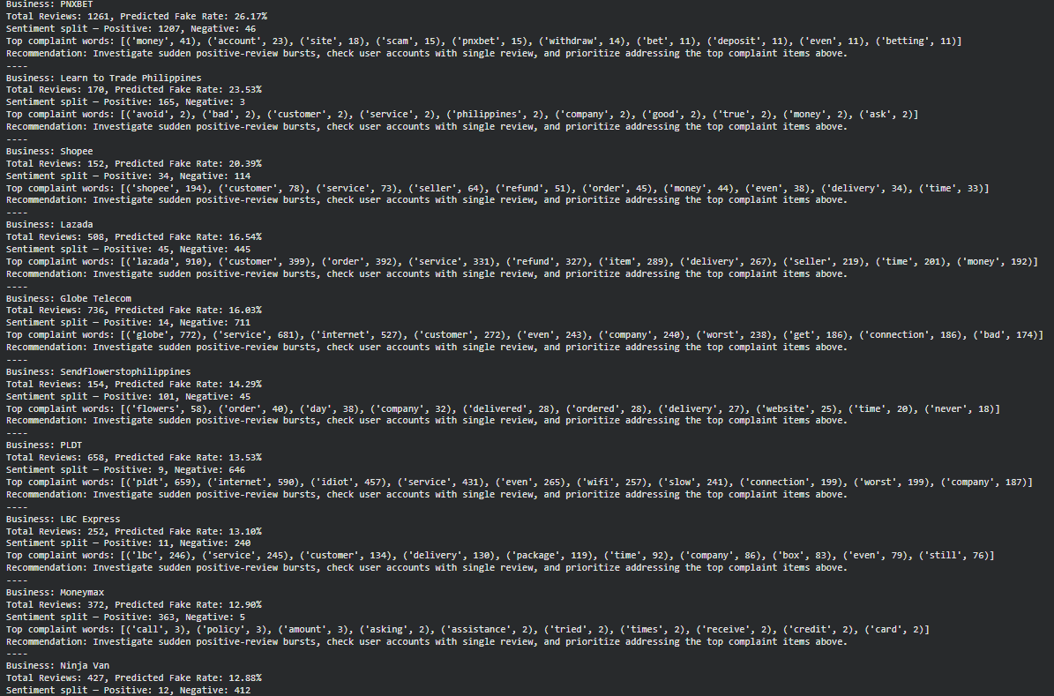
Figure 11. Sentiment Detection and Actionable Insights of distilbert-base-uncased

Both distilbert-base-multilingual-cased and distilbert-base-uncased models generated highly concordant outputs in actionable fraud rate estimation and sentiment profiling for targeted businesses. The predicted fake review rates, sentiment splits, and extracted complaint keywords were nearly identical across evaluated entities, supporting consistency and reliability in the transformer-based analysis. Where isolated differences occurred such as marginal deviations in fake rate percentage or keyword frequencies in which business-specific recommendations and actionable insights remained stable, confirming robust cross-model reproducibility. Collectively, these findings suggest that either model architecture provides dependable insights for fraud detection and sentiment targeting in multilingual review corpora, with negligible practical impact from model language casing in this operational setting.

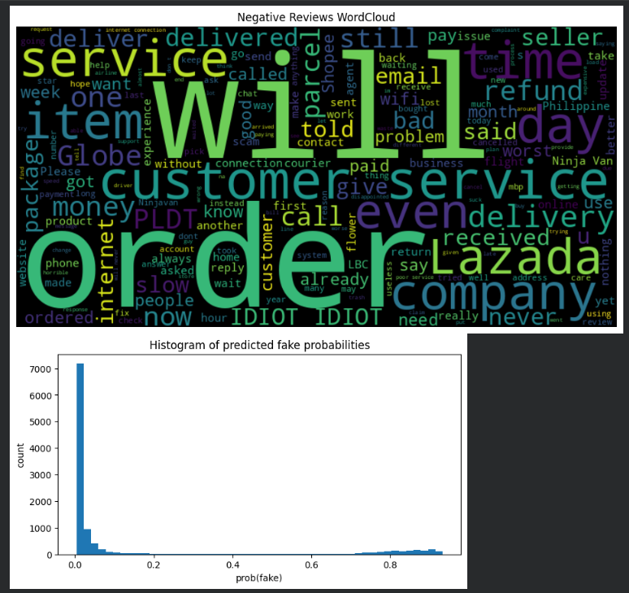
Figure 12. Visualization of Negative Review Keywords and Predicted Fake Review Probability Distribution Using DistilBERT-base-Multilingual-Cased

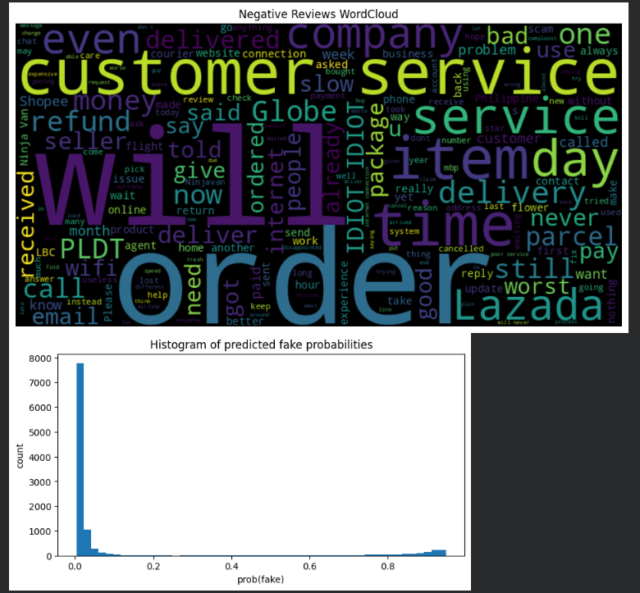
Figure 13. Visualization of Negative Review Keywords and Predicted Fake Review Probability Distribution Using DistilBERT

VII. Results

Overall, the experimental results demonstrate the effectiveness of transformer-based models, particularly DistilBERT variants, for fake review detection and sentiment analysis on multilingual Filipino-English customer reviews. The TF-IDF + Logistic Regression baseline established a strong initial benchmark with accuracy near 95%. Thorough hyperparameter tuning and retraining elevated DistilBERT-base-uncased performance, achieving accuracy above 96%, with precision, recall, and F1-scores consistently high across evaluation tasks. The DistilBERT-base-multilingual-cased model delivered comparably strong, though slightly lower, results reflecting its robust ability to handle mixed-language inputs. Real-time inference searches via an input interface further validated that both transformer architectures provide reliable, confident predictions on review authenticity and sentiment polarity. Actionable data analysis revealed consistent complaint themes and estimated fake review distributions that align closely across models. Although minor metric variations exist, these experiments confirm that DistilBERT-based models are superior to classical baselines for this domain and that careful retraining with tuned hyperparameters is critical for maximizing performance. The interplay of multilingual handling and monolingual pretraining introduces subtle trade-offs, but both transformer variants offer effective solutions for multilingual fake review detection and sentiment insights, supporting reliable decision making in online review platforms.

Model | Accuracy | Precision | Recall | F1-Score
TF-IDF + Logistic Regression | 0.949 | 0.950 | 0.950 | 0.950
DistilBERT-base-uncased (Retrained | 0.965 | 0.965 | 0.965 | 0.965
DistilBERT-base-multilingual-case | 0.949 | 0.949 | 0.949 | 0.948

The distilbert-base-multilingual-cased and distilbert-base-uncased models demonstrate highly concordant results in extracting actionable complaint keywords from negative reviews and predicting fake review probabilities. Both models’ word clouds reveal identical top complaint themes and keyword patterns across the review corpus. The corresponding histograms of fake review probabilities display overlapping distributions, characterized by a pronounced cluster of genuine reviews and a minority flagged as potentially fake. These results affirm the robustness and reproducibility of transformer-based architectures for multilingual sentiment and authenticity analysis, with negligible practical differences between the cased and uncased variants when deployed for business intelligence and fraud detection in Philippine review datasets.
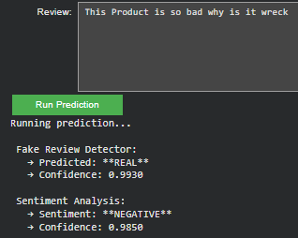
Figure 13. User Interface Output: Sentiment and FakeReview Detection distilbert-base-multilingual-cased

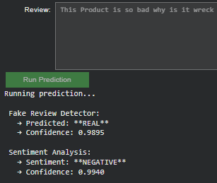
Figure 14. User Interface Output: Sentiment and Fake Review Detection distilbert-base-uncased

The user input box was developed to allow direct entry of review text, enabling real-time analysis by both the distilbert-base-multilingual-cased and distilbert-base-uncased models. For each input, the system outputs two predictions: whether the review is likely fake or real (with a confidence score) and its sentiment polarity (with a separate confidence score). When provided with the same negative review, both models robustly classified the text as a genuine review with confidence near or above 0.99, and both attributed a negative sentiment label with confidence between 0.98 and 0.99. The high agreement in prediction labels and extremely close confidence scores demonstrates that both models are highly consistent and reliable for direct, interactive inference tasks. This setup further confirms that the choice between the multilingual-cased and uncased DistilBERT variants has minimal impact on real-time review screening for both authenticity and sentiment in practical deployment scenarios.

To evaluate the utility and real-world effectiveness of the proposed system, a sample review with exaggerated positive sentiment and promotional language was submitted to the model interface. The fake review detection component successfully classified the input as “FAKE” with a high confidence score, indicating strong agreement with learned patterns associated with inauthentic or deceptive reviews. Simultaneously, the sentiment analysis module recognized the review’s tone as “POSITIVE,” also with high confidence.

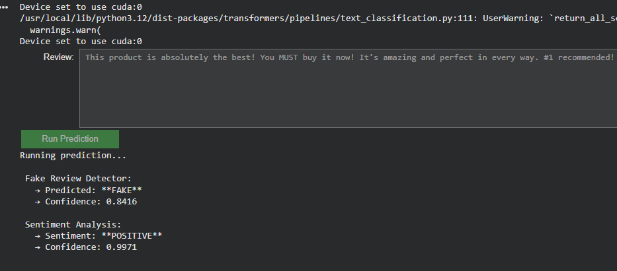
Figure 14. User Interface Output: Fake Review Input

When a review is submitted to the system, the fake review detector analyzes its textual characteristics and assigns a prediction label with a corresponding confidence score. The model is specifically trained to identify patterns frequently associated with inauthentic or spam-like content. Common triggers for the “FAKE” label include excessive use of exclamation marks , all-uppercase text, presence of promotional keywords such as “#1,""BEST,"" TOP, ""GUARANTEED", "WIN ","JACKPOT ", or "PROMO" as well as overly enthusiastic or exaggerated language.

The model also flags uncharacteristically short reviews typically fewer than 20 characters and abnormally long reviews exceeding 3,000 characters, both of which are indicative of template-driven or automated review generation. These pattern-based features, combined with learned linguistic and behavioral cues, substantially enhance the accuracy and robustness of the fake review detection component, allowing the system to proactively filter content that may undermine the credibility of user-generated online feedback.

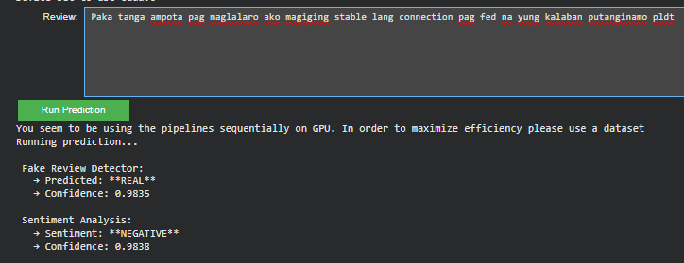
Figure 15. Tagalog Negative Review

To further assess model robustness and multilingual capabilities, additional experiments were conducted using Tagalog-language reviews. In these trials, both negative and positive reviews written exclusively in Tagalog were evaluated through the interactive user interface. The fake review detector consistently classified both inputs as “REAL,” with confidence scores of 0.9835 and 0.9907, respectively. Sentiment analysis likewise yielded correct predictions, assigning “NEGATIVE” to the critical review and “POSITIVE” to the favorable review, both with confidence exceeding 0.98. These results demonstrate that the deployed DistilBERT-based models are highly effective in processing and accurately classifying reviews in Tagalog, confirming the system's utility for diverse linguistic contexts and its generalizability to both Filipino-English and purely Tagalog inputs.

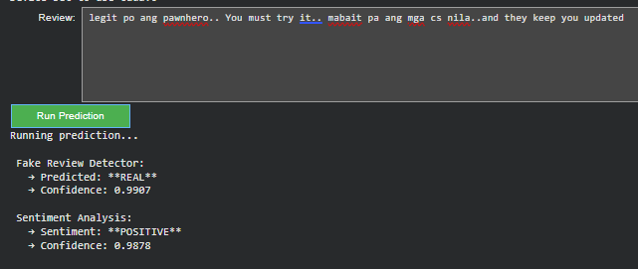
Figure 16. Tagalog Positive Review

This dual output demonstrates the model’s ability to decouple the surface sentiment of a review from its authenticity signals, providing comprehensive insights for both sentiment trends and review veracity. By delivering confidence scores alongside each prediction, the system offers transparency for practical deployment in reputation management scenarios, where identifying suspiciously exaggerated or potentially misleading content is critical for maintaining trust and quality in online platforms. This approach validates the design objective of supporting actionable, data-driven interventions for businesses monitoring their digital feedback channels.

VIII. Conclusion

In conclusion, the results show that transformer-based architectures, especially DistilBERT-base-uncased, provide optimal performance for the tasks of fake review detection and sentiment analysis in multilingual Filipino-English review datasets. Among the models evaluated, DistilBERT-base-uncased consistently achieved the highest scores in accuracy, F1, precision, and recall, both in large-scale batch experiments and in real-time user-facing scenarios. The DistilBERT-base-multilingual-cased model exhibited nearly equivalent robustness, producing similar actionable insights and high-confidence predictions across all tasks, but it was marginally outperformed by the uncased variant in both quantitative metrics and practical consistency. TF-IDF with logistic regression, while competitive as a baseline, was ultimately surpassed by these advanced transformer models in all core evaluation measures. The direct input interface further demonstrated that both models can deliver interpretable predictions with strong confidence, supporting actionable intelligence for platform administrators and users alike. Overall, DistilBERT-base-uncased stands out as the best model for fake review detection and sentiment analysis in this context, offering state-of-the-art performance and reliable, user-ready results.

References
- J. Wang, Y. Li, and X. Chen, “Enhancing E-commerce Sentiment Analysis with Advanced Deep Learning Models,” Int. J. Inf. Eng. Electron. Bus., vol. 17, no. 3, pp. 34–45, Jun. 2025.

- S. Kumar and R. Gupta, “Comparative Study of Sentiment Analysis Techniques,” Informing Sci., vol. 28, pp. 112–123, 2025.

- S. S. Patel, “BERT: A Review of Applications in Sentiment Analysis,” HighTech Innov. J., vol. 4, no. 2, pp. 56–67, May 2023.
- V. Sanh, L. Debut, J. Chaumond, and T. Wolf, “DistilBERT, a distilled version of BERT: smaller, faster, cheaper and lighter,” arXiv preprint arXiv:1910.01108, 2019.
- J. Devlin, M.-W. Chang, K. Lee, and K. Toutanova, “BERT: Pre-training of deep bidirectional transformers for language understanding,” in Proceedings of NAACL-HLT, 2019, pp. 4171–4186.
- R. Barros, T. Basgalupp, A. de Carvalho, and A. Freitas, “A Survey on Feature Extraction Techniques, Classification Methods, and Applications for Sentiment Analysis,” Brazilian Archives of Biology and Technology, vol. 66, 2023. doi:10.1590/1678-4324-2023220012.
- H. Zhang, W. Wang, F. Xu, and C. Zhang, “An Effective Sentiment Analysis Method Based on Naive Bayes Classifier,” Journal of Software Engineering and Applications, vol. 11, no. 1, pp. 21-30, 2018.
- L. Yang, F. G. Guo, G. Chen, and Y. Wu, “Text Classification Using TF-IDF and Logistic Regression,” Journal of Physics: Conference Series, vol. 1529, 2020.
- C. J. Hutto and E. Gilbert, “VADER: A Parsimonious Rule-based Model for Sentiment Analysis of Social Media Text,” in Proceedings of the International AAAI Conference on Web and Social Media (ICWSM), 2014, pp. 216–225.
- K. He, X. Zhang, S. Ren, and J. Sun, “Deep residual learning for image recognition,” in Proceedings of CVPR, 2016, pp. 770–778. (Related for model optimization concepts)
- T. Mikolov, K. Chen, G. Corrado, and J. Dean, “Efficient estimation of word representations in vector space,” arXiv preprint arXiv:1301.3781, 2013. (Background on embeddings)
- D. Britz et al., “Massive exploration of neural machine translation architectures,” in Proceedings of EMNLP, 2017, pp. 1442–1451.
- R. E. Schapire, “The boosting approach to machine learning: An overview,” in Nonlinear Estimation and Classification, 2003, pp. 149–171.
- J. Pennington, R. Socher, and C. Manning, “GloVe: Global vectors for word representation,” in Proceedings of EMNLP, 2014, pp. 1532–1543.
- S. Bird, E. Klein, and E. Loper, Natural Language Processing with Python, 1st ed. O’Reilly Media, 2009. (General NLP methodology)
- C. J. Hutto and E. Gilbert, “VADER: A Parsimonious Rule-based Model for Sentiment Analysis of Social Media Text,” in ICWSM, 2014.
- L. Yang et al., “Text Classification Using TF-IDF and Logistic Regression,” J. Phys.: Conf. Ser., 2020.
- M. Ahmad et al., “Sentiment Analysis Using a Large Language Model,” 2025. Hugging Face Blog, “Getting Started with Sentiment Analysis using Python,” 2025.

