1. Problem Statement : Many user are unaware of how to create strong passwords, making their accounts vulnerable to hacking.
2. Project Objective The objective of this application is to build an intuitive, real-time web tool that evaluates user passwords for cryptographic strength and actively guides them in generating secure, hack-resistant alternatives.
3. Solution Description This project is a responsive web application designed to act as a password analyzer. As a user types a potential password, the system evaluates its entropy—checking for length, character variety, and common predictable patterns. It provides immediate visual feedback via a dynamic, color-coded strength meter and offers specific, actionable tips for improvement (e.g., "Add symbols" or "Avoid common dictionary words"). To further solve the problem.
4. Application Screenshots
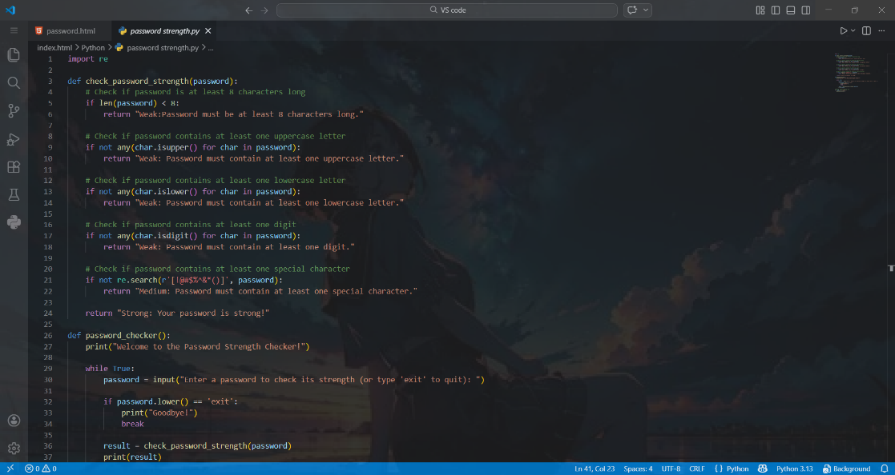

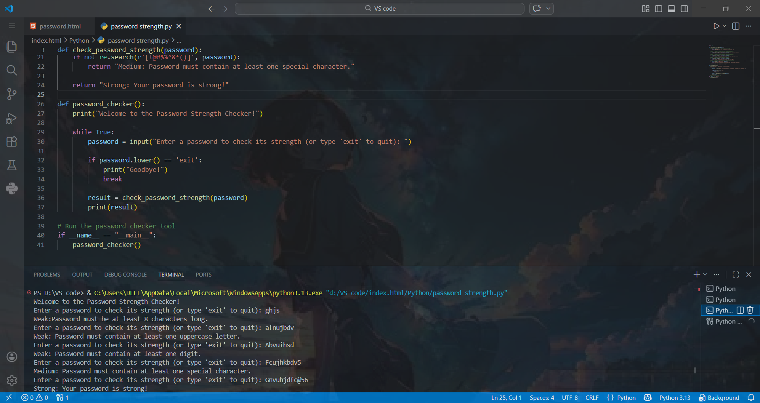
5. Technology use
Python
6. Open Source Code Link
- GitHub Repository: https://github.com/Deobratkashyap/Password-strength-checker
7. Future Scope
- Breach Database Integration: Integrating with secure APIs (like Have I Been Pwned) to securely check hashes and alert users if their chosen password has appeared in known data leaks.
- Browser Extension: Packaging the web application into a browser extension to provide on-the-fly password checking and generation directly on account creation pages.
- Crack Time Estimation: Implementing an algorithm to display the estimated time it would take a modern computer to crack the entered password using brute force.

