1. Download and Install R, and then RStudio on your computer. Both are free, and can be easily googled.
2. Save this file into a folder on your computer.

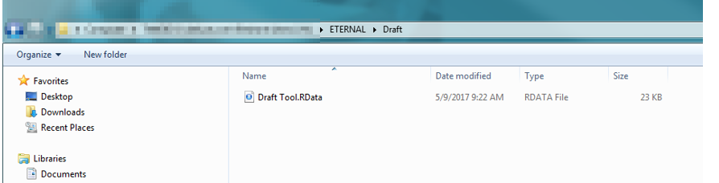

1. Double Click the File
2. This should open up a window that looks like below. If it doesn’t, close the program, and then right click the file, open-with, and then select RStudio.

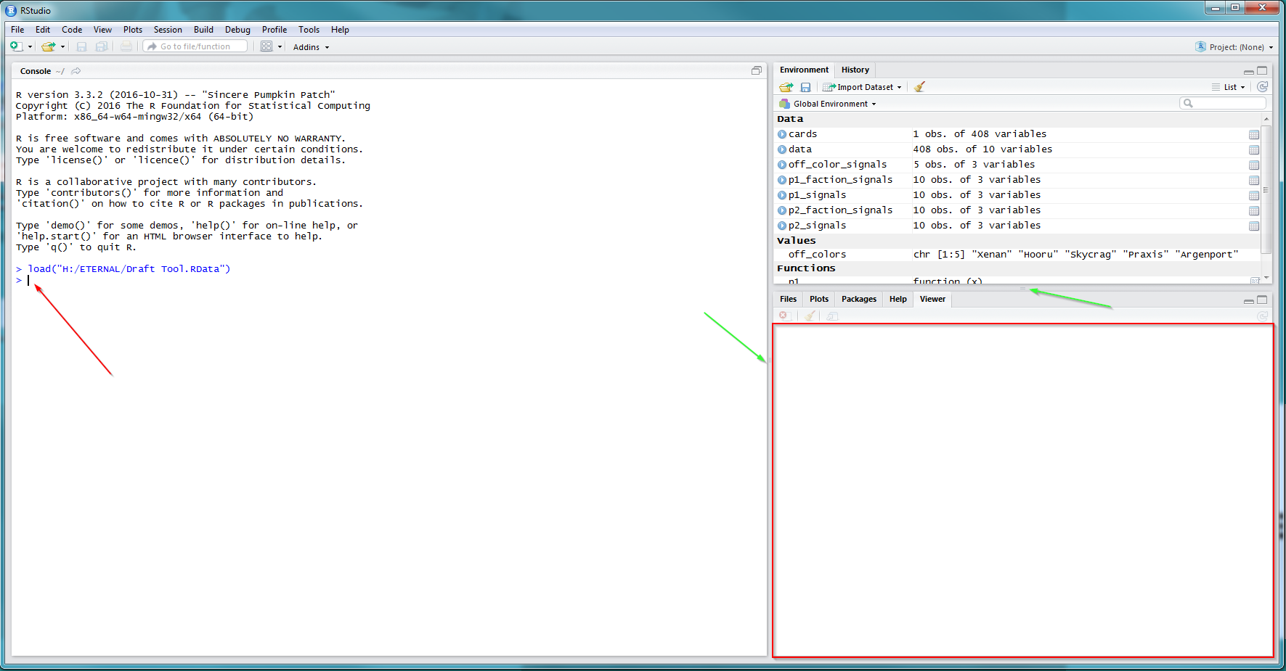

1. The left hand side of the program, called the ‘Console’ is where you will type the code, where the ‘Red Arrow’ is pointing.
   1. The results are going to appear in the section with the Red Box, in the bottom right. Make sure this section is big enough, like in the screenshot. If this section is small, you can use the draggers to make the section bigger, indicated by where the green arrows are pointing.
2. In the console, type these commands. After each one, press the enter button.
   1. attach(data)
   2. attach(cards)
      1. YOU NEED TO DO THESE TWO COMMANDS EVERY TIME YOU OPEN UP RSTUDIO TO USE THIS.
   3. It should look like this:

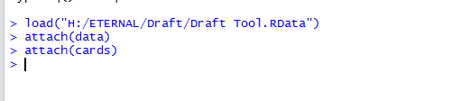

1. You may run the program on pick1 of pack1, and it will show you the best cards to pick for each faction pairing, but this data is not used in determining the signal strength of packs that are passed to you. The data is stored separately for packs that you open vs packs that are passed to you.
   1. The first time that you run the code, you will see some red text as it downloads some necessary packages in order to run the code. Just wait until it is finished.
2. To enter the picks, first type this: p1()
   1. Inside of the parenthesis, now type this: c()
   2. It should look like this: p1(c())



* 1. You will enter in each card inside of the c() section, separated by a comma.
  2. \*\*PLEASE NOTE: The p1() means pack1, so use p1 when picking from your first and third packs. You can use p2(c()) when picking from the 2nd and 4th packs, as these are coming from a different person. DON’T use p1(c()) for all 4 packs. Use p1(c()) for packs 1 and 3, and use p2(c()) for packs 2 and 4.

1. Start typing the name of a card, the program will detect the possible cards as you type, as seen below.
   1. A list of possible options will show up.

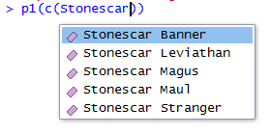

* 1. \*\*ALWAYS SELECT THE CARD FROM THE LIST, EVEN IF THERE IS ONLY ONE OPTION\*\*

1. You will want to type in all cards in the first pack that is passed to you with each one separated by a comma, like this:



* 1. Note, some of the cards with have an apostrophe around them, and some wont. Don’t worry about this, if you selected the card from the list, everything will work fine.
     1. Cards with spaces in the name with get the apostrophe’s, the ones without spaces will not. If you had to manually type a card name out and not select from the list, you would want to make sure you used the apostrophes.
  2. Hit Enter

1. You will see data show up in the results section that I mentioned before, it will look like the screenshot below. If the result window is too small, make the window bigger following the instructions in instruction 5.) a.

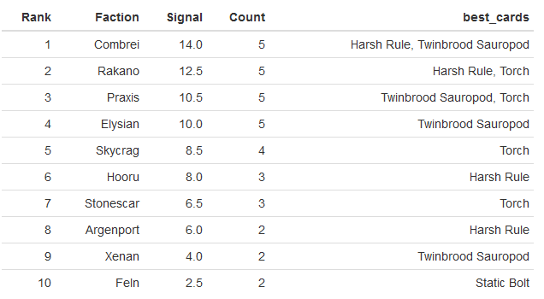

* 1. The faction column lists each possible color combination.
  2. The ‘Signal’ column shows the collective strength of that faction. The higher number means better cards are being passed to you in that faction.
     1. The list is sorted by the strongest signaled faction, to the weakest.
     2. Of the 5-real factions, find the lowest one on the list. This is likely the faction that the person passing to you is.
  3. The ‘Count’ column shows how many cards of that color have been passed.
  4. The ‘Best Cards’ column will show you what are the best cards to choose from for each given faction.

1. Use the data to help determine which colors are open in this direction.
2. When getting packs 2 and 4, you will need to figure out what colors are open in that direction, then compare with the colors that are open in packs 1 / 3 to figure out what your final colors should be.
3. Repeat this process for each pick that is passed to you. The table showing the results will keep adding data after each pick, and will update the results based on the best faction.