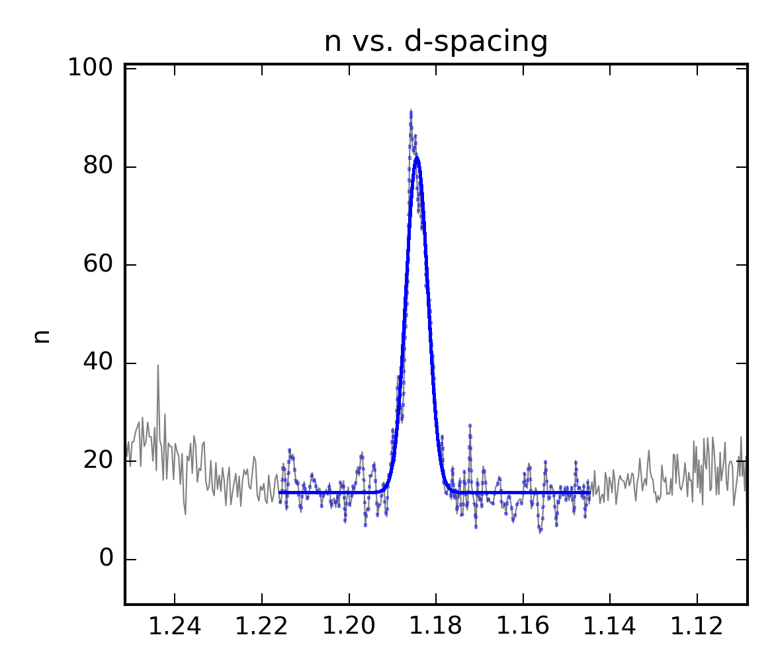

|  |  |  |  |
| --- | --- | --- | --- |
|  | Val_0 | Stdev_0 |  |
| Range_start | 92 |  |  |
| Range_end | 302 |  |  |
| d-spacing | 1.1844 | 6.21E-05 |  |
| FWHM | 0.0059 | 1.52E-04 |  |
| Intensity | 68.2868 | 1.48E+00 | Peak height (~81) – Background (~13) = ~68 |
| Background | 13.6329 | 3.28E-01 |  |
| Chi^2 | 9.22E-01 |  |  |
| R^2 | 0.933 |  |  |
| nIter | 9 |  |  |
| Time | 0.01 |  |  |
| Intensity_sum | 1248.455 |  | For each xy point in the selected range, the background value is subtracted from the fitted y value and all results are added together |
| Intensity_area | 0.4298 |  | For each xy point in the selected range, the absolute of the background value subtracted from the fitted y value and multiplied by the width (∆x) for the datapoint and all results are added together |
| Counts | 4111.373 |  | For each xy point in the selected range, the y values are added together |
| Err_µɛ | 74.1714 |  |  |