**Functional Requirements Specification (FRS) for OpenCart Ecommerce Website**

**1. Introduction**

**1.1 Purpose**

The purpose of this document is to define the functional requirements for the OpenCart ecommerce website. It outlines the functionality, usability, performance, and security criteria that the website must meet to satisfy business and technical needs.

**1.2 Scope**

This FRS covers the end-to-end functionality of the ecommerce website, including customer workflows, account management, order management, payment gateway integration, and the admin module. It also includes performance, security, and compatibility requirements.

**2. Overall Description**

**2.1 Product Perspective**

The ecommerce website serves as an online platform for customers to browse, search, add products to the cart, checkout, and make payments. It also includes administrative features for managing products, orders, and user accounts.

**2.2 Product Functions**

* Customer workflows: search, browse, add to cart, checkout, payments
* Account registration and management
* Order management and tracking
* Integration with payment gateways
* Admin module and workflows

**2.3 User Characteristics**

* Customers: Individuals who browse and purchase products
* Administrators: Staff who manage products, orders, and user accounts
* Mobile Users: Customers accessing the website via mobile devices

**2.4 Constraints**

* Compliance with security standards (OWASP Top 10)
* Compatibility with major browsers and devices
* Scalability to handle peak loads

**3. Functional Requirements**

**3.1 Customer Workflows**

**3.1.1 Search**

Users must be able to search for products using keywords. The search results should be relevant and display product details.

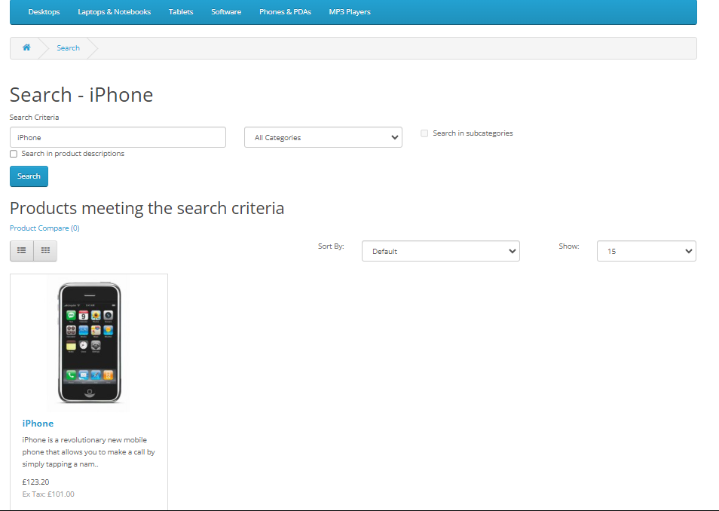

*Screenshot: Search Results Page*

**3.1.2 Add to Cart**

Users must be able to add products to a shopping cart. The cart should update in real-time with the selected products and total price.

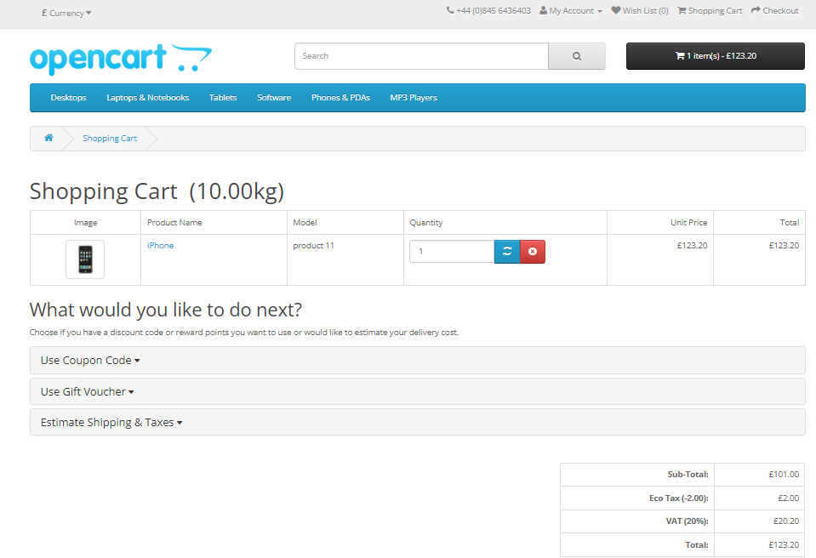

*Screenshot: Shopping Cart Page*

**3.1.3 Checkout**

Users must be able to proceed to checkout from the cart. The checkout process should include steps for entering shipping details, selecting payment methods, and reviewing the order.

*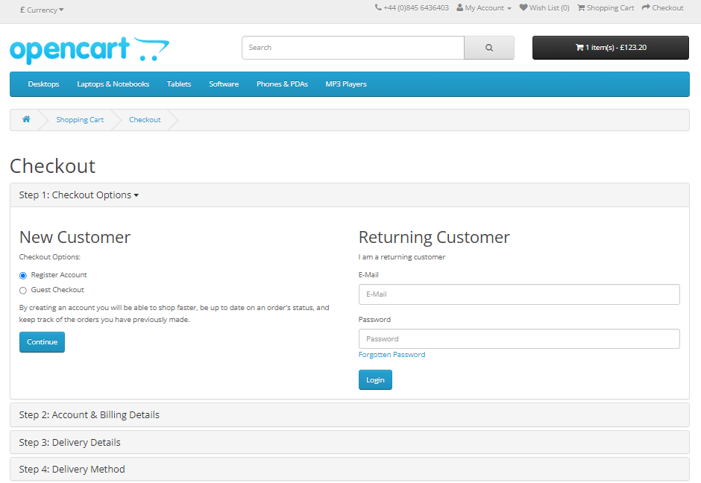Screenshot: Checkout Page*

**3.1.4 Payments**

Users must be able to complete payments using integrated payment gateways. The system should handle payment processing securely and confirm the transaction.

**3.2 Account Management**

**3.2.1 Registration**

Users must be able to create an account by providing necessary information (name, email, password). The system should validate and store user information securely.

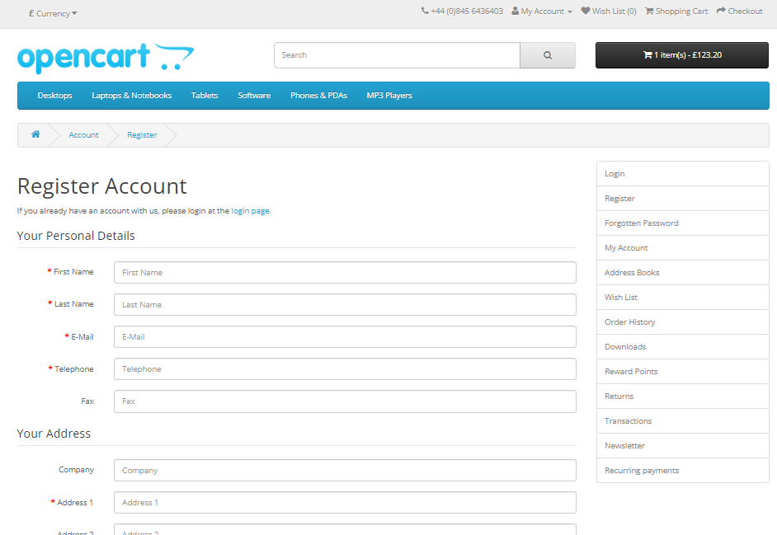

*Screenshot: Account Registration Page*

**3.2.2 Login**

Registered users must be able to log in using their email and password. The system should authenticate users and grant access to their account dashboard.

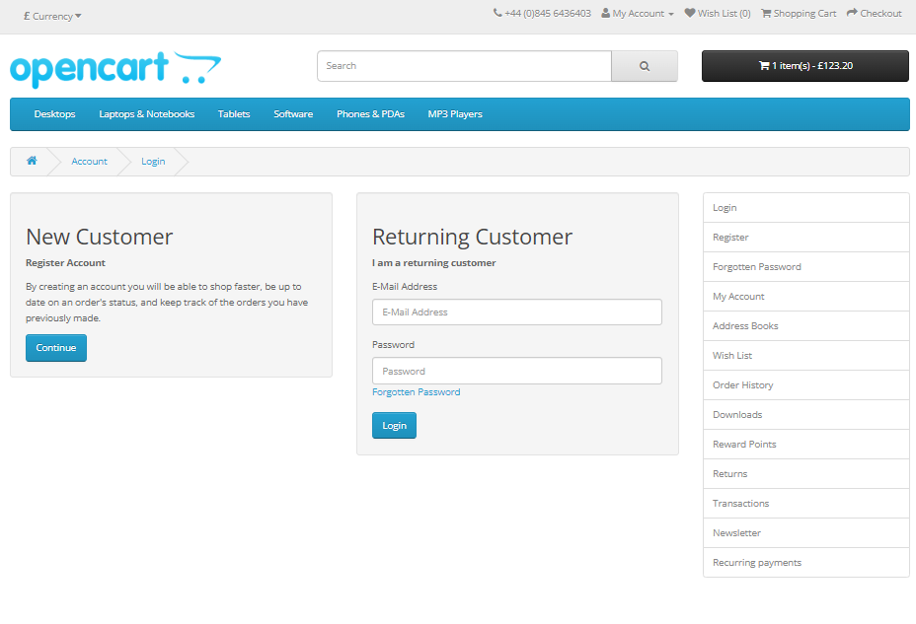

*Screenshot: Login Page*

**3.2.3 Profile Management**

Users must be able to view and edit their profile information. The system should save changes and update the user’s profile.

**3.2.4 Order History**

Users must be able to view their past orders. Each order should display details such as order date, items, total amount, and status.

**3.3 Order Management and Tracking**

**3.3.1 Order Placement**

The system must record and store details of each order placed by a user. An order confirmation should be sent to the user via email.

**3.3.2 Order Tracking**

Users must be able to track the status of their orders. The system should update the order status in real-time.

**3.4 Contact Us**

The Contact Us page allows users to get in touch with the website administrators or customer support. Here are the functional requirements for this page:

**3.4.1 Contact Form**

* Users should be able to access a contact form on the Contact Us page.
* The form should include fields for the user’s name, email address, subject, and message.
* Validation rules should ensure that required fields are filled out correctly.
* Upon submission, the form should send an email notification to the website administrators.

**3.4.2 Display Contact Information**

* The Contact Us page should display relevant contact information, such as the company’s address, phone number, and email address.
* Users should be able to see this information without filling out the contact form.

**3.4.3 Confirmation Message**

* After submitting the contact form, users should receive a confirmation message indicating that their message has been successfully sent.
* Consider providing a reference number or tracking ID for follow-up purposes.

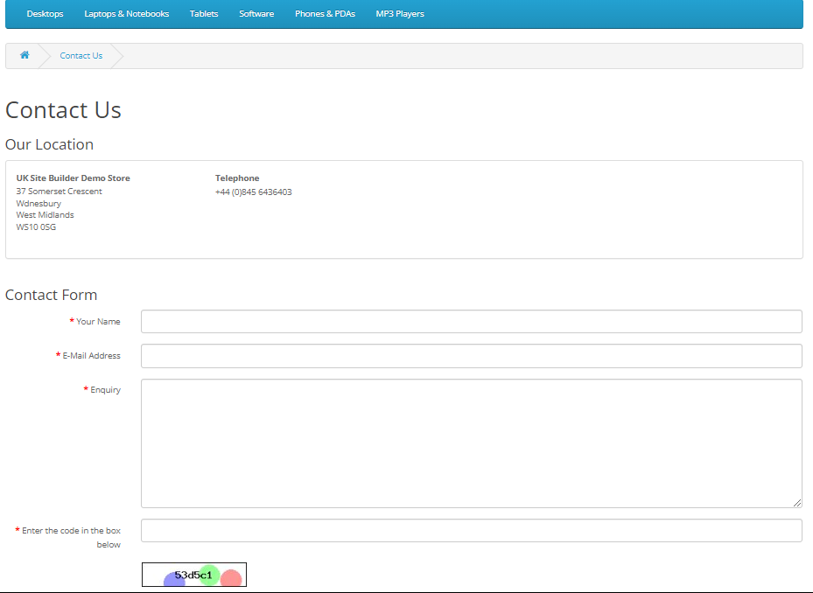

*Screenshot: Contact Us*

**3.2.3 Captcha or Anti-Spam Measures**

* To prevent spam submissions, consider implementing a CAPTCHA or other anti-spam measures on the contact form.
* This helps ensure that genuine inquiries reach the administrators.

**3.5 Integration with Payment Gateways**

**3.5.1 Payment Processing**

The system must integrate with multiple payment gateways for processing transactions. Payment gateways should handle various payment methods, including credit/debit cards and digital wallets.

**3.5.2 Security**

The system must ensure that payment information is encrypted and handled securely. Payment processing should comply with relevant security standards and regulations.

**3.6 Admin Module and Workflows**

**3.6.1 Product Management**

Administrators must be able to add, update, and delete products. The system should allow for bulk product uploads and updates.

**3.6.2 Order Management**

Administrators must be able to view and manage orders. The system should provide tools for updating order statuses and handling customer inquiries.

**3.6.3 User Management**

Administrators must be able to manage user accounts, including registration approvals and account deletions. The system should log administrative actions for audit purposes.

**3.7 Web and Mobile Site**

**3.7.1 Compatibility**

The website must be compatible with major browsers (IE, Chrome, Firefox). The website must be responsive and accessible on mobile devices.

**3.8 Performance**

**3.8.1 Load Handling**

The system must handle at least 1000 concurrent users without performance degradation. Load testing should ensure the system’s scalability and reliability under peak loads.

**3.9 Security**

**3.9.1 Vulnerability Testing**

The system must be tested for vulnerabilities, particularly those listed in the OWASP Top 10. Regular security assessments should be conducted to identify and mitigate risks.

**4. Non-Functional Requirements**

**4.1 Usability**

The website must be easy to use, with intuitive navigation and accessible interfaces. Usability testing should include feedback from at least 10 end users.

**4.2 Performance**

The website must load within 2 seconds under normal conditions. Performance metrics should be monitored and optimized continuously.

**4.3 Reliability**

The system must have an uptime of at least 99.9%. Redundant systems should be in place to ensure high availability.

**5. Deliverables**

* Functional test cases and reports
* Performance test scripts and results
* Security vulnerabilities report
* User acceptance testing report
* Test coverage and defect reports
* Automation regression suite

**6. Testing Team & Schedule**

**6.1 Team**

A testing team of 5 members is required for a 4-month testing effort.

**6.2 Schedule**

* April: Functional and security testing
* May: Load/performance testing
* June: Compatibility testing, UAT
* July: Regression testing

**7. Entry & Exit Criteria**

**7.1 Entry Criteria**

User stories to be tested must meet the defined 'Ready for Testing' criteria.

**7.2 Exit Criteria**

Testing completes when all test cases execute with no critical defects outstanding.

**8. Risks**

* Delay in test environment availability
* Lack of access to third-party payment systems
* Complex workflows may require more time and resources