BI4016 Research Project Thesis 2024/2025 School of Biological Sciences

Road collisions and deer; a growing problem?

Student ID: 52425761

Work completed in partial fulfilment of the requirements for the degree BSc Honours Zoology
Word count (excluding references and legends): 4632

Abstract
Road networks are expanding globally and create persistent pressures for wildlife, including high levels of wildlife–vehicle collisions. In Scotland, roe deer (Capreolus capreolus) are widespread and regularly recorded in human-modified landscapes, raising concerns about collision risk. Yet, in mixed farmland–woodland mosaics, it remains unclear whether roe deer reduce their use of roadside habitats, or whether they continue to occupy areas close to roads despite associated disturbance. This study investigated whether road proximity influences roe deer occupancy in a farmland–woodland landscape in north-east Scotland, and how road-related and habitat variables shape spatial patterns of site use.
I analysed camera-trap data from 43 locations monitored over 14 repeated 24-hour sampling occasions using a Bayesian single-season occupancy model. Site-level covariates included distance to the nearest road, distance to the nearest main road, distance to the nearest building, and dominant vegetation type (woodland, arable and garden). Survey-level covariates (temperature, rainfall and wind speed) were used to model variation in detection probability.
Estimated occupancy was generally high across the study area (typically ~0.70–0.95), and there was little evidence that increasing distance to either main or secondary roads systematically altered occupancy probability. Woodland sites tended to have slightly higher predicted occupancy than arable or garden sites, but credible intervals were wide and strongly overlapping. Together, these results indicate that roe deer commonly use habitats both near to and farther from roads, and do not exhibit strong road-avoidance behaviour within this landscape.
From a management perspective, the combination of high occupancy near roads and weak road-distance effects suggests that the risk of deer–vehicle collisions is likely to be distributed along many road sections rather than concentrated at a few predictable crossing points. Mitigation planning may therefore be more effective when it considers longer stretches of road where suitable roe deer habitat coincides with substantial traffic, rather than relying solely on highly localised warning signs.Introduction
Introduction
Roads are among the most widespread linear human infrastructures globally and have profound effects on the structure and functioning of terrestrial ecosystems (Coffin, 2007). A large body of research has shown that roads not only fragment habitats, but also alter wildlife movement routes, habitat selection and population dynamics through barrier and filter effects, visual and acoustic disturbance, and increased mortality risk associated with traffic (Spellerberg, 1998; Forman & Alexander, 1998). These impacts are particularly pronounced in medium- and large-bodied mammals, often manifesting as behavioural changes, reductions in home-range size, shifts in foraging strategies, and elevated risks of wildlife–vehicle collisions (Forman & Alexander, 1998; Seiler, 2001; McLellan & Shackleton, 1988).
In Europe, deer–vehicle collisions represent one of the most common forms of wildlife–vehicle conflict. In countries such as Sweden and Germany, tens of thousands of collisions are reported annually, with roe deer (Capreolus capreolus) accounting for a substantial proportion of recorded incidents (Bruinderink & Hazebroek, 1996). In the United Kingdom, continued increases in deer abundance and spatial expansion have led to an estimated 20,000–42,000 deer–vehicle collisions each year, approximately 20% of which occur in Scotland (Putman et al., 2004). These collisions pose serious risks to road users and generate considerable economic costs, making them a long-standing issue in both road safety and deer management in the UK (Putman, 1997).
Roe deer are the most widespread deer species in Scotland, highly adaptable, and commonly found in agricultural and peri-urban landscapes. Within the farmland–woodland mosaic landscapes typical of much of Scotland, roe deer are widely distributed and frequently occur near roads, making them a focal species in discussions of road safety and deer management.However, the existing road ecology literature is unevenly distributed across species and landscape contexts. Many studies focus on larger, intensively managed ungulates such as red deer (Cervus elaphus) or on large, contiguous forest systems in continental Europe (Meisingset et al., 2013), whereas comparatively few examine roe deer in farmland–woodland mosaic landscapes.
More critically, many studies of deer–vehicle collisions rely primarily on retrospective collision records to predict where and when future collisions are likely to occur (Cunningham et al., 2022). Such approaches focus on where accidents have already happened, rather than on how deer use habitats near roads under normal conditions. As a result, they cannot readily distinguish between road sections that are regularly used by deer and those where collisions occur due to rare or opportunistic crossings by individual animals. They may also bias analyses towards high-traffic roads, potentially under-representing areas with lower or moderate traffic volumes but frequent deer activity.
From a behavioural ecology perspective, the risk-tolerance framework suggests that when disturbances associated with roads are largely non-lethal and relatively predictable, animals may gradually increase their tolerance through repeated exposure, reducing strong avoidance responses over time (Sutherland, 1998; Courbin et al., 2022). Under such conditions, it cannot be assumed a priori that deer will actively avoid roads to reduce collision risk. Instead, their spatial use of habitats across road-distance gradients must be tested using quantitative data, particularly in farmland–woodland mosaic landscapes such as those found in north-east Scotland.
Compared with approaches based solely on collision records, occupancy models offer a means of directly assessing habitat use prior to collision events. Using camera-trap data, occupancy models estimate both whether a site is used by a species (occupancy) and the probability that the species is detected if present (detection), explicitly accounting for imperfect detection, including situations in which roe deer are present but not recorded by cameras (MacKenzie et al., 2017). This framework allows the effects of road distance and environmental covariates on site use to be evaluated while controlling for detection bias, rather than inferring risk patterns solely from past collision data.
Against this background, this study uses camera-trap data and a Bayesian single-season occupancy model to assess the relationship between roe deer occupancy probability and distance to the nearest road in farmland–woodland mosaic landscapes of north-east Scotland. Vegetation type and other environmental variables were included as site-level covariates to control for underlying habitat preferences and to more clearly isolate the effect of road distance. The central research question is whether roe deer occupancy probability changes systematically with increasing distance from roads, indicating road-avoidance behaviour, or whether site use remains relatively high in close proximity to roads. Unlike approaches based solely on historical collision records, this study focuses on habitat use prior to collision events, aiming to test whether roe deer reduce the risk of vehicle encounters through spatial avoidance of roads. The results have potential implications for road safety and deer management by helping to identify road sections where mitigation measures such as speed reduction, fencing, or roadside vegetation management may be most effectively prioritised.

Materials and methods
3.1 Study Area
This study was conducted in Aberdeenshire, Scotland, during the summer of 2025. The study area is a typical farmland-woodland mosaic landscape, mainly composed of cultivated land, improved grassland, small patches of broadleaf forest and coniferous forest, interspersed with low shrub wasteland and rural or suburban settlements. These habitats are widely used by roe deer, providing them with abundant pasture and cover (Hewison et al., 2001). The vegetation types were classified using the habitat classification system in the UKCEH Land Cover Map 2019 (LCM2019).
3.2 Deployment of Infrared Camera Traps and Field Data Acquisition
From June 18 to August 20, 2025, a total of 45 infrared camera traps were deployed. The cameras were mounted on trees or fence posts approximately 40 cm above the ground, and their orientation was adjusted to avoid direct sunlight and obvious pedestrian paths, thereby reducing false triggering and accidental capture of people. Each camera operated continuously at each location for 14 days before being moved to a new location.
After camera retrieval or relocation, batteries were replaced, and the field of view was adjusted as needed. At each camera location, basic environmental information was recorded using the Epicollect5 mobile application, including GPS coordinates, elevation, primary vegetation type, canopy cover, ground cover, and visible signs of human activity. All deployments were authorized by the landowners, and camera locations were chosen to minimize the likelihood of capturing images of identifiable people.
3.3 Construction of Detection History
Although a total of 45 cameras were deployed, two cameras failed to provide usable data due to equipment failure or data loss; therefore, the final analysis was based on 43 camera sites. All camera images were manually reviewed. For each camera site, each 24-hour period was considered a sampling period, with 14 repeated samplings per site. If at least one image of a roe deer was recorded within a given 24-hour period, the detection result for that period was coded as 1; otherwise, it was coded as 0. This resulted in a 43 × 14 binary detection history matrix, which formed the basis of the occupancy analysis.
3.4 Environmental Covariates
Two sets of covariates were used in the occupancy model. At the site level, three continuous covariates were included: distance to the nearest road, distance to the nearest main road, and distance to the nearest building. Additionally, a categorical covariate describing the primary vegetation type was used; each camera site was categorized as woodland, cultivated land, or garden, with woodland serving as the reference level in the model. Distances were measured using Google Maps' distance measurement tool. For each camera location (defined by its Epicollect5 coordinates), the shortest straight-line distances to the nearest road, nearest main road, and nearest building were recorded. The same measurement procedure was used for all sites to ensure comparability between different sites.

At the survey level, three meteorological covariates were used for each 24-hour sampling period: daily average temperature, daily rainfall, and average wind speed. Meteorological data were obtained from the NASA POWER (Global Energy Resources Prediction) database, which provides gridded daily meteorological variables. Before model fitting, all continuous covariates were standardized by z-scores (mean = 0, standard deviation = 1) to improve numerical stability and model convergence.
3.5 Bayesian occupancy model
All analyses were conducted in R version 4.2.2 using the spOccupancy package to fit a single-season Bayesian occupancy model (Doser et al., 2022). The model consists of a latent state process describing true site use and an observation process describing detections conditional on site use.
For each site i, the true occupancy state zᵢ was modelled as:
zᵢ ~ Bernoulli(ψᵢ),
where ψᵢ represents the probability that roe deer use site i. Site-level covariates were linked to ψᵢ through a logit-linear model:
logit(ψᵢ) = β₀ + β₁ · dist_roadᵢ + β₂ · dist_mainroadᵢ + β₃ · dist_buildingᵢ
+ β₄ · Arableᵢ + β₅ · Gardenᵢ.
Here, dist_roadᵢ, dist_mainroadᵢ, and dist_buildingᵢ denote the z-score–standardised Euclidean distances from site i to the nearest road, main road, and building, respectively. Vegetation type was included as a categorical predictor with three levels (woodland, arable land, and garden). Woodland was used as the reference category; therefore, Arableᵢ and Gardenᵢ are indicator variables taking a value of 1 when the dominant vegetation type at site i was arable land or garden, respectively, and 0 otherwise.
For each site i and survey occasion j, the observed detection outcome yᵢⱼ was modelled as:
yᵢⱼ ~ Bernoulli(pᵢⱼ · zᵢ),
where pᵢⱼ represents the probability of detecting roe deer during survey occasion j, conditional on the species using site i. Detection probability was modelled as a function of survey-level meteorological covariates:
logit(pᵢⱼ) = α₀ + α₁ · tempᵢⱼ + α₂ · rainᵢⱼ + α₃ · windᵢⱼ,
where tempᵢⱼ, rainᵢⱼ, and windᵢⱼ represent the standardised daily mean temperature, daily rainfall, and mean wind speed at site i during survey occasion j, respectively.
3.6 MCMC settings and convergence assessment
The occupancy model was fitted using the spOccupancy package with four parallel Markov chain Monte Carlo (MCMC) chains, each run for 4,000 iterations. The first 500 iterations of each chain were discarded as burn-in, leaving 3,500 posterior samples per chain (14,000 samples in total) for inference. No thinning was applied (n.thin = 1).
Model convergence was assessed using standard diagnostic methods. Trace plots for all parameters indicated good mixing across chains with no apparent trends, and Gelman–Rubin R̂ statistics ranged between 1.00 and 1.01, indicating that all chains had converged to a common posterior distribution.
Results
4.1 Roe deer detection and occupancy patterns
Roe deer were recorded at least once at 37 of the 43 camera-trap sites, representing 86% of all sampling locations. This naïve occupancy proportion does not account for imperfect detection and therefore reflects only whether the species was ever recorded at a site. Across the 14 repeated survey occasions, detection frequencies varied among sites: some cameras recorded roe deer only occasionally, whereas others detected repeated activity across multiple surveys.
After accounting for imperfect detection and environmental covariates, the Bayesian occupancy model estimated generally high levels of site use across the study area, with a mean occupancy probability of approximately ψ ≈ 0.84 across all sites. Posterior mean occupancy probabilities for individual sites ranged from approximately 0.55–0.60 to 0.90 or higher, indicating a difference of around 30 percentage points among sites (Figure 1). This suggests that, although roe deer are a common species in the study area, their intensity of space use varies substantially between sampling locations.
These differences did not form a simple north–south or east–west gradient, but instead were characterised by localised variation in occupancy probability (Figure 1). Sites with relatively low occupancy probabilities (approximately 0.55–0.60; shown as blue and dark green points) were interspersed with clusters of sites exhibiting high occupancy (ψ close to or exceeding 0.9; predominantly yellow points). Such spatial clustering of high and low site use was particularly evident in the eastern and north-eastern parts of the study area (Figure 1). Overall, roe deer were widely distributed throughout the study region, but predicted occupancy probabilities nonetheless showed pronounced local variation among sites.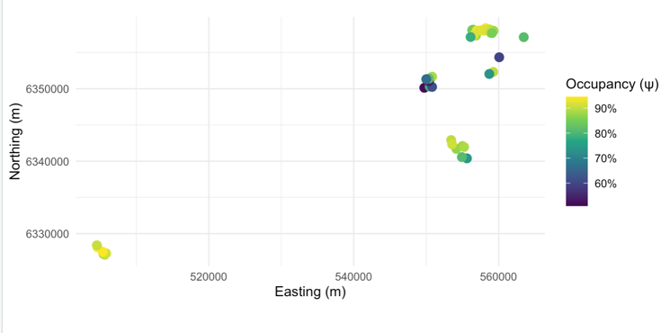
Figure 1. Spatial variation in predicted occupancy (ψ) of roe deer across the study area. Points represent camera locations, coloured by posterior mean occupancy probability from the Bayesian single-season occupancy model. Coordinates are shown in British National Grid Easting and Northing.
4.2 Model diagnostics
To assess model performance, MCMC trace plots and posterior distributions were examined for all parameters in the occupancy and detection models. For all parameters, chains fluctuated around stable central values with no evidence of systematic trends or drift, and posterior densities showed substantial overlap across chains, indicating adequate model convergence.
Corresponding trace plots and posterior density plots are technical in nature. To avoid repetition of similar figures in the main text, these diagnostics are presented in Appendix A (Figures S1–S3) and are provided for reference where needed.
4.3 Environmental covariates and model estimates
4.3.1 Site-level covariates and occupancy probability
The Bayesian single-season occupancy model indicated that roe deer maintained generally high predicted occupancy probabilities across the observed ranges of all three distance covariates (Figures 2a–c). Along the gradient of distance to the nearest road, mean ψ values remained close to 0.9 across the sampled range, with little overall variation. Mean ψ showed a slight decrease with increasing distance from the nearest main road, whereas a slight increase was observed with increasing distance from the nearest building. For all three covariates, the 95% credible intervals were wide and showed substantial overlap across their respective ranges.
Predicted occupancy probabilities were similarly high across the main vegetation types (Figure 2d). Woodland sites showed slightly higher mean ψ values than arable land and garden sites; however, the 95% credible intervals for all three vegetation categories were wide and largely overlapping, providing no clear evidence of strong differences in occupancy among dominant vegetation types.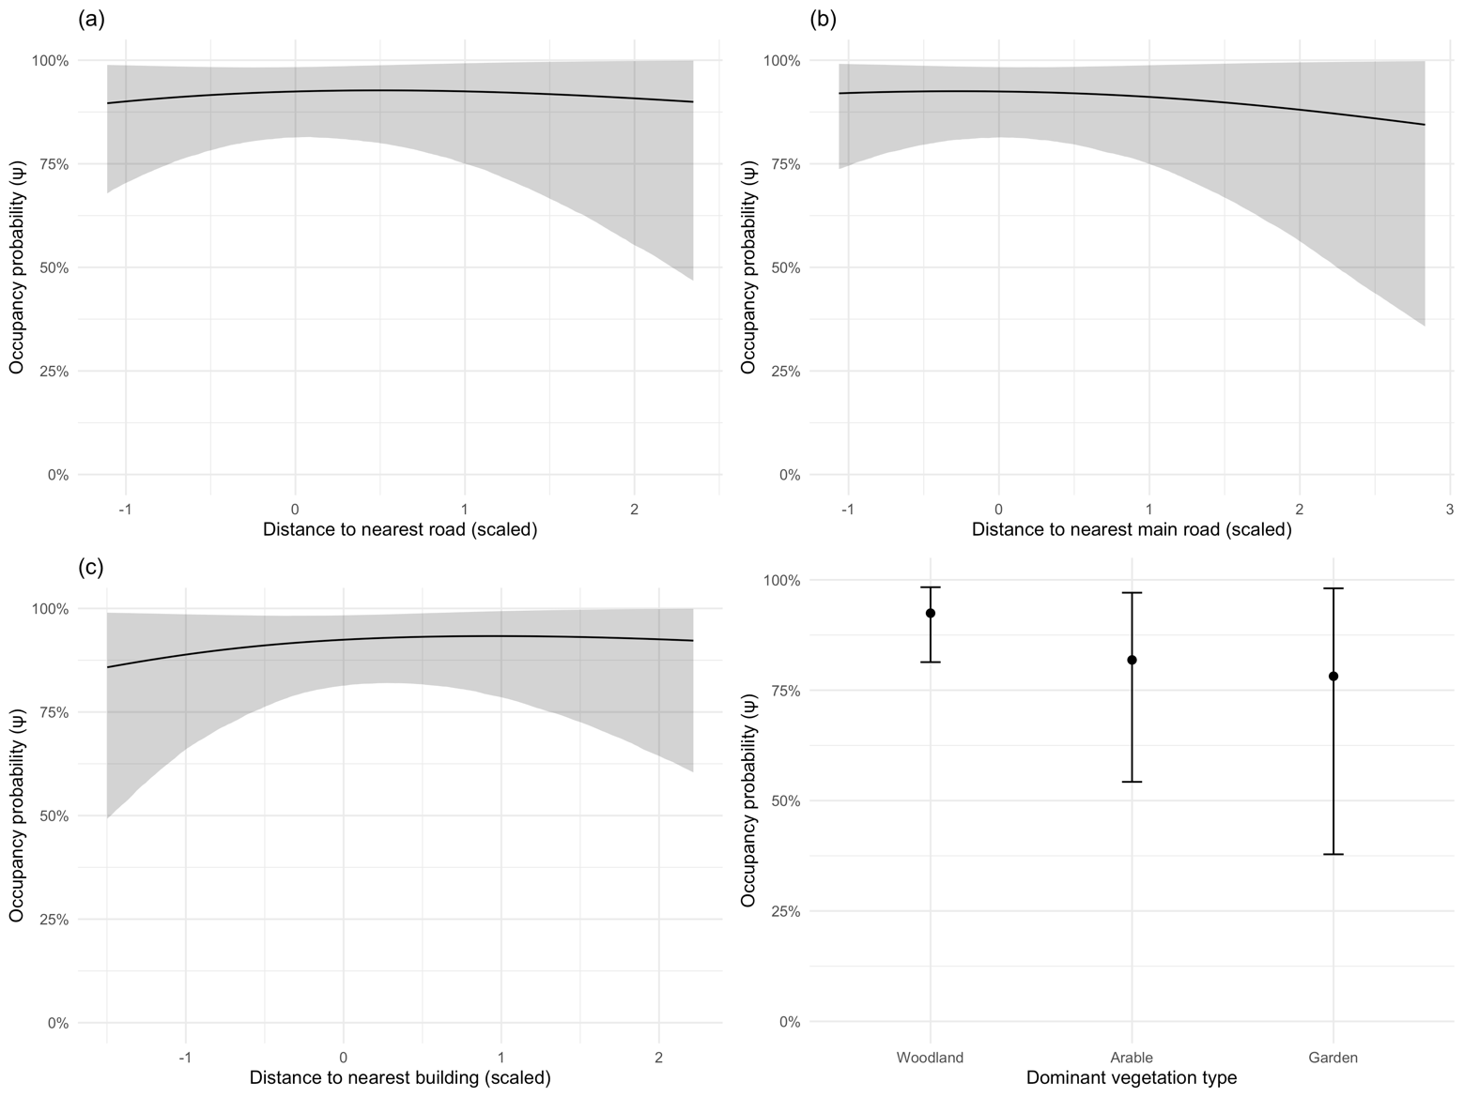
Figure 2. Effects of site-level covariates on predicted occupancy (ψ) of roe deer from the Bayesian single-season occupancy model.
(a) Distance to nearest road (scaled).
(b) Distance to nearest main road (scaled).
(c) Distance to nearest building (scaled).
(d) Dominant vegetation type (Woodland, Arable, Garden).
Lines show posterior mean predictions and shaded ribbons show 95% credible intervals for continuous covariates (a–c).
Points indicate posterior means and vertical lines indicate 95% credible intervals for vegetation categories (d).
4.3.2 Survey-level covariates and detection probability
Across varying meteorological conditions, detection probability remained at a moderate level overall, with mean p values generally ranging between 0.3 and 0.6. Estimates from the detection model indicated negative relationships between detection probability and both temperature and rainfall, whereas wind speed was positively associated with detection probability.
However, the 95% credible intervals associated with these meteorological covariates were wide and showed substantial overlap across the observed covariate ranges. This indicates that, although directional trends can be identified in the model, the strength of these effects is subject to considerable uncertainty. Predicted relationships and their corresponding credible intervals are presented in Appendix Figure A1.
Discussion
5.1 The core objective of this study was to assess how road distance influences the occupancy probability of roe deer in the study area, and whether roe deer show road avoidance and thus pose a reduced risk to drivers.. Although the Bayesian occupancy model included multiple environmental covariates and explicitly accounted for imperfect detection, the estimated effects of distance to primary and secondary roads were weak, with 95% credible intervals overlapping zero. This pattern does not necessarily indicate that the analysis was underpowered; rather, under the fitted model, there is little evidence that roe deer occupancy changes systematically with road distance. In this study area, the results therefore provide little evidence of clear road avoidance in occupancy (site use).
5.2 This interpretation is consistent with the overall results. Predicted occupancy probabilities were generally high across sampling points and showed no clear, regular pattern along the road-distance gradient, suggesting that roe deer are widely distributed in the study area and that site use remains relatively high even close to roads. Compared with arable land and gardens, woodland was predicted to have slightly higher occupancy, consistent with previous findings that structurally complex vegetation provides both forage and cover, enabling roe deer to maintain concealment even within human-modified landscapes (Hewison et al., 2001). Meteorological covariates were included in the detection model to account for imperfect detection, but these parameters are not the focus of the present study and are therefore not discussed in detail here.
5.3 The findings of this study are consistent with a broader body of literature indicating that roe deer responses to human disturbance are context-dependent. Roe deer space use is influenced by local disturbance intensity, vegetation structure, and landscape configuration, and populations in different regions may adopt different behavioural strategies (Gill, 1992; Hewison et al., 2001). In parts of continental Europe, dense road networks and high traffic volumes have been shown to restrict roe deer activity, producing road-avoidance patterns and acting as partial barriers or high-risk areas (Märtz et al., 2024; Forman & Alexander, 1998). In contrast, the road network in this study area primarily traverses woodland–farmland mosaics with good vegetation cover, and most roads experience relatively low traffic volumes. These conditions may reduce perceived risk for roe deer, allowing site use to remain high near roads.
Accordingly, the weak road-distance effect estimated by the occupancy model is consistent with roads acting as a relatively minor disturbance in this landscape rather than a strong physical barrier. Given that suitable habitat remains available on both sides of roads and overall traffic pressure is relatively low, road distance may have limited influence on occupancy probability. In other words, roe deer may still use habitats near roads, and roads themselves may not substantially reshape their spatial distribution in this study area.
5.4 Local studies in the UK also support this interpretation. Roe deer frequently use areas near roads and, in some cases, may exploit roadside habitats as resource-rich foraging grounds (Märtz et al., 2024; Ward, 2005). In landscapes where roads do not form large, continuous barriers, roe deer spatial strategies may be influenced more by the distribution of food and cover than by the presence of roads alone. From a behavioural ecology perspective, this pattern aligns with the risk-tolerance framework, which proposes that animals can learn to increase tolerance to predictable, non-lethal human disturbance (Sutherland, 1998; Courbin et al., 2022). Repeated exposure to mild disturbance may gradually increase tolerance and reduce the energy costs of repeated flight responses, allowing individuals to continue using favourable habitats near human activity.
In summary, the weak road-distance effect observed in the occupancy model is unlikely to be anomalous and may be consistent with a system in which roadside resources are available and disturbance is frequent but typically non-lethal. Under such conditions, increased tolerance could mean that clear road avoidance is not expressed at the occupancy (site-use) level.
5.5 Precisely because the occupancy model fitted in this study did not reveal clear road-avoidance behavior, road-related management issues become even more critical. In this study area, roe deer had a high occupancy rate near roadside habitat; combined with the generally high roe deer density across Scotland, this means that the potential probability of deer-vehicle encounters on roads with moderate to high traffic volume is considerable. Early assessments in the UK have documented a large and continuously increasing number of deer-vehicle collisions and their economic costs (Putman, 1997; Bruinderink & Hazebroek, 1996). Although these estimates are decades old, they indicate that "deer on the road" has long been considered a significant safety and management issue.
In this context, the results of this study directly address the core research question: whether the occupancy probability of roe deer changes systematically with road distance, thus exhibiting significant road-avoidance behavior. The results show that in this study area, this occupancy pattern varying with road distance is very weak; roe deer do not spontaneously reduce the risk of encountering vehicles by actively moving away from the road. In other words, behavioral avoidance does not provide a reliable "natural buffer" for drivers, highlighting the need for targeted mitigation measures based on specific traffic conditions and local habitat structure, rather than simply relying on deer spontaneously moving away from roads.
Furthermore, the weak road distance effect in the occupancy model itself has management implications. Model estimation results show that the occupancy probability of roe deer at sampling points near and far from roads is roughly equal, indicating that the roads in this study area do not effectively exclude roe deer from nearby habitats. In this case, the potential risk of deer-vehicle encounters is likely not limited to a few known crossing points, but may occur on multiple road sections, especially on sections with high traffic volume and suitable habitats for roe deer activity on both sides. This spatial pattern means that collision risk is better assessed holistically over longer road sections, rather than focusing on individual point locations.
In this situation, relying solely on a few static warning signs, such as fixed "Deer crossing" signs, is unlikely to match the flexible and spatially dispersed activity patterns of roe deer. In other words, if management measures assume that "roe deer only cross a few fixed road sections," the actual risks in other road sections may be underestimated. This aligns with Sutherland's (1998) view: management measures that ignore animals' actual spatial utilization patterns often fail to achieve the desired results. In this study, multiple sampling points on the road network showed high occupancy probabilities, suggesting that collision risks are spatially dispersed. Combining the above theories, it can be argued that setting up local signs only on individual road sections is insufficient to cover the main risk areas; in contrast, implementing broader mitigation measures on road sections with frequent roe deer activity and high traffic volume, such as reducing speed limits, setting up targeted fencing in key areas, or appropriately adjusting roadside vegetation management, is more likely to achieve better mitigation results.
5.6 This study has several significant limitations in terms of methodology and data, which need to be considered when interpreting the results and designing future research. First, road impact was simplified to "Euclidean distance to the nearest road" in this study. This distance-based indicator cannot distinguish between different road types or levels of disturbance—such as side roads versus high-traffic arterial roads—and does not incorporate differences in traffic flow, speed limits, noise, or lighting. These factors are likely to influence roe deer's use of roadside habitat; therefore, simple distance measurements can only roughly approximate road-related disturbances, potentially underestimating or masking the true gradient of road impacts and weakening the detectability of road distance effects in the model to some extent. Future research, by incorporating more refined road information, such as traffic flow, speed limits, road class, or simple noise and lighting indicators, could potentially examine whether roe deer respond differently to low-disturbance and high-disturbance roads, thus distinguishing between the two explanations: "roe deer do indeed have high tolerance for roads" and "the coarse indicator failed to capture key differences."
Second, the occupancy model used in this study only measured the presence/absence of roe deer at each camera location, rather than their number or group size. Roe deer can appear alone or in small groups, and their local density is likely to vary with habitat quality and management practices. From an ecological and road safety perspective, locations used occasionally by many individuals may pose different risk levels than locations used frequently by a single individual, but presence/absence data treats these two scenarios as equivalent. Joseph emphasized that observed wildlife records are influenced by both actual population variations and detection processes; in contrast, presence/absence data only retains the "present or absent" status, failing to reflect the impact of population variations and incomplete detection. In this study, the occupancy model framework is sufficient to describe the overall pattern of site use within the road network, but it cannot reveal how roe deer populations or group sizes change with road distance, nor can it determine whether roads primarily affect local density or only "present or absent" status.
To address this limitation, future research could incorporate abundance or group size information based on camera monitoring. For example, applying N-mixture models or other count-based methods to repeated camera recordings of the same location can estimate local abundance while considering incomplete detection, thus answering questions such as "Does the road alter the number of roe deer near different distances and road types?" and "Which road segments have a higher concentration of individuals potentially exposed to traffic risks?" Furthermore, combining occupancy or abundance estimates with traffic flow and recorded deer-vehicle collision data can establish collision risk prediction models on road networks. These models can be used to examine whether road segments with "high roe deer utilization + high traffic flow" are truly high-risk collision areas, and based on this, identify road segments that require priority for mitigation measures.
5.7 Overall, this study used a single-season Bayesian occupancy model to analyze camera trap data and examine whether roe deer in northern Scotland mitigate risk by reducing their use of roadside habitat. The results showed that the predicted occupancy rate of roe deer was generally high in the study area, and the effect of road distance on the estimation probability of occupancy was weak and unstable. Only woodland showed a slightly higher utilization level compared to cultivated land and gardens. This indicates that in the woodland-farmland mosaic landscape represented by this study, roe deer do not exhibit significant road avoidance behavior, but rather extensively utilize habitats close to roads.
From a broader perspective of road ecology, this study supports the view that road effects are context-dependent: the impact of roads on the spatial distribution of wildlife changes with landscape structure and disturbance patterns, and is not always a strong negative effect. For management, this means that roe deer behavior itself is unlikely to provide a "natural buffer" against road collisions. Road safety strategies should be developed under the assumption that roe deer will continue to use roadside habitats, and targeted mitigation measures such as speed limits, fencing, or curb vegetation management should be prioritized in sections of road with frequent deer activity and high traffic volume.

Reference list

Bruinderink, G. G., & Hazebroek, E. (1996). Ungulate traffic collisions in
Europe. Conservation biology, 10(4), 1059-1067.

Cunningham, C. X., Nuñez, T. A., Hentati, Y., Sullender, B., Breen, C., Ganz, T. R.,
Kreling, S. E. S., Shively, K. A., Reese, E., Miles, J., & Prugh, L. R. (2022).
Permanent daylight saving time would reduce deer-vehicle collisions. Current biology
: CB, 32(22), 4982–4988.e4. https://doi.org/10.1016/j.cub.2022.10.007

Courbin, N., Garel, M., Marchand, P., Duparc, A., Debeffe, L., Börger, L., & Loison,
A. (2022). Interacting lethal and nonlethal human activities shape complex risk
tolerance behaviors in a mountain herbivore. Ecological Applications, 32(7), e2640.

Coffin, A. W. (2007). From roadkill to road ecology: a review of the ecological effects of roads. Journal of transport Geography, 15(5), 396-406.

Doser, J. W., Finley, A. O., Kéry, M., Zipkin, E. F., & Banerjee, S. (2022).
spOccupancy: An R package for single-species, multi-species, and spatially explicit occupancy models.
Methods in Ecology and Evolution, 13(8), 1670–1678.
https://doi.org/10.1111/2041-210X.13897

Forman, R. T., & Alexander, L. E. (1998). Roads and their major ecological effects.
Annual review of ecology and systematics, 29(1), 207-231.

Gill, R. M. A. (1992). A review of damage by mammals in north temperate forests: 1. Deer. Forestry: An International Journal of Forest Research, 65(2), 145-169.
Hewison, A. J., Vincent, J. P., Joachim, J., Angibault, J. M., Cargnelutti, B., & Cibien,
C. (2001). The effects of woodland fragmentation and human activity on roe deer
distribution in agricultural landscapes. Canadian journal of zoology, 79(4), 679-689.

Meisingset, E. L., Loe, L. E., Brekkum, Ø., Van Moorter, B., & Mysterud, A. (2013).
Red deer habitat selection and movements in relation to roads. The Journal of wildlife
management, 77(1), 181-191.

MacKenzie, D. I., Nichols, J. D., Royle, J. A., Pollock, K. H., Bailey, L., & Hines, J. E. (2017). Occupancy estimation and modeling: inferring patterns and dynamics of
species occurrence. Elsevier.

McLellan, B. N., & Shackleton, D. M. (1988). Grizzly bears and resource-extraction
industries: effects of roads on behaviour, habitat use and demography. Journal of Applied
Ecology, 451-460.

Märtz, J., Brieger, F., & Bhardwaj, M. (2024). Crossings and collisions–Exploring
how roe deer navigate the road network. Landscape Ecology, 39(5), 101.

Putman, R., Langbein, J., & Staines, B. W. (2004). Deer and Road Traffic Accidents,
a Review of Mitigation Measures: Costs and Cost-effectiveness. Inverness, UK:
Scottish Natural Heritage.

Putmam, R. J. (1997). Deer and road traffic accidents: options for
management. Journal of environmental management, 51(1), 43-57.

Seiler, A. (2001). Ecological effects of roads: a review.

Sutherland, W. J. (1998). The importance of behavioural studies in conservation
biology. Animal behaviour, 56(4), 801-809.

Spellerberg, I. A. N. (1998). Ecological effects of roads and traffic: a literature review. Global
Ecology & Biogeography Letters, 7(5), 317-333.

UKCEH. (2020). Land Cover Map 2019 (25m raster, GB). Environmental
Information Data Centre. https://doi.org/10.5285/0bbed23a-0286-45d0-8a56-
7bfc0f9b87b2

Ward, A. I. (2005). Expanding ranges of wild and feral deer in Great Britain. Mammal
Review, 35(2), 165-173.

Appendix

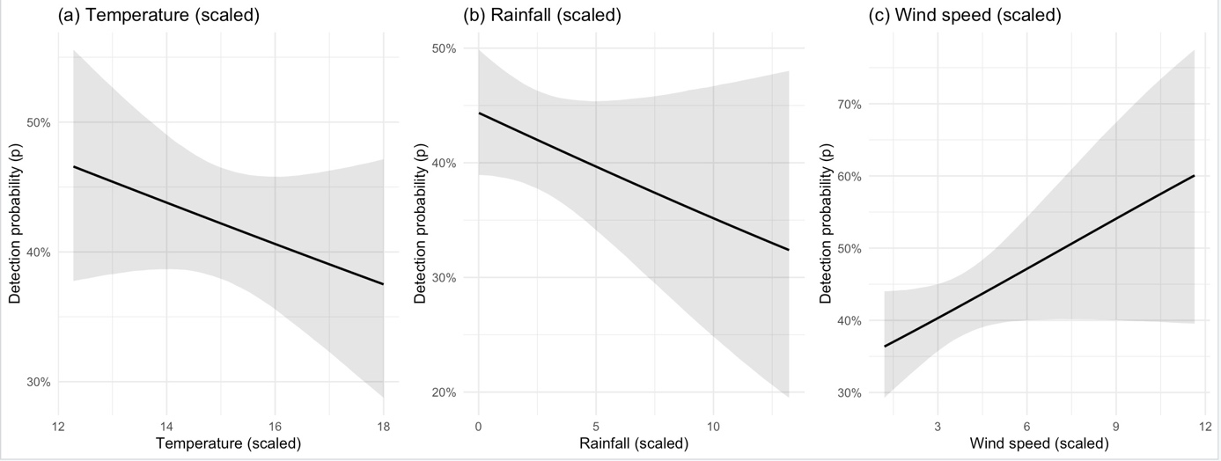
Appendix A. Survey-level covariates and detection probability
Appendix Figure A1.
Effects of survey-level meteorological covariates on detection probability (p) of roe deer. Panels show predicted relationships for (a) temperature (scaled), (b) rainfall (scaled), and (c) wind speed (scaled). Solid lines represent posterior mean predictions and shaded ribbons indicate 95% credible intervals. Detection probability is shown on the response scale, with all other covariates held at their median values.
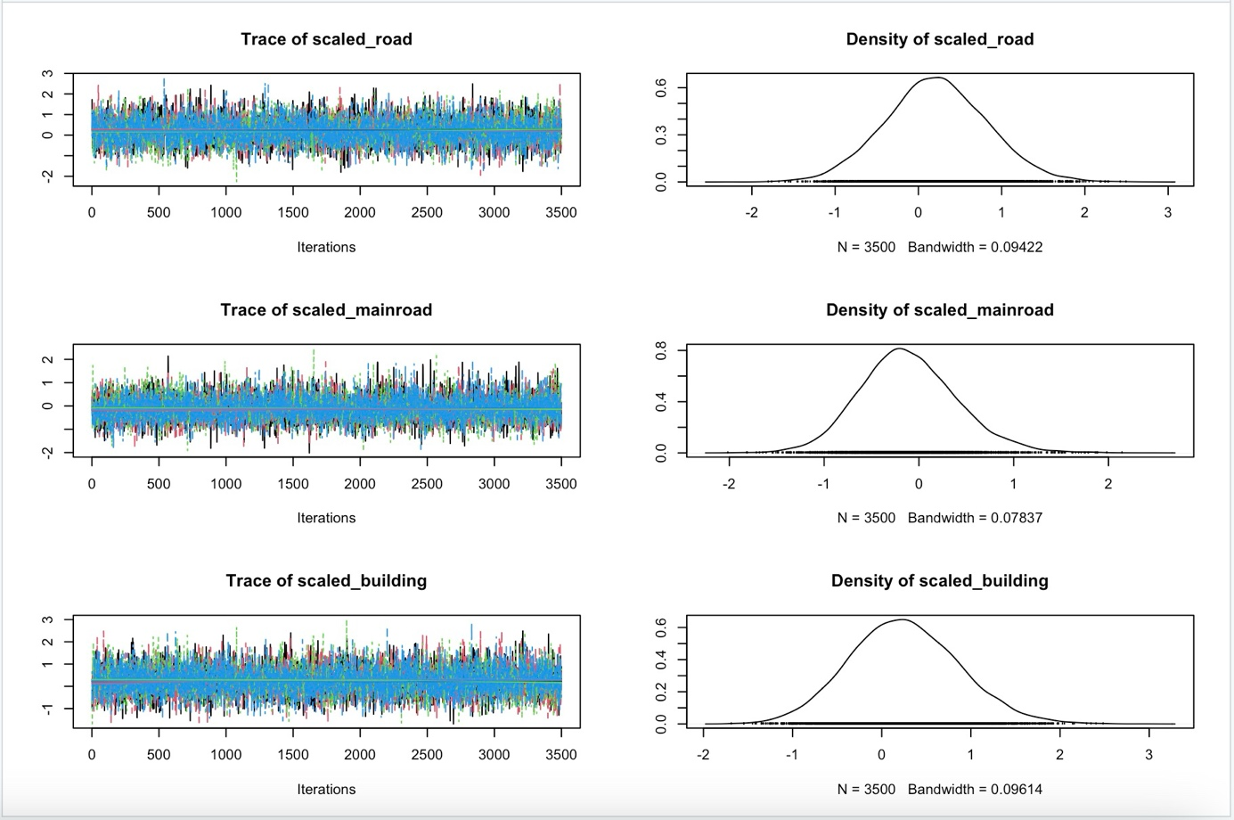
Figure S1.MCMC diagnostics for road-related occupancy covariates (ψ), including scaled distance to minor roads, scaled distance to main
roads, and scaled distance to buildings. Trace plots (left) demonstrate stable mixing across chains, while posterior densities (right) show
substantial overlap among chains. These patterns collectively indicate successful convergence for all road-distance parameters in the
occupancy sub-model.

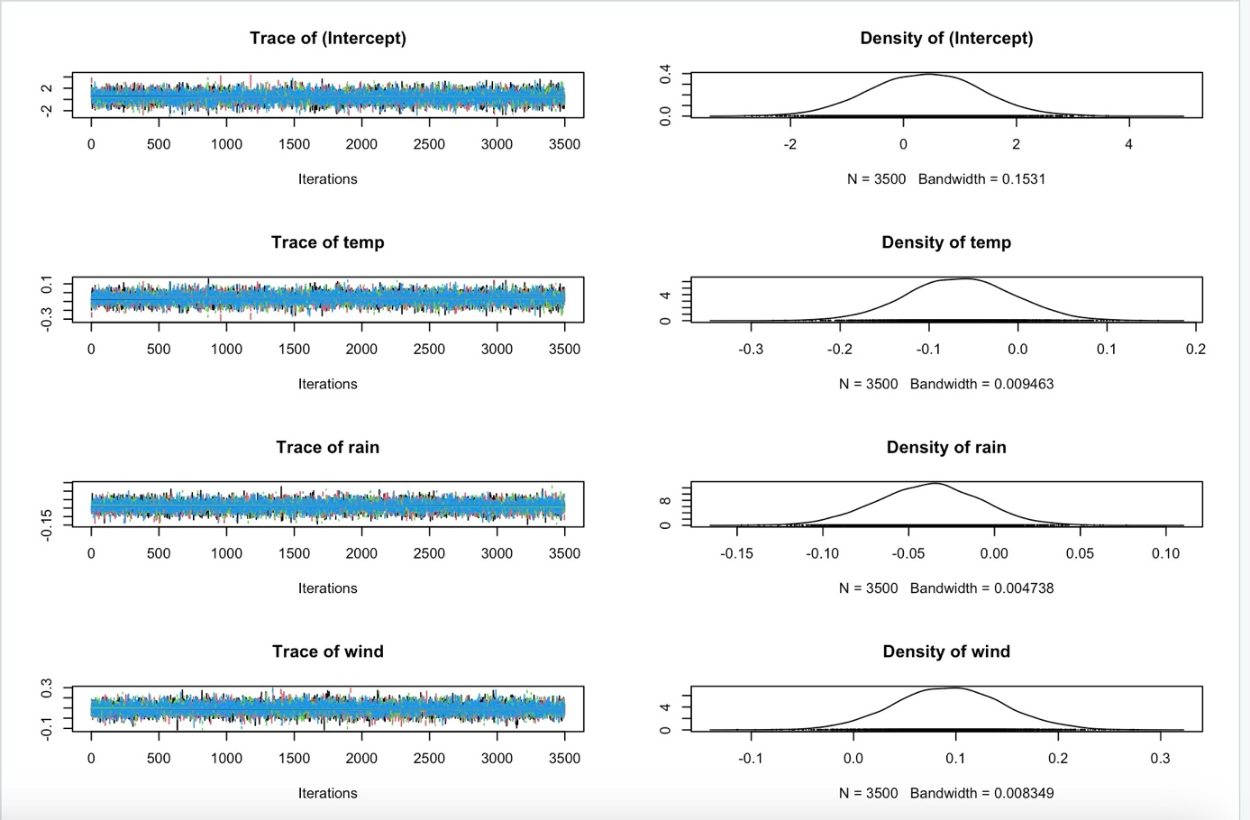
Figure S2.. Markov chain Monte Carlo (MCMC) diagnostics for the detection sub-model parameters (p), including the intercept,
temperature, rainfall, and wind speed. Left panels show trace plots for four parallel chains, all exhibiting good mixing with no visible
trends or drifts. Right panels show the corresponding posterior density estimates, with strong overlap among chains, indicating
satisfactory convergence of the detection component of the Bayesian single-season occupancy model.
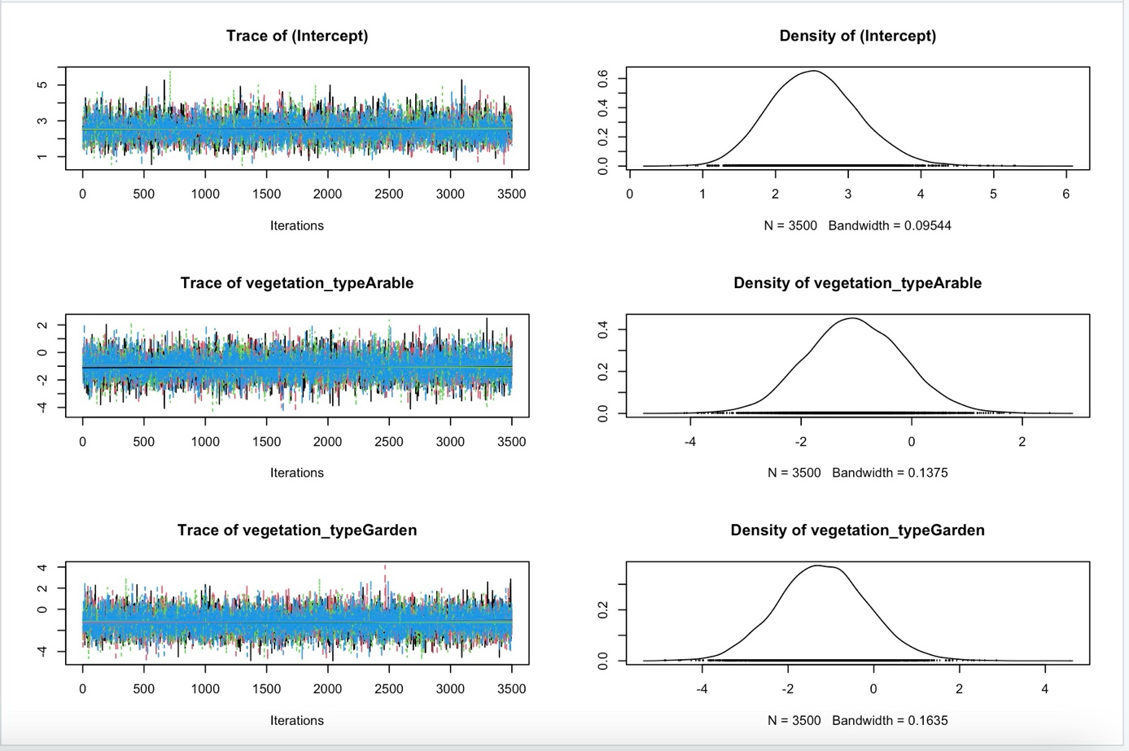
Figure S3.MCMC diagnostics for habitat-type occupancy covariates, including the intercept and vegetation types Arable and Garden
(with Woodland as the reference category). Trace plots (left) show well-mixed chains without drift, and posterior density plots (right)
reveal consistent distributions across chains, confirming adequate convergence for the habitat-related parameters of the occupancy model.

