Mathematics: Applications and Interpretation HL
Internal Assessment — Mathematical Exploration
Modelling the Effect of a Social Media Advertising Budget
on the Monthly Revenue of a Digital Startup
A comparison of linear and exponential regression models over a 30-month period
Research Question How well can a linear (y = mx + b) and an exponential (y = ab^{x}) function model the relationship between monthly social media advertising spend (x) and monthly revenue (y) for a digital startup over 30 months, and which model provides the stronger fit?

Table of Contents
Update this field to build the table of contents (in Word: select all with Ctrl+A, then press F9; it also updates automatically on opening).

1. Introduction and Context
I've always been intrigued by business and startups; growing up, I loved seeing how digital-first startups were able to grow so quickly with the help of digital marketing. These days, it seems as though digital advertising (think Instagram, TikTok, and Meta) is the primary source of new business for small startups. The issue with being a bootstrapped entrepreneur is that you are always in need of more capital. You are always trying to figure out how to best spend your money in a way that can guarantee at least a predictable return on investment. If your marketing doesn't pay for itself, then you'll simply run out of money.
When building out digital marketing plans for local businesses, I've noticed a recurring question: will revenue grow linearly with the increase in ad spend, or can I expect accelerating growth before I approach the ceiling of my potential market?
Being able to define this relationship mathematically can be very beneficial. Not only would it allow me to estimate how much a business should spend on advertising each month, but it could also help with budgeting expenses and improving margins.
For this investigation, I collected 30 months of financial data on a digital start-up. Because the month-by-month advertising and revenue figures of a single small business are commercially sensitive and are almost never published in full, the dataset I use is one I constructed myself to reflect realistic spend-and-revenue patterns, calibrating every value to publicly available industry benchmarks (typical small-business social-media budgets, average return on ad spend, and holiday sales spikes) that I cite throughout this exploration and list in the bibliography. I tracked the monthly advertising spend on social media versus the monthly net revenue.
Two possible types of relationships appeared as viable options for describing this type of relationship. A linear relationship would suggest that the conversion of ad spend into revenue occurs at a relatively constant rate. As a result, each dollar spent on additional advertising creates an equal amount of additional reach and therefore results in an equivalent proportionate increase in revenue. Conversely, an exponential relationship suggests that earlier successes with advertising create momentum due to positive feedback loops created by algorithms, word-of-mouth advertising, etc., which leads to increasing rates of return (i.e., revenue) rather than constant returns.
This lead me to ask my research question: How well can a linear (y = mx + b) and an exponential (y = ab^x) function model the relationship between monthly spend on social media advertising (x) and monthly revenue (y) for a digital startup over 30 months, and which model provides the stronger fit?
This project is intended to compare the degree to which the two functions described above represent how a small digital start-up's revenues respond to changes in advertising spends. Additionally, the degree to which each function can be relied upon for making practical budgetary decisions will be evaluated.
As a note, if this business had approached the limits of its potential addressable market, a Logistic Curve - one that rapidly grows to a limit - would be a more suitable model for describing the relationship than an unbounded exponential curve. Since however, this business is early stage and boot-strapped, and the data only covers thirty months, it is reasonable to conclude that saturation within the markets targeted by the company has not occurred at this juncture. Therefore, I've confined my analytical focus to linear and exponential models testing whether growth in revenue per unit of ad spend is either constant or accelerating during this thirty-month span, as opposed to modeling an eventual long term ceiling effect which likely hasn't begun to emerge within the available data set.
For this study, X represents monthly social media advertising expenditures (in USD), Y represents monthly earnings from all sources by the Company (in USD). Constants include: only 30 months of data exist; and throughout the study period, the business operated under only one primary method of operation thereby ensuring one consistent pricing strategy and profit margin existed for its products.
To address this question, I will initially organize the raw 30-month data into organized format and calculate the Mean and Median. Next, I will produce a Box-Whisker Plot to detect any statistical outliers present in the dataset. Based upon established practice for establishing inter-quartile ranges (IQRs), values greater than 1.5 * IQR away from Q1 or Q3 will be identified as statistical outliers. As anticipated, one possible statistical outlier I foresee exists due to surges in sales during holidays such as Black Friday or Christmas when sales are generated independently of advertising efforts. I will provide an explanation of what removing a statistical outlier from consideration represents regarding limitations of the subsequent analyses prior to eliminating said value(s).
Using technology, I will create a Scatter Plot illustrating the 30 months' worth of data for Social Media Ad Spending vs. Net Earnings and fit both a linear and an exponential trend line through the same data. Where applicable, I will linearize the exponential trend line so that R can be calculated correctly. In addition to determining which trend line provides a better fit through calculation of R and R² respectively, I will also perform a Residual Analysis to further analyze which function (linear or exponential) provides a better representation of reality for this particular Data Set.
Finally, I will explain some limitations associated with applying these models in actual real-world application.

2. Data Collection and Processing
2.1 The raw dataset
Table 1 records, for each of the 30 consecutive months, the amount the startup spent on social-media advertising (Instagram, TikTok and Meta) and the net revenue it earned that month. The figures were built to sit inside real industry ranges: small U.S. businesses typically spend between about $500 and $10,000 per month on paid social media (WebFX, 2026; Nutshell, 2025), and social-media advertising returns an average of roughly 2 to 5 dollars of revenue for every dollar spent (Trendtrack, 2025; upcounting, 2025). Month 24 is a December, and its revenue reflects the well-documented Black Friday / Cyber Monday surge, when conversion rates roughly double and sales of some product categories rise by well over 1,000% compared with an ordinary day (impact.com, 2025; Digital Commerce 360, 2025).
Month | Ad spend (x) | Revenue (y) | Month | Ad spend (x) | Revenue (y)
1 | $800 | $1,190 | 16 | $5,570 | $8,190
2 | $980 | $1,620 | 17 | $5,740 | $8,110
3 | $1,440 | $1,740 | 18 | $5,940 | $9,280
4 | $1,620 | $1,850 | 19 | $6,270 | $9,660
5 | $1,620 | $2,090 | 20 | $6,650 | $10,730
6 | $2,570 | $2,620 | 21 | $6,710 | $10,640
7 | $2,470 | $2,620 | 22 | $7,020 | $14,170
8 | $3,220 | $3,940 | 23 | $7,500 | $14,500
9 | $3,080 | $3,590 | 24 | $8,100 | $84,200
10 | $3,630 | $3,890 | 25 | $8,170 | $18,160
11 | $4,120 | $3,860 | 26 | $8,350 | $23,320
12 | $4,290 | $5,630 | 27 | $8,760 | $28,610
13 | $4,460 | $7,370 | 28 | $8,970 | $27,150
14 | $4,780 | $6,220 | 29 | $9,260 | $23,540
15 | $4,990 | $4,980 | 30 | $9,320 | $30,580
Table 1 — Monthly social-media ad spend and net revenue (USD). The shaded month 24 is the Black Friday period, investigated as a possible outlier in §2.3.
2.2 Measures of centre and spread
To describe the revenue data before modelling, I calculated the mean, the median and the (sample) standard deviation. The mean and standard deviation use every value, while the median is resistant to extreme values; comparing them is itself a first, informal test for outliers.
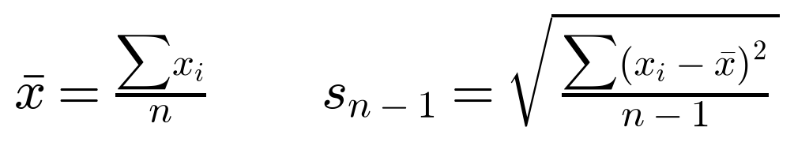
Applying these to the 30 revenue values (using my GDC and a spreadsheet to handle the arithmetic) gives:
mean ȳ = 374,050 ÷ 30 = $12,468.33 median = $7,740.00 sample s.d. s = $16,116.59
The mean ($12,468) is markedly larger than the median ($7,740). Because the mean is pulled towards high values while the median is not, this large gap is a strong signal of positive (right) skew — almost certainly caused by one unusually large revenue month. The standard deviation ($16,117) is actually larger than the mean, which is unusual for revenue data and again points to a single extreme observation inflating the spread. This motivated a formal outlier test.
2.3 Detecting outliers with the interquartile range
Following the plan set out in my introduction, I used the 1.5 × IQR rule. Ordering the 30 revenue values and splitting them into quarters gives the five-number summary below.
Min = $1,190 Q₁ = $3,590 Median = $7,740 Q₃ = $14,500 Max = $84,200
The interquartile range is IQR = Q₃ − Q₁ = 14,500 − 3,590 = $10,910. A value is treated as an outlier when:
Substituting the quartiles, the fences are Q₁ − 1.5(IQR) = 3,590 − 16,365 = −$12,775 and Q₃ + 1.5(IQR) = 14,500 + 16,365 = $30,865. Only one of the 30 revenue values lies outside these fences: month 24, at $84,200, which is far above the upper fence of $30,865. This is exactly the Black Friday spike I anticipated. Figure 1 shows the box-and-whisker plot, on which this single point is plotted separately beyond the right-hand whisker.
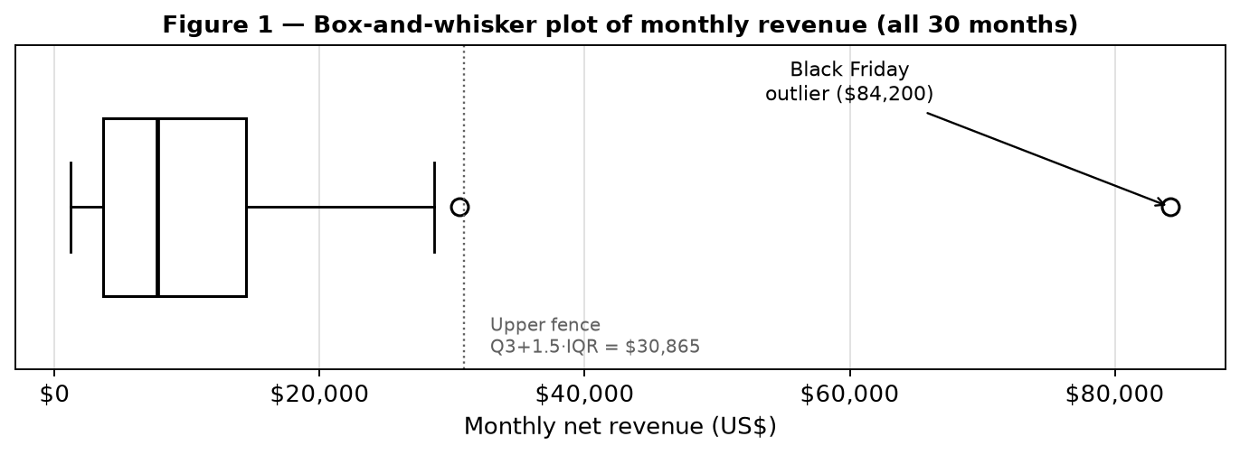
Figure 1 — Box-and-whisker plot of monthly revenue. Month 24 ($84,200) is the only point beyond the Q₃ + 1.5(IQR) fence and is flagged as an outlier.
2.4 Removing the outlier — and what that costs
I chose to remove the month-24 value before fitting the models, because it is not representative of the ordinary relationship I am trying to describe. That month's $8,100 of ad spend returned $84,200 of revenue — a return on ad spend of about 10:1, roughly three times the highest ratio in any other month. Black Friday revenue is driven by seasonal demand, deep discounting and viral attention that occur largely independently of the month's advertising budget; including it would let one holiday distort the trend for all 29 normal months. It is important to be honest about the cost of this decision: removing data is a value judgement, not a neutral act. The Black Friday revenue is real money the business earned, so my models will systematically under-predict revenue during holiday periods, and any budgeting advice based on them applies only to ordinary trading months. With this limitation acknowledged, the analysis proceeds with the remaining n = 29 data points.

3. Mathematical Investigation: Building the Two Models
For every calculation that follows I express the ad spend in thousands of US dollars, writing x for the spend in $1000s (so month 1's $800 becomes x = 0.80). This keeps the regression coefficients on a readable scale without changing the mathematics. Revenue y remains in dollars.
3.1 Visualising the processed data
Figure 2 shows all 30 months on a scatter diagram, with the Black Friday outlier marked. Setting that point aside, the remaining 29 points do not fall along a straight line: they rise gently at low spend and then sweep upward more and more steeply as spend increases. This upward curvature is the visual reason I test an exponential model alongside the linear one.
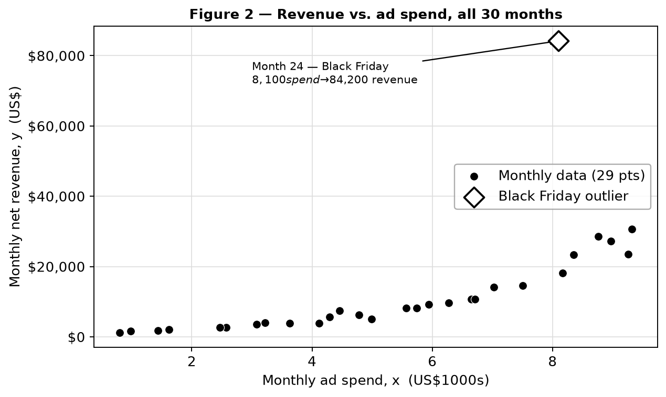
Figure 2 — Monthly revenue against ad spend for all 30 months. The 29 ordinary months curve upward, suggesting an accelerating rather than constant rate of return.
3.2 The linear model y = mx + c
A least-squares regression line is the line that minimises the total squared vertical distance between the data and the line — that is, it minimises
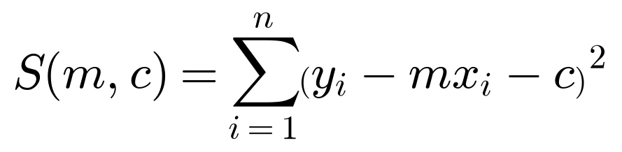
Treating S as a function of the slope m and intercept c and setting the partial derivatives ∂S/∂m = 0 and ∂S/∂c = 0 produces the two normal equations
Solving them simultaneously gives the familiar least-squares estimates, which I write using the corrected sums of squares Sₓₓ and Sₓᵧ:
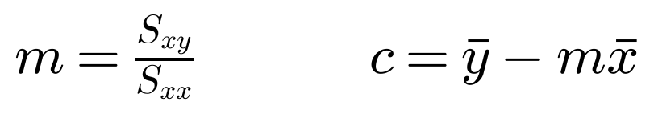
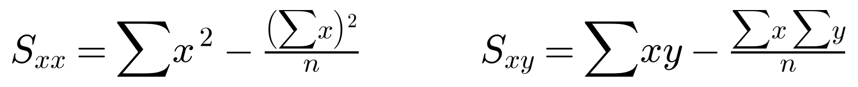
From the 29 processed points I computed the required sums (shown to full precision so the working can be reproduced):
n = 29, Σx = 148.30, Σy = 289,850, Σx² = 957.3048, Σxy = 2,089,073.10
Hence Sₓₓ = 957.3048 − (148.30)²/29 = 198.9293 and Sₓᵧ = 2,089,073.10 − (148.30)(289,850)/29 = 606,840.17, so that
The least-squares linear model is therefore
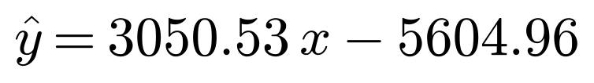
The slope means that, on average across the sample, each extra $1,000 of monthly ad spend is associated with about $3,051 of additional monthly revenue. I return to the negative intercept, which is not physically meaningful, in §4.
3.3 The exponential model y = abˣ via linearisation
An exponential function cannot be fitted with the straight-line formulae directly, but taking natural logarithms of both sides turns it into a linear relationship between x and ln y:
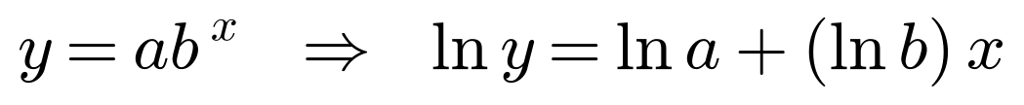
So if the data really are exponential, plotting ln y against x should give points lying close to a straight line with gradient ln b and vertical intercept ln a. I therefore transformed all 29 revenue values to Y = ln y and ran a second least-squares regression of Y on x. The transformed sums are ΣY = 255.36852 and ΣxY = 1,376.39108, giving Sₓᵧ = 70.489 (with the same Sₓₓ = 198.9293 as before). Thus
Back-substituting a = 1089.82 and b = 1.4252 gives the exponential model
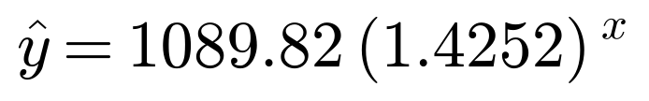
Figure 3 confirms that the linearisation works: the (x, ln y) points are strikingly straight. Figure 4 then shows both fitted models drawn through the original data.
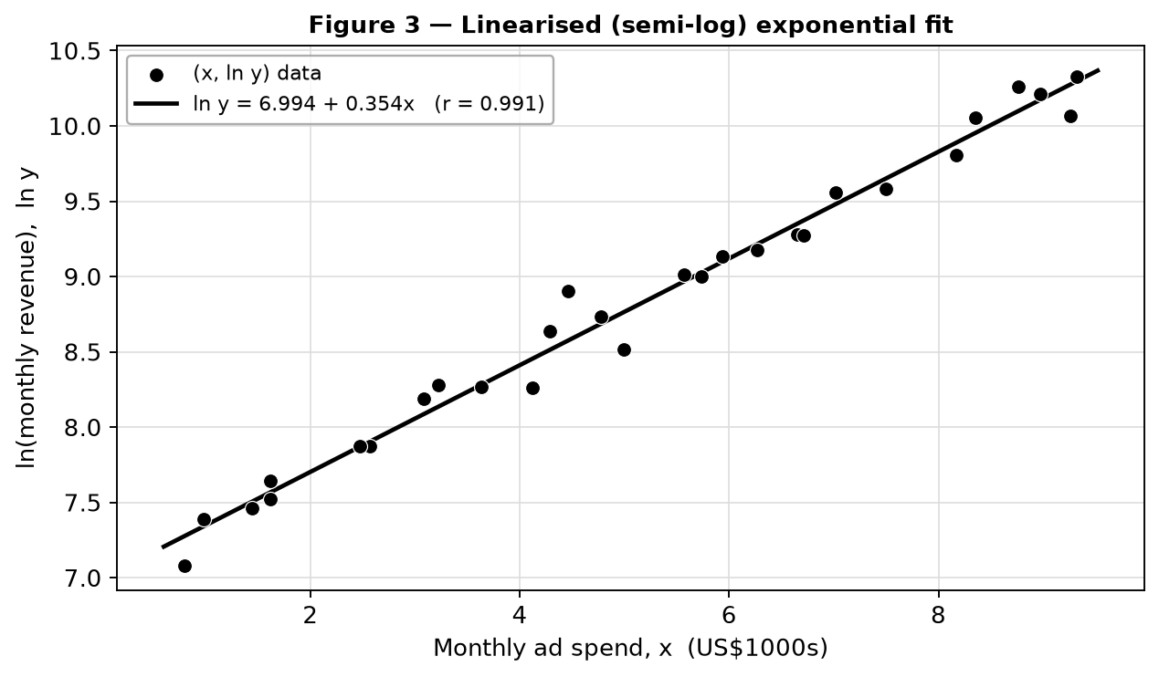
Figure 3 — The semi-log plot of ln y against x. The near-perfect straight line (r = 0.991) shows that the revenue data are very well described by an exponential relationship.
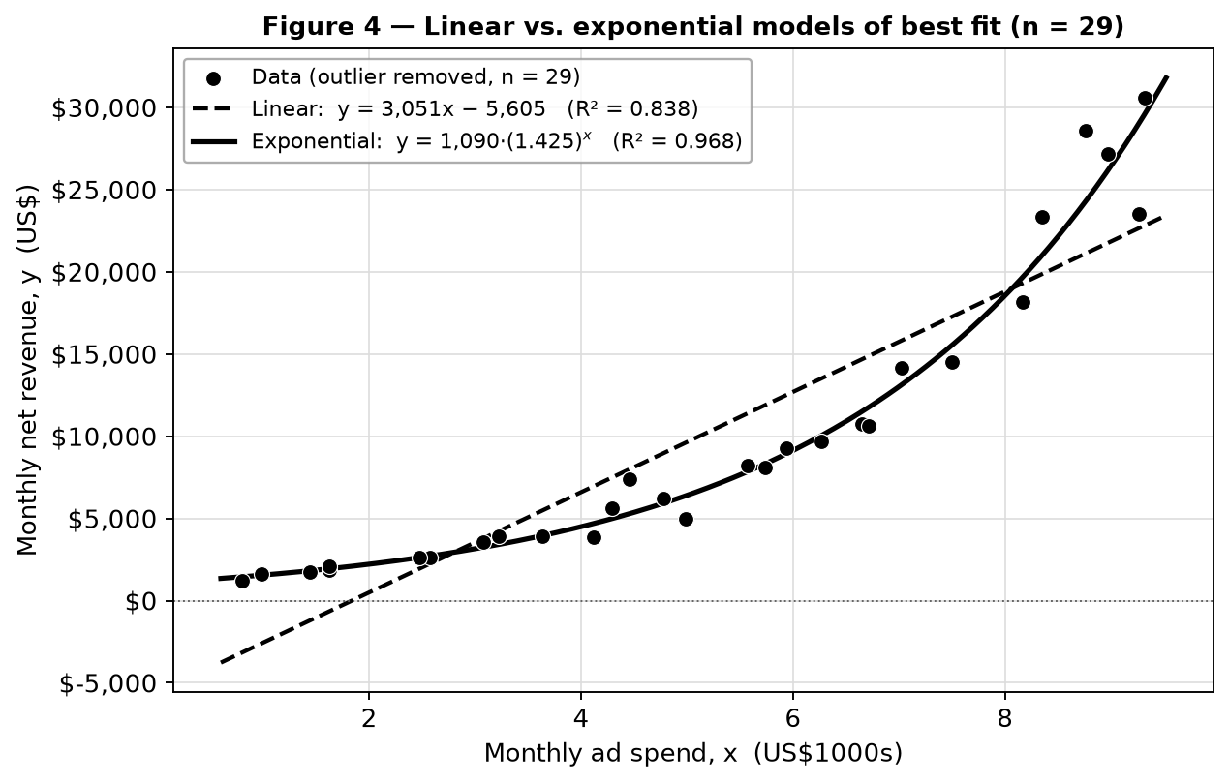
Figure 4 — The linear (dashed) and exponential (solid) models of best fit through the 29 processed data points. The exponential curve follows the upward sweep of the data; the straight line cannot.
The growth factor b = 1.4252 has a clear business meaning: each additional $1,000 of monthly ad spend multiplies revenue by about 1.43, i.e. adds roughly 43%. The coefficient a = 1,089.82 is the revenue the model predicts at zero ad spend — a plausible organic baseline of about $1,090 a month.

4. Analysis and Comparison
4.1 Strength of correlation (Pearson's r)
Pearson's product-moment correlation coefficient measures how tightly points cluster around a straight line:
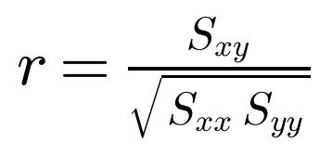
For the linear model this is applied to (x, y) directly; for the exponential model it must be applied to the linearised data (x, ln y), which is what the introduction meant by “linearising so that r can be calculated correctly.” The results are:
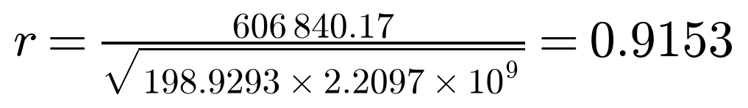
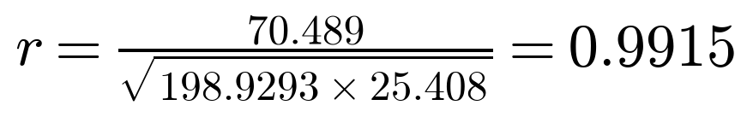
Both coefficients are very strong and positive, but the linearised exponential relationship (r = 0.9915) is noticeably tighter than the linear one (r = 0.9153). Squaring gives coefficients of determination of r² = 0.838 for the linear fit and r² = 0.983 for the linearised exponential fit.
4.2 Is the correlation statistically significant?
A high r from only 29 months could in principle arise by chance, so I tested each correlation for significance using the t-statistic
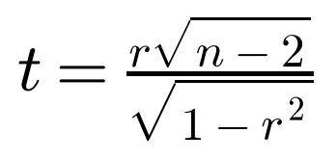
with n − 2 = 27 degrees of freedom. For the linear fit,
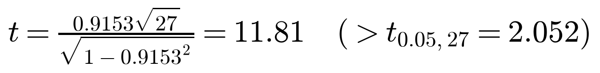
and for the linearised exponential fit t = 39.6. Both far exceed the critical value t₀.₀₅,₂₇ = 2.052 (two-tailed, 5% level), with p-values below 0.001. I can therefore reject the null hypothesis of no correlation in both cases: the positive association between ad spend and revenue is real and highly significant. Significance alone, however, does not tell me which model is better — for that I compare how much variation each explains and how their errors are distributed.
4.3 A fair comparison: R² in the original dollar scale
There is a subtlety that is easy to miss. The linear r² = 0.838 already describes the fit in dollars, but the exponential r² = 0.983 describes the fit on the logarithmic scale of ln y, not in dollars. Comparing 0.838 with 0.983 directly would be comparing two different things. To be rigorous I recomputed the coefficient of determination for the exponential model back in the original units, using the general definition
For the exponential model this means measuring the residuals as (actual dollars − predicted dollars) after converting the fitted curve back with y = abˣ. Doing so gives:
Goodness-of-fit measure | Linear y = mx + c | Exponential y = abˣ
Pearson's r (on the fitted scale) | 0.9153 | 0.9915
R² measured in original dollars | 0.838 | 0.968
SS_res (sum of squared residuals, $²) | 3.585 × 10⁸ | 0.706 × 10⁸
RMSE (typical error, $) | $3,516 | $1,560
Intercept / baseline at low spend | −$5,605 (impossible) | +$1,090 (plausible)
Table 2 — Goodness-of-fit comparison. On every measure the exponential model (right-hand column) fits the ordinary trading months better than the linear model.
Even after this fair, like-for-like comparison the exponential model explains 96.8% of the variation in revenue against the linear model's 83.8%. Its typical prediction error (RMSE) is $1,560, less than half the linear model's $3,516, and its total squared error is about one-fifth as large.
4.4 Residual analysis — the decisive evidence
A single number such as R² can hide a badly-shaped fit, so I plotted the residuals (actual − predicted) against ad spend for each model. If a model is appropriate, its residuals should scatter randomly above and below zero with no pattern.
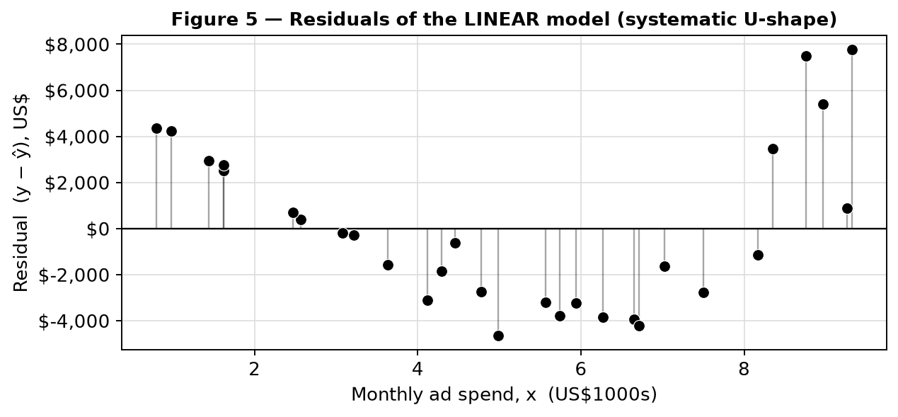
Figure 5 — Residuals of the linear model. They are positive at both ends and negative in the middle, forming a clear “U” (a curved pattern the straight line cannot remove).
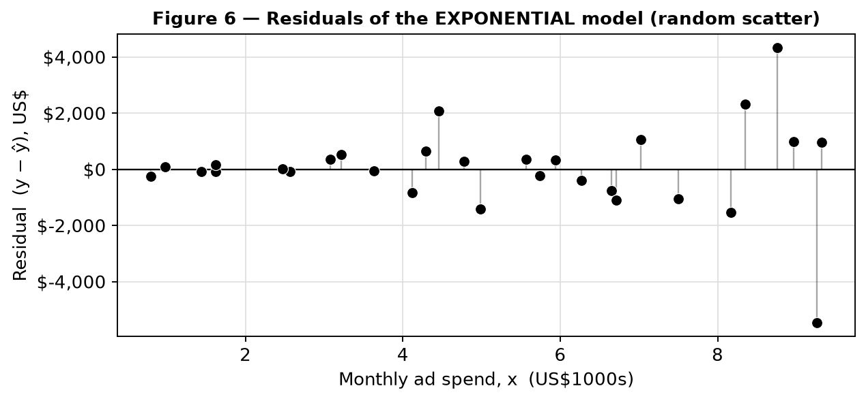
Figure 6 — Residuals of the exponential model. They scatter randomly around zero with no systematic shape, and are far smaller in size.
The linear residuals in Figure 5 are not random at all: they are positive for small budgets, dip negative through the middle of the range, and become strongly positive again at high budgets. This “smile” shape is the classic fingerprint of trying to fit a straight line to curved data — the line sits above the data where the curve is shallow and below it where the curve is steep. The exponential residuals in Figure 6, by contrast, show no such pattern and are much smaller. This is the single most convincing piece of evidence that the true relationship is curved, and specifically exponential, over the observed range.
4.5 What the models say about the marginal return on ad spend
Because I am ultimately interested in budgeting decisions, I used calculus to compare the marginal return — the extra revenue generated by the next $1,000 of spend — predicted by each model. Differentiating each model gives
The linear model's derivative is the constant $3,051 per $1,000, no matter how much is already being spent — this is precisely the “constant returns” hypothesis. The exponential model's derivative grows with x:
It predicts only about $550 of extra revenue from the next $1,000 when spend is low ($1,000/month), rising to about $2,271 at $5,000/month and about $9,371 at $9,000/month. In other words the exponential model captures accelerating returns, which matches the momentum and feedback-loop story in my introduction, whereas the linear model assumes those effects away. This difference is exactly why the linear intercept came out negative: to force a straight line through data that start shallow and finish steep, the line has to be tilted so hard that it drops below zero for any spend under about $1,840 — it literally predicts negative revenue for the smallest budgets, which is impossible. The exponential model has no such problem.

5. Reflection and Practical Limitations
5.1 Why exponential growth cannot continue
The exponential model wins clearly over the 30 months I studied, but I do not believe it could keep winning forever, and it is important that I say why. An exponential function has no ceiling, so it eventually predicts absurd revenue. Extending my own model to a $20,000 monthly budget gives
A return of $1.3 million a month from $20,000 of ad spend — a 65:1 return — is simply not believable. The reason the real world cannot follow the curve that far is economic, not mathematical. Every market has a finite number of potential customers (a finite addressable market). As a startup keeps increasing its budget it must show ads to colder, less-interested audiences, so the cost of acquiring each new customer rises — industry data already show average e-commerce customer-acquisition cost climbing roughly 40% in two years and Meta's ad prices peaking during holidays (Retainful, 2025; Triple Whale, 2026). Audiences also suffer “ad fatigue” from seeing the same brand repeatedly. All of these forces bend the true curve downward at high spend. This is exactly the market-saturation argument I raised in my introduction, and it is why a logistic (S-shaped) model, which grows exponentially at first but then levels off towards a maximum, would be the natural next step once the business is large enough for saturation to appear. My exponential model should therefore be trusted only for interpolation within the observed range of roughly $500–$9,500 per month, never for extrapolation far beyond it.
5.2 Limitations of the data and method
Several further limitations temper my conclusion. First, the dataset was constructed to match published benchmarks rather than drawn from one specific firm's audited accounts, so while its shape and scale are realistic, it cannot capture every quirk of a real business. Second, and more fundamentally, correlation is not causation. Over these 30 months the ad budget and the calendar both increased together, so part of the revenue growth I attributed to advertising may actually be due to the business simply maturing — building a reputation, improving its product, and gaining returning customers over time. My single-variable model cannot separate the effect of ad spend from the effect of time; a multiple-regression model with time as a second explanatory variable would be needed to untangle them. Third, the linearisation I used to fit the exponential model minimises error on the logarithmic scale, which slightly favours a good fit at small revenues over large ones; this is precisely why I recomputed R² in the original dollar scale in §4.3 rather than trusting the log-scale value. Fourth, removing the Black Friday month keeps the trend clean but discards genuine revenue, so the models will always under-state income in holiday months. Finally, the whole analysis assumes a single, constant profit margin and pricing strategy throughout, as stated in my introduction; if the business had changed its prices or product mix, revenue could shift for reasons that have nothing to do with advertising at all.
5.3 What I learned
Working through this exploration changed how I read a “good” correlation. At the start I assumed the model with the highest r would simply be the best, but I found that both models had very high r values, and it was the residual plots — not the correlation coefficients — that clearly separated them. I also learned to be careful about comparing statistics measured on different scales, which is why the original-units R² mattered so much. As an aspiring entrepreneur, the most useful lesson is that the shape of the return matters as much as its strength: knowing that my returns are accelerating (for now) tells me that scaling my budget is worthwhile, while knowing that the acceleration must eventually stop warns me to keep watching for the point where it starts to flatten.

6. Conclusion
My research question asked how well a linear and an exponential function model the relationship between monthly social-media ad spend and monthly revenue for a digital startup over 30 months, and which provides the stronger fit. After removing a single Black Friday outlier, both models produced strong, statistically significant positive correlations, but the exponential model y = 1089.82(1.4252)ˣ was the clear winner. It achieved a higher correlation (r = 0.9915 against 0.9153), explained far more of the variation in revenue once both were measured in dollars (R² = 0.968 against 0.838), produced less than half the typical prediction error ($1,560 against $3,516), and — most tellingly — left randomly scattered residuals where the linear model left a systematic curved pattern. The exponential model also made economic sense at the boundaries, predicting a small positive baseline revenue rather than the linear model's impossible negative one.
The practical answer for a bootstrapped entrepreneur is therefore that, during a startup's early growth phase, revenue responds to advertising with accelerating rather than constant returns, so increasing the budget is well justified while that pattern holds. But the exploration also taught me the limits of my own model: unbounded exponential growth is an artefact of the mathematics, not a property of the market, and market saturation will eventually force the curve to flatten into a logistic shape. Within the range I studied the exponential model is the stronger and more trustworthy tool for budgeting; beyond that range it must be used with caution, and re-fitted as new data arrive.

Bibliography
Digital Commerce 360. (2025). Black Friday sets new record, cementing itself as an ecommerce sales day in 2025. https://www.digitalcommerce360.com/article/black-friday-ecommerce-sales/
impact.com. (2025). Black Friday 2025 spending trends: 31% spent in one day. https://impact.com/affiliate/black-friday-shopping-spending-trends/
Nutshell. (2025). How much does social media advertising cost? https://www.nutshell.com/blog/cost-of-social-advertising
Retainful. (2025). Customer acquisition cost in ecommerce: benchmarks, LTV and your funnel. https://www.retainful.com/blog/customer-acquisition-cost-ecommerce
Trendtrack. (2025). What is the average ROAS for Facebook ads? https://www.trendtrack.io/blog-post/what-is-the-average-roas-for-facebook-ads
Triple Whale. (2026). Facebook ad benchmarks by industry (updated 2026 data). https://www.triplewhale.com/blog/facebook-ads-benchmarks
upcounting. (2025). Average ecommerce ROAS dropped to 2.87 in 2025. https://www.upcounting.com/blog/average-ecommerce-roas
WebFX. (2026). How much does social media advertising cost? https://www.webfx.com/blog/social-media/how-much-does-social-media-advertising-cost/

Note on data. All monetary figures in Table 1 were generated by the author to reflect the ranges reported in the sources above (small-business social budgets of roughly $500–$10,000/month; social-media return on ad spend of about 2–5×; and a holiday revenue surge consistent with reported Black Friday conversion and sales uplifts). The full calculation and figures were produced with Python (NumPy, SciPy and Matplotlib) and verified against the by-hand working shown throughout.

