**Bansilal Ramnath Agarwal Charitable Trust’s**

**Vishwakarma Institute of Technology**

(An Autonomous Institute affiliated to Savitribai Phule Pune University)

Bibwewadi, Upper Indira Nagar, Pune-411037



A Course Project Report

Based on

**“Simulating Automatic door opener and closure along with display of total count of people gone into the shop/bank using Raspberry pi ”**

Submitted by

Division - ET-A, Batch – 3, Group No. - 3

Under the Guidance of

**“Prof.** **Sunil Tayde Sir”**

**Electronics and Telecommunication Engineering Department**

**Academic Year 2020-2021**

**BANSILAL RAMNATH AGARWAL CHARITABLE TRUST’S**

**VISHWAKARMA INSTITUTE OF TECHNOLOGY**

**PUNE-411 037**

**Acknowledgement**

We wish to express our deep gratitude and sincere thanks to our guide and **“Prof.**  **Sunil Tayde Sir”** for his invaluable guidance, constant encouragement and immense motivation which has sustained our efforts at all stages of this project.

We would also like to thank our parents for their constant support.

**OUR TEAM**

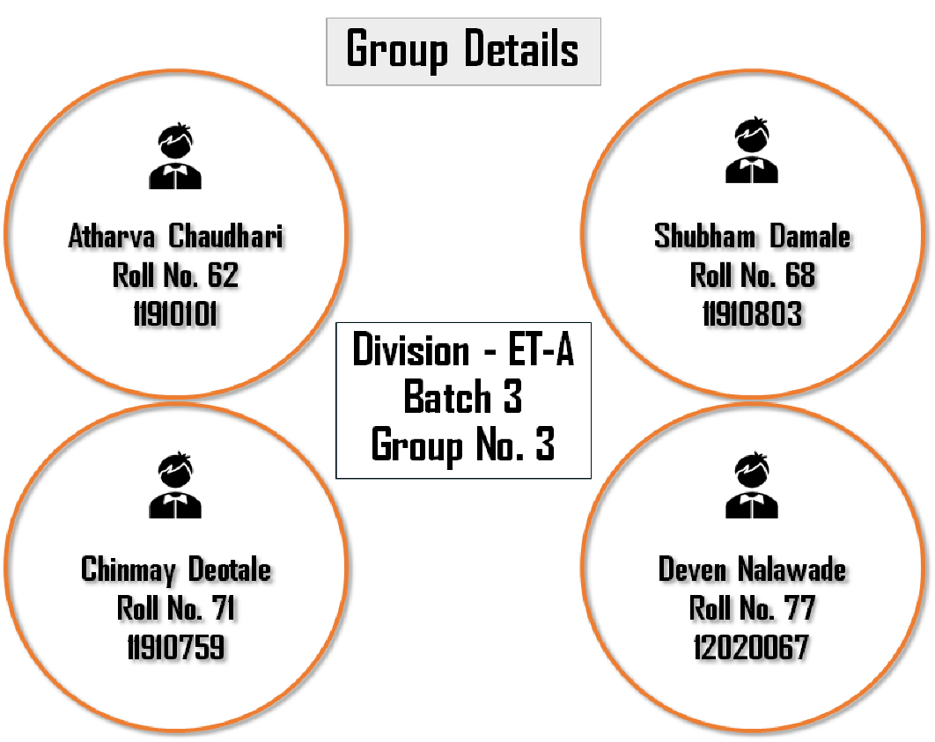

**Index**

* **Project Description and Objective :**
* **Tools and Technology Used :**
* **Results :**
* **Advantages and Applications :**
* **Conclusion :**
* **Future Scope :**
* **References :**
* **Project Description and Objective :**

With the advancement of technology intelligent devices are fast approaching the realm of necessity from the status of luxury. With limited energy resources and COVID crisis , it is the need of time to revolutionize the traditional methods of counting visitors inside hotels, recreational places, meeting rooms and cinemas to control the electrical appliances. Though a number of systems have been developed in this field but most of them are not practically applicable due to outdated technology.

Our Objective of our project is to simulating Automatic door opener and closure along with display of total count of people gone into the shop/bank using Raspberry pi . This will help the owner of hotels, recreational places, meeting rooms and cinemas to keep a track of people visiting such places instead of using traditional method of visitor counting .

This system will also help control COVID spread as the owner will also know the number of people inside the shop/bank and will manage the people entering accordingly .

* **Tools and Technology Used :**
* **PLATFORM :**
* **PROTEUS (8.9):** The Proteus is an electronic circuit design software which includes a **schematic capture**, **simulation** and **PCB ( Printed Circuit Board) Layout modules** . Even though -if u are not using for PCB designing u can view the PCB layout of the component individually while selecting the component it helps during the soldering of components in PCB.

Proteus help simulating the circuits containing the micro controllers where we can simulate the circuit by uploading the hex code to the Micro-controller . **Netlist file** ( Written in Verilog Code) if needed for your usage can also be extracted from the tools option in this software.

* **COMPONENTS USED :**
* **RASPBERRY PI 3 :** The Raspberry Pi is a low-cost, credit-card-sized computer that plugs into a computer monitor or TV, and uses a standard keyboard and mouse. It is a capable little device that enables people of all ages to explore computing and to learn how to program in languages like Scratch and Python

It is based on a Broadcom SOC (System on a Chip) that includes an ARM7 core, a Video core iv GPU and USB controller. It has either 256MB or 512MB on the board and an SD card slot for storage.

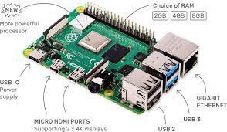

We have used RASPBERRY PI 3 as our microcontroller to take inputs from sensor and do other computations .

* **16*2 ALPHA-NUMERIC LCD :**

An LCD (Liquid Crystal Display) screen is an electronic display module and has a wide range of applications. A 16x2 LCD display is very basic module and is very commonly used in various devices and circuits.

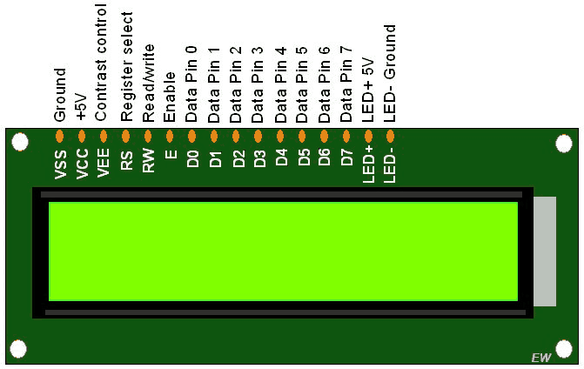

A 16x2 LCD means it can display 16 characters per line and there are 2 such lines. In this LCD each character is displayed in 5x7 pixel matrix. The 16 x 2 intelligent alphanumeric dot matrix display is capable of displaying 224 different characters and symbols. This LCD has two registers, namely, Command and Data.

* **PIR (Pyroelectric ("Passive") InfraRed Sensors ) SENSOR :**

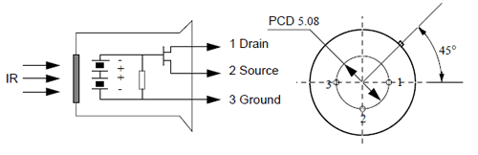PIR sensor itself has two slots in it, each slot is made of a special material that is sensitive to IR. The lens used here is not really doing much and so we see that the two slots can 'see' out past some distance (basically the sensitivity of the sensor).

When the sensor is idle, both slots detect the same amount of IR, the ambient amount radiated from the room or walls or outdoors. When a warm body like a human or animal passes by, it first intercepts one half of the PIR sensor, which causes a positive differential change between the two halves. When the warm body leaves the sensing area, the reverse happens, whereby the sensor generates a negative differential change. These change pulses are what is detected.

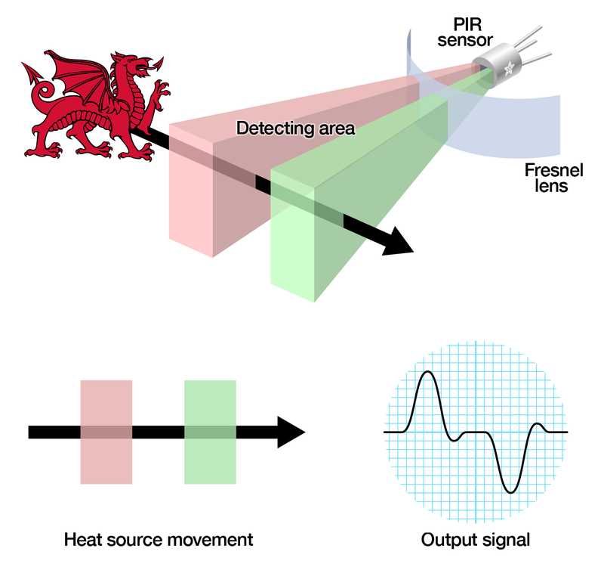

* **L293D MOTOR DRIVER :**

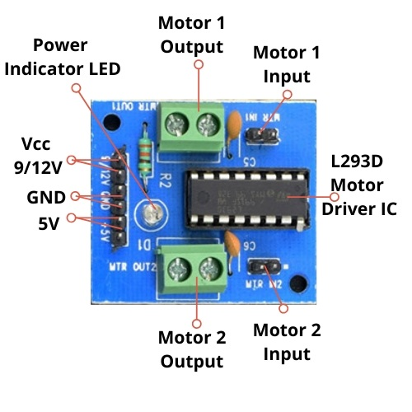A motor driver IC is an integrated circuit chip which is usually used to control motors in autonomous robots. Motor driver ICs act as an interface between microprocessors in robots and the motors in the robot. The most commonly used motor driver IC’s are from the L293 series such as L293D, L293NE, etc. These ICs are designed to control 2 DC motors simultaneously. L293D consist of two H-bridge.

H-bridge is the simplest circuit for controlling a low current rated motor. For this tutorial we will be referring the motor driver IC as L293D only. L293D has 16 pins, they are comprised as follows:

1. Ground Pins - 4
2. Input Pins - 4
3. Output Pins - 4
4. Enable pins - 2
5. Voltage Pins – 2

* **DC MOTOR :**

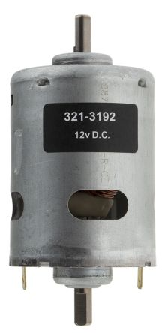A direct current (DC) motor is a type of electric machine that converts electrical energy into mechanical energy. DC motors take electrical power through direct current, and convert this energy into mechanical rotation.

DC motors use magnetic fields that occur from the electrical currents generated, which powers the movement of a rotor fixed within the output shaft. The output torque and speed depends upon both the electrical input and the design of the motor.

* **And other components like ALERT LED , LOGIC GATES , and some other .**
* **Block Diagram :**

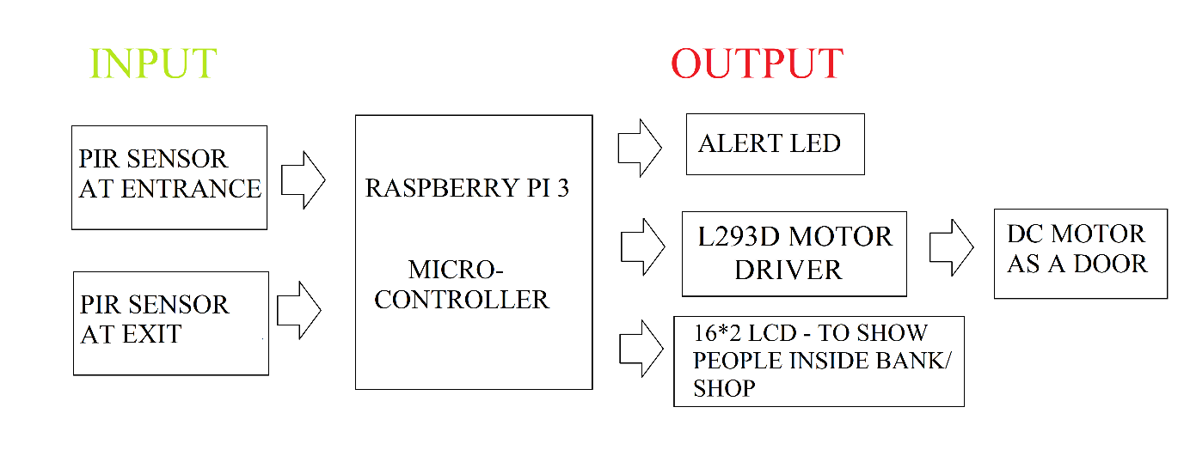

Above figures shows the block diagram of our system

* **SCHEMATIC CAPTURE OF THE CIRCUIT :**

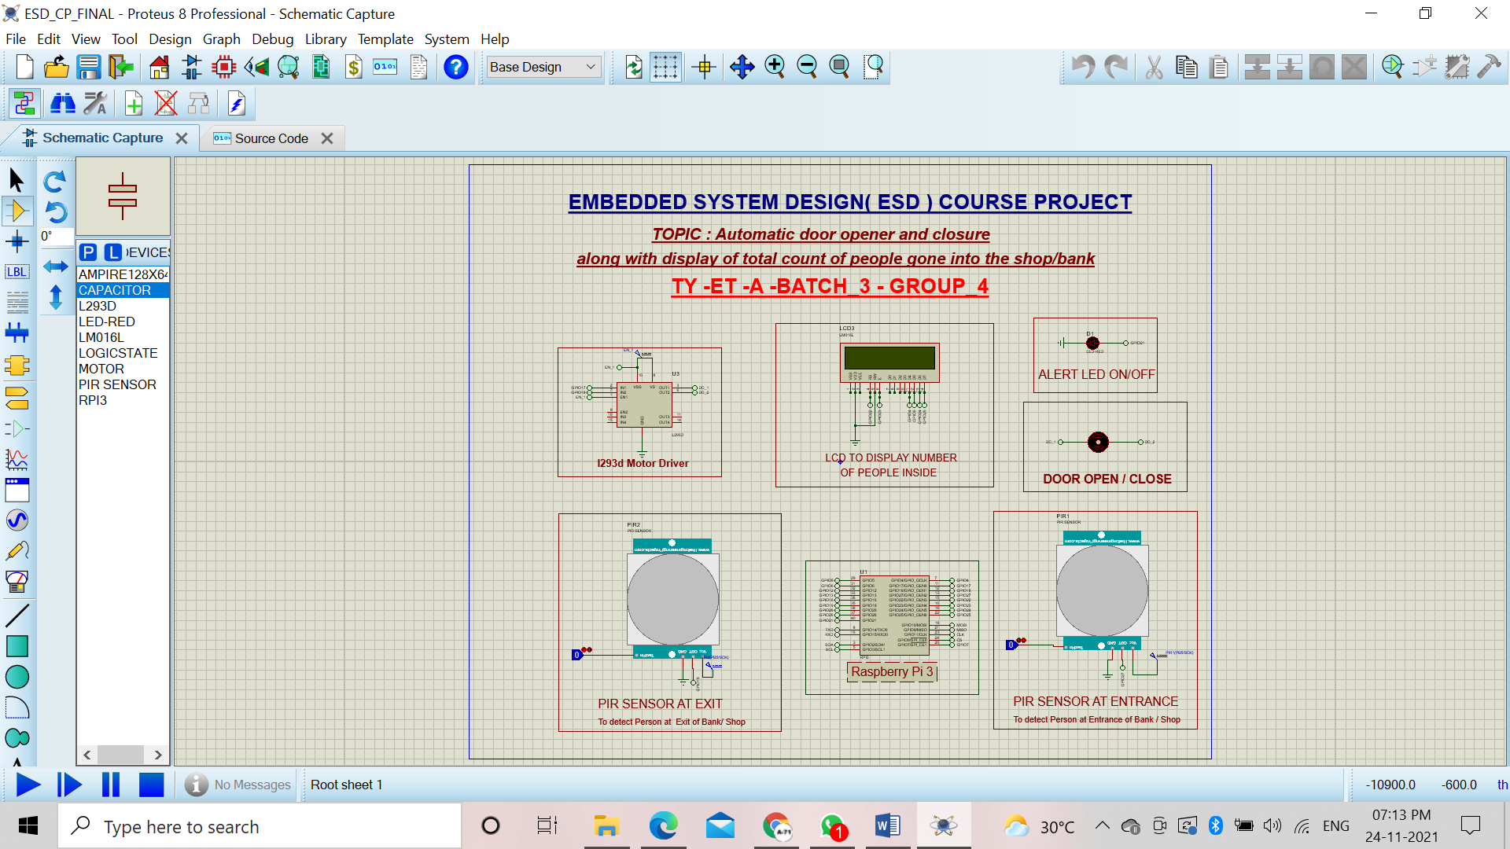

* **Source Code :**

#IMPORT IMPORTANT LIBRARIES \

import time

import RPi.GPIO as GPIO

GPIO.setmode(GPIO.BOARD)

GPIO.setwarnings(False)

# Define GPIO to LCD mapping

Led_pin = 40

Motor_1= 11

Motor_2 =12

PIR_Sensor =13

PIR_SENSOR_out =35

# Define GPIO to LCD mapping

LCD_RS = 15

LCD_E = 16

LCD_D4 = 7

LCD_D5 = 29

LCD_D6 = 18

LCD_D7 = 22

# Define some device constants

LCD_WIDTH = 16 # Maximum characters per line

LCD_CHR = True

LCD_CMD = False

LCD_LINE_1 = 0x80 # LCD RAM address for the 1st line

LCD_LINE_2 = 0xC0 # LCD RAM address for the 2nd line

# Timing constants

E_PULSE = 0.0005

E_DELAY = 0.0005

delay = 1

def lcd_init():

# Initialise display

lcd_byte(0x33,LCD_CMD) # 110011 Initialise

lcd_byte(0x32,LCD_CMD) # 110010 Initialise

lcd_byte(0x06,LCD_CMD) # 000110 Cursor move direction

lcd_byte(0x0C,LCD_CMD) # 001100 Display On,Cursor Off, Blink Off

lcd_byte(0x28,LCD_CMD) # 101000 Data length, number of lines, font size

lcd_byte(0x01,LCD_CMD) # 000001 Clear display

time.sleep(E_DELAY)

def lcd_byte(bits, mode):

# Send byte to data pins

# bits = data

# mode = True for character

# False for command

GPIO.output(LCD_RS, mode) # RS

# High bits

GPIO.output(LCD_D4, False)

GPIO.output(LCD_D5, False)

GPIO.output(LCD_D6, False)

GPIO.output(LCD_D7, False)

if bits&0x10==0x10:

GPIO.output(LCD_D4, True)

if bits&0x20==0x20:

GPIO.output(LCD_D5, True)

if bits&0x40==0x40:

GPIO.output(LCD_D6, True)

if bits&0x80==0x80:

GPIO.output(LCD_D7, True)

# Toggle 'Enable' pin

lcd_toggle_enable()

# Low bits

GPIO.output(LCD_D4, False)

GPIO.output(LCD_D5, False)

GPIO.output(LCD_D6, False)

GPIO.output(LCD_D7, False)

if bits&0x01==0x01:

GPIO.output(LCD_D4, True)

if bits&0x02==0x02:

GPIO.output(LCD_D5, True)

if bits&0x04==0x04:

GPIO.output(LCD_D6, True)

if bits&0x08==0x08:

GPIO.output(LCD_D7, True)

# Toggle 'Enable' pin

lcd_toggle_enable()

def lcd_toggle_enable():

# Toggle enable

time.sleep(E_DELAY)

GPIO.output(LCD_E, True)

time.sleep(E_PULSE)

GPIO.output(LCD_E, False)

time.sleep(E_DELAY)

def lcd_string(message,line):

# Send string to display

message = message.ljust(LCD_WIDTH," ")

lcd_byte(line, LCD_CMD)

for i in range(LCD_WIDTH):

lcd_byte(ord(message[i]),LCD_CHR)

#Setup LCD

GPIO.setwarnings(False)

GPIO.setup(LCD_E, GPIO.OUT) # E

GPIO.setup(LCD_RS, GPIO.OUT) # RS

GPIO.setup(LCD_D4, GPIO.OUT) # DB4

GPIO.setup(LCD_D5, GPIO.OUT) # DB5

GPIO.setup(LCD_D6, GPIO.OUT) # DB6

GPIO.setup(LCD_D7, GPIO.OUT) # DB7

#setup other components

GPIO.setup(Led_pin, GPIO.OUT) # E

GPIO.setup(Motor_1, GPIO.OUT) # Motor_1

GPIO.setup(Motor_2, GPIO.OUT) # Motor_1

GPIO.setup(PIR_Sensor, GPIO.IN)

GPIO.setup(PIR_SENSOR_out , GPIO.IN)

#Initialize LCD with WELCOME message

lcd_init()

lcd_string("welcome to bank /shop ",LCD_LINE_1)

#Variables

count =0

people_entered = 0

people_exited = 0

pir=True

pir_1=True

#LOOP

while 1:

#FOR ENTRANCE

if(GPIO.input(PIR_Sensor ) ):

GPIO.output(Motor_1, True)

GPIO.output(Motor_2, False)

GPIO.output(Led_pin, True)

if(pir == True):

count=count+1#increment counter

people_entered = people_entered +1

pir=False

lcd_string("people inside:"+str(count),LCD_LINE_2)#Display number of people inside

time.sleep(0.5)

continue

else:

pir=True

GPIO.output(Motor_1, False)

GPIO.output(Motor_2, False)

GPIO.output(Led_pin, False)

lcd_string("people inside:"+str(count),LCD_LINE_2)#Display number of people inside

time.sleep(0.5)

#FOR EXIT

if(GPIO.input(PIR_SENSOR_out ) ):

GPIO.output(Motor_1, False)

GPIO.output(Motor_2, False)

GPIO.output(Led_pin, False)

if(pir_1 == True):

count=count-1#decrement counter

people_exited = people_exited +1

pir_1=False

lcd_string("people inside:"+str(count),LCD_LINE_2) #Display number of people inside

time.sleep(0.5)

continue

else:

pir_1=True

GPIO.output(Motor_1, False)

GPIO.output(Motor_2, False)

GPIO.output(Led_pin, False)

lcd_string("people inside:"+str(count),LCD_LINE_2)#Display number of people inside

time.sleep(0.5)

* **Results:**

We were able to successfully achieve Simulate a system which would automatically open door(DC Motor) after sensing through PIR Sensor at entrance and Display the number of people inside the Bank / Shop .The result will be shown by Alert Led glowing and Rotating DC Motor(showing opening of door ) .Similarly if a person exits Bank / Shop PIR Sensor will detect the presence of that person and update the number inside number on display at Entrance by deducing one .

Following Screen-shots shows above explained functionality in Proteus 8.9 Simulation Software

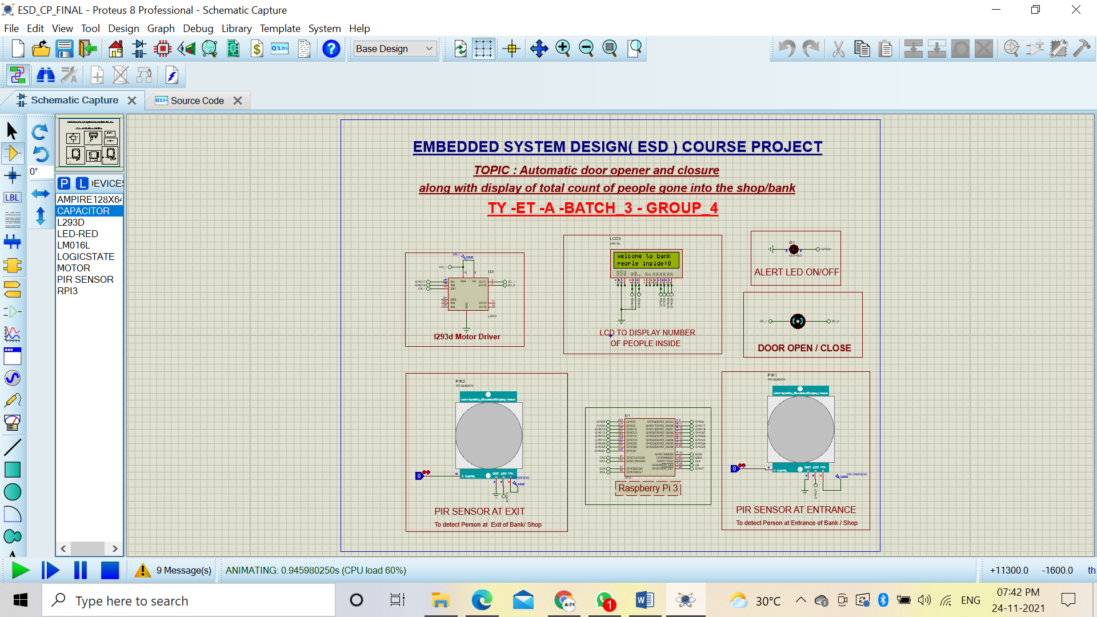

Above Figure show how the Display would show Welcome message on LCD along with number of people count as ‘0’ as no people have entered yet .

Now lets say a person enters Bank or Shop which is shown by turning logic gate at PIR sensor at entrance to ‘1’ . As seen in figure LED turns on , DC motor starts rotating and number of people on display is updated .

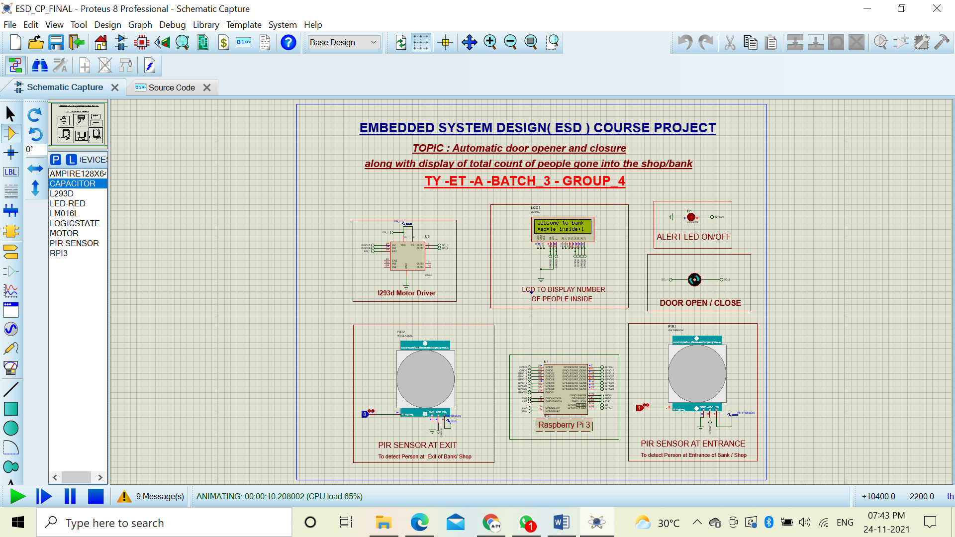

The system will work the same as above till person enters the Shop / Bank . Now lets say the person wants to exit from exit door . Once he enters exit door PIR sensor will sense his /her presence and update the Number of people count on the Display on LCD by deducing by ‘1’ . The same is shown in below figure .

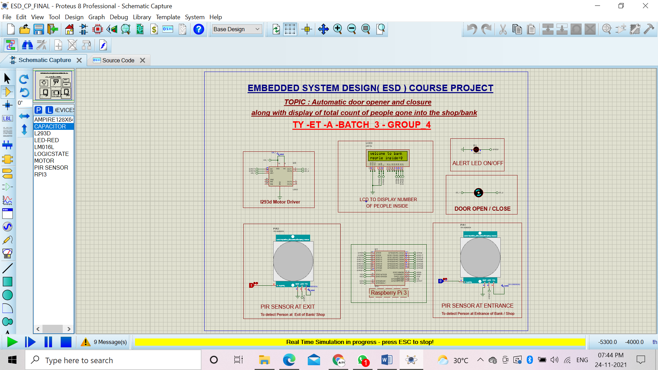

* **Conclusion :**

We were able to successfully Stimulate a system which would automatically open door(DC Motor) after sensing through PIR Sensor at entrance and Display the number of people inside the Bank / Shop .The result will be shown by Alert Led glowing and Rotating DC Motor(showing opening of door ) .Similarly if a person exits Bank / Shop PIR Sensor will detect the presence of that person and update the number inside number on display at Entrance by deducing one .

* **Future Scope & Limitations :**

1. We can add a MLX90614 body temperature sensor to add the Temperature screening for ensuring COVID safety .
2. We can make the Hardware for the same Schematic to implement in Real like places like Bank or Shop .
3. **Power Failure:** The circuit will powered by electricity, if the Bank or Shop has a power failure, then the system will not work. Buying a battery powered system will not get affected if there is a power failure.

* **References :**

**[1]** A. Mathur, K. S. Nagl, "Microcontroller-based bidirectional visitor counter", Electronics for You, 78-81 (2007).

**[2]** Gaurav Waradkar, Hitesh Ramina, Vinay Maitry, Tejasvi Ansurkar, Asha Rawat, Parth Das, "Automated room light controller with visitor counter", Imper. J. Interdisc. Res., 2(4): 777-780 (2016).

**[3]** A. Dey, S. Chakraborty, S. Islam, M. Pramanik, Md. AH Malick, "Design of controllable bidirectional visitor counter", Int. J. Innov. Res. Elect Electro., Instru. Cont. Engg., 4(5): 133-136 (2016).

**[4]** Mohanaprakash, Sathya, Dhanabal, "Modern multipurpose security and power management system", Int. J. Engg. Res. Gen. Sci., 3(2): (2015)