Fgwrgae

I did simulate this scenario by filling up my /webroot with same kind of files:

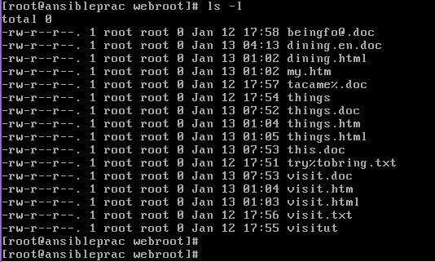

My plan was to use two options to rename the files:

* Via Ansible
* Via Bash shell Scripting

**VIA ANSIBLE**

The plan was to write a playbook that will find all files with “.htm” and “.html” extensions and rename them to “.en.htm” and “.en.html”. Then delete all other files with the non-required extensions

I started wring a playbook to find required files.

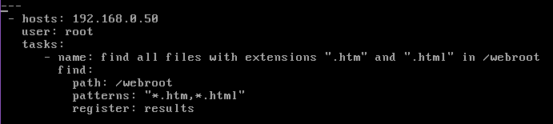

Its results:

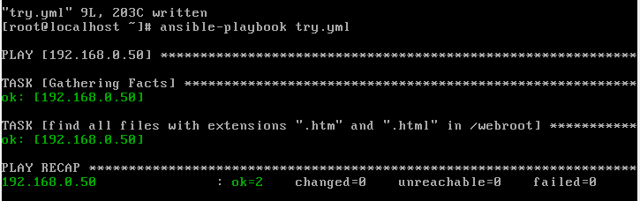

At this point it got difficult for me to get the fitting ansible module to rename files.

So I am still trying.

**VIA Bash Shell script:**

Using the method I tried the other way round. First delete all files containing the non-concerned extensions and then continue to replace the wrong extensions with the right ones.

So I started the script:

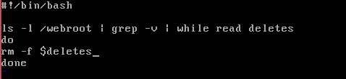

Apparently this did not work.

I tried my best but realized my multiple file naming skills are to be developed. I have not given up on the assessment but will take it as growth opportunity

Many thinks for the opportunity though