**Basics of Using the Moodle CMS**

<https://docs.moodle.org/33/en/Main_page>

**Basics of Custom Plugin Development**

<https://docs.moodle.org/dev/Tutorial#The_skeleton_of_your_plugin>

**Generates code for the skeleton**

<https://moodle.org/plugins/tool_pluginskel>

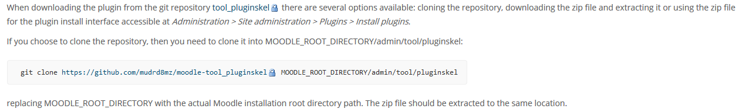

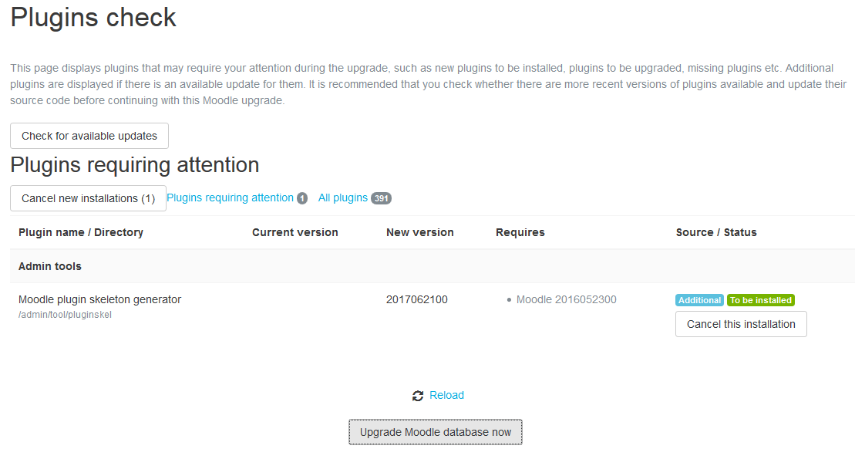

<https://github.com/moodlehq/moodle-mod_newmodule>

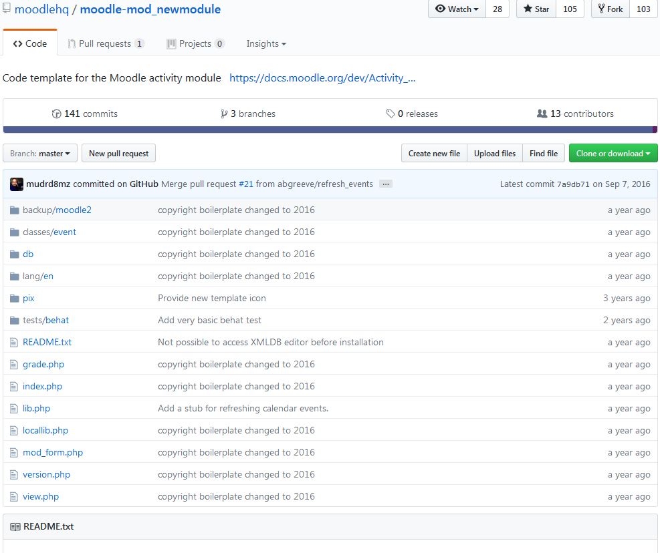

FOLLOW DIRRECTIONS ON THIS PAGE

Path:

D:\Projects\ScratchEncore\scratch-encore-testing\Moodle-Testing\server\moodle\mod\scratchencore