1. (5) Provide a short answer to the questions below, and provide a reference from reading the Executive Summary section ES.1 (Introduction) from Wind Vision to support your claims (page number and line number).
   1. By how much has the installed capacity of wind turbines increased since 2008?   
      **Installed capacity had risen from 25 GW in 2008 to 61 GW in 2013. (p. xxxv)**
   2. Other influences could have a positive effect on the deployment of wind energy. Name three.   
      **High Fossil Fuel costs, low wind power costs and high electricity demand can all positively affect the deployment of wind energy. (p. xxx)**
   3. For the Wind Vision Study Scenario, how much of a decrease in cost of wind-generated electricity was assumed at different points in the study?   
      **The Study Scenario assumes the following cost reductions over today's cost: 24% by 2020, 33% by 2030, 37% by 2050 (p. xxxii)**
   4. What level of penetration does offshore wind have in 2030 in Wind Vision Study Scenario?   
      **Offshore wind resource development would achieve 2% penetration by 2030 and 7% penetration by 2050. (p. xxxiii)**
   5. What is the purpose of the baseline scenario?  
      **The Baseline Scenario provides a no-further-wind-development plan to compare effects on the energy market between further developing wind resources over the next several decades or not. (p. xxvii)**
2. (7) Provide a short answer to the questions below, and provide a reference from reading the Executive Summary section ES.2 (State of the Wind industry) from Wind Vision to support your claims (page number and line number).
   1. Has the growth of the wind industry met, exceeded, or fallen short of the levels set in the 20% by 2020 report? Give two specific examples to support your answer.   
      **The wind industry has exceeded predictions since 2008, but has not reached 20% yet. In 2013, installed capacity exceeding predictions by 13 GW (27%) and the number of states with Utility-Scale Wind Development was 39, as opposed to the predicted 35. (p. xxxv)**
   2. Although the domestic wind industry grew in response to development levels experienced between 2008 and 2013, list the challenges to the industry that caused some plants to scale back or close their operations.   
      **Wildlife impacts, low natural gas prices.**
   3. What factors affect the Levelized Cost of Electricity (LCOE)?   
      **"The LCOE for wind is influenced by the quality of the wind resource and access to transmission, as well as by capital and balance of system costs, plant performance and productivity, operations and maintenance (O&M) costs, and financing costs." (p. xxxvi)**
   4. What factor(s) have caused electricity demand to remain flat over the past several years?   
      **Economic Downturn**
   5. The focus of technical improvements in the wind industry has shifted away from improvements to single turbines. To where has the focus shifted?   
      **The development of wind plants, over individual units. (p. xxxvii/xxxviii)**
   6. The integration of wind into the electricity supply has been easier than many expected. What factors made this possible?   
      **"Improved wind forecasting, wind plant controls, and expanding the geographical area for reserve sharing and demand response have all contributed to increased power system flexibility." (p. xxxviii)**
   7. What has been the primary hurdle in the way of developing many sites with excellent wind resources?  
      **Access to transmission lines and facilities has been the largest hurdle for some of the best wind sites. (p. xxxix)**
3. (20) A common way of determining the suitability of a site for wind power is to make measurements at a specific location and then compare to long-term data available from locations such as airports. In this assignment, we will look at airport data from the Laramie airport (the reported winds are for a height of 10 m). A Matlab program that reads the data file and returns the wind speed (and other parameters) is provided.
   1. (a) Develop a program that is capable of reading the data in the file. Convert wind speeds to an 80 m height as this is a common hub height used for commercial turbines. Use a power law estimation with a roughness coefficient of a=0.19 for this purpose. Provide a plot of the wind speed at 80 m for the month of January 2014 to demonstrate this capability.
   2. (b) Use this program to determine the monthly average wind speed (you should get 12 averages - one for each month) for the 10 years of data included in the file. Plot this average wind speed versus month. Calculate the average monthly wind speed for just 2014 and compare it to the longer 10 year average. Discuss what you find.

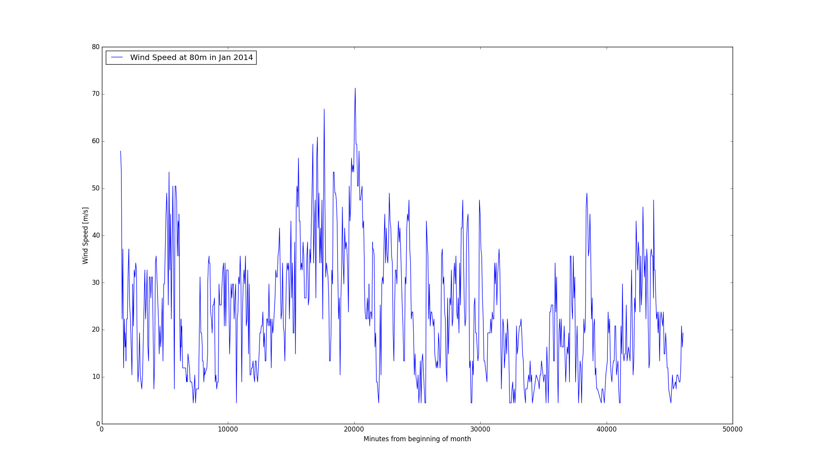You may use whatever software you want for performing these calculations, but I will not be able to help with all packages as my expertise is limited to more traditional programming.

3.a.

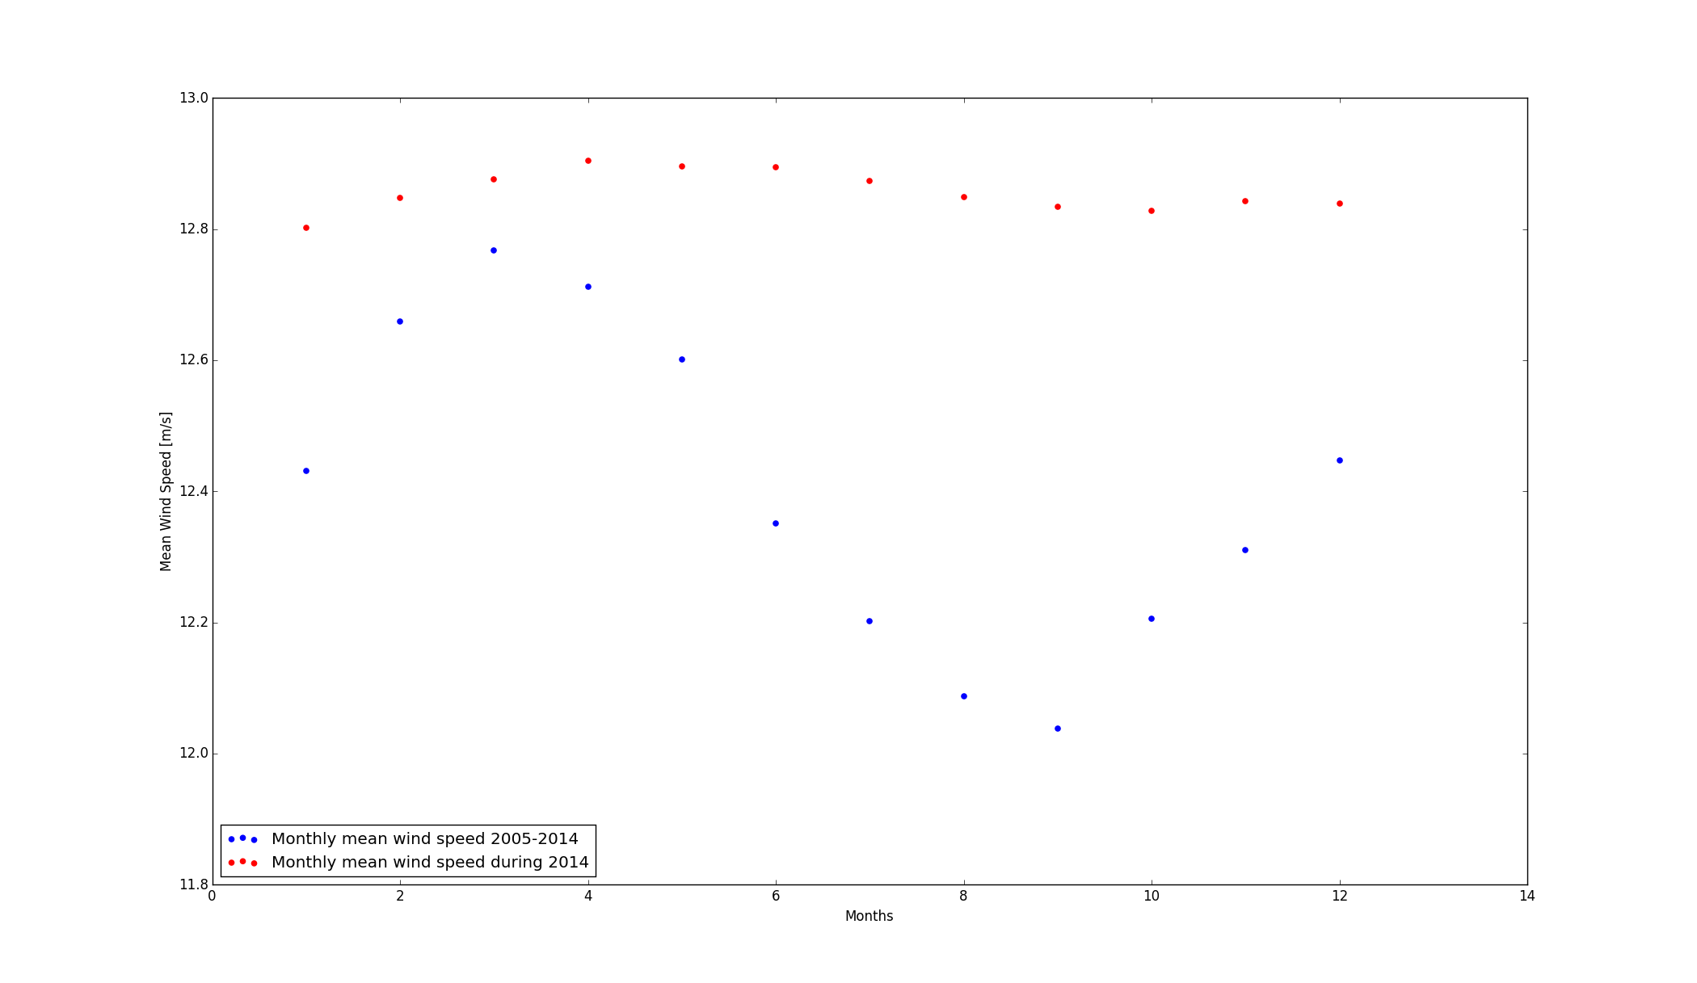3.b.

The monthly averages from just 2014 are not only far more consistent than the overall averages from the previous decade, but are also a good bit higher overall. This could come from a large number of factors, including decade-scale atmospheric variations and climate change.